1. Hacking (a game) ROM. (i) Learn how to hack a game ROM from this link http://www.nin tendoage.com/forum/messageview.cfm?catid=22&threadid=19733 (ii) Change 2 PLAYER GAME in menu to 2 Your Name GAME, e.g. I change the 2 PLAYER GAME to 2 EKARAT GAME. Capture and paste your change. * You can download the target game ROM (Super Mario Adventure (SMB1 Hack).nes) HERE.
→Just follow the instructions on the website.

2. Use your Hex editor to modify any programs you want, and tell us (i) What is the target program? (ii) What is your modification? Show the captured screen of the result.
→placeholder

3. Havij. (i) Install Havij. (ii) Explain how to use this tool to crack a database.
→I tried hard, but I still cannot find an effective link to download the program. The following image is taken from the Internet (by TheHallo80, under the CC BY License).
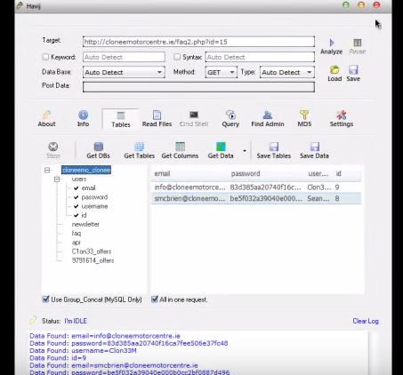

→First find a website that SQL injection can be applied. (Usually, when we modify the URL parameter of a vulnerable website to an arbitrary value, we will encounter some unexpected behavior, e.g. seeing some SQL error messages.) Then, just click analyze. It will try to inject the database behind the website. After succeeding, we can use the GUI to retrieve the table schema and content.

4. Burp Suite. (i) Install Burp Suite. (ii) Explain how to use this tool. (iii) Using Burp Suite to scan a target, what kind of information can you get?
→I can only get the Free Edition from its official website.

