Introduction

The sinking of the RMS Titanic is one of the most infamous shipwrecks in history.  On April 15, 1912, during her maiden voyage, the Titanic sank after colliding with an iceberg, killing 1502 out of 2224 passengers and crew. This sensational tragedy shocked the international community and led to better safety regulations for ships.

One of the reasons that the shipwreck led to such loss of life was that there were not enough lifeboats for the passengers and crew. Although there was some element of luck involved in surviving the sinking, some groups of people were more likely to survive than others, such as women, children, and the upper-class.

Business understanding

In this report, we ask you to complete the analysis of what sorts of people were likely to survive. In particular, we apply the tools of machine learning to predict which passengers survived the tragedy. We find an appropriate and credible dataset and analyze how its features and dimensions help with our predictions. This will be done by choosing appropriate data mining models used in everyday data analytics.

The data science solutions workflow solves for seven major goals.

**1.1.1 Classifying.** We may want to classify or categorize our samples. We may also want to understand the implications or correlation of different classes with our solution goal.

**1.1.2 Correlating.** One can approach the problem based on available features within the training dataset. Which features within the dataset contribute significantly to our solution goal? Statistically speaking is there a [correlation](https://en.wikiversity.org/wiki/Correlation) among a feature and solution goal? As the feature values change does the solution state change as well, and visa-versa? This can be tested both for numerical and categorical features in the given dataset. We may also want to determine correlation among features other than survival for subsequent goals and workflow stages. Correlating certain features may help in creating, completing, or correcting features.

**1.1.3 Converting.** For modeling stage, one needs to prepare the data. Depending on the choice of model algorithm one may require all features to be converted to numerical equivalent values. So for instance converting text categorical values to numeric values.

**1.1.4 Completing.** Data preparation may also require us to estimate any missing values within a feature. Model algorithms may work best when there are no missing values.

**1.1.5 Correcting.** We may also analyze the given training dataset for errors or possibly innacurate values within features and try to corrent these values or exclude the samples containing the errors. One way to do this is to detect any outliers among our samples or features. We may also completely discard a feature if it is not contribting to the analysis or may significantly skew the results.

**1.1.6 Creating.** Can we create new features based on an existing feature or a set of features, such that the new feature follows the correlation, conversion, completeness goals.

Data understanding

**Data collection**

The initial data is collected from Kaggle competition. As a result, twelve attributes were collect, there are 891 records in the train dataset and there are 418 value in the test dataset.

**Data Description**

After data collection, we need to know the detail information about each attribute, the following table describes the data type and provides the example value for each attributes.

|  |  |  |
| --- | --- | --- |
| Variable | Definition | Key |
| survival | Survival | 0 = No, 1 = Yes |
| pclass | Ticket class | 1 = 1st, 2 = 2nd, 3 = 3rd |
| sex | Sex |  |
| Age | Age in years |  |
| sibsp | # of siblings / spouses aboard the Titanic |  |
| parch | # of parents / children aboard the Titanic |  |
| ticket | Ticket number |  |
| fare | Passenger fare |  |
| cabin | Cabin number |  |
| embarked | Port of Embarkation | C = Cherbourg, Q = Queenstown, S = Southampton |

**What are the data types for each feature?**

* Survived: int
* Pclass: int
* Name: string
* Sex: string
* Age: float
* SibSp: int
* Parch: int
* Ticket: string
* Fare: float
* Cabin: string
* Embarked: string

|  |  |  |  |  |  |  |  |  |  |  |  |  |
| --- | --- | --- | --- | --- | --- | --- | --- | --- | --- | --- | --- | --- |
|  | PassengerId | Survived | Pclass | Name | Sex | Age | SibSp | Parch | Ticket | Fare | Cabin | Embarked |
| 0 | 1 | 0 | 3 | Braund, Mr. Owen Harris | male | 22.0 | 1 | 0 | A/5 21171 | 7.2500 | NaN | S |
| 1 | 2 | 1 | 1 | Cumings, Mrs. John Bradley (Florence Briggs Th... | female | 38.0 | 1 | 0 | PC 17599 | 71.2833 | C85 | C |
| 2 | 3 | 1 | 3 | Heikkinen, Miss. Laina | female | 26.0 | 0 | 0 | STON/O2. 3101282 | 7.9250 | NaN | S |
| 3 | 4 | 1 | 1 | Futrelle, Mrs. Jacques Heath (Lily May Peel) | female | 35.0 | 1 | 0 | 113803 | 53.1000 | C123 | S |
| 4 | 5 | 0 | 3 | Allen, Mr. William Henry | male | 35.0 | 0 | 0 | 373450 | 8.0500 | NaN | S |

Data exploration

**Which features are categorical?**

These values classify the samples into sets of similar samples. Within categorical features are the values nominal, ordinal, ratio, or interval based? Among other things this helps us select the appropriate plots for visualization.

* Categorical: Survived, Sex, and Embarked. Ordinal: Pclass.

**Which features are numerical?**

Which features are numerical? These values change from sample to sample. Within numerical features are the values discrete, continuous, or timeseries based? Among other things this helps us select the appropriate plots for visualization.

* Continous: Age, Fare. Discrete: SibSp, Parch.

**Which features are mixed data types?**

Numerical, alphanumeric data within same feature. These are candidates for correcting goal.

* Ticket is a mix of numeric and alphanumeric data types. Cabin is alphanumeric.

**Which features may contain errors or typos?**

This is harder to review for a large dataset, however reviewing a few samples from a smaller dataset may just tell us outright, which features may require correcting.

* Name feature may contain errors or typos as there are several ways used to describe a name including titles, round brackets, and quotes used for alternative or short names.

**Which features contain blank, null or empty values?**

These will require correcting.

* Cabin > Age > Embarked features contain a number of null values in that order for the training dataset.
* Cabin > Age are incomplete in case of test dataset.

**What are the data types for various features?**

Helping us during converting goal.

* Seven features are integer or floats. Six in case of test dataset.
* Five features are strings (object).

**What is the distribution of numerical feature values across the samples?**

This helps us determine, among other early insights, how representative is the training dataset of the actual problem domain.

* Total samples are 891 or 40% of the actual number of passengers on board the Titanic (2,224).
* Survived is a categorical feature with 0 or 1 values.
* Around 38% samples survived representative of the actual survival rate at 32%.
* Most passengers (> 75%) did not travel with parents or children.
* Nearly 30% of the passengers had siblings and/or spouse aboard.
* Fares varied significantly with few passengers (<1%) paying as high as $512.
* Few elderly passengers (<1%) within age range 65-80.

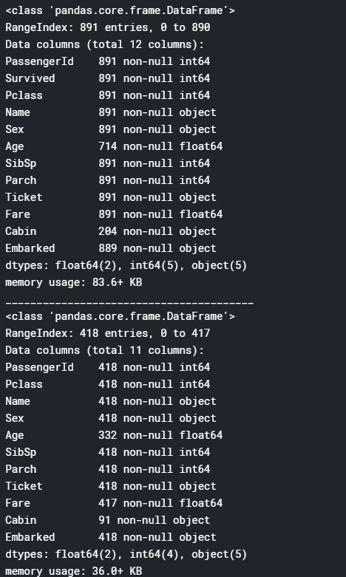

**What is the distribution of categorical features?**

* Names are unique across the dataset (count=unique=891)
* Sex variable as two possible values with 65% male (top=male, freq=577/count=891).
* Cabin values have several dupicates across samples. Alternatively several passengers shared a cabin.
* Embarked takes three possible values. S port used by most passengers (top=S)
* Ticket feature has high ratio (22%) of duplicate values (unique=681).

|  |  |  |  |  |  |
| --- | --- | --- | --- | --- | --- |
|  | Name | Sex | Ticket | Cabin | Embarked |
| count | 891 | 891 | 891 | 204 | 889 |
| unique | 891 | 2 | 681 | 147 | 3 |
| top | Lester, Mr. James | male | 347082 | G6 | S |
| freq | 1 | 577 | 7 | 4 | 644 |

Data analysis

We arrive at following assumptions based on data analysis done so far. We may validate these assumptions further before taking appropriate actions.

**Correlating.**

We want to know how well does each feature correlate with Survival. We want to do this early in our project and match these quick correlations with modelled correlations later in the project.

**Completing.**

1. We may want to complete Age feature as it is definitely correlated to survival.
2. We may want to complete the Embarked feature as it may also correlate with survival or another important feature.

**Correcting.**

1. Ticket feature may be dropped from our analysis as it contains high ratio of duplicates (22%) and there may not be a correlation between Ticket and survival.
2. Cabin feature may be dropped as it is highly incomplete or contains many null values both in training and test dataset.
3. PassengerId may be dropped from training dataset as it does not contribute to survival.
4. Name feature is relatively non-standard, may not contribute directly to survival, so maybe dropped.

**Creating.**

1. We may want to create a new feature called Family based on Parch and SibSp to get total count of family members on board.
2. We may want to engineer the Name feature to extract Title as a new feature.
3. We may want to create new feature for Age bands. This turns a continous numerical feature into an ordinal categorical feature.
4. We may also want to create a Fare range feature if it helps our analysis.

**Classifying.**

We may also add to our assumptions based on the problem description noted earlier.

1. Women (Sex=female) were more likely to have survived.
2. Children (Age<?) were more likely to have survived.
3. The upper-class passengers (Pclass=1) were more likely to have survived.

Analyze by pivoting features

To confirm some of our observations and assumptions, we can quickly analyze our feature correlations by pivoting features against each other. We can only do so at this stage for features which do not have any empty values. It also makes sense doing so only for features which are categorical (Sex), ordinal (Pclass) or discrete (SibSp, Parch) type.

* **Pclass** We observe significant correlation (>0.5) among Pclass=1 and Survived (classifying #3). We decide to include this feature in our model.
* **Sex** We confirm the observation during problem definition that Sex=female had very high survival rate at 74% (classifying #1).
* **SibSp and Parch** These features have zero correlation for certain values. It may be best to derive a feature or a set of features from these individual features (creating #1).

## Analyze by visualizing data

Now we can continue confirming some of our assumptions using visualizations for analyzing the data.

### Correlating numerical features

Let us start by understanding correlations between numerical features and our solution goal (Survived).

A histogram chart is useful for analyzing continous numerical variables like Age where banding or ranges will help identify useful patterns. The histogram can indicate distribution of samples using automatically defined bins or equally ranged bands. This helps us answer questions relating to specific bands (Did infants have better survival rate?)

Note that x-axis in historgram visualizations represents the count of samples or passengers.

**Observations.**

* Infants (Age <=4) had high survival rate.
* Oldest passengers (Age = 80) survived.
* Large number of 15-25 year olds did not survive.
* Most passengers are in 15-35 age range.

**Decisions.**

This simple analysis confirms our assumptions as decisions for subsequent workflow stages.

* We should consider Age (our assumption classifying #2) in our model training.
* Complete the Age feature for null values (completing #1).
* We should band age groups (creating #3).

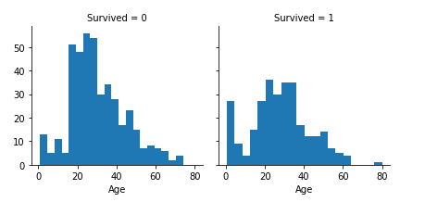

### Correlating numerical and ordinal features

We can combine multiple features for identifying correlations using a single plot. This can be done with numerical and categorical features which have numeric values.

**Observations.**

* Pclass=3 had most passengers, however most did not survive. Confirms our classifying assumption #2.
* Infant passengers in Pclass=2 and Pclass=3 mostly survived. Further qualifies our classifying assumption #2.
* Most passengers in Pclass=1 survived. Confirms our classifying assumption #3.
* Pclass varies in terms of Age distribution of passengers.

**Decisions.**

* Consider Pclass for model training.

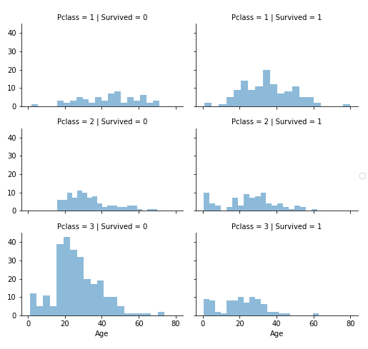

Correlating categorical features

Now we can correlate categorical features with our solution goal.

**Observations.**

* Female passengers had much better survival rate than males. Confirms classifying (#1).
* Exception in Embarked=C where males had higher survival rate. This could be a correlation between Pclass and Embarked and in turn Pclass and Survived, not necessarily direct correlation between Embarked and Survived.
* Males had better survival rate in Pclass=3 when compared with Pclass=2 for C and Q ports. Completing (#2).
* Ports of embarkation have varying survival rates for Pclass=3 and among male passengers. Correlating (#1).

**Decisions.**

* Add Sex feature to model training.
* Complete and add Embarked feature to model training.

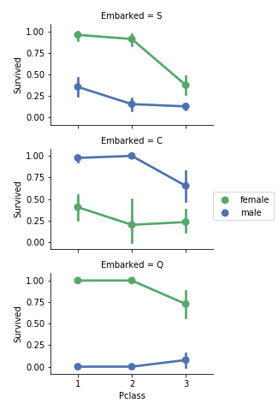

### Correlating categorical and numerical features

We may also want to correlate categorical features (with non-numeric values) and numeric features. We can consider correlating Embarked (Categorical non-numeric), Sex (Categorical non-numeric), Fare (Numeric continuous), with Survived (Categorical numeric).

**Observations.**

* Higher fare paying passengers had better survival. Confirms our assumption for creating (#4) fare ranges.
* Port of embarkation correlates with survival rates. Confirms correlating (#1) and completing (#2).

**Decisions.**

* Consider banding Fare feature.

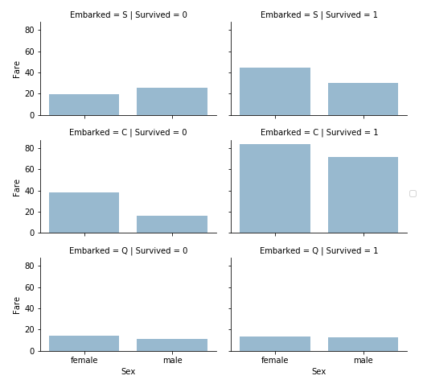

## Wrangle data

We have collected several assumptions and decisions regarding our datasets and solution requirements. So far we did not have to change a single feature or value to arrive at these. Let us now execute our decisions and assumptions for correcting, creating, and completing goals.

### Correcting by dropping features

This is a good starting goal to execute. By dropping features we are dealing with fewer data points. Speeds up our notebook and eases the analysis.

Based on our assumptions and decisions we want to drop the Cabin (correcting #2) and Ticket (correcting #1) features.

Note that where applicable we perform operations on both training and testing datasets together to stay consistent.

### Creating new feature extracting from existing

We want to analyze if Name feature can be engineered to extract titles and test correlation between titles and survival, before dropping Name and PassengerId features.

In the following code we extract Title feature using regular expressions. The RegEx pattern (\w+\.) matches the first word which ends with a dot character within Name feature. The expand=False flag returns a DataFrame.

**Observations.**

When we plot Title, Age, and Survived, we note the following observations.

* Most titles band Age groups accurately. For example: Master title has Age mean of 5 years.
* Survival among Title Age bands varies slightly.
* Certain titles mostly survived (Mme, Lady, Sir) or did not (Don, Rev, Jonkheer).

**Decision.**

* We decide to retain the new Title feature for model training.

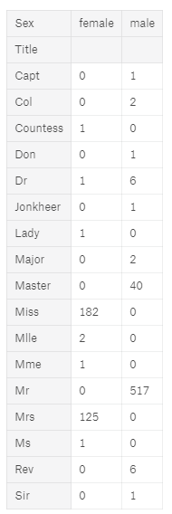

### Converting a categorical feature

Now we can convert features which contain strings to numerical values. This is required by most model algorithms. Doing so will also help us in achieving the feature completing goal.

Let us start by converting Sex feature to a new feature called Gender where female=1 and male=0.

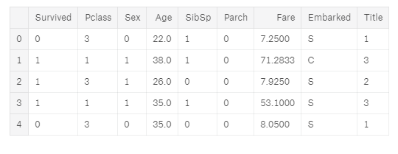

### Completing a numerical continuous feature

Now we should start estimating and completing features with missing or null values. We will first do this for the Age feature.

We can consider three methods to complete a numerical continuous feature.

1. A simple way is to generate random numbers between mean and [standard deviation](https://en.wikipedia.org/wiki/Standard_deviation).
2. More accurate way of guessing missing values is to use other correlated features. In our case we note correlation among Age, Gender, and Pclass. Guess Age values using [median](https://en.wikipedia.org/wiki/Median) values for Age across sets of Pclass and Gender feature combinations. So, median Age for Pclass=1 and Gender=0, Pclass=1 and Gender=1, and so on...
3. Combine methods 1 and 2. So instead of guessing age values based on median, use random numbers between mean and standard deviation, based on sets of Pclass and Gender combinations.

Method 1 and 3 will introduce random noise into our models. The results from multiple executions might vary. We will prefer method 2.

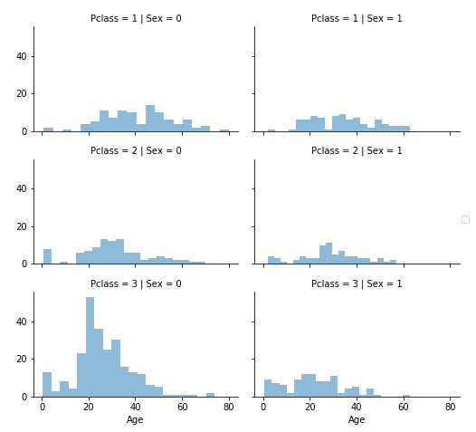

Model, predict and solve

Now we are ready to train a model and predict the required solution. There are 60+ predictive modelling algorithms to choose from. We must understand the type of problem and solution requirement to narrow down to a select few models which we can evaluate. Our problem is a classification and regression problem. We want to identify relationship between output (Survived or not) with other variables or features (Gender, Age, Port...). We are also perfoming a category of machine learning which is called supervised learning as we are training our model with a given dataset. With these two criteria - Supervised Learning plus Classification and Regression, we can narrow down our choice of models to a few. These include:

* Logistic Regression
* KNN or k-Nearest Neighbors
* Support Vector Machines

Logistic Regression is a useful model to run early in the workflow. Logistic regression measures the relationship between the categorical dependent variable (feature) and one or more independent variables (features) by estimating probabilities using a logistic function, which is the cumulative logistic distribution. Reference [Wikipedia](https://en.wikipedia.org/wiki/Logistic_regression).

Note the confidence score generated by the model based on our training dataset.

*# Logistic Regression*

logreg = LogisticRegression()

logreg.fit(X_train, Y_train)

Y_pred = logreg.predict(X_test)

acc_log = round(logreg.score(X_train, Y_train) * 100, 2)

acc_log

accuracy： 80.359999999999999

We can use Logistic Regression to validate our assumptions and decisions for feature creating and completing goals. This can be done by calculating the coefficient of the features in the decision function.

Positive coefficients increase the log-odds of the response (and thus increase the probability), and negative coefficients decrease the log-odds of the response (and thus decrease the probability).

* Sex is highest positivie coefficient, implying as the Sex value increases (male: 0 to female: 1), the probability of Survived=1 increases the most.
* Inversely as Pclass increases, probability of Survived=1 decreases the most.
* This way Age*Class is a good artificial feature to model as it has second highest negative correlation with Survived.
* So is Title as second highest positive correlation.

coeff_df = pd.DataFrame(train_df.columns.delete(0))

coeff_df.columns = ['Feature']

coeff_df["Correlation"] = pd.Series(logreg.coef_[0])

coeff_df.sort_values(by='Correlation', ascending=False)

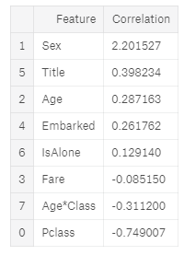

Next we model using Support Vector Machines which are supervised learning models with associated learning algorithms that analyze data used for classification and regression analysis. Given a set of training samples, each marked as belonging to one or the other of **two categories**, an SVM training algorithm builds a model that assigns new test samples to one category or the other, making it a non-probabilistic binary linear classifier. Reference [Wikipedia](https://en.wikipedia.org/wiki/Support_vector_machine).

Note that the model generates a confidence score which is higher than Logistics Regression model.

*# Support Vector Machines*

svc = SVC()

svc.fit(X_train, Y_train)

Y_pred = svc.predict(X_test)

acc_svc = round(svc.score(X_train, Y_train) * 100, 2)

acc_svc

accuracy： 83.840000000000003

In pattern recognition, the k-Nearest Neighbors algorithm (or k-NN for short) is a non-parametric method used for classification and regression. A sample is classified by a majority vote of its neighbors, with the sample being assigned to the class most common among its k nearest neighbors (k is a positive integer, typically small). If k = 1, then the object is simply assigned to the class of that single nearest neighbor. Reference [Wikipedia](https://en.wikipedia.org/wiki/K-nearest_neighbors_algorithm).

KNN confidence score is better than Logistics Regression but worse than SVM.

knn = KNeighborsClassifier(n_neighbors = 3)

knn.fit(X_train, Y_train)

Y_pred = knn.predict(X_test)

acc_knn = round(knn.score(X_train, Y_train) * 100, 2)

acc_knn

accuracy： 84.739999999999995

Model evaluation

We can now rank our evaluation of all the models to choose the best one for our problem.We choose to use KNN as they correct for decision trees' habit of overfitting to their training set.

|  |  |  |
| --- | --- | --- |
|  | Model | Score |
| 1 | KNN | 84.74 |
| 0 | Support Vector Machines | 83.84 |
| 2 | Logistic Regression | 80.36 |

Our submission to the competition site Kaggle results in scoring 3,883 of 6,082 competition entries. This result is indicative while the competition is running. This result only accounts for part of the submission dataset. Not bad for our first attempt. Any suggestions to improve our score are most welcome.