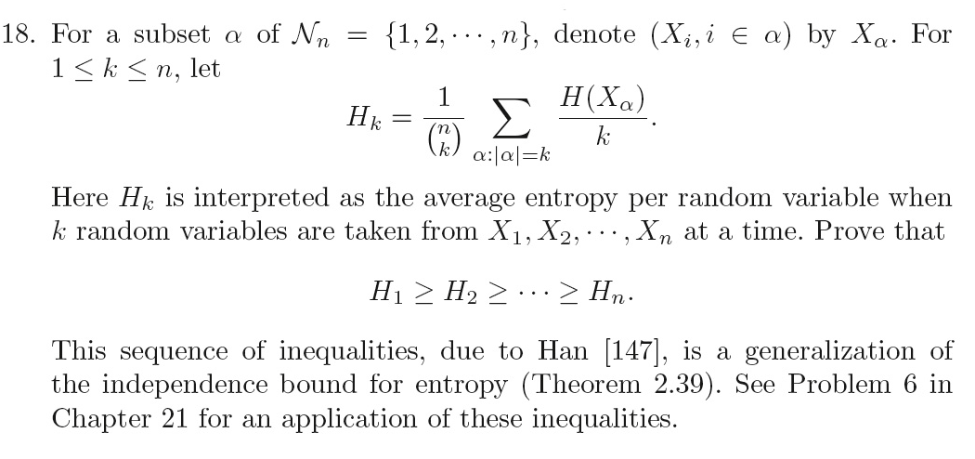

Proof

First it can be proved that

 (1)

which is a generalization of Problem 17 in last homework and can be proved using similar method. Using (1) we have

 (2)

It can be proved that

 (3)

because each  is counted  times on the left side. Thus from (3) and (2), we have

 (2)

Q.E.D.





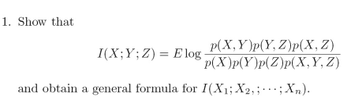





Yes. It can be seen from the information diagram that I(X;YZ)=0

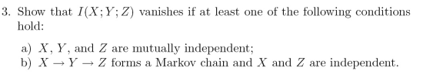



if a) holds, i.e., X,Y and Z are mutually independent, we have



So 

Also



If b) holds, i.e., X->Y->Z forms a Markov chain and X and Z are independent, we have



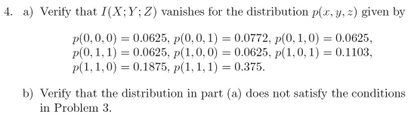

1. (X,Y) has the following distribution:

|  |  |  |  |
| --- | --- | --- | --- |
| p(0,0) | p(0,1) | p(1,0) | p(1,1) |
| 0.1397 | 0.125 | 0.1728 | 0.5625 |

I(X;Y)=0.054 bit

p(X,Y|Z=0) has the following distribution:

|  |  |  |  |
| --- | --- | --- | --- |
| p(0,0) | p(0,1) | p(1,0) | p(1,1) |
| 0.1667 | 0.1667 | 0.1667 | 0.5 |

I(X;Y|Z=0) = 0.045 bit

p(X,Y|Z=1) has the following distribution:

|  |  |  |  |
| --- | --- | --- | --- |
| p(0,0) | p(0,1) | p(1,0) | p(1,1) |
| 0.1667 | 0.1667 | 0.1667 | 0.5 |

I(X;Y|Z=0) = 0.0592 bit

I(X;Y|Z) is the expectation: I(X;Y|Z)=0.375*0.045+0.625*0.0592=0.054 bit

I(X;Y;Z) = I(X;Y) - I(X;Y|Z)= 0

1. p(X)

|  |  |
| --- | --- |
| p(0) | p(1) |
| 0.2647 | 0.7353 |

p(Y)

|  |  |
| --- | --- |
| p(0) | p(1) |
| 0.3125 | 0.6875 |

p(X)*p(Y)

|  |  |  |  |
| --- | --- | --- | --- |
| p(0,0) | p(0,1) | p(1,0) | p(1,1) |
| 0.0827 | 0.1820 | 0.2298 | 0.5055 |

So p(X)*p(Y) does not equal to p(X,Y). Thus X and Y are not independent.

(X,Z) the following distribution:

|  |  |  |  |
| --- | --- | --- | --- |
| p(0,0) | p(0,1) | p(1,0) | p(1,1) |
| 0.125 | 0.1397 | 0.25 | 0.4853 |

p(X)

|  |  |
| --- | --- |
| p(0) | p(1) |
| 0.2647 | 0.7353 |

P(Z)

|  |  |
| --- | --- |
| p(0) | p(1) |
| 0.375 | 0.625 |

p(X)*p(Z)

|  |  |  |  |
| --- | --- | --- | --- |
| p(0,0) | p(0,1) | p(1,0) | p(1,1) |
| 0.0993 | 0.1654 | 0.2757 | 0.4596 |

So p(X)*p(Z) does not equal to p(X,Z). Thus X and Z are not independent.

Both conditions in problem 3 do not hold.