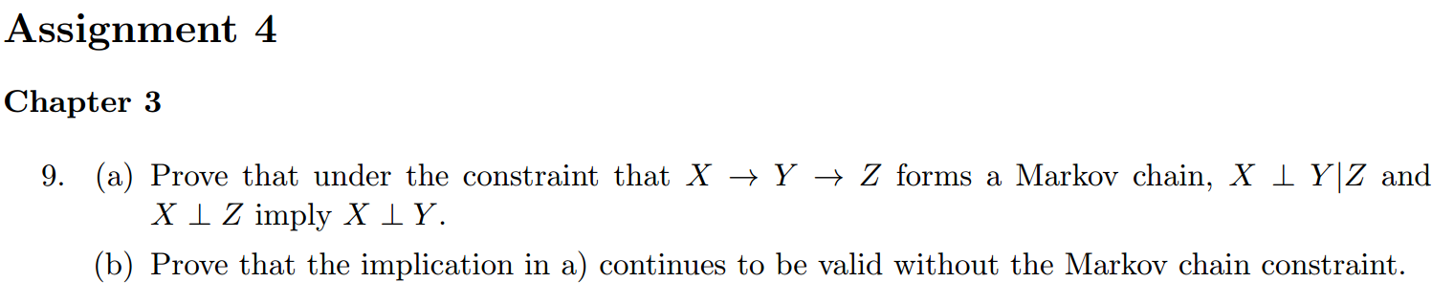

Since X->Y->Z forms a Markov chain, the information diagram is shown in the above diagram.

 means I(X;Y|Z)=0

 means I(X; Z)=0

As shown above, these conditions imply that I(X;Y)=0, i.e., 

b)

X

Y

Z

0

a

-a

The conditions lead to the above information diagram. Since I(X;Y)>=0, a has to equal to 0. Thus .



a)

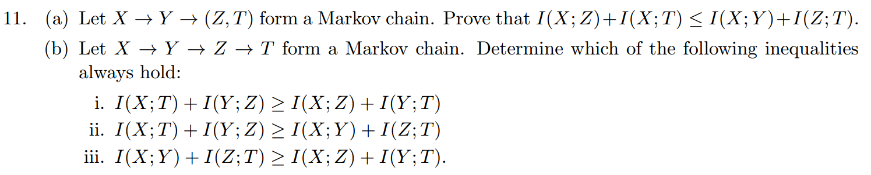

X

Y

Z

T

From the above information diagram, we can see that



b)

It can be seen from the information diagram that i) and iii) always hold.

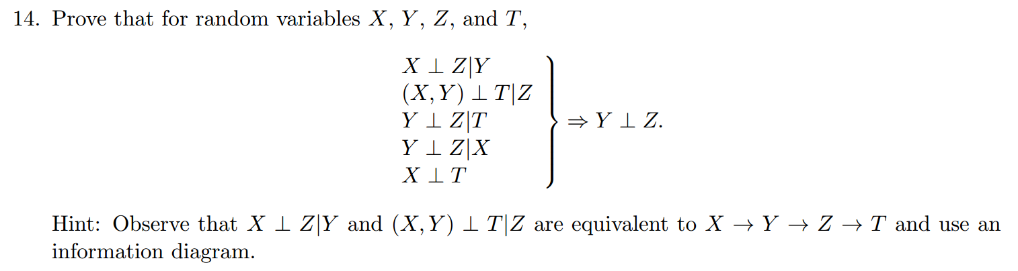

As given by the hint, X->Y->Z->T forms an Markov chain. Thus we should have the following information diagram.

X

Y

Z

T

a

-a

a

0

Since u\* is always non-negative, we have a=0. Thus I(Y;Z)=0 ⬄.

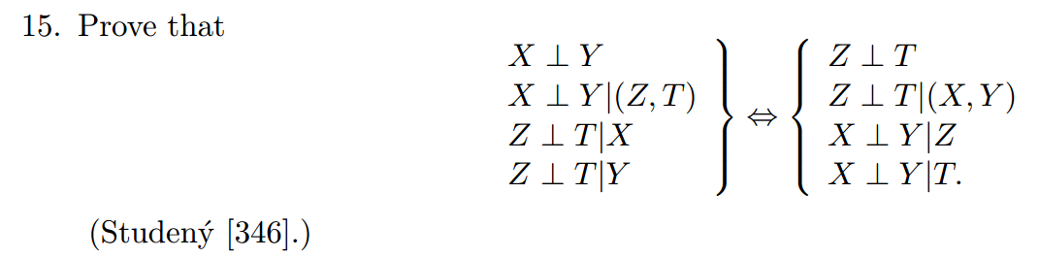

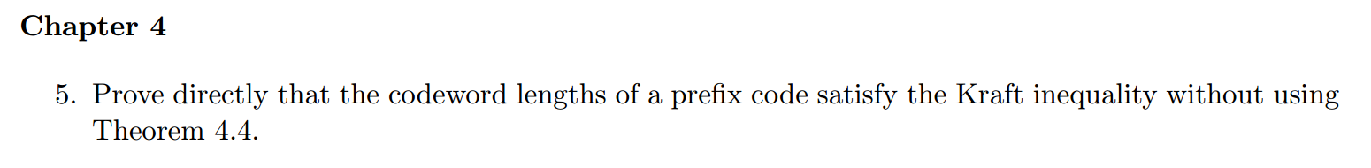

A prefix code implies that the code only goes to leaves on a code tree. Since a full tree makes the Kraft inequality tight, all other cases should satisfy Kraft inequality.



Just decode the suffix code stream backwards. Then suffix code turns into prefix code and is uniquely decodable.

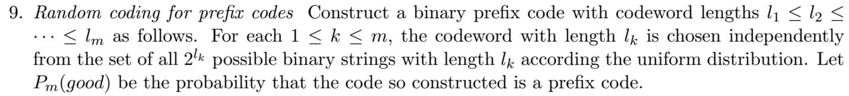

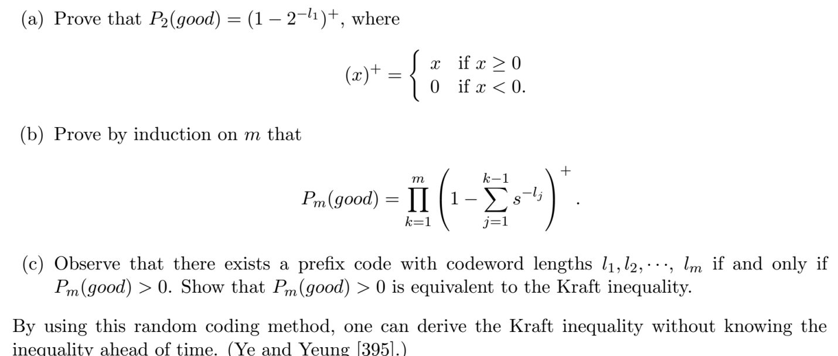

1. For the code with length *l*2 to be prefix code, it should not be chosen as the child of the code with length *l*1.

The total number of choices of the code with length *l*2 is .

The number of children of the code with length *l*1 that has the length of is *l*2 .

So P2(good) = 

1. As shown in a), the result holds for m=2.

Suppose the result holds for m. For m+1, the new code cannot be the child of any previous codes in a code tree. Thus

.

If the new term in the product is less than zero, the probability is zero.

The result is proved.

1. Since we need Pm>0, the last term in the product needs to be greater than zero. This is equivalent to Kraft inequality.