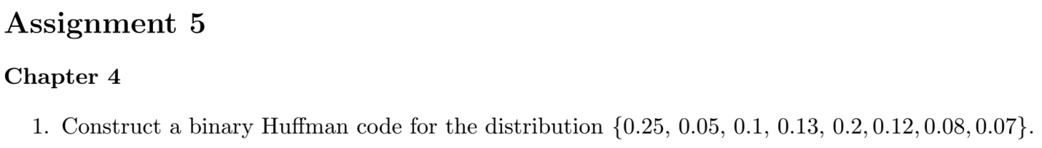

Left 0, Right 1



Add one zero probability mass.





We can first construct the 4-nary Huffman code, and convert it into the binary Huffman code with even lengths.



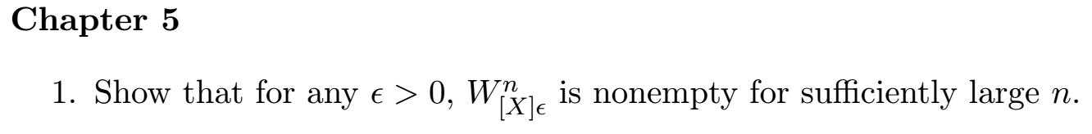

Proof

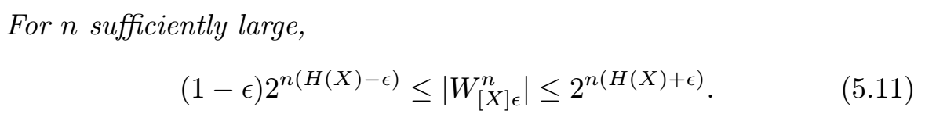

For sufficient large *n*, we can make , i.e., nonempty .