Project 1: Test a Perceptual Phenomenon

1. What is our independent variable? What is our dependent variable?

The independent variable is the conditions of the task: a congruent words condition, and an incongruent words condition, as described in the background information.

The dependent variable is the time that takes for each participant to name the ink colors in equally-sized lists from each condition.

1. What is an appropriate set of hypotheses for this task? What kind of statistical test do you expect to perform? Justify your choices.

Based on the result of myself, which is 18.165 seconds from the congruent words condition and 26.219 seconds from the incongruent words condition, as well as the dataset provided, we may suggest that it takes longer time to name the ink colors from the incongruent words condition.

Mathematically speaking, we want to see if the population mean (denoted as µ2) of the time from the incongruent words condition is significantly higher than the population mean (denoted as µ1) of the time from the congruent words condition. Therefore, an appropriate set of hypotheses is listed as below:

H0: µ1 ≥ µ2

HA: µ1 < µ2

Given that the task is done on the same sample but different conditions, assuming the time difference is normally distributed, we expect to perform a dependent samples t-test. We should use a t-test instead of a z-test because the population variance is unknown and the sample size is only 24. The t-test should also be a one-tailed t-test, because we predict that the incongruent words condition would take longer time than the congruent words condition.

1. Report some descriptive statistics regarding this dataset. Include at least one measure of central tendency and at least one measure of variability.

Sample average of the time from the congruent condition: 14.05

Sample standard deviation of the time from the congruent condition: 3.56

Sample average of the time from the incongruent condition: 22.02

Sample standard deviation of the time from the incongruent condition: 4.80

Sample average of the time difference between the two conditions: 7.96

Sample standard deviation of the time difference between the two conditions: 4.86

1. Provide one or two visualizations that show the distribution of the sample data. Write one or two sentences noting what you observe about the plot or plots.

First, we can make a scatterplot of the time from the congruent condition against the time from the incongruent condition. The plot is shown as below:

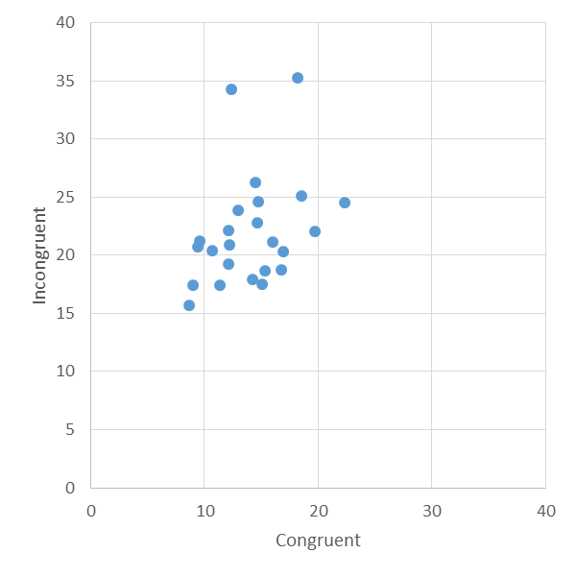

The horizontal axis shows the time from the congruent condition, and the vertical axis shows the time from the incongruent condition. In the plot, it is clear that dots are distributed in the left and top part. Therefore it tends to support the alternative hypothesis.

Second, we can make a bar chart comparing the times from each participant. The plot is shown as below:

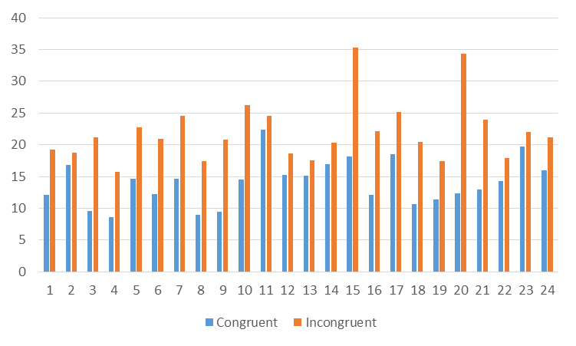

The blue bars show the time from the congruent condition, and the orange bars show the time from the incongruent condition. In the plot, all orange bars are higher than blue bars for each participant. This also tends to support the alternative hypothesis in another way.

1. Now, perform the statistical test and report your results. What is your confidence level and your critical statistic value? Do you reject the null hypothesis or fail to reject it? Come to a conclusion in terms of the experiment task. Did the results match up with your expectations?

Based on the data, we can calculate the t-statistic to be 8.021; using the confidence level of 95% and one-tailed t-test, we can get the critical statistic value of 1.714.

Since the t-statistic is larger than the critical statistic value, we could reject the null hypothesis. Therefore, in terms of the experiment task, we could say that the incongruent condition significantly increases the time it takes to name the ink colors correctly.

The results did match up with my expectation, as we observed in question 4.

1. What do you think is responsible for the effects observed? Can you think of an alternative or similar task that would result in a similar effect?

I could think of two possible reasons for the effects:

* 1. Words are easier to be recognized by people than colors. When I was doing the test, the words are very straightforward to me and I could directly say them out. However, it takes longer time to really think about the exact color.
  2. People can make easier decisions when they find the colors and words are matching. When I was doing the test, if the word is matching the color, I could quickly know that and say out the right color. However, if the word is not matching the color, I would think what the color really is.

These reasons combined together make it even harder to recognize the colors from the incongruent condition.

A similar task could be designed to test people’s ability to recognize animals. In this task, participants are given a list of words of common animals (for example bird, fish, cat and dog) along with picture of some animals. There are also two conditions: the congruent condition, where words can match the pictures, and the incongruent condition, where the words cannot match the pictures. Participants have to say out the correct name of the animals shown in the picture. We could measure the time it takes for each participant to name the animals in equally-sized lists.

In my perspective, this similar task would possibly results in a similar effect: it takes longer time to name the animals from the incongruent condition.

**A detailed Excel file comes together with pdf to support the answers.**

Reference:

1. <https://en.wikipedia.org/wiki/Stroop_effect>
2. <https://www.udacity.com/course/statistics--st095>
3. Sarah Boslaugh. 2012. *Statistics in a Nutshell, Second Edition*. Sebastopol, CA: O'Reilly Media