TASK 1 Listen
1. put a “√” if we have the place and an “×” if we don’t have
2. match
places | √ or× | things can do
bank
restaurant
hotel
post office
hospital
police station
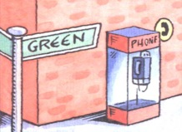
TASK 2. Listen and match.
Things can do
a. send a letter or postcard
b. take out money
c. ask for police’s help
d. eat different kinds of food
e. stay for a vacation
f. see a doctor
across from the library.
on Green Street.
in front of the library
next to the library..
between the post office and the library.
behind the library

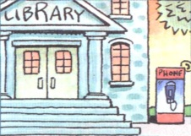

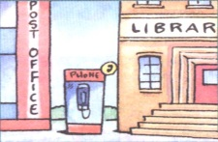

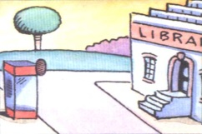
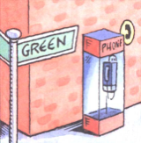
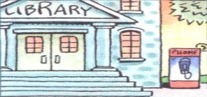

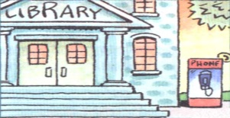
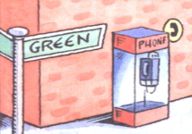

TASK 3. Listen and fill in the blanks.
1.The police station is _______the restaurant and the ________.
2. The park is ____________________.
3. The hospital is _____ Bridge Street.
4. The pay phone is ____________________.
5. ________________________the post office.
6. __________________the police station.
TASK 4. Group work (What neighborhood of school do you want ?)
提问者回答者：
Is there a / any … … ? /Are there any … … ?
Yes … / No …
We can … there. It’s …for us to … .
Where … ?
It’s … / They’re …
reporter 汇报者：
开头: Hello. Mike. This is the neighborhood of school we want.
中间：There is / are … . The … is / are … . We can … there. It’s …for us to … .
结尾：I hope this will help you.

