Contents

Query1.pig 2

Query_1a output test 1 Input: 430 8

Query_1a output test 2 input: 405 8

Query_1a output test 3 input: 919 9

Query_1b output: 10

Query_1c test 1 input: 666 11

Query_1c test 2 input: 333 11

Query_1c test 3 input: 233 12

Task 2 13

query2.PIG: 13

New Rank Twitter Account 15

Copy output data into file: HW4old_twitter_account_rank.csv 15

Find k_percentile_accounts.pig 16

Task3 output test 1 Input: 0.3 18

Task3 output test 2 Input: 0.0042 18

Task3 output test 2 Input: 0.005 19

# Query1.pig

-- Format:

--{follower_twitter_account_id: int,subject_twitter_account_id: int}

follows_account = LOAD '/oracle/stuhomes/yu1357/hk4/HW4-follows_account.txt' using PigStorage(',') AS (follower_twitter_account_id: int,subject_twitter_account_id: int);

-- Format:

--{twitter_account_id: int,email_address: chararray,phone_number: chararray,user_location: chararray,num_tweets: int}

twitter_account = LOAD '/oracle/stuhomes/yu1357/hk4/HW4-twitter_account.txt' USING PigStorage(',') AS (twitter_account_id: int, email_address: chararray , phone_number: chararray , user_location: chararray , num_tweets: int);

-- Format:

--{twitter_account_id: int,twitter_account_rank: float}

old_twitter_account_rank = LOAD '/oracle/stuhomes/yu1357/hk4/HW4-old_twitter_account_rank.txt' using PigStorage(',') AS (twitter_account_id:int, twitter_account_rank:float);

-- Format:

--{email_address: chararray,reputation: int,num_questions: int}

stack_overflow_account = LOAD '/oracle/stuhomes/yu1357/hk4/HW4-stack_overflow_account.txt' using PigStorage(',') AS (email_address:chararray, reputation: int, num_questions: int);

--query_1a 1st test

----------------------------------------------------------------------------------

-- Format

-- {twitter_account_id: int,email_address: chararray,phone_number: chararray,user_location: chararray,num_tweets: int}

filter_phone = FILTER twitter_account by STARTSWITH(phone_number, '430');

DESCRIBE filter_phone;

-- Format

-- {group: chararray,filter_phone: {(twitter_account_id: int,email_address: chararray,phone_number: chararray,user_location: chararray,num_tweets: int)}}

grouped_phone = GROUP filter_phone BY SUBSTRING(phone_number, 0, 3);

DESCRIBE grouped;

-- Format

-- {group: chararray,{(email_address: chararray)}}

result_a1 = FOREACH grouped_phone GENERATE group, $1.email_address;

DESCRIBE result_a1;

STORE result_a1 INTO query_1a1;

dump result_a1;

--query_1a 2rd test

----------------------------------------------------------------------------------

-- Format

-- {twitter_account_id: int,email_address: chararray,phone_number: chararray,user_location: chararray,num_tweets: int}

filter_phone = FILTER twitter_account by STARTSWITH(phone_number, '405');

DESCRIBE filter_phone;

-- Format

-- {group: chararray,filter_phone: {(twitter_account_id: int,email_address: chararray,phone_number: chararray,user_location: chararray,num_tweets: int)}}

grouped_phone = GROUP filter_phone BY SUBSTRING(phone_number, 0, 3);

DESCRIBE grouped;

-- Format

-- {group: chararray,{(email_address: chararray)}}

result_a2 = FOREACH grouped_phone GENERATE group, $1.email_address;

DESCRIBE result_a2;

STORE result_a2 INTO query_1a2;

dump result_a2;

--query_1a 3rd test

----------------------------------------------------------------------------------

-- Format

-- {twitter_account_id: int,email_address: chararray,phone_number: chararray,user_location: chararray,num_tweets: int}

filter_phone = FILTER twitter_account by STARTSWITH(phone_number, '555');

DESCRIBE filter_phone;

-- Format

-- {group: chararray,filter_phone: {(twitter_account_id: int,email_address: chararray,phone_number: chararray,user_location: chararray,num_tweets: int)}}

grouped_phone = GROUP filter_phone BY SUBSTRING(phone_number, 0, 3);

DESCRIBE grouped;

-- Format

-- {group: chararray,{(email_address: chararray)}}

result_a3 = FOREACH grouped_phone GENERATE group, $1.email_address;

DESCRIBE result_a3;

STORE result_a3 INTO query_1a3;

dump result_a3;

--query_1b

----------------------------------------------------------------------------------

--Format

--{group: chararray,twitter_account: {(twitter_account_id: int,email_address: chararray,phone_number: chararray,user_location: chararray,num_tweets: int)}}

group_city = GROUP twitter_account BY user_location;

--Format

--result_b = FOREACH group_city GENERATE group AS user_location, COUNT($1) AS num_acc;

result_b = FOREACH group_city GENERATE group AS user_location, COUNT($1) AS num_acc;

DESCRIBE result_b;

STORE result_b INTO query_1b;

dump result_b;

--query_1c 1st test

----------------------------------------------------------------------------------

--Format

--{twitter_account::twitter_account_id: int,twitter_account::email_address: chararray,twitter_account::phone_number: chararray,twitter_account::user_location: chararray,twitter_account::num_tweets: int,stack_overflow_account::email_address: chararray,stack_overflow_account::reputation: int,stack_overflow_account::num_questions: int}

joined = JOIN twitter_account BY email_address, stack_overflow_account by email_address;

--Format

--{twitter_account::twitter_account_id: int,twitter_account::email_address: chararray,twitter_account::phone_number: chararray,twitter_account::user_location: chararray,twitter_account::num_tweets: int,stack_overflow_account::email_address: chararray,stack_overflow_account::reputation: int,stack_overflow_account::num_questions: int}

filtered_num_tweets = FILTER joined BY num_tweets > 666;

--Format

--{twitter_account::num_tweets: int,stack_overflow_account::reputation: int}

email_reputations = FOREACH filtered_num_tweets GENERATE twitter_account::num_tweets, stack_overflow_account::reputation;

--Format

--{group: chararray,email_reputations: {(twitter_account::num_tweets: int,stack_overflow_account::reputation: int)}}

email_reputations_group = GROUP email_reputations ALL;

--Format

--{num_tweets: long,avg_stack_overflow_reputation: double}

result_c1 = FOREACH email_reputations_group GENERATE SUM($1.$0) AS num_tweets, AVG($1.$1) AS avg_stack_overflow_reputation;

DESCRIBE result_c1;

STORE result_c1 INTO query_1c;

dump result_c;

--query_1c 2rd test

----------------------------------------------------------------------------------

--Format

--{twitter_account::twitter_account_id: int,twitter_account::email_address: chararray,twitter_account::phone_number: chararray,twitter_account::user_location: chararray,twitter_account::num_tweets: int,stack_overflow_account::email_address: chararray,stack_overflow_account::reputation: int,stack_overflow_account::num_questions: int}

joined = JOIN twitter_account BY email_address, stack_overflow_account by email_address;

--Format

--{twitter_account::twitter_account_id: int,twitter_account::email_address: chararray,twitter_account::phone_number: chararray,twitter_account::user_location: chararray,twitter_account::num_tweets: int,stack_overflow_account::email_address: chararray,stack_overflow_account::reputation: int,stack_overflow_account::num_questions: int}

filtered_num_tweets = FILTER joined BY num_tweets > 666;

--Format

--{twitter_account::num_tweets: int,stack_overflow_account::reputation: int}

email_reputations = FOREACH filtered_num_tweets GENERATE twitter_account::num_tweets, stack_overflow_account::reputation;

--Format

--{group: chararray,email_reputations: {(twitter_account::num_tweets: int,stack_overflow_account::reputation: int)}}

email_reputations_group = GROUP email_reputations ALL;

--Format

--{num_tweets: long,avg_stack_overflow_reputation: double}

result_c2 = FOREACH email_reputations_group GENERATE SUM($1.$0) AS num_tweets, AVG($1.$1) AS avg_stack_overflow_reputation;

DESCRIBE result_c2;

STORE result_c2 INTO query_1c2;

dump result_c2;

--query_1c 2rd test

----------------------------------------------------------------------------------

--Format

--{twitter_account::twitter_account_id: int,twitter_account::email_address: chararray,twitter_account::phone_number: chararray,twitter_account::user_location: chararray,twitter_account::num_tweets: int,stack_overflow_account::email_address: chararray,stack_overflow_account::reputation: int,stack_overflow_account::num_questions: int}

joined = JOIN twitter_account BY email_address, stack_overflow_account by email_address;

--Format

--{twitter_account::twitter_account_id: int,twitter_account::email_address: chararray,twitter_account::phone_number: chararray,twitter_account::user_location: chararray,twitter_account::num_tweets: int,stack_overflow_account::email_address: chararray,stack_overflow_account::reputation: int,stack_overflow_account::num_questions: int}

filtered_num_tweets = FILTER joined BY num_tweets > 666;

--Format

--{twitter_account::num_tweets: int,stack_overflow_account::reputation: int}

email_reputations = FOREACH filtered_num_tweets GENERATE twitter_account::num_tweets, stack_overflow_account::reputation;

--Format

--{group: chararray,email_reputations: {(twitter_account::num_tweets: int,stack_overflow_account::reputation: int)}}

email_reputations_group = GROUP email_reputations ALL;

--Format

--{num_tweets: long,avg_stack_overflow_reputation: double}

result_c3 = FOREACH email_reputations_group GENERATE SUM($1.$0) AS num_tweets, AVG($1.$1) AS avg_stack_overflow_reputation;

DESCRIBE result_c3;

STORE result_c3 INTO query_1c3;

dump result_c3;

## Query_1a output test 1 Input: 430

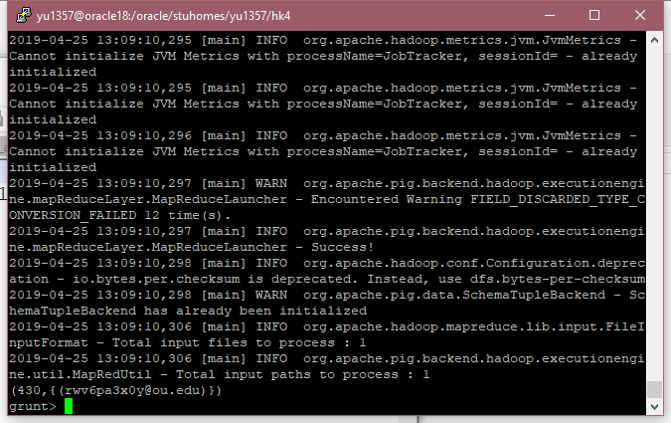

## Query_1a output test 2 input: 405

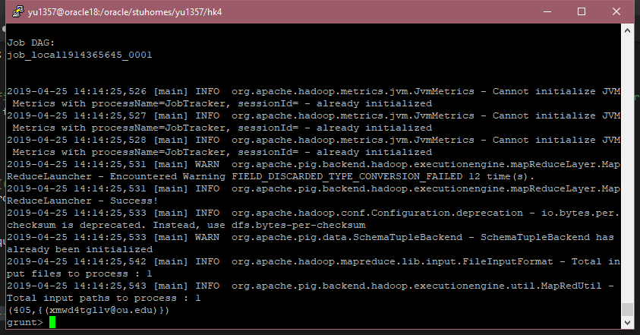

## Query_1a output test 3 input: 919

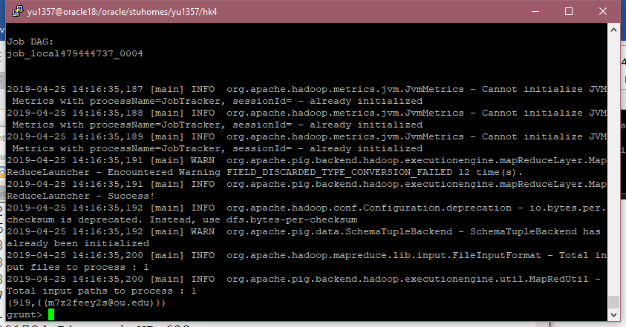

## Query_1b output:

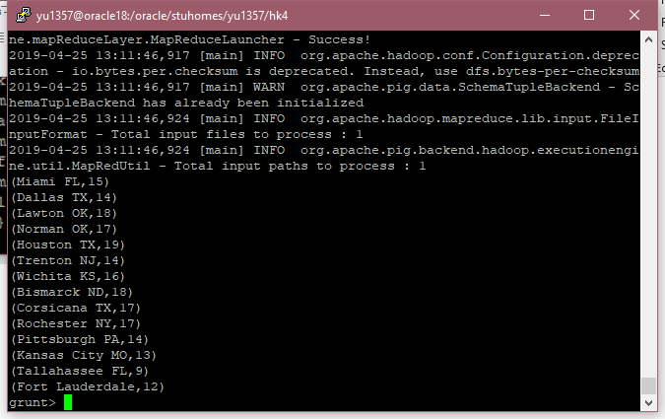

## Query_1c test 1 input: 666

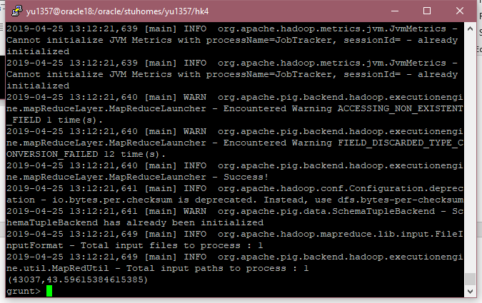

## Query_1c test 2 input: 333

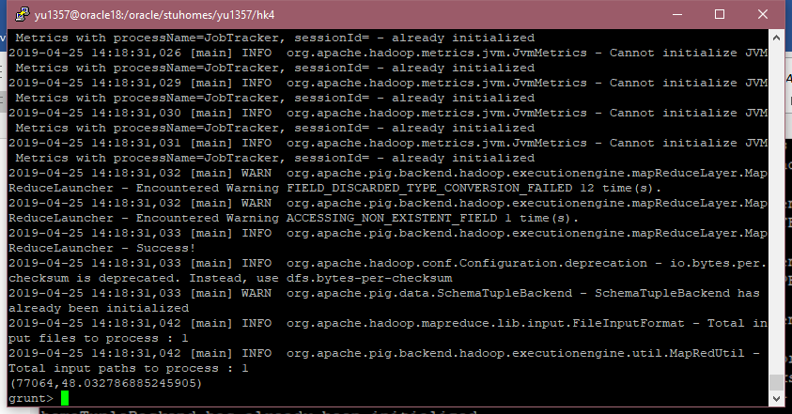

## Query_1c test 3 input: 233

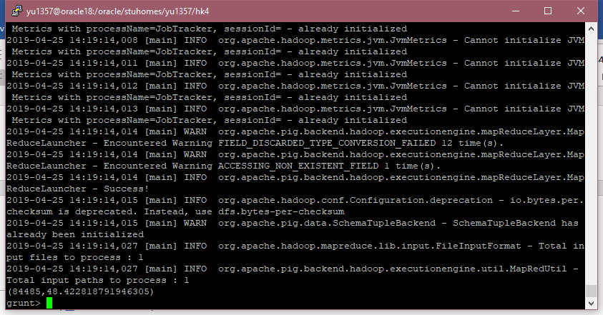

# Task 2

## query2.PIG:

-- Format:

--{follower_twitter_account_id: int,subject_twitter_account_id: int}

follows_account = LOAD '/oracle/stuhomes/yu1357/hk4/HW4-follows_account.txt' using PigStorage(',') AS (follower_twitter_account_id: int,subject_twitter_account_id: int);

-- Format:

--{twitter_account_id: int,email_address: chararray,phone_number: chararray,user_location: chararray,num_tweets: int}

twitter_account = LOAD '/oracle/stuhomes/yu1357/hk4/HW4-twitter_account.txt' USING PigStorage(',') AS (twitter_account_id: int, email_address: chararray , phone_number: chararray , user_location: chararray , num_tweets: int);

-- Format:

--{twitter_account_id: int,twitter_account_rank: float}

old_twitter_account_rank = LOAD '/oracle/stuhomes/yu1357/hk4/HW4-old_twitter_account_rank.txt' using PigStorage(',') AS (twitter_account_id:int, twitter_account_rank:float);

--Format

--{group: int,follows_account: {(follower_twitter_account_id: int,subject_twitter_account_id: int)}}

B = GROUP follows_account BY follower_twitter_account_id;

--Format

--{group: int,long}

follower = FOREACH B GENERATE group, COUNT($1);

--Format

--{old_twitter_account_rank::twitter_account_id: int,old_twitter_account_rank::twitter_account_rank: float,follower::group: int,long}

follower = JOIN old_twitter_account_rank BY twitter_account_id, follower BY $0;

--Format

--{follower_twitter_account_id: int,follower_rank: float,num_following: long}

follower = FOREACH follower GENERATE $0 AS follower_twitter_account_id, $1 AS follower_rank, $3 AS num_following;

--Format

--{follows_account::follower_twitter_account_id: int,follows_account::subject_twitter_account_id: int,follower::follower_twitter_account_id: int,follower::follower_rank: float,follower::num_following: long}

sub_folnum = JOIN follows_account BY follower_twitter_account_id, follower BY $0;

--Format

--{subject_twitter_account_id: int,follower_rank: float,num_following: long}

sub_count = FOREACH sub_folnum GENERATE $1 AS subject_twitter_account_id, $3 AS follower_rank, $4 AS num_following;

--Format

--{follows_account::follower_twitter_account_id: int,float}

sub_count1 = FOREACH sub_folnum GENERATE $0, (follower_rank/num_following);

--Format

--{group: int,sub_count1: {(follows_account::follower_twitter_account_id: int,float)}}

C = GROUP sub_count1 BY $0;

--Format

--{group: int,{(float)}}

temp = FOREACH C GENERATE group, $1.$1;

--Format

--{group: int,double}

temp1 = FOREACH temp GENERATE $0 , SUM($1);

--Format

--{group: int,double}

result = FOREACH temp1 GENERATE $0, ((1-0.85)/213 + 0.85*$1);

dump result;

STORE result INTO 'myoutput.txt' using PigStorage(',');

## New Rank Twitter Account

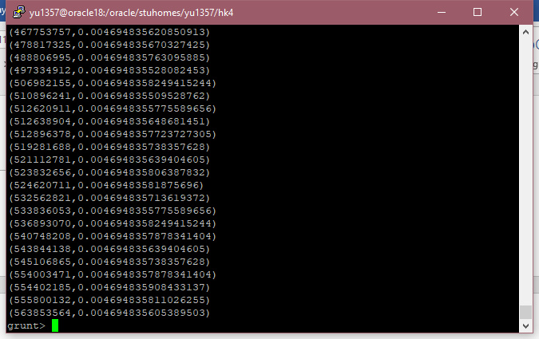

## Copy output data into file: HW4old_twitter_account_rank.csv

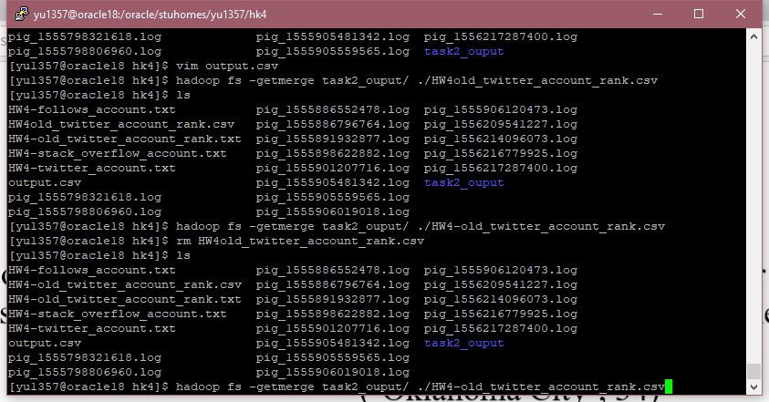

# Find k_percentile_accounts.pig

-- Format:

--{twitter_account_id: int,email_address: chararray,phone_number: chararray,user_location: chararray,num_tweets: int}

twitter_account = LOAD '/oracle/stuhomes/yu1357/hk4/HW4-twitter_account.txt' USING PigStorage(',') AS (twitter_account_id: int, email_address: chararray , phone_number: chararray , user_location: chararray , num_tweets: int);

-- Format:

--{twitter_account_id: int,twitter_account_rank: float}

old_twitter_account_rank = LOAD '/oracle/stuhomes/yu1357/hk4/HW4-old_twitter_account_rank.csv' using PigStorage(',') AS (twitter_account_id:int, twitter_account_rank:float);

--------------------------------first time testing----------------------------

-- Format

--{twitter_account::twitter_account_id: int,twitter_account::email_address: chararray,twitter_account::phone_number: chararray,twitter_account::user_location: chararray,twitter_account::num_tweets: int,old_twitter_account_rank::twitter_account_id: int,old_twitter_account_rank::twitter_account_rank: float}

join_twitter = JOIN twitter_account BY twitter_account_id, old_twitter_account_rank BY twitter_account_id;

--Format

--{twitter_account_id: int,email_address: chararray,twitter_rank: float}

percentile_accounts = FOREACH join_twitter GENERATE $0 AS twitter_account_id, $1 AS email_address, $6 AS twitter_rank;

result1 = FILTER percentile_accounts BY twitter_rank > 0.3;

DESCRIBE result1;

STORE result1 INTO task3_1;

dump result1;

--------------------------------Second time testing----------------------------

-- Format

--{twitter_account::twitter_account_id: int,twitter_account::email_address: chararray,twitter_account::phone_number: chararray,twitter_account::user_location: chararray,twitter_account::num_tweets: int,old_twitter_account_rank::twitter_account_id: int,old_twitter_account_rank::twitter_account_rank: float}

join_twitter = JOIN twitter_account BY twitter_account_id, old_twitter_account_rank BY twitter_account_id;

--Format

--{twitter_account_id: int,email_address: chararray,twitter_rank: float}

percentile_accounts = FOREACH join_twitter GENERATE $0 AS twitter_account_id, $1 AS email_address, $6 AS twitter_rank;

result2 = FILTER percentile_accounts BY twitter_rank > 0.0042;

DESCRIBE result2;

STORE result2 INTO task3_2;

dump result2;

--------------------------------thrid time testing----------------------------

-- Format

--{twitter_account::twitter_account_id: int,twitter_account::email_address: chararray,twitter_account::phone_number: chararray,twitter_account::user_location: chararray,twitter_account::num_tweets: int,old_twitter_account_rank::twitter_account_id: int,old_twitter_account_rank::twitter_account_rank: float}

join_twitter = JOIN twitter_account BY twitter_account_id, old_twitter_account_rank BY twitter_account_id;

--Format

--{twitter_account_id: int,email_address: chararray,twitter_rank: float}

percentile_accounts = FOREACH join_twitter GENERATE $0 AS twitter_account_id, $1 AS email_address, $6 AS twitter_rank;

result3 = FILTER percentile_accounts BY twitter_rank > 0.005;

DESCRIBE result3;

STORE result3 INTO task3_3;

dump result3;

## Task3 output test 1 Input: 0.3

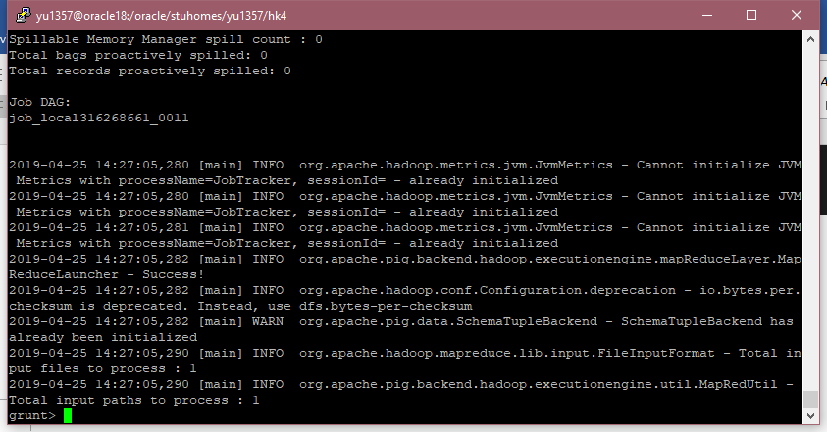

## Task3 output test 2 Input: 0.0042



## Task3 output test 2 Input: 0.005

