**Introduction** This is a webpage built for a Dog Café that focus on sweet bites and also interaction with their dogs at the café. Due to the current pandemic, business have not been good recently as lesser and lesser Singaporeans are willingly to go out, and especially interaction with animals. Therefore, this webpage was made so that customer that are not willingly to visit can still order their sweet bites, especially old timers that come for our sweet delights, will have the chance now to order online and get it delivered right in front of their doorstep. If we are met with another wave of COVID-19 cluster, with the Café closed, we are able to use this platform to promote our sweet delight, sales will definitely be better.  
 A booking system is implemented for customers that so that we can limit the number of visitors in the shop and the also there will be a time limit for each booking so that everyone can visit and enjoy our lovely pets. This will also ensure that safety distancing can be done efficiently as per regulation. Through this we can show that we care for the customers and also, we will be able to create a safer environment for our customers and our pets. As times pass, words of our Café safety measure and clean environment will spread, this will attract more customers.   
 There are also pages that will let customers know more about us and our pets, these is more targeted more towards the dog lovers out there who do not own a dog. As we know in Singapore to own a dog there are many rules, regulation and processes to go through, also there are only a few species of dogs that can be allowed in HDB. In Singapore almost 80% of Singaporean citizen lived in HDB, if found with dog breeds that are banned, a fine will be given out. Therefore, our idea to include this page, is to attract customers to our Café, with our pets that are banned in HDB flats. These way customers can visit them and also enjoy our sweet delights at the same time without having to go against the law.  
 In conclusion, a company site is a must for now, as almost every Singaporean, from young to old have a smartphone and access to the internet, most importantly the Social Media. Through this channel I believe that sales in our café will be boosted greatly in spite of the current pandemic situation.

**Storyboard**  
Index

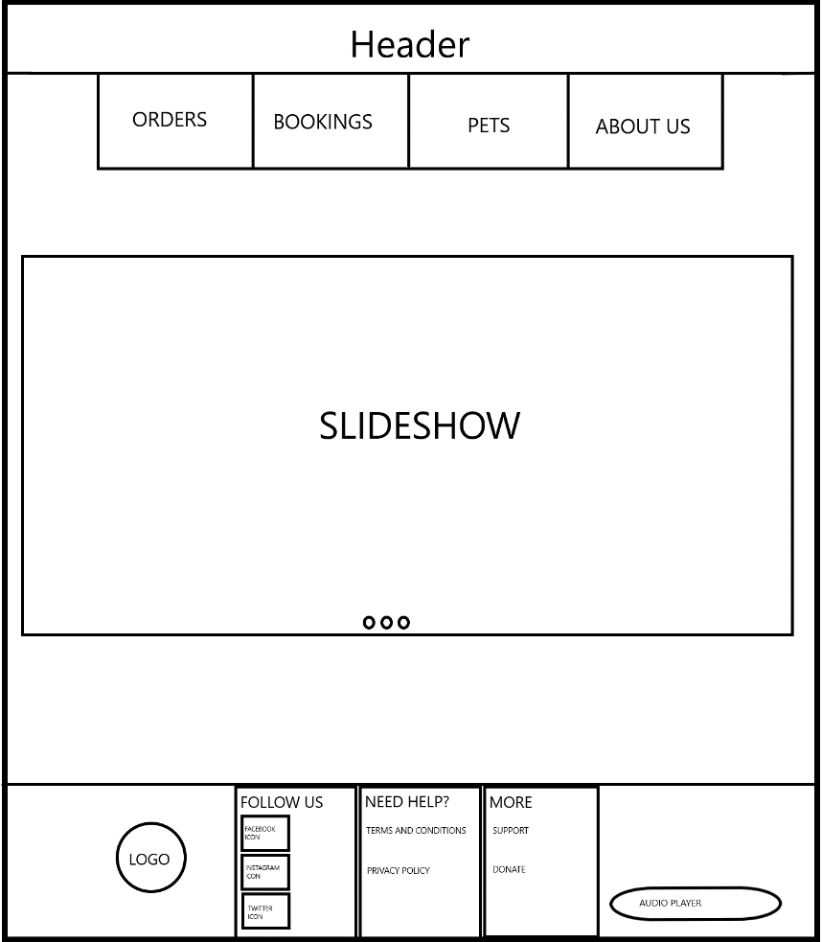

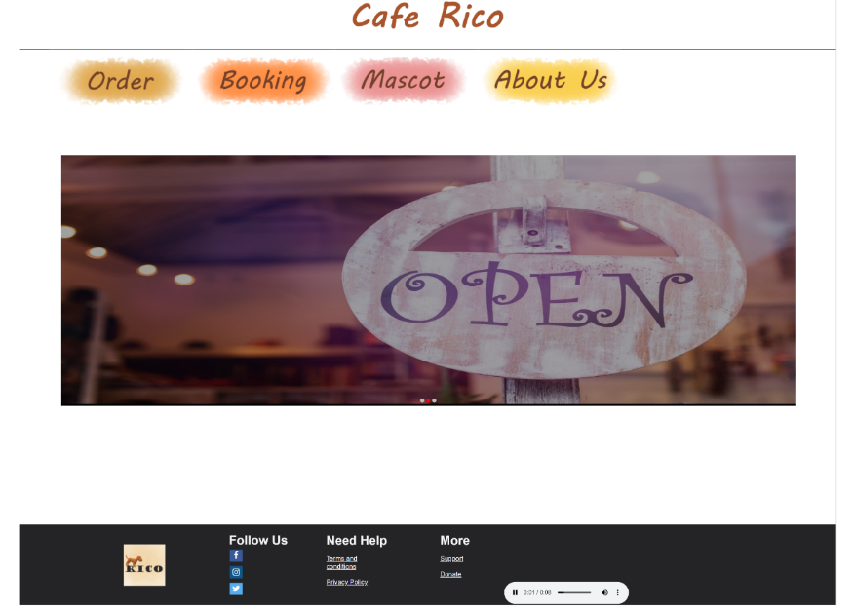  
  
This is the Index page, a simple page where our café name is on the Header, also include four hyperlink references to other pages. A slideshow showing Café and also some messages. Lastly a footer with our logo, with hyperlink to our social media and a simple audio player.

Order  
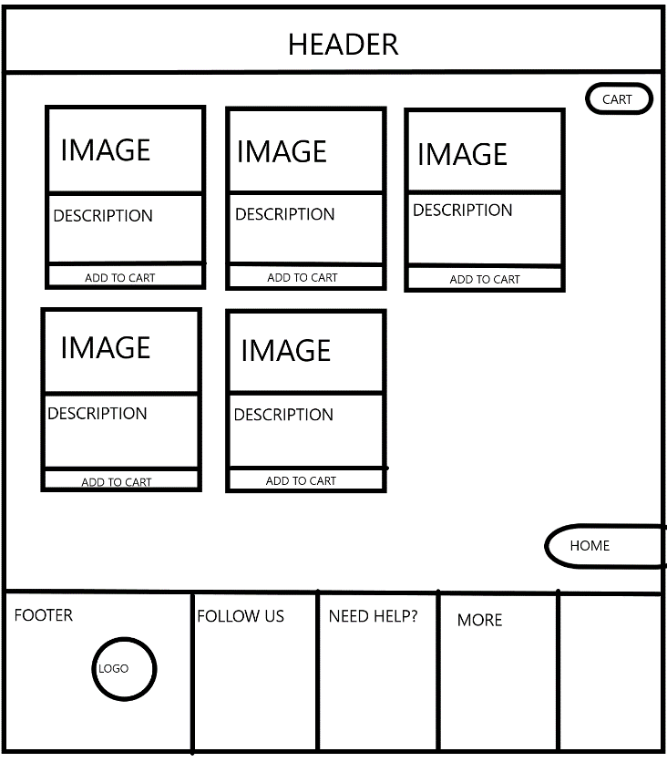  
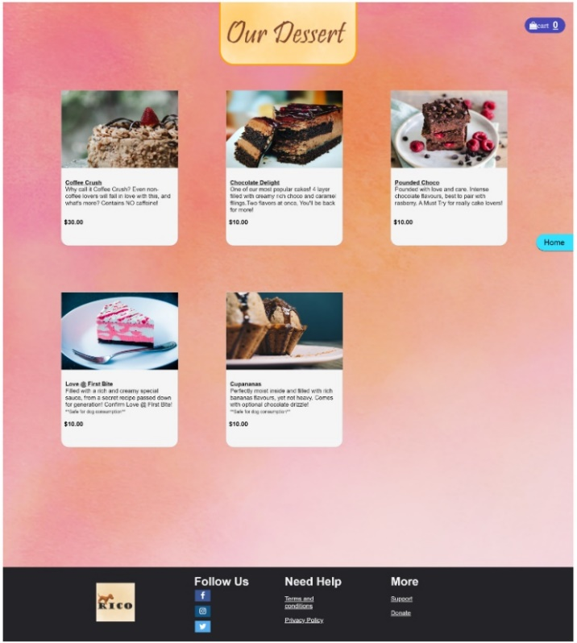  
  
Our page where customer can order their dessert. Customer can add their choices to cart by clicking on Add to Cart when they hover over the specific DIV, number of items added to cart will be shown on the top right cart section. A home button where it will link them back to the Index page.

Booking  
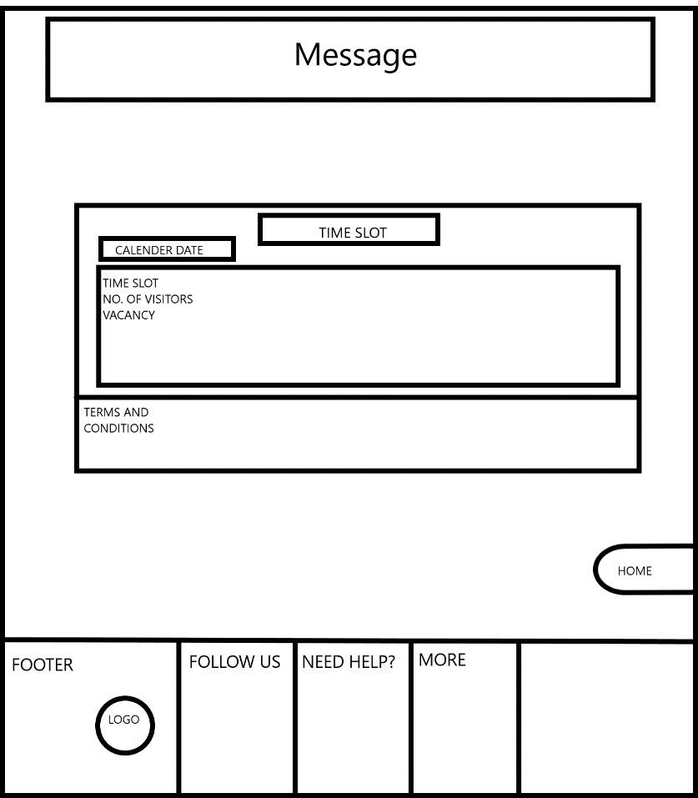  
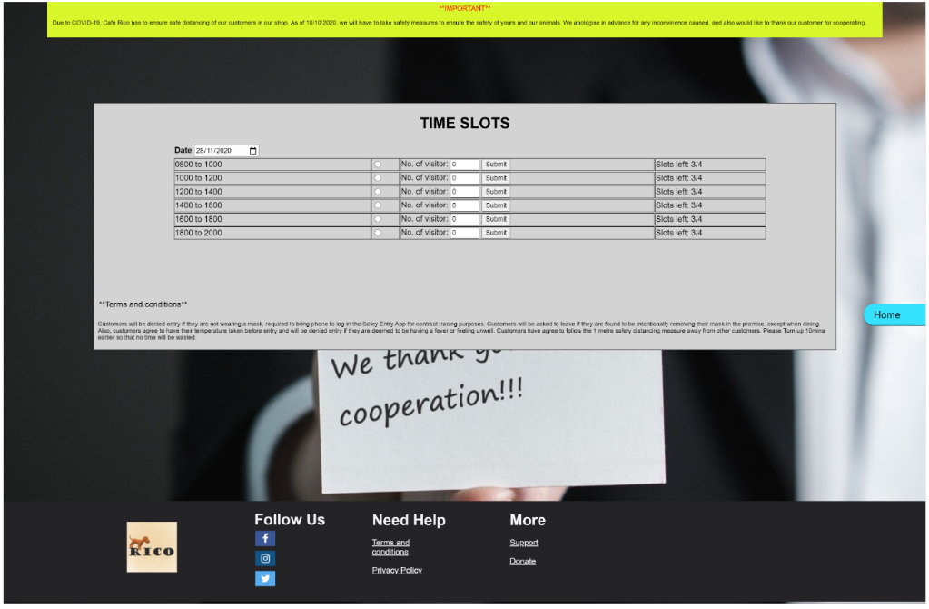  
  
This is our booking page, where customer can select the dates, the time slots, and the number of visitors. Also, a slots limitation on the far right to show them which time slots are full.

Mascot  
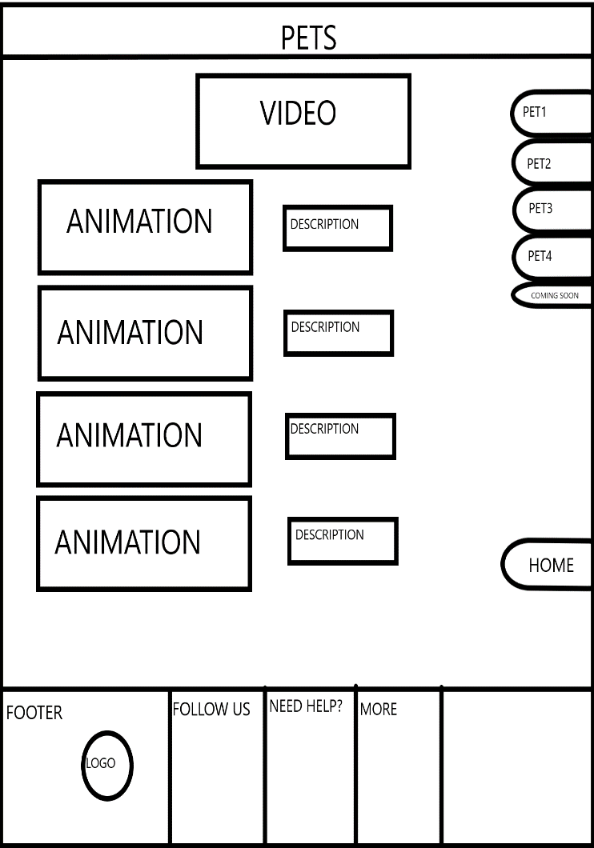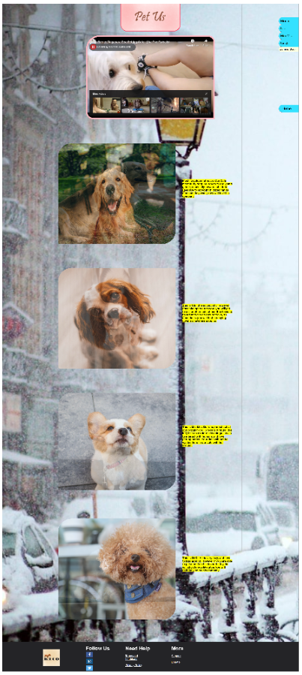  
  
Mascot page, where there will be a short video showing some interaction with our café pets, also a short image animation of our café pets, with a short description of them by the side. A small navigation section on the right where it will go to respective pets when clicked on, so as to not let user scroll too much when more and more of our café pets are being posted up.

About Us  
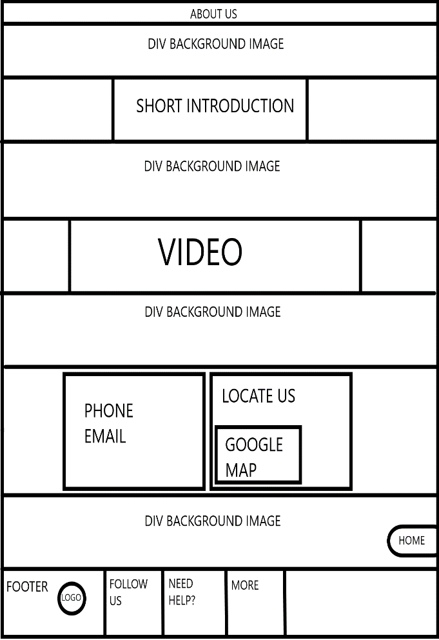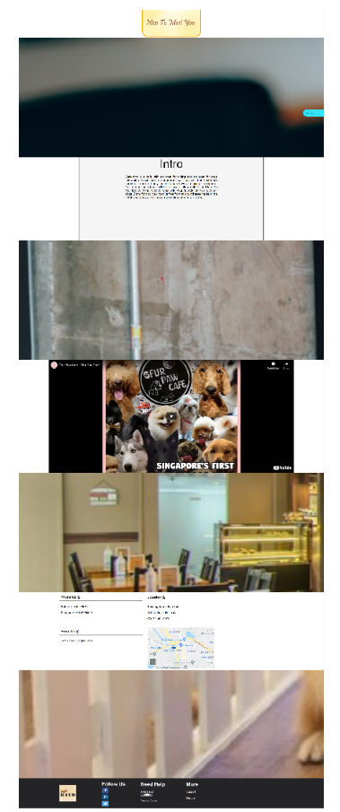

Our about us page, have a short intro and a short video, also includes our contact us details, and location. It is designed with the DIV background set to fixed, while scrolling user will be able to check out our café interior. While getting to know more about us, they will be able to view the interior of our café too.

References

1. Gandy, D. (n.d.). *Font awesome license*. Font Awesome. <https://fontawesome.com/v4.7.0/license/>
2. *HTML tutorial*. (n.d.). <https://www.w3schools.com/html/default.asp>
3. *Image-rendering*. (2020, August 3). CSS-Tricks. <https://css-tricks.com/almanac/properties/i/image-rendering/>
4. *Public housing – A Singapore icon*. (n.d.). Housing & Development Board (HDB). <https://www.hdb.gov.sg/cs/infoweb/about-us/our-role/public-housing-a-singapore-icon#:~:text=The%20flats%20spell%20home%20for,optimal%20living%20environment%20for%20residents>
5. CSS tutorial. (n.d.). W3Schools Online Web Tutorials. <https://www.w3schools.com/css/>