**A new design of a sliding window integrated with PV cell, thermoelectric cooler and PCM**

1. **Physical model**

The conventional sliding window is used as a curtain in the building application. However, the proposed sliding window can decrease the air conditioning system energy consumption, and store electrical energy in batteries to use it, as shown in Figure 1.

|  |  |
| --- | --- |
| **(a) Traditional window** | **(b) Proposed window** |

Fig. 2. The sliding window in the (a) conventional design, and (b) proposed design.

In the proposed sliding window as shown in Figure 2, the PCM (RT-35) was contained within a 10 mm wide glass container. The exterior side of the sliding layers accommodates the PV cell. It is important to note that because the PV cell is located on the exterior, it generates electricity in both closed and open sliding window situations. The thermal coupling between the PV cells and the PCM container allows the heat generated by the PV cells during the day to be transferred to the PCM. Consequently, during the day, both the temperature of the PV cell and the heat flux through the window decrease during the day. Also, in the other side of the PCM there is series of thermoelectric cooler. The hot side of the TEC is connected to the PCM to absorbed heat from it and cool it while the cold side is subjected to the inside room temperature. this system can be used when the air conditioning is operated to absorb part of the room load and that would decrease the electricity consumption of the air conditioning unit in the summer soloistic. Also, when changed the terminal of the TEC, it can be used as a warmer in the winter soloistic.

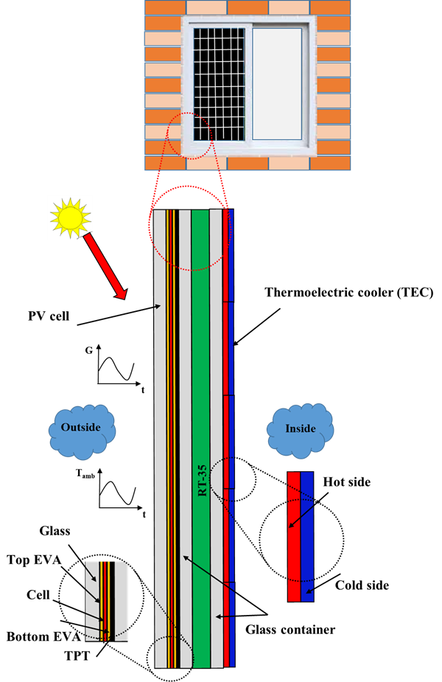

Fig. 2. The proposed system component.