## Android.Location.bearingTo((Location dest) method:

N

S

N

myLocation

destLocation

0

45

90

180

-135

-90

-45

135

**Returned value of myLocation.bearingTo(destLocation)**

## Orientation Data from SensorEvent

**public** **void** onSensorChanged(SensorEvent evt) {

**if** (evt.sensor.getType() == Sensor.*TYPE_ACCELEROMETER*) {

**for**(**int** i=0;i<3;i++)

gravity[i]=evt.values[i];

}

**if** (evt.sensor.getType() == Sensor.*TYPE_MAGNETIC_FIELD*) {

**for**(**int** i=0;i<3;i++)

geomagnetic[i]=evt.values[i];

}

**float**[] R=**new** **float**[9];**float**[] I=**new** **float**[9];

SensorManager.*getRotationMatrix*(R, I, gravity, geomagnetic);

SensorManager.*getOrientation*(R, orientation);}

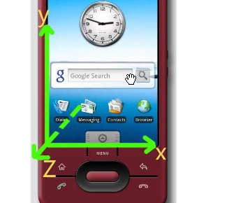In the sample code, orientation[0] changes when the “head” of phone turns (in the following figure, the direction which y axis heads is the “head” of the phone). When the phone heads north, it’s 0; when south, it’s \pi; when east, it’s \pi/2 and when west, it\s -\pi/2.

N

S

N

Where the phone heads to

0

$$∓π$$

**Returned value of orientation[0]**

$$π/2$$

$$-π/2$$