Name: yuxi mao

Student id: 16254545

Code of task 1

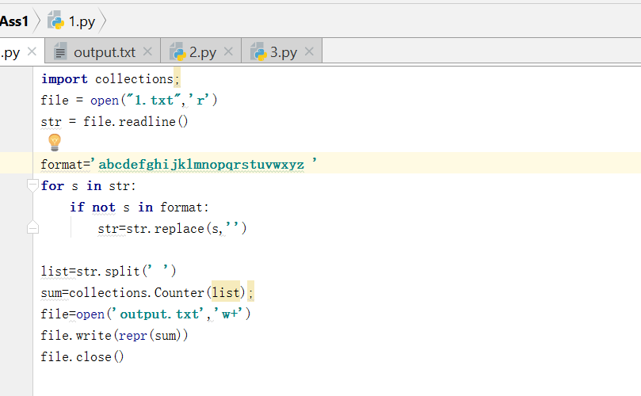

Code of task2:

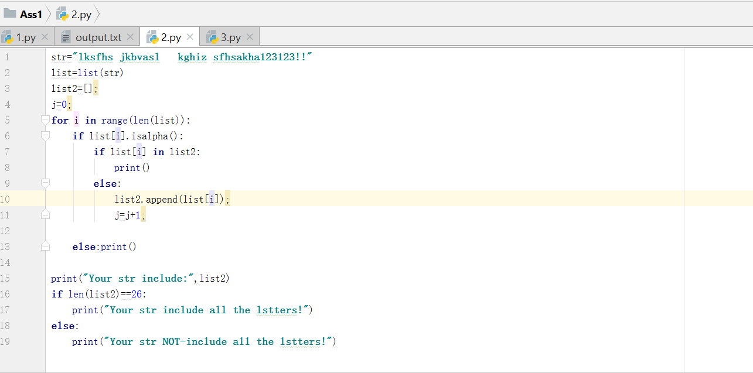

Code of task3:

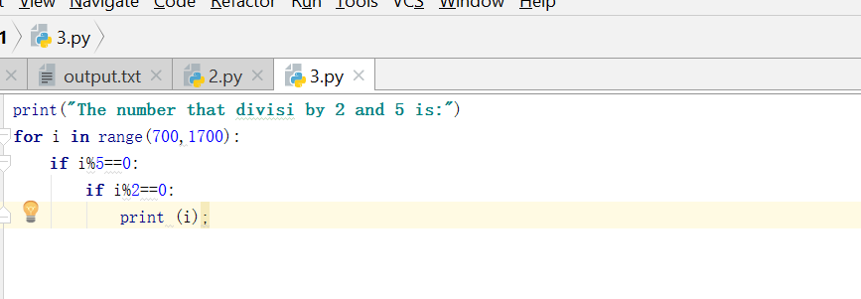

Result of task1:

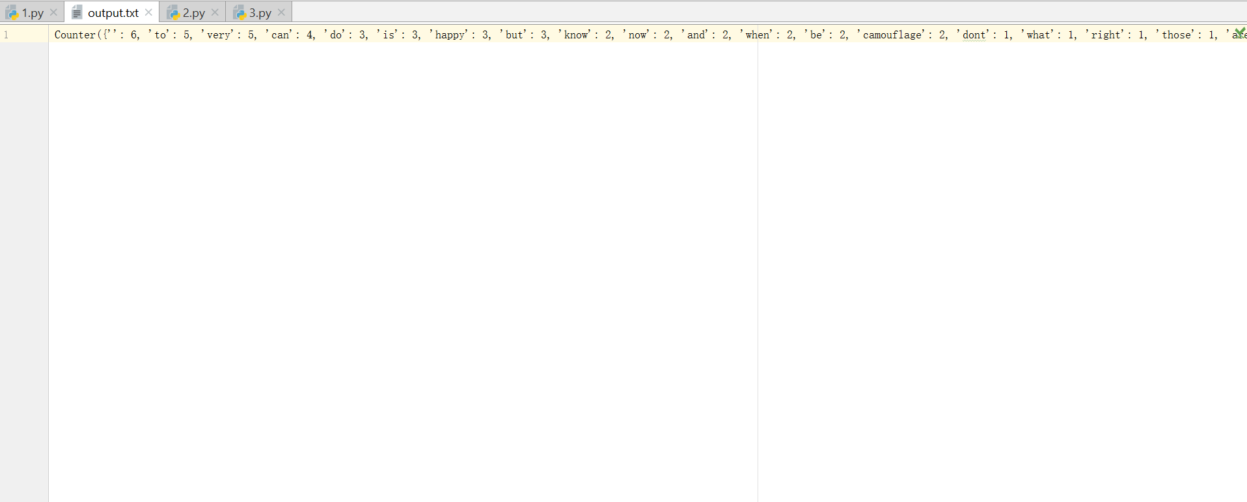

Result of task2:

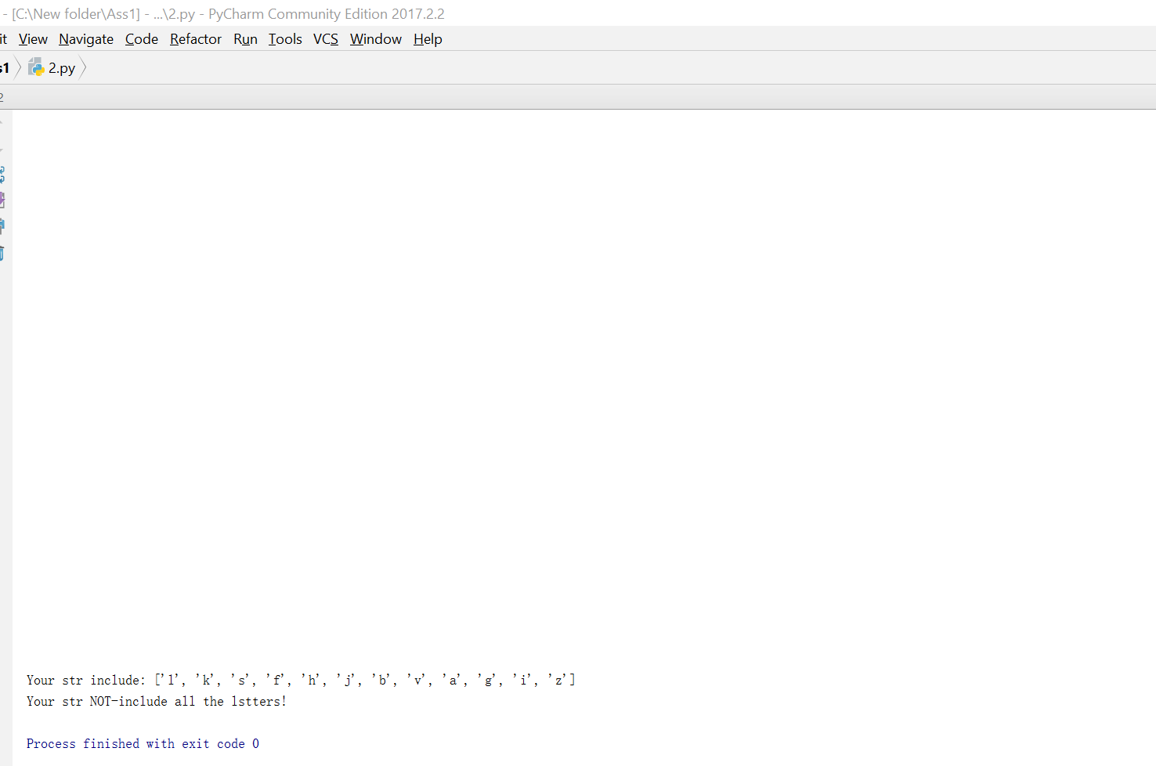

Result of task3:

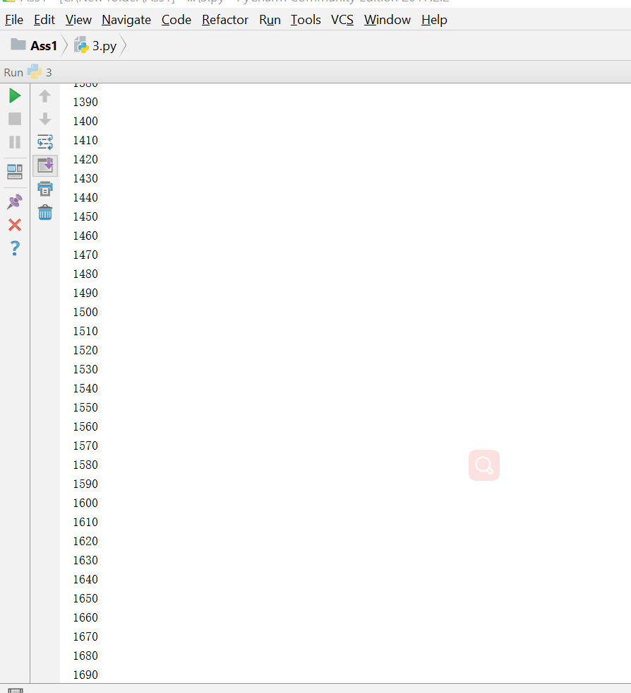

Code1:

**import** collections;  
file = open(**"1.txt"**,**'r'**)  
str = file.readline()  
  
format=**'abcdefghijklmnopqrstuvwxyz '  
for** s **in** str:  
 **if not** s **in** format:  
 str=str.replace(s,**''**)  
  
list=str.split(**' '**)  
sum=collections.Counter(list);  
file=open(**'output.txt'**,**'w+'**)  
file.write(repr(sum))  
file.close()

Code2:

str=**"lksfhs jkbvasl kghiz sfhsakha123123!!"**list=list(str)  
list2=[];  
j=0;  
**for** i **in** range(len(list)):  
 **if** list[i].isalpha():  
 **if** list[i] **in** list2:  
 print()  
 **else**:  
 list2.append(list[i]);  
 j=j+1;  
  
 **else**:print()  
  
print(**"Your str include:"**,list2)  
**if** len(list2)==26:  
 print(**"Your str include all the lstters!"**)  
**else**:  
 print(**"Your str NOT-include all the lstters!"**)

Code3:

print(**"The number that divisi by 2 and 5 is:"**)  
**for** i **in** range(700,1700):  
 **if** i%5==0:  
 **if** i%2==0:  
 print (i);