**CS5560 Knowledge Discovery Management**

**Lab Assignment 4**

**Yuxi Mao**

**Class id: 6**

1. **Ontology Description**

Trace the following Steps using the reference

**1. Determine the domain and scope of the ontology.**

**2. Consider reusing existing ontologies.**

**3. Enumerate important terms.**

**4.** **Define the classes & class hierarchy.**

**5. Define the properties of classes.**

**6. Define the facets of the slots.**

**7. Create instances.**

**a. Determine the domain and scope of the ontology**  
The domain of ontology decides the main purpose or foundational of  
ontology, in our case, is the mental health symptoms. And the scope  
of ontology decides the direction of mental health symptoms go to,  
remain in a certain scope.  
**b. Consider reusing existing ontologies**  
Relative to our topic relied on “mental illness”, reusing the existing  
ontologies might be an effective way to extent the dataset and  
evaluate the ontology we are able to generate. The “MFO Mental  
Disease Ontology” and “Mental Functioning Ontology” can be  
satisfied the needs of mental health symptoms.  
**c. Enumerate important terms in the ontology**  
As an effective method to assess the important terms, TF-IDF is  
employed in this context and then the selected terms list as below.

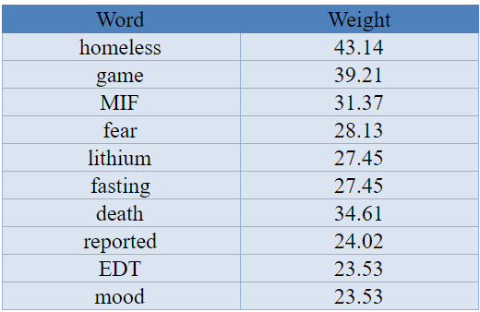  
**d. Define the classes and the class hierarchy**  
Ontology as a method to conduct the connection between each term, a  
hierarchical structure is needed. In order of that, classes or subclasses  
will be employed as the main nodes or secondary nodes. To simplify  
the processes, the main five categories from BioNLP is adopt for  
easier collections, which is diseases, gene, species, chemical and  
other. While, the high frequent terms employ as the subclasses node to  
build the connection with the rest.  
**e. Define the properties of classes**  
We define the predict (verb) section of triplet as the properties of  
classes, since we believe there’s more information involving at these  
sections. For example, the norm section of mental disease involving  
sentence will only rely on the type of disease or some sorts of objects.  
**f. Define the facets of the slots**

Facet in ontology seems as the terms belong to some sorts of classes  
or subclasses. In mental disease, some types are only considered as  
the facet of slots instead of classes or subclasses.  
**g. Create instances**  
Instance, according to my understanding, can be seem as the classified  
or identical method for some sort of terms in ontology. Relative to the  
mental disease, the general instances involve organism instance,  
disease instance and process instance.

1. **Characterize the triplets based on the following Rules (minimum 5)**

**Triplets:**

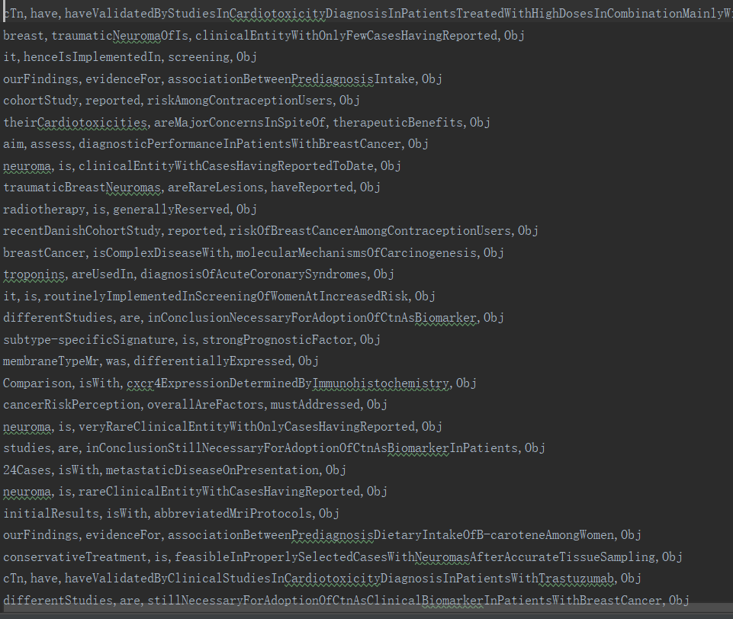

* 1. **Inverse Of**

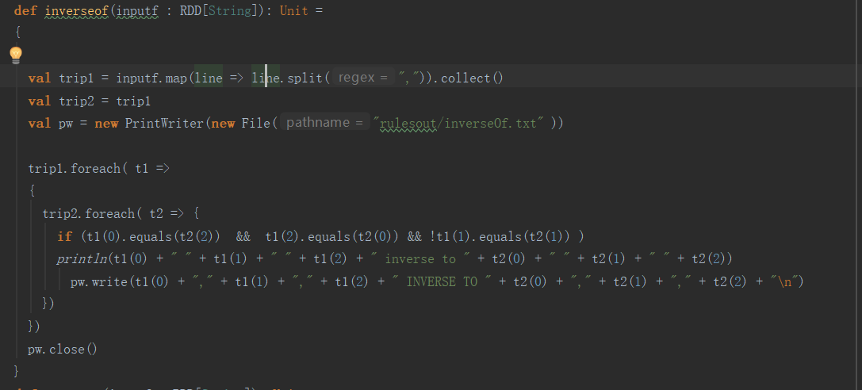

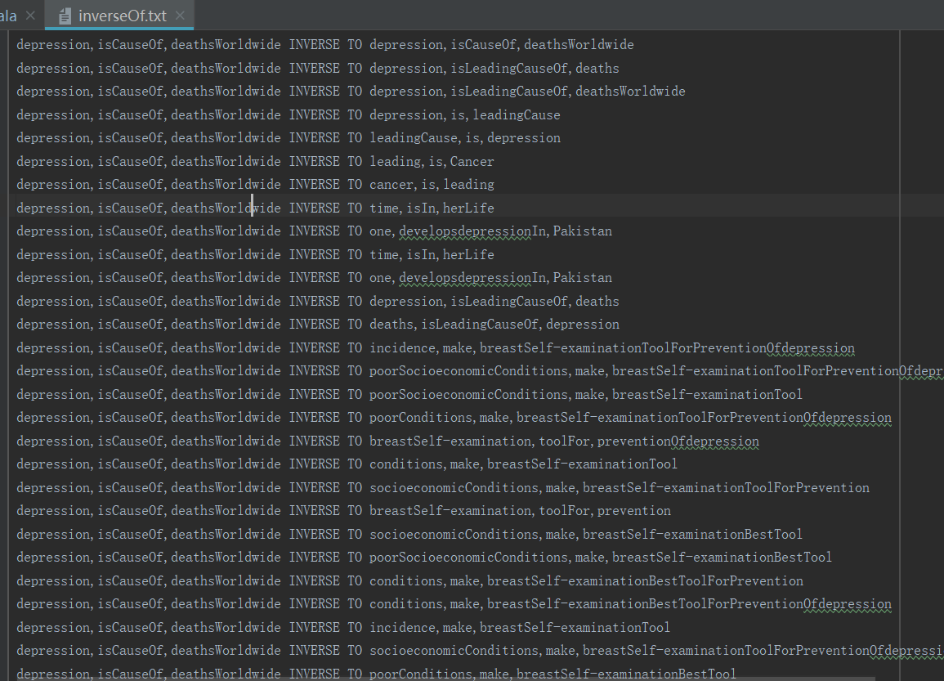

* 1. **Symmetric Property**

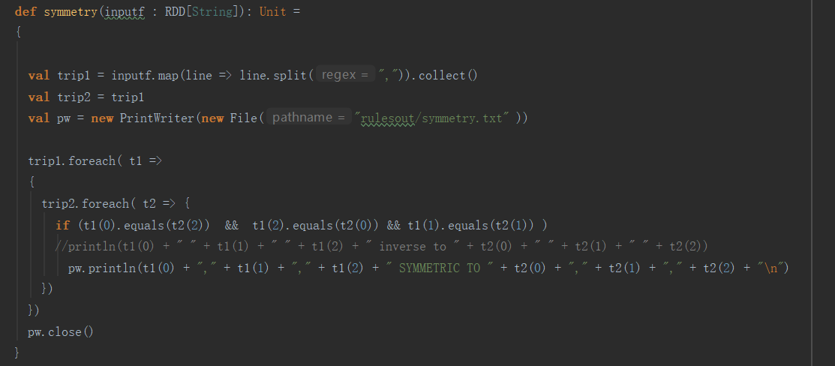

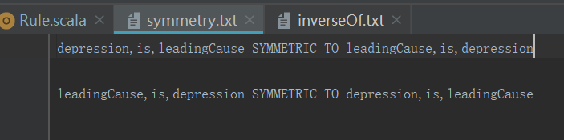

* 1. **Transitive Property**

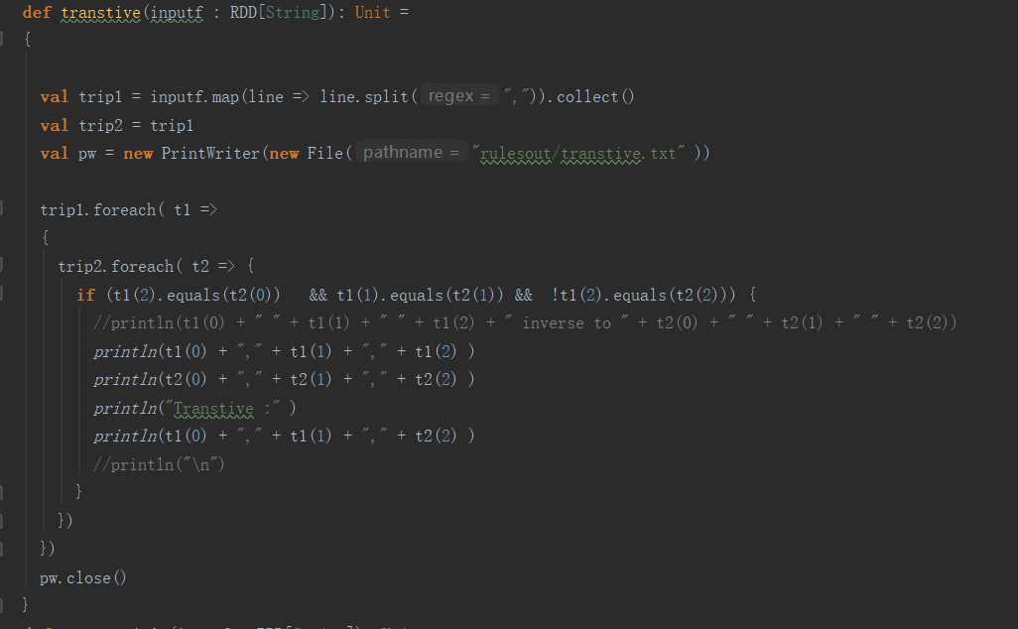

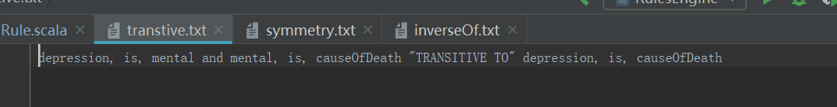

* 1. **Property Chain Axiom**

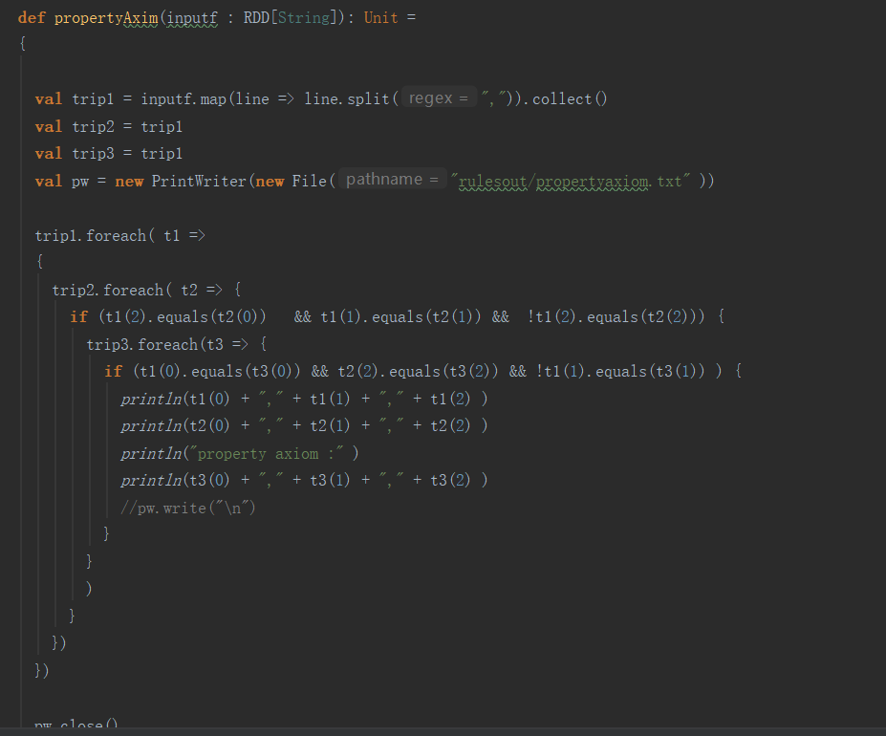

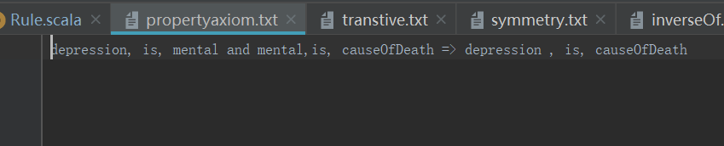

* 1. **Asymmetric Property**

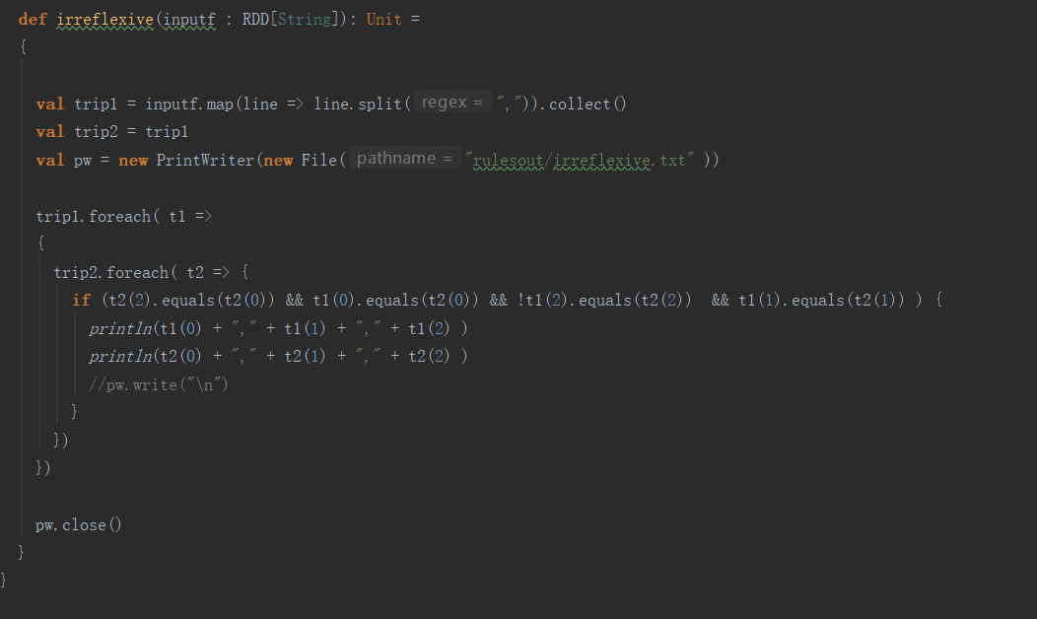

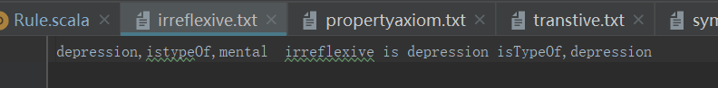

1. **Record unique features noted from your ontology**

The word we did include these:

1.      Entity recognition creation

2.      Subclasses creation

3.      Synonyms creation

4.      Top words creation