1.5

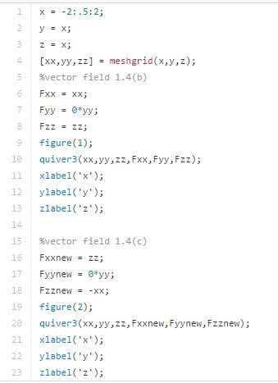

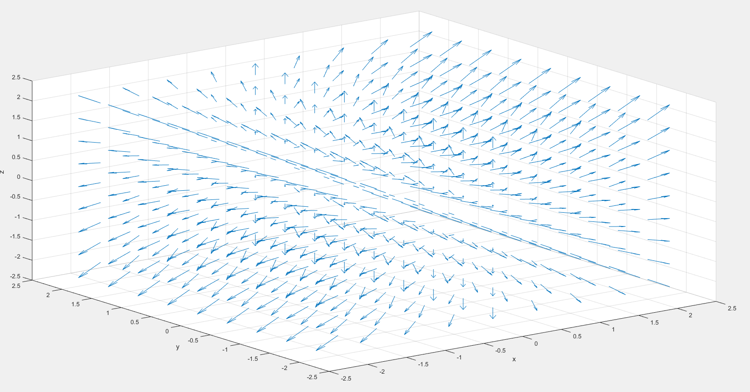

This vector field is expanding outwards indicated by a net outflow of the flux; therefore the divergence of the above vector field is expected to be positive.

The curl of the field is zero because the field is not rotating from the plot.

And these observations match the computation results from 1.4. div = 2, curl = 0;

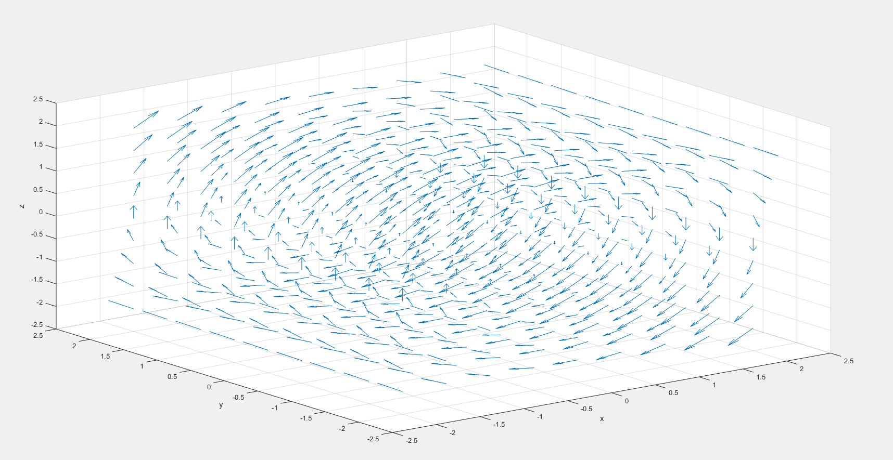

This vector field is neither expanding nor compressing, so the divergence is equal to 0. This agrees with the previous calculated results.

By visual inspection, we can see that the field is rotating. If we place a paddle wheel anywhere, we see immediately its tendency to rotate clockwise. Using the right-hand rule, we expect the curl to be along the direction, which is also consistent with the computation in 1.4(c).i.e. curl = 2.

2.1.7

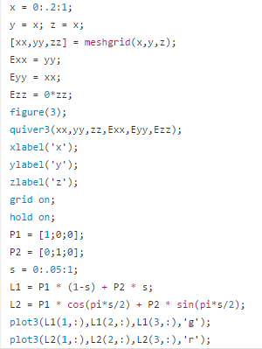

The graph obtained is shown next page:

