**COMP9444 Project Summary**

<Color Transfer Based on Neural Style Transfer>

<MA Jingyang z5380704 > <Yuxin Meng z5348583> <Yunyi Li z5291577> <Guoling Dong z5327713>

<Han Lin z5341269>

**Introduction & Motivation**

For a painting, at the physical level, we believe that there are three parts that can be created: "painting content", "painting tools" and "color matching". For the current style transfer, the texture part is transferred as the style. In other words, the current AI can select its own drawing tools to draw specific objects to a certain extent. Our work is mainly based on the style transfer of the IOB-NST method, adding an interesting color transfer part.

Our program has three inputs, a style picture, a color picture and a content picture, and the final output picture has the style of the style picture, the color of the color picture, and the content of the content picture at the same time.

We hope that this will enable AI to have a better anthropomorphic artistic creation ability. For our project, this is an exploratory fresh start, not a simple optimization, prediction or comparison.

**Literature Review**

IOB-NST: Image-Optimization-Based Online Neural Methods. This is an online learning method that uses a convolutional neural network to obtain intermediate layer features as texture features and content features. For the style loss part, first use Gram-based visual texture modeling technology to model the style, and then calculate the MSE loss of the output image and style image. For the content loss part, the MSE loss of the output image and the content image is used. Finally, the weighted summation of style loss and content loss is used to obtain the total loss function L. Through continuous iteration, IOB-NST reduces the loss function L, and tries to make the output image have the smallest style loss and content loss at the same time, so as to obtain an output that combines content and style images.

**Methods**

There are also other neural network style transfer algorithms, but we prefer to perform style transfer anytime, anywhere. Therefore, the online learning method (IOB-NST) is chosen as the baseline, rather than the algorithm that must be based on the training model. This also determines that our method does not have any training set and test set.

For color transfer, we mainly design two methods to achieve it:

Method 1, uses two style transfer, the first time takes the style image as the style and the color image as the content, to obtain a picture with both the target color and the target texture. Next, use this image as the style input and the target content image as the content input, perform style transfer again, and finally obtain the final output with "texture of style image", "color of color image" and "content of content image".

Method 2, first, overlay the color image directly onto the style image. Then use this image as the style input to transfer the style of the content image. This is an improvement over the first approach, avoiding the need for two style transfers.

**Experimental Setup**

The general parameters and models we use are as follows, but in specific comparative experiments, we transform the style layer and content layer, and even the network model.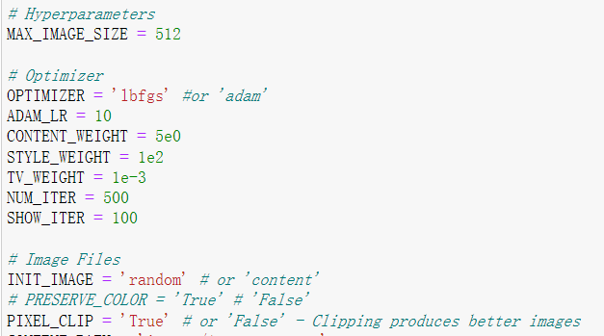 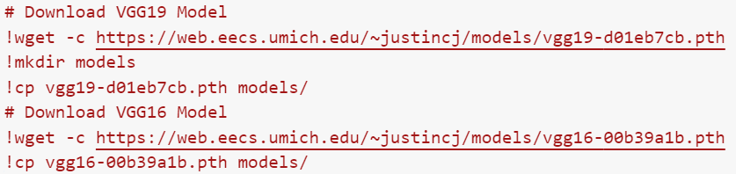

**Results**

We have carried out a variety of comparative experiments, and there is no more space here to describe the parameters and specific comparison methods in detail, which will be explained in more detail in the PPT and code. Only some results/conclusions are presented below.

1. VGG19 obviously learns more style and texture structure than VGG16, and deeper network layers will help extract more detailed information (but lose content information).

2. For our two color transfer methods, the second transfer scheme is slightly less effective than the first (fairly close) because we also affect the texture information when overriding the color. (The essence of the texture may just be more detailed colors)

3. The second color transfer scheme is generally successful, and it achieves almost the same final result as the first method on the basis of only one style transfer (almost double the efficiency).

**Conclusions & Future work**

Compared with the existing style transfer, we successfully added color transfer based on the style transfer. It should be noticed that the color transfer we are trying to achieve is not simple coloring, but hope that artificial intelligence can be like human, abstract/souled coloring, rather than simple overlay. We can see that the shading distribution of the color transfer is irregular. This meets our initial expectations, and it can generate colorful ink abstract paintings or dreamy castles (sample output) based on different colors and different textures we input.

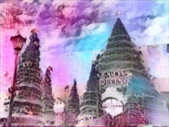 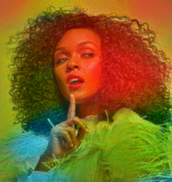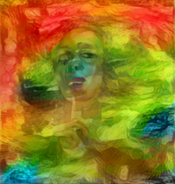

But we also realize that most of the current style transfer techniques only stop at the transfer of the texture/edge sharpness of the image, which is not enough to replicate the real master works（For Van Gogh's masterpiece Starry Night, style transfer did not really transfer Van Gogh's unique swirling style）. For color transfer, the logic of coloring is only to minimize the loss of information, not to generate aesthetics.

For the future, we may refine this colorization logic to make it object-based or incorporate color transfer for human aesthetics.