XJTLU Entrepreneur College (Taicang) Cover Sheet

Module code and Title | DTS106TC: Introduction to Database
School Title | School of AI and Advanced Computing
Assignment Title | Assessment Task 001 (CW): Individual Coursework
Submission Deadline | May 16th, 2025 at 11:59 PM
Final Word Count | NA
If you agree to let the university use your work anonymously for teaching and learning purposes, please type “yes” here. |  | Yes

I certify that I have read and understood the University’s Policy for dealing with Plagiarism, Collusion and the Fabrication of Data (available on Learning Mall Online). With reference to this policy I certify that:
- My work does not contain any instances of plagiarism and/or collusion.
My work does not contain any fabricated data.

By uploading my assignment onto Learning Mall Online, I formally declare that all of the above information is true to the best of my knowledge and belief.
Scoring – For Tutor Use
Student ID |  |  |  | 2363570
Stage of Marking |  | Marker  Code | Learning Outcomes Achieved （F/P/M/D）  (please modify as appropriate) |  |  |  | Final  Score
 |  | Marker  Code | A | B | C | D | Final  Score
1st Marker – red pen
Moderation  – green pen |  | IM  Initials | The original mark has been accepted by the moderator (please circle as appropriate): |  |  |  | Y / N
 |  |  | Data entry and score calculation have been checked by another tutor (please circle): |  |  |  | Y
2nd Marker if needed – green pen
For Academic Office Use |  |  | Possible Academic Infringement (please tick as appropriate)
Date  Received | Days late | Late Penalty | ☐ Category A |  | Total Academic Infringement Penalty (A,B, C, D, E, Please modify where necessary) _____________________
 |  |  | ☐ Category B
 |  |  | ☐ Category C
 |  |  | ☐ Category D
 |  |  | ☐ Category E

Q1:
The database of our website is used to store, manage and provide access to data of movies and user behaviors.
In Business Scenario,
- Each user needs an account and relative information.
- New movies require users to create entries and add/update information.
- The interaction of users with movies should be stored, and the platform needs to build a relation to the movie/user.
- Platforms need to provide the SEARCH function for users.
- User actions and comments/ratings should be traceable.
To achieve this, our database should effectively store:
1. Each movie and its related information (meta information, review records, genre, etc.)
2. User account and personal information (email, password, review records, etc.)
3. Entry operation/comment log (to facilitate tracing and avoid legal risks)
The reasons why I choose database:
1. Database supports the construction of complex data relationships (e.x. user-review-movie),
2. Database ensures safe and feasible concurrent writing and maintains data consistency,
3. Database supports fast and reliable multi-condition retrieval.
Business rules and assumptions:
RULES:
- Every user/movie/review has a unique user/movie/review ID.
- Every movie entry contains basic information.
- Every user must register before using interactive functions.
- Users have the right to delete an account at any time.
- Users can edit movie entry information.
- Each movie must belong to a genre, and each genre can contain multiple movies.
- A movie can have multiple actors, and an actor can participate in multiple movies.
- A director can direct multiple movies, but each movie has only one main director.
- Users can only keep one final recorded rating and review for each movie, which can be modified or deleted at any time.
- Each comment must be associated with a unique, existing user and movie.
- The platform must archive all ratings/comments/operations.
- The platform needs to support filtering movies by multiple conditions.
ASSUMPTIONS:
- The information of a movie may be updated. But the UPDATE function of movie information may be misused. So, the data should support updates and version tracking.
- Some movie entry information may be incomplete at the beginning, and the system needs to allow NULL.
- For multiple ratings/comments of the same movie by the same user, the system will only display the last submitted version.
Problems and possible solutions:
Law: If the platform does not provide account cancellation or comment deletion, it will violate the Personal Information Protection Law. My solution is to enable DELETE both for account and review.
Ethics: If this platform is designed with social functions, it may lead to cyber violence. My solution is to cut down the community and social functions of this platform.
Finance: If the database is not designed properly, the expansion of data volume and high concurrent access will make the platform invest more in hardware costs. My solution is to store pictures and media information externally when the database only saves references.
Requirements:
- Allow users to create accounts, log in, and delete account.
- Allow users to add, modify, and delete movie information.
- Users can and can only keep one "currently effective" rating + comment for the same movie, which can be updated or deleted at any time.
- Movies need to have multiple associated classes, such as genre, actor, director, etc.
- Support users to filter movies by release years, rating ranges, etc.
- Allow system to timestamp each record and change, the person and time of change.
- Allow system to timestamp each review and score, and corresponding information.
Reflection:
When collecting requirements for our platform, I tried to consider the problem as comprehensively as possible. For example, I didn’t consider that users need to delete their accounts at first, but I found it in the analysis of the problems, and added it. Meanwhile, I asked the “why” behind each requirement. I found that users want the search function to efficiently find the movies they want to watch. Then, I thought. What kind of movies do users really want to watch? Through research on Douban’s search function and reflection on my own search habits, I introduced factors such as genre and release time to help users filter movies.
(word count: 699)

Q2:
Step 1:
According to the given scenario and my requirements analysis, I find the User is a core entity, who can register, log in, and manage their movie reviews. Then, Movie is also an entity, with basic information. Genre, Actor, Director are entities associated with Movie. The actions of reviewing and rating mean that Review is an entity, including attributes like score and comment. To support tracing back , I introduce OperationLog and ReviewLog entities to respectively record user actions and review snapshots. The whole list of entities and attributes is as follows:
User
user_id
name
email
password
reg_ip
is_deleted

Movie
movie_id
title
release_year
synopsis #nullable
media_url #nullable
genre_id #FK to Genre
director_id #FK to Director
actor_ids #FK to Actor
avg_score #derived
review_count #derived
is_deleted

Genre
genre_id
name

Director
director_id
name

Actor
actor_id
name

Review
review_id
user_id #FK to User
movie_id #FK to Movie
score
content #nullable
created_at
updated_at
is_deleted

OperationLog
olog_id
user_id #FK to User
movie_id #FK to Movie
action
op_time

ReviewLog
rlog_id
review_id #FK to Review
user_id #FK to User
movie_id #FK to Movie
score
content
op_time
op_ip

Step 2:
- According to the rule that each comment must be associated with a unique, existing user and movie, the relationship between User and Review is a writes (1:M) relationship.
- According to the rule that each comment must be associated with a unique, existing user and movie, the relationship between Movie and Review is receives (1:M).
- According to the rule that a movie can feature multiple actors and an actor can act in multiple movies, the relationship between Movie and Actor is features (M:N).
- According to the rule that a movie is directed by one director and a director can direct multiple movies, the relationship between Movie and Director is is directed by (M:1).
- According to the rule that each movie belongs to one genre and one genre can include many movies, the relationship between Movie and Genre is belongs to (M:1).
- According to the archive rule for operations, and one user can have several operations, the relationship between User and OperationLog is performs (1:M).
- According to the archive rule for reviews, and one review can be updated several times, the relationship between Review and ReviewLog is is archived as (1:M).

Step3:
- Primary Key (PK) of User is user_id;
- PK of Movie is movie_id. It contains three foreign keys, genre_id, which connects the movie to a genre, actor_id to associate the movie with actors, director_id, which links the movie to one director;
- PK of Actor is actor_id;
- PK of Genre is genre_id;
- PK of Review is review_id, Review owns two Foreign Keys (FK). One is user_id, which ensures that every review is written by only one user. The other is movie_id, which ensures that each review belongs to one specific movie.
- PK of OperationLog is olog_id. It contains two FKs, user_id and movie_id, which links each log entry to one user and one movie, ensuring that all system operations are traceable to the correct user.
- PK of ReviewLog is rlog_id. It includes three foreign keys: review_id, which connects the log entry to the original review; user_id, which records the author of the review; and movie_id, which associates the review log with its corresponding movie.

Step4:
Figure1. ERD (Next Page)
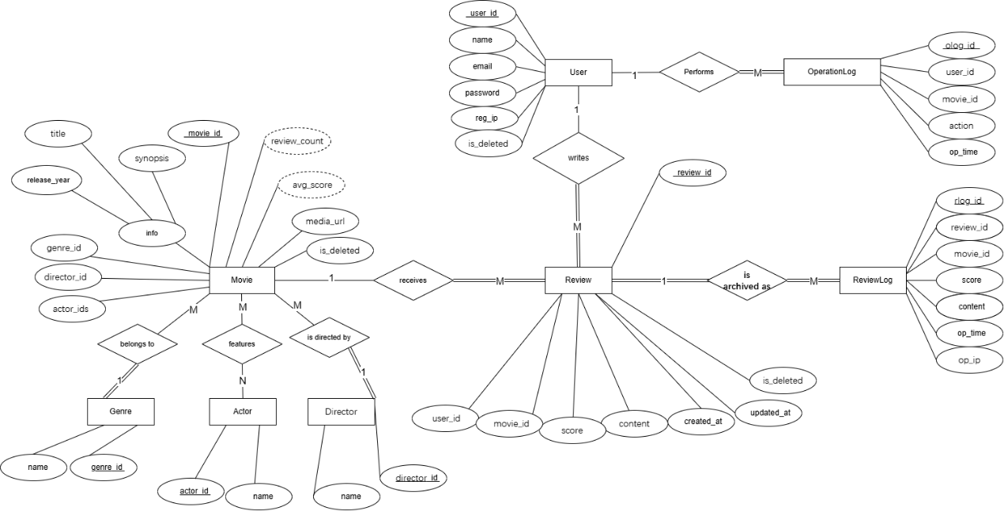

Assumptions and constraints:
- Movies can be created even if the cast or director has not been finalized, so actor_ids or director_id can be temporarily null.
- All reviews are archived at least once (upon creation) and again whenever updated or deleted.
- All operations are archived when conducted by a user.
- Derived attributes like avg_score and review_count are externally computed and will not be reflected in the physical design of the movie class in the database.
- The Media_url attribute in the Movie class points to external storage to prevent resource runs caused by data expansion.
- Because a movie is strongly associated with a genre/director, so once a genre/director is defined, it cannot be deleted.
- The many-to-many relationship between actors and movies requires a relational table in the coming physical model.
- Although a comment is mandatory to be bound to a valid user/movie, a user/movie does not necessarily need a comment.

Reflection:
As I mentioned in the previous part of Q2, this ERD reflects the requirements and business rules/assumptions very well. During the whole process of answering Q2, I reviewed the business rules and assumptions I set before and found some problems and made some changes. For example, when I was drawing the ERD, I found that a review must be associated with one and only one valid movie and user. But I only mentioned that the review must be associated with the user. So, I adjusted this missing rule. Meanwhile, to improve readability, I set the title, release_year and synopsis under movie into the parent attribute info. I also studied the mutual mandatory relationships of each class and reflected them in the ERD.

Q3:
Figure 2. Logical Model
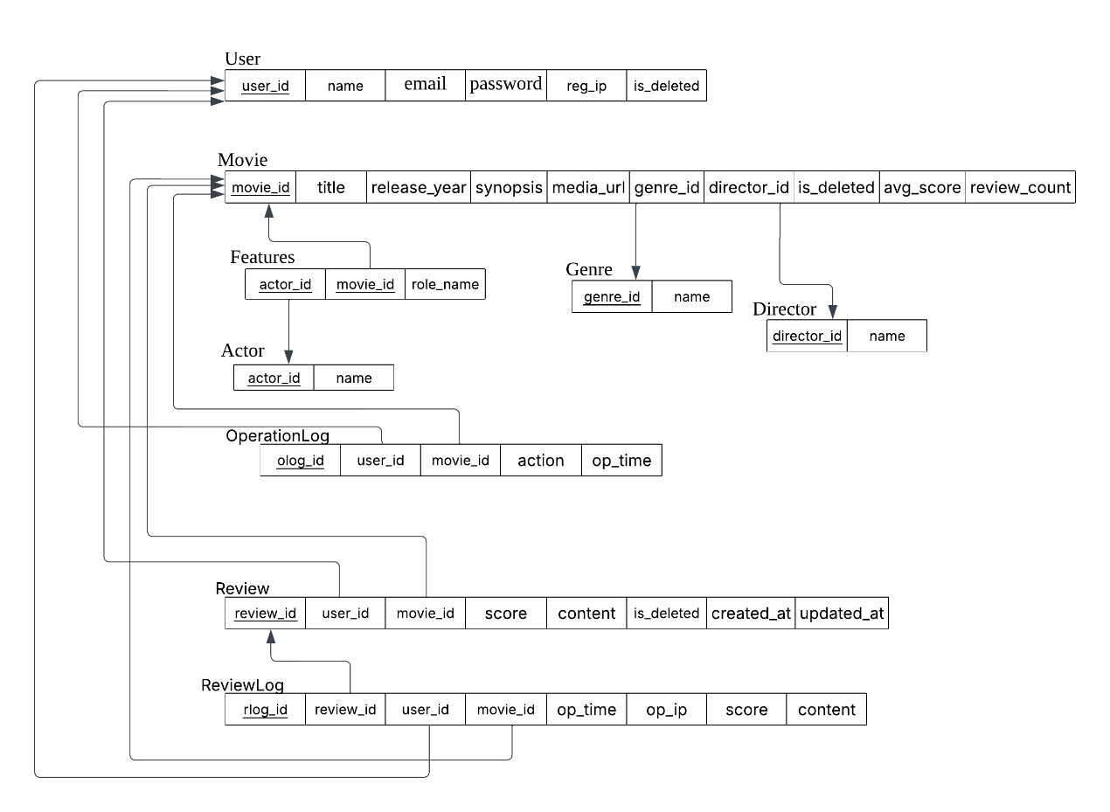
Analysis:
User: PK is user_id, which determines the other non-primary key. I assume that the registered email address is unique among users, but the username is not unique. So, email also determines the other non-primary keys as the candidate key. is_deleted defaults to FALSE, and other attributes are set to NOT NULL.
Movie: PK is movie_id, which determines the other non-primary key. I assume that avg_score and review_count are derived values, logically determined by movie_id, but not stored in the physical table. To maintain consistency with the ERD, I will temporarily put it in the logical model, but it will not appear in the physical model and will not affect the 3NF of the model. When a movie poster and other media files have not been uploaded, media_url is set to NULL. If it is confirmed that there is no such file, it is set to "". The same is true for synopsis. According to the rule that a movie must belong to one genre and one director, genre_id and director_id are NOT NULL. But actor_ids can be NULL.
Actor: PK is actor_id, which determines the other non-primary key. ‘name’ is NOT NULL.
Genre: PK is genre_id, which determines the other non-primary key. ‘name’ is NOT NULL.
Director: PK is director_id, which determines the other non-primary key. ‘name’ is NOT NULL.
Review”: PK is review_id, which determines the other non-primary key. I assume that empty comments are allowed, so content can be set to ''" or NULL, but empty ratings are not allowed, so score is set to NOT NULL. The timestamp updated_at is NULL if it is not modified and is_deleted defaults to FALSE.
ReviewLog: PK is rlog_id, which determines the other non-primary key. All other keys are set to NOT NULL to ensure complete audit logs. If the content of a review is empty, the content of this class can also be "" or NULL.
OperationLog: PK is olog_id, which determines the other non-primary key. All other keys are set to NOT NULL to ensure complete audit logs.
Features: As a many-to-many association table between Movie and Actor, the composite primary key (movie_id, actor_id) of Features also serves as a foreign key to reference the primary table, ensuring that one mapping record corresponds to only one movie and one actor. Its functional dependency is (movie_id, actor_id) → role_name, which is completely dependent on the entire primary key and complies with 3NF.

Further explanation:
As shown above, when converting ERD to logical model, I converted a many-to-many relationship between movie and actor into intersection entity 'Features’ and used 'movie_id' and 'actor_id' as both primary key and foreign key, and the remaining attribute 'role_name' in the table is completely dependent on the entire primary key. I ensure 3NF for it. Furthermore, for other entities, there are no repeating groups or arrays (1NF), and each entity has only one PK, eliminating partial dependencies (2NF). And as I mentioned before, all non-primary key attributes are directly and completely dependent on the table's primary key, without any transitive dependencies (3NF). Except for the intersection entity 'Features' relationship I have established, the remaining relationships in my model are all 1:M relationships between different entities. How I use foreign keys to link primary keys and implement relationships is shown in the figure.

Q4:
TABLES and Explanations (DATA type and SAMPLE):
For the primary key of all entities, I use SERIAL PRIMARY KEY because it can be easily auto increased.

Table1: USERS:
Column Name | USER_ID | EMAIL | PASSWORD | REG_IP | IS_DELETED
Key Type | PK
Not Null = NN  Unique = U | NN, U | NN, U | NN | NN
DATA Type | SERIAL | VARCHAR | VARCHAR | VARCHAR | BOOLEAN
Length | / | 200 | 255 | 45 | /

User:
email VARCHAR(200) NOT NULL UNIQUE ensures that each user registers with a unique email address;
password VARCHAR(255) NOT NULL to accept strong encryption passwords provided by some companies (such as Apple);
reg_ip VARCHAR(45) NOT NULL supports the maximum length of IPv6;
is_deleted BOOLEAN DEFAULT FALSE is used for soft deletion.
I inserted normal and soft deleted users into the sample data to verify the system's query and filtering of different account statuses.

Movie:
Table2: MOVIES:
Column Name | MOVIE_ID | TITLE | RELEASE_YEAR | SYNOPSIS | MEDIA_URL | GENRE_ID | DIRECTOR_ID | IS_DELETED
Key Type | PK |  |  |  |  | FK | FK
Not Null = NN  Unique = U | NN, U | NN, U | NN |  |  | NN | NN
DATA Type | SERIAL | VARCHAR | SMALLINT | TEXT | VARCHAR | INTEGER | INTEGER | BOOLEAN
Length | / | 200 | / | / | 500 | / | / | /

title VARCHAR(200) NOT NULL to avoid long titles that cannot be stored;
release_year SMALLINT NOT NULL CHECK (release_year BETWEEN 1888 AND EXTRACT(YEAR FROM CURRENT_DATE)+1) to ensure the legality of the release year;
synopsis TEXT supports variable length storage,
media_url VARCHAR(500) limits the maximum length to avoid malicious links;
genre_id INTEGER NOT NULL REFERENCES genre(genre_id) and director_id INTEGER NOT NULL REFERENCES director(director_id) force each movie to be associated with a genre and a main director;
is_deleted BOOLEAN DEFAULT FALSE to achieve soft deletion;
avg_score and review_count are derived attributes that are calculated later and are not physically stored in the main table.
I introduced several movies of the same genre/director into the table to help simulate conditional filtering. I also included both fully filled entries (such as "SciFi Galaxy") and partially missing entries (such as "13th" and "Speed ​​Chase" with media_url to NULL) to simulate the incomplete media resources in the early stage of the launch. I also designed a soft deletion for a movie.

Genre:
Table3: GENRES:
Column Name | GENRE_ID | NAME
Key Type | PK
Not Null = NN  Unique = U | NN, U | NN, U
DATA Type | SERIAL | VARCHAR
Length | / | 100

name VARCHAR(100) NOT NULL UNIQUE realizes name uniqueness.
The sample data covers 15 common types.

Director:
Table4: DIRECTORS:
Column Name | DIRECTOR_ID | NAME
Key Type | PK
Not Null = NN  Unique = U | NN, U | NN, U
DATA Type | SERIAL | VARCHAR
Length | / | 150

name VARCHAR(150) NOT NULL meets the name required.
The sample data covers 15 famous director.

Actor:
Table5: ACTORS:
Column Name | ACTOR_ID | NAME
Key Type | PK
Not Null = NN  Unique = U | NN, U | NN, U
DATA Type | SERIAL | VARCHAR
Length | / | 150

name VARCHAR(150) NOT NULL meets the name required.
The sample data covers 15 famous actor.

Review:
Table6: REVIEWS:
Column Name | REVIEW_ID | USER_ID | MOVIE_ID | SCORE | CONTENT | CREATED_AT | UPDATED_AT | IS_DELETED
Key Type | PK | FK | FK
Not Null = NN  Unique = U | NN, U | NN | NN | NN |  | NN
DATA Type | SERIAL | INTEGER | INTEGER | SMALLINT | VARCHAR | TIMESTAMP | TIMESTAMP | BOOLEAN
Length | / | / | / | / | 500 | / | / | /

INTEGER NOT NULL REFERENCES "user"(user_id) and INTEGER NOT NULL REFERENCES movie(movie_id) to ensure that movie reviews must be associated with valid users and movies;
score SMALLINT NOT NULL CHECK (score BETWEEN 0 AND 10) enforces the score range;
content VARCHAR(500) allows empty strings or NULL to simulate ‘no comments’;
created_at TIMESTAMP NOT NULL and updated_at TIMESTAMP capture the first and edit times;
is_deleted BOOLEAN DEFAULT FALSE handles soft deletion;
The review table contains both records that have not been modified since the initial creation and updated entries with updated_at timestamps, and the soft deletion is simulated through the is_deleted flag.

ReviewLog:
Table7: REVIEWLOGS:
Column Name | RLOG_ID | REVIEW_ID | USER_ID | MOVIE_ID | SCORE | CONTENT | OP_TIME | OP_IP
Key Type | PK | FK | FK | FK
Not Null = NN  Unique = U | NN, U | NN | NN | NN | NN |  | NN | NN
DATA Type | SERIAL | INTEGER | INTEGER | INTEGER | SMALLINT | VARCHAR | TIMESTAMP | VARCHAR
Length | / | / | / | / | / | 500 | / | 45

review_id INTEGER NOT NULL REFERENCES review(review_id) etc. ensure that each log can accurately map the review, user and movie;
score SMALLINT NOT NULL CHECK (score BETWEEN 0 AND 10) and content VARCHAR(500) are consistent with the review table;
op_time TIMESTAMP NOT NULL and op_ip VARCHAR(45) NOT NULL record the time and IP;
For each review with an updated record, I introduced the original rating and review before it was updated (at creation time) in ReviewLog, and kept the user and movie unchanged to simulate the real update situation.

OperationLog:
Table8: OPERATIONLOGS:
Column Name | OLOG_ID | USER_ID | MOVIE_ID | ACTION | OP_TIME
Key Type | PK | FK | FK
Not Null = NN  Unique = U | NN, U | NN | NN |  | NN
DATA Type | SERIAL | INTEGER | INTEGER | VARCHAR | TIMESTAMP
Length | / | / | / | 50 | /

user_id INTEGER NOT NULL REFERENCES "user"(user_id) etc. ensure that each log associates the initiator of the operation with the affected movie;
action VARCHAR(50) NOT NULL describes the operation type;
op_time TIMESTAMP NOT NULL records the operation time;
I simulated multiple CREATE and UPDATE operations in OperationLog, and I also set a user DELETE operation in the log for a movie marked as soft deleted in the movie class to simulate reality.

Features:
Table9: FEATURES:
Column Name | MOVIE_ID | ACTOR_ID | ROLE_NAME
Key Type | PK, FK | PK, FK
Not Null = NN  Unique = U | NN | NN
DATA Type | INTEGER | INTEGER | VARCHAR
Length | / | / | 100

As a many-to-many association between Movie and Actor, the Features table uses a composite primary key (movie_id, actor_id) to achieve a unique combination; both are defined as INTEGER NOT NULL REFERENCES... to ensure the integrity of the relationship;
role_name VARCHAR(100) allows NULL.
For the optional association between movies and actors, I set several role_names to NULL to simulate the lack of role information.

Reflection:
- To support the search function, I reserved avg_score and review_count attributes during the initial ERD design, but I couldn't determine their physical storage form, and I was always worried that it would damage 3NF of movie. For this reason, I first searched the official PostgreSQL document and realized that these are derived data and could be processed later. Later, after learning about SQL queries in class, I understood how to calculate these values ​​in the database.
- I knew nothing when choosing proper length. Therefore, I searched the official PostgreSQL document and analyzed the sample data. For example, I fetched the title lengths of the top 100 popular movies on IMDb and found that their lengths ranged from 3 to 89 characters, with the 95th percentile being about 60 characters. But when I further searched, I found that some movie titles in certain languages ​​have very large amounts of characters. For example, I found a movie with a title of 161 characters. So I finally chose the movie title as VARCHAR(200).

Tables created in the database:
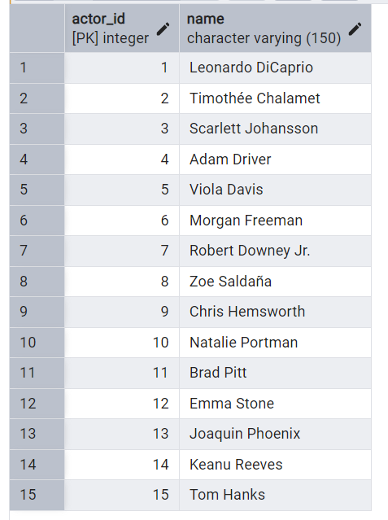
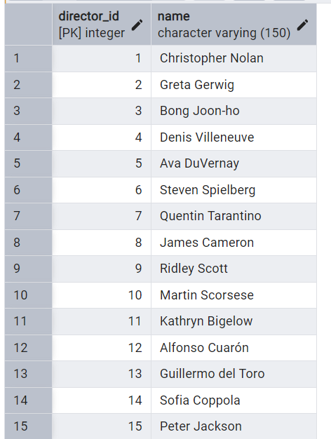
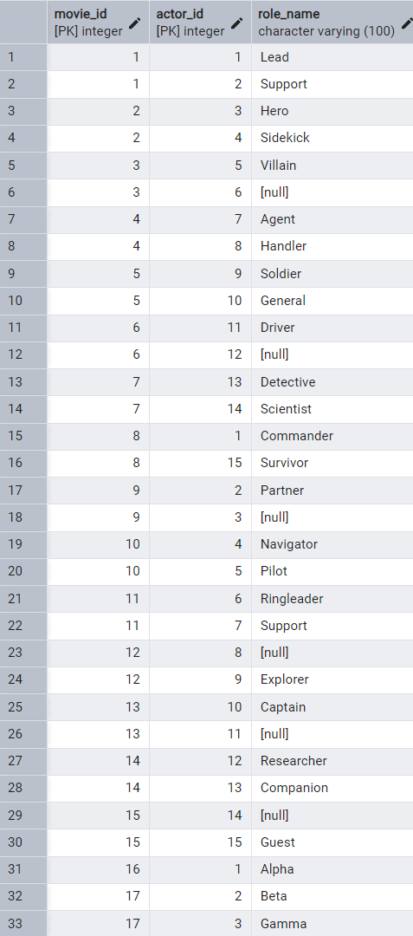
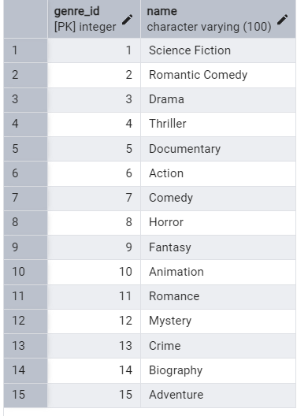
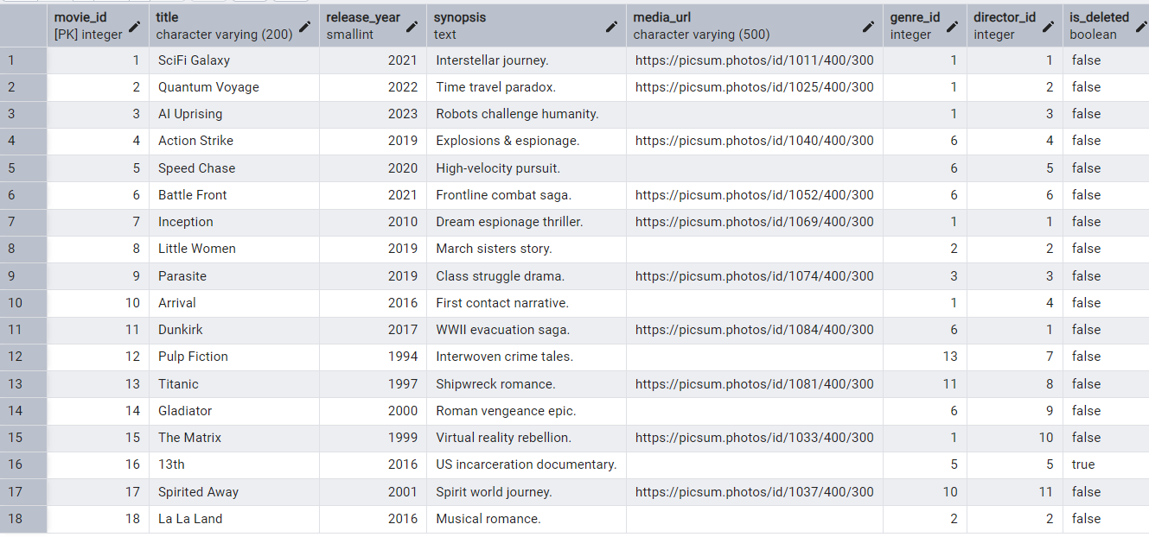
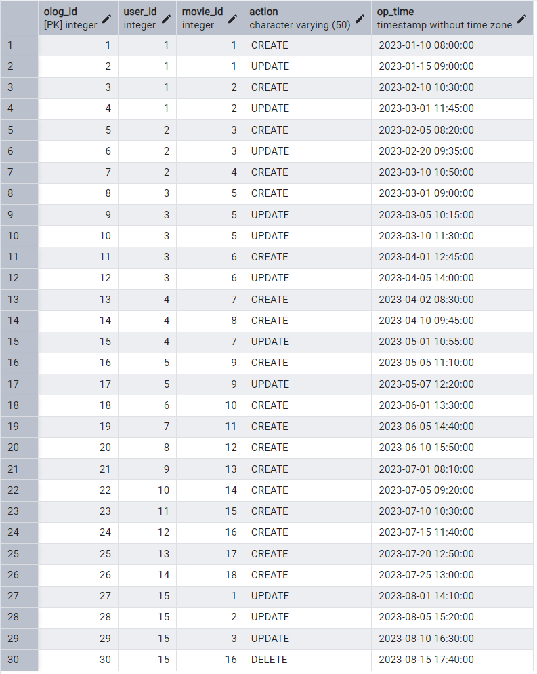
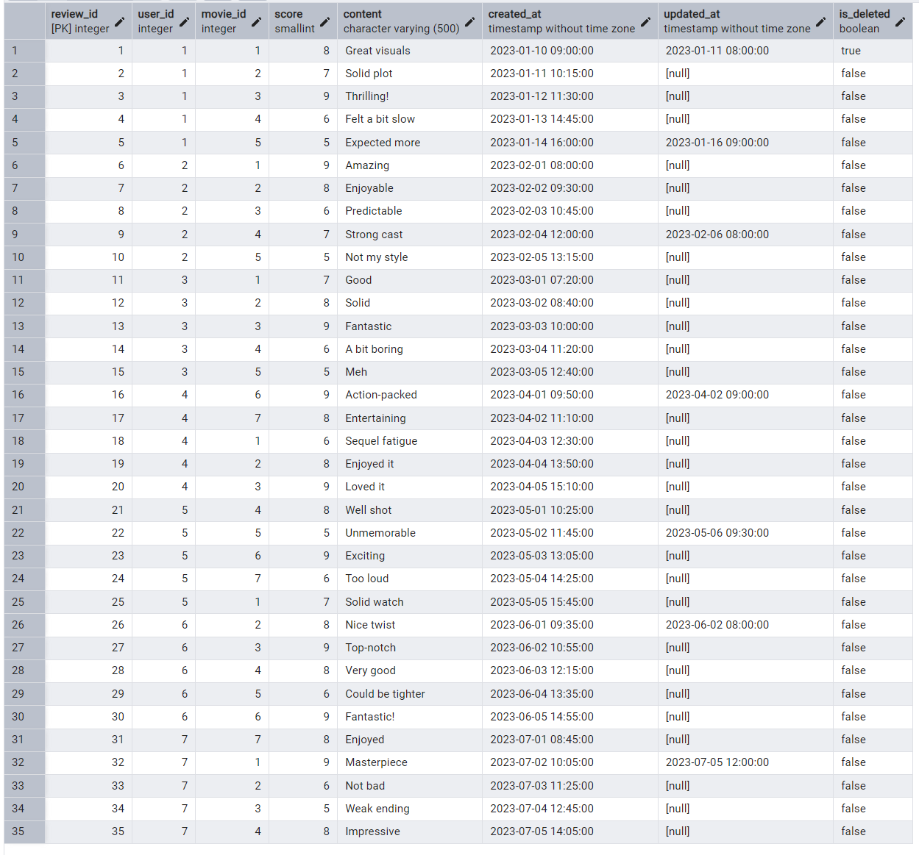
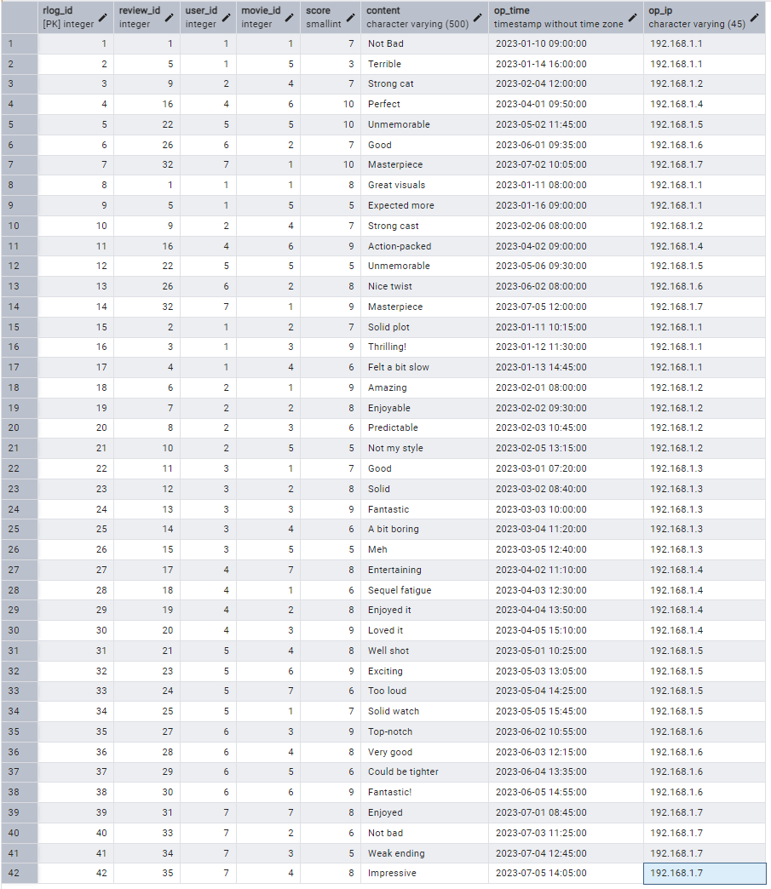
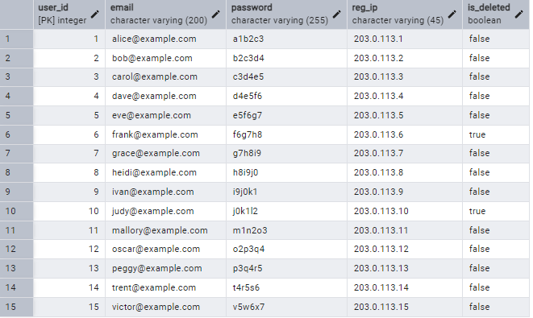
Q5:
Query 1: Films Released After 2018 with Strong Audience Reception
This query identifies movies released after 2018 whose average review score is larger than 7 and which have received more than one active review.
This combines the movie and review tables using a JOIN; filters out logically deleted records and restricts to the desired release date via the WHERE clause; groups reviews per film using GROUP BY; and applies a HAVING to filter the average‐score and review‐count condition.
This simulates the user's searching movies based on conditions (year to release, score, etc.)
Data Output:
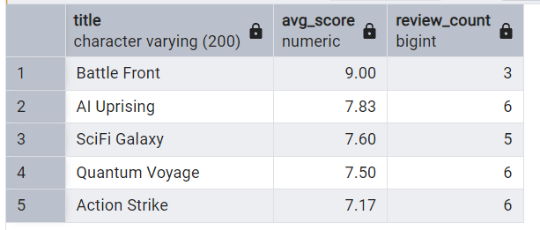
Query 2: Science Fiction Films by Greta Gerwig with High Average Score
This query identifies all Science Fiction movies directed by Greta Gerwig whose average review score is larger than 7.
This combines the movie and review tables using a JOIN; filters out logically deleted records and restricts to the Sci-Fi genre and specific director via WHERE; groups the scores per film using GROUP BY; and applies a HAVING to filter the average‐score.
This simulates the user's searching movies based on conditions (genre, director, etc.)
Data Output:
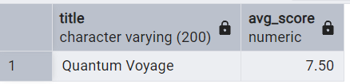
Query 3: May 2023 Low Ratings by “eve@example.com” with Historical Versions
This query identifies all reviews (rating below 7) submitted by user using email eve@example.com during May 2023 on existing movies, and the review’s historical version.
This combines the review, user, movie, and reviewlog tables using JOINs; filters out logically deleted records, restricts to the specified email, date range, and score via WHERE; uses a LEFT JOIN (with rl.op_time < r.updated_at) to fetch historical reviews; groups scores and comments using GROUP BY.
This simulates the user seeing both their current and historical feedback based on some conditions.
Data Output:
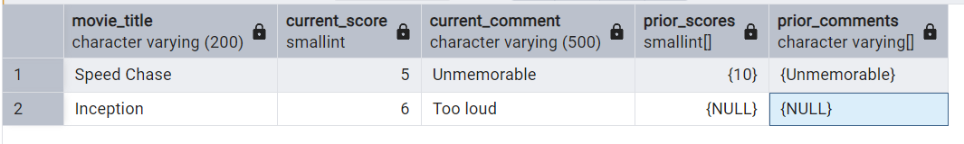
Query 4: Active Users Who Updated “SciFi Galaxy” in 2023
This query returns all users who conducted UPDATE operations on the movie “SciFi Galaxy” between 2023-01-01 00:00 and 2023-12-31 23:59, along with the count of their updates.
This combines the movie, user and operationlog tables using a JOIN; restricts to the 'SciFi Galaxy' movie, ‘UPDATE’ operation, BETWEEN 2023-01-01 00:00 AND 2023-12-31 23:59’ time range via WHERE; groups entries per user email using GROUP BY.
This simulates the tracing of user behavior (even if deleted of the interactive page)
Data Output:
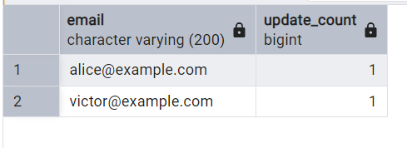
Query 5: Identify Users with Historical Ratings Below Their Current Score
This query identifies all active users posting at least one review for an existing movie and whose historical review score (from the audit log) was lower than their current score for the same film, then groups by user and film to count how many times they improved their rating.
This combines the reviewlog, review and user tables, as well as reviews and movie tables using JOINs; filters out logically deleted records and restricts to only those log entries where the old score is less than the current one via WHERE; groups each user–film combination using GROUP BY.
This simulates the platform's statistics on users' change between movie ratings.
Data Output:
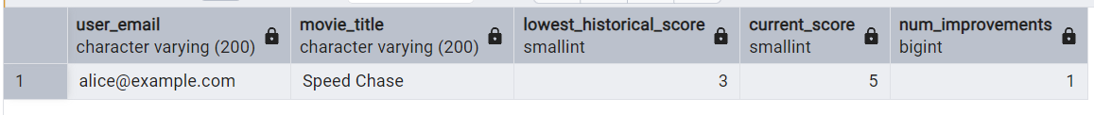
Reflection:
During this part, I found that statistics require a large amount of samples, and the samples I created manually were very insufficient. I also discovered a new business need in the process: by counting the trend of changes in users' movie ratings, the platform can determine whether a movie may have a "second viewing" evaluation update.

Q6:
User Data:
When people register on our platform, we need to collect their email addresses to serve as a unique login credential. We also collect usernames, passwords as login credentials and IP addresses to locate account.
When they upload a review, the system will collect their review content and scores to support the platform and archive in the reviewlog. We will also record their ip address and make a timestamp to help trace back.
When they edit the entry information, the system will record their operation type and make a timestamp to help trace back.
Data storage and Privacy problems:
- The physical location of the data center should be a climate-controlled, safe environment. We either carefully select the location before setting up the server or choose a reliable cloud provider.
- We monitor the IP addresses of user operations to avoid attacks on the database caused by high-risk addresses.
- We use appropriate encryption algorithms to encrypt and protect the database and back it up in time.
- We should monitor the input content part (especially the media_url in the movie entry) in real time to avoid malicious input.
- We regularly conduct security audits on reviewlog and operationlog to identify potential dangerous information.
- The platform may have both Chinese users and international users. According to China’s Personal Information Protection Law, Chinese user data must be stored domestically. My solution is to separate the data of Chinese users from that of overseas users based on the IP address at the time of registration. Prioritize storing data in domestic data centers and in future, set up data center in the international user’s area.
- According to the China’s Cybersecurity Law, we will archive user’s ratings/comments/operations and retain relevant logs for no less than six months to record the platform’s status.
- According to the China’s Personal Information Protection Law, personal information processors should actively delete relevant personal information when the processing purpose has been achieved, or the legal retaining date has expired. Therefore, once the above requirements are met, we will delete or irreversibly anonymize them.
- If the platform collects too much information beyond the necessary need, it will violate the minimum necessary principle of the China’s Personal Information Protection Law. My solution is to only collect information necessary for the service (email, password and IP address).
- If we do not anonymize users when making analyses based on their information, we may violate privacy regulations. My solution is to replace private identifiers with pseudonym and remove personally identifiable information.
(word count: 422)

