XJTLU Entrepreneur College (Taicang) Cover Sheet

Module code and Title | DTS106TC: Introduction to Database
School Title | School of AI and Advanced Computing
Assignment Title | Assessment Task 002 (CW) ): Individual Coursework
Submission Deadline | May 21st ,2025 at 17:00 PM (GMT +8)
Final Word Count | NA
If you agree to let the university use your work anonymously for teaching and learning purposes, please type “yes” here. |  | Yes

I certify that I have read and understood the University’s Policy for dealing with Plagiarism, Collusion and the Fabrication of Data (available on Learning Mall Online). With reference to this policy I certify that:
- My work does not contain any instances of plagiarism and/or collusion.
My work does not contain any fabricated data.

By uploading my assignment onto Learning Mall Online, I formally declare that all of the above information is true to the best of my knowledge and belief.
Scoring – For Tutor Use
Student ID
Stage of Marking |  | Marker  Code | Learning Outcomes Achieved （F/P/M/D）  (please modify as appropriate) |  |  |  |  | Final  Score
 |  | Marker  Code | A | B | C | D | E | Final  Score
1st Marker – red pen
Moderation  – green pen |  | IM  Initials | The original mark has been accepted by the moderator (please circle as appropriate): |  |  |  |  | Y / N
 |  |  | Data entry and score calculation have been checked by another tutor (please circle): |  |  |  |  | Y
2nd Marker if needed – green pen
For Academic Office Use |  |  | Possible Academic Infringement (please tick as appropriate)
Date  Received | Days late | Late Penalty | ☐ Category A |  | Total Academic Infringement Penalty (A,B, C, D, E, Please modify where necessary) _____________________
 |  |  | ☐ Category B
 |  |  | ☐ Category C
 |  |  | ☐ Category D
 |  |  | ☐ Category E

Q1:
Figure1: ERD
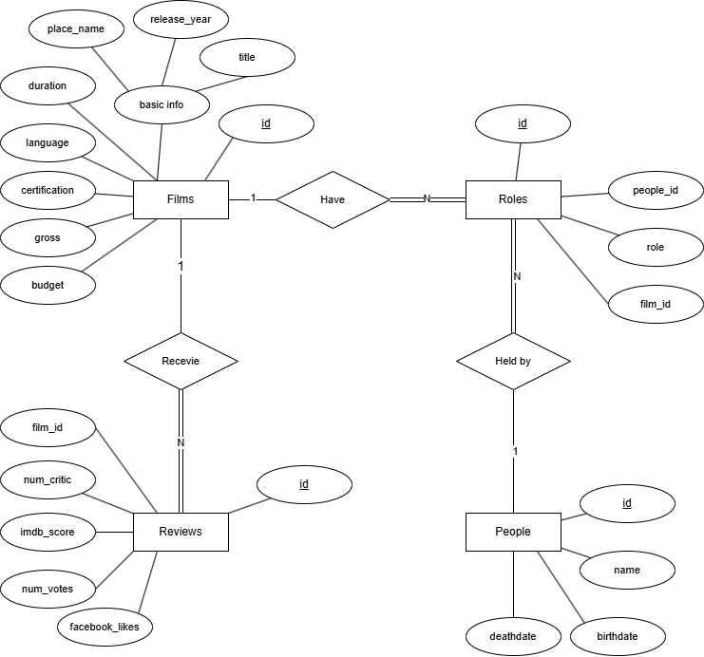
Explanation:
As shown in the figure, the four entities have their attributes, relationships. Each review must correspond to exactly one film, and same for the role. One role must be held by exactly one person, while a person can act as different roles. As for the keys, each entity’s Primary Key is its id, which should be unique and Not Null. And Review’s film_id, Role’s film_id and people_id are foreign keys. The Receive, Held by, Have relationships are all one-side mandatory. Because I choose the id for ‘Roles’ as its PK, there is no weak entity in my ERD.

Q2:
Initial analysis:
Films: There are no repeating groups or arrays in attributes (1NF), there is only one PK ‘id’ in Films, so there is no partial dependency (2NF). I initially suspect that ‘language’ of films may be influenced by ‘place_name’, but after searching, I found that multiple languages can be seen for some place (such as Australia), and there are some empty values exist in ‘language’. Then I suspect that ‘title’ of films can determine other attributes if they are unique, but there are different films with same title (such as Out of the Blue). Furthermore, I find that if the combination of ‘title’, ‘release_year’, ‘place_name’ is not unique in each line, they may act as a non-primary key to determine other attributes, disobeying 3NF.

Reviews: There are no repeating groups or arrays in attributes (1NF), there is only one PK ‘id’ in Films, so there is no partial dependency (2NF). I initially suspect that ‘film_id’, a foreign key, may dominate other non-primary keys. However, I didn’t find any situations where the candidate key or combination of candidate keys can determine other non-primary keys. So, there are no transitive dependencies (3NF).
Roles: There are no repeating groups or arrays in attributes (1NF), there is only one PK ‘id’ in Films, so there is no partial dependency (2NF). I found that there exist different roles of the same ‘film_id’ and ‘people_id’ combination (e.x. When film_id == 159, and people_ id == 8297, the role can be both actor and director). So, combination cannot determine other non-primary keys (3NF).
People: There are no repeating groups or arrays in attributes (1NF), there is only one PK ‘id’ in Films, so there is no partial dependency (2NF). Considering that people's names often repeat in real life, I don't think we should regard ‘name’ as an attribute that can determine other attributes. Therefore, the PK ‘id’ determines all non-key attributes, so there are no transitive dependencies (3NF).

Normalization:
Films:
- The same lines (all attributes are the same, except for id) are meaningless when store the film entry information.
- In reality, it is almost impossible to have a different film with the same title, same release year and same country. But if one of these three elements is missing, the possibility will increase significantly.
- If I split the Films table, I need to create a table with every attribute except for id in the current table, when keeping one table with ’id’, ‘title’, ‘release_year’, ‘place_name’, forcing every film lookup to perform extra joins.
According to the factors mentioned above, I choose to
1. Edit meaningless duplicate entries in the current data (as well as the foreign key in other tables).
2. Add a UNIQUE constraint on {title, release_year, place_name} to make it become a candidate key when building a database to prevent true duplicates, thus supporting 3NF.

Improvements:
Given that many movies can have different languages when published in different countries, which is not considered in current structure. And when we try to add new language to the current ‘film’ entity, it will disobey 1NF. Therefore, I create two new tables: FilmLanguage and Languages. These will handle with the ‘many-to-many’ relationship between ‘Films’ and ‘Languages’. The detailed description are as follows:

Updated Structures:
Besides the current tables, I will create two new tables: FilmLanguage (intersection entity) and Languages. FilmLanguage have two keys which are both PK and FK: ‘film_id’ and ‘language_id’. Languages will have PK ‘language_id’ and non-primary attribute ‘language_name’. The new relationships are Films Obtain FilmLanguage (1: N) and FilmLanguage Is Languages (N:1). And the FilmLanguage → Films and FilmLanguage → Languages are both one-side mandatory, while in opposite direction are both optional. I will draw a new ERD to better demonstrate my updated structure.
Figure2: ERD (Updated)
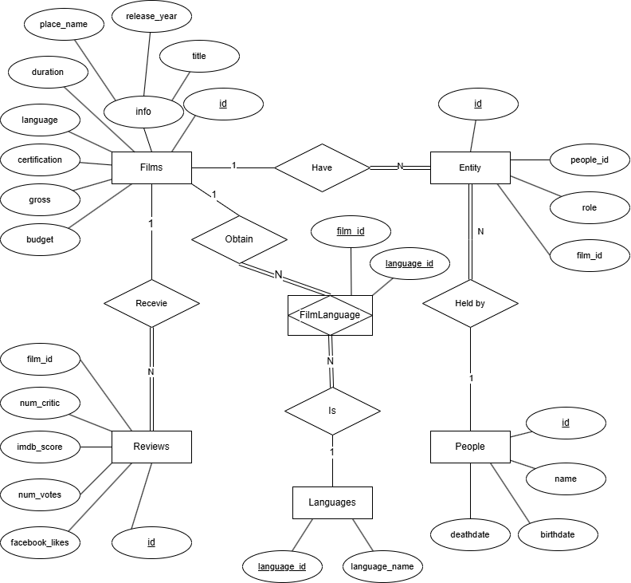

Q3:
Preface: Although I did create two new tables to maintain normalization regarding the situation that one movie may have several languages. But given that the dataset only contains films with only 0/1 language, and I have made sure that all four tables are normalized with the given dataset. In the following parts, I will only create four tables in the database.
Table1: FILMS
Column Name | ID | TITLE | RELEASE_YEAR | PLACE_NAME | DURATION | LANGUAGE | CERTIFICATION | GROSS | BUDGET
Key Type | PK
Not Null = NN  Unique = U | NN, U | NN | NN | NN
DATA Type | INTEGAR | VARCHAR | INTEGER | VARCHAR | NUMERIC | VARCHAR |  | NUMERIC | NUMERIC
  VARCHAR
Length | / | 200 | / | 50 | (5,1) | 30 | 20 | (12,2) | (14,2)
Other conditions: I will enforce a UNIQUE constraint on {title, release_year, place_name}, declaring a candidate key.

Table2: PEOPLE
Column Name | ID | NAME | BIRTHDATE | DEATHDATE
Key Type | PK
Not Null = NN  Unique = U | NN, U | NN
DATA Type | INTEGAR | VARCHAR | TEXT | TEXT
Length | / | 100 | / | /
Explanation: PostgreSQL doesn’t receive the datestyle in the dataset. When I tried to import the data, it returned WRONG again and again. Therefore, I changed the DATE to TEXT.
Table3: REVIEWS
Column Name | ID | FILM_ID | NUM_CRITIC | IMDB_SCORE | NUM_VOTES | FACEBOOK_LIKES
Key Type | PK | FK
Not Null = NN  Unique = U | NN, U | NN |  | NN
DATA Type | INTEGAR | INTEGER | INTEGER |  | INTEGER | INTEGER
  NUMERIC
Length | / | 200 | / | (3,1) | / | /

Table4: ROLES
Column Name | ID | FILM_ID | PEOPLE_ID | ROLE
Key Type | PK
Not Null = NN  Unique = U | NN, U | NN | NN | NN
DATA Type | INTEGAR |  | INTEGER | VARCHAR
  INTEGER
Length | / | / | / | 20

Image Sharing and Explanation:
- Films:
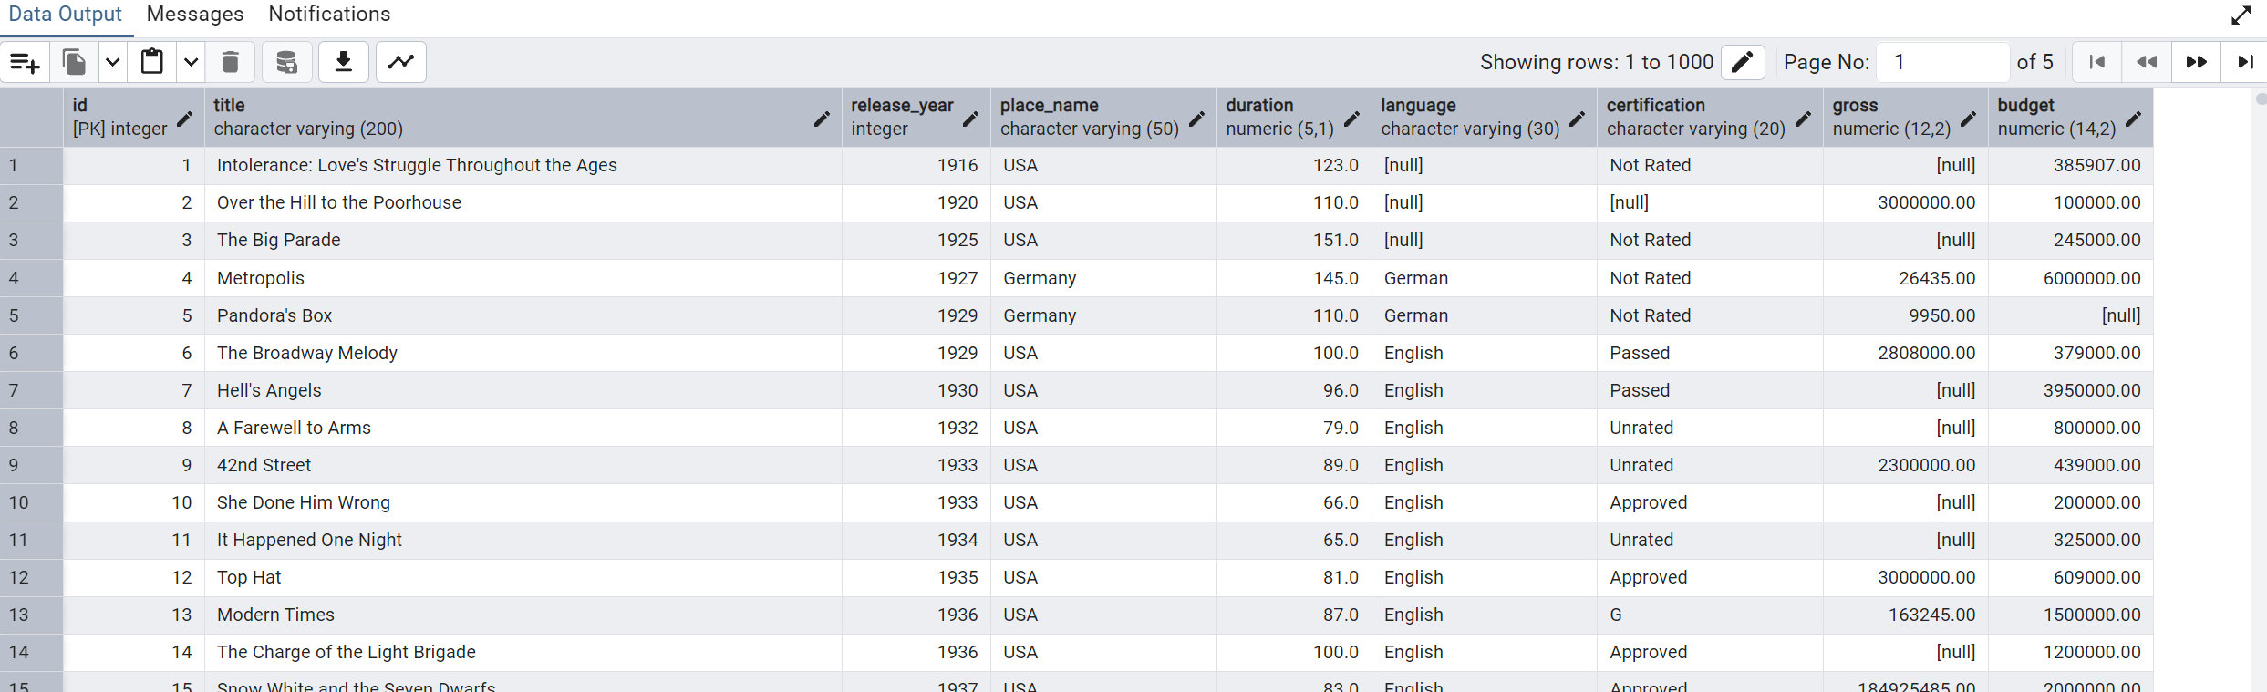
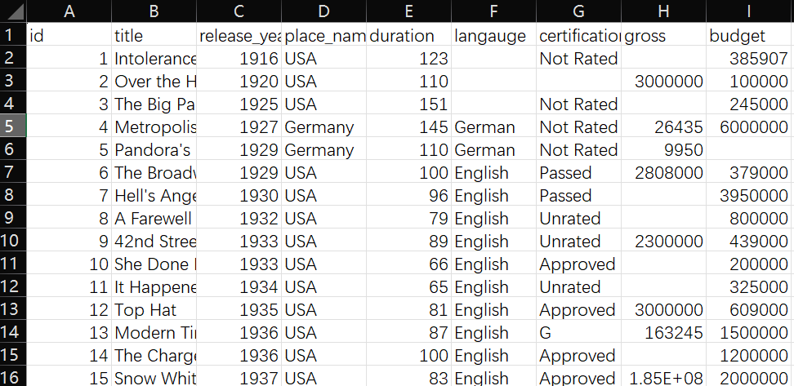
Explanation: The result well presents the dataset. Some small differences exist in the decimal points under duration, gross, and budget, because I use NUMERIC datatypes to improve scalability. I also converted the release_year values in the dataset from one‐decimal‐place numbers to pure integers, since it’s unreasonable for year to be a decimal.
- People:
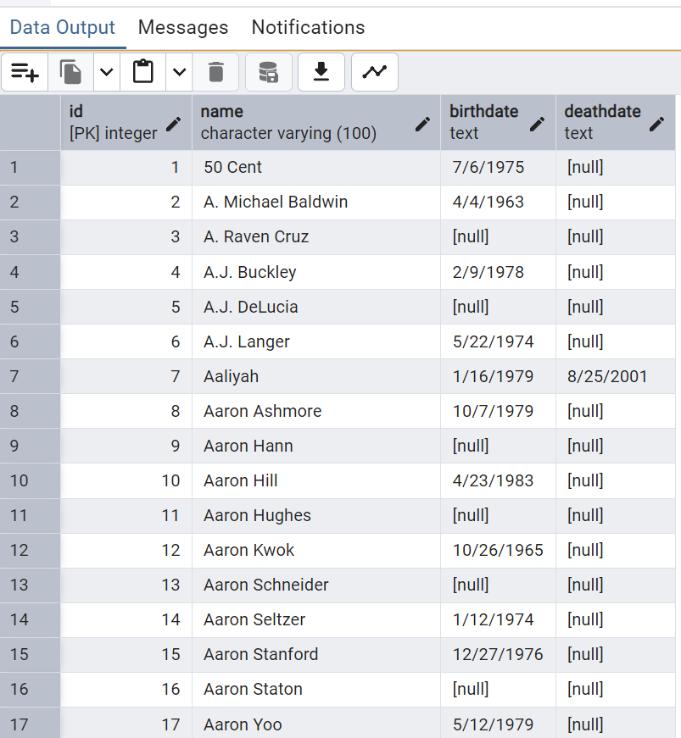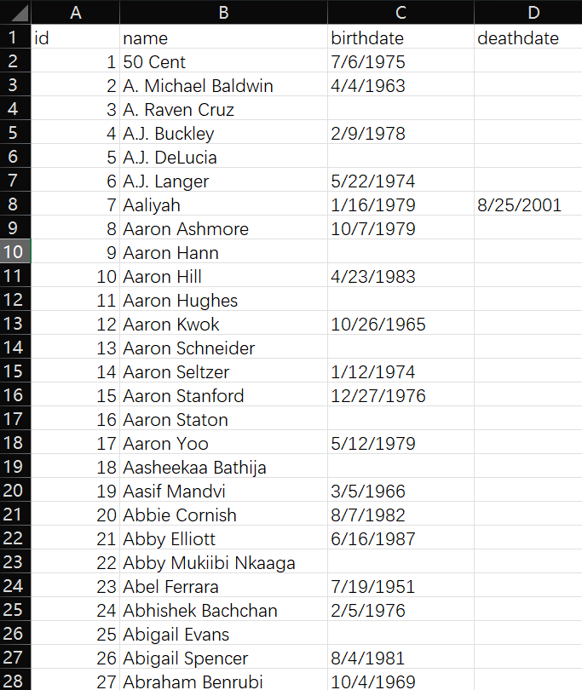
Explanation: If I need to filter actors by birthdate/deathdate in the future, I will convert the text format back to DATE format.
- Reviews:
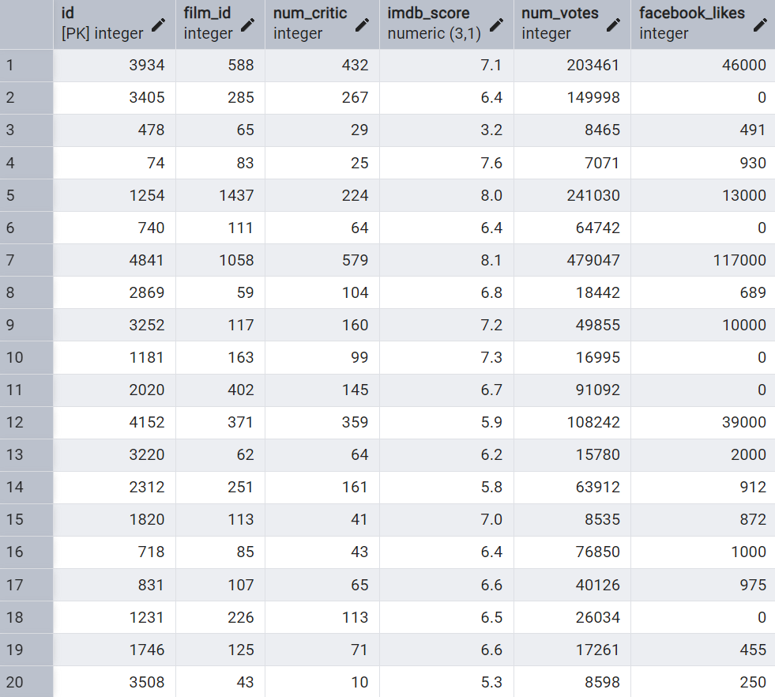
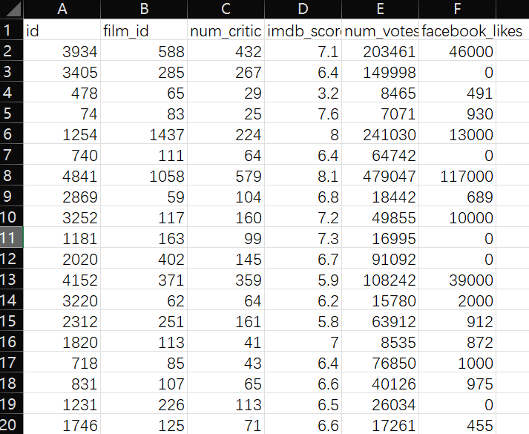
Explanation: If I expand the imdb_score column in the CSV, the values show up as seven‐decimal‐place numbers that are very close to the original one‐decimal values, so I standardized them to one decimal place in the database. I also converted the num_critic values in the dataset from one‐decimal‐place numbers to pure integers, since it’s unreasonable for a count of people to be a decimal.

- Roles:
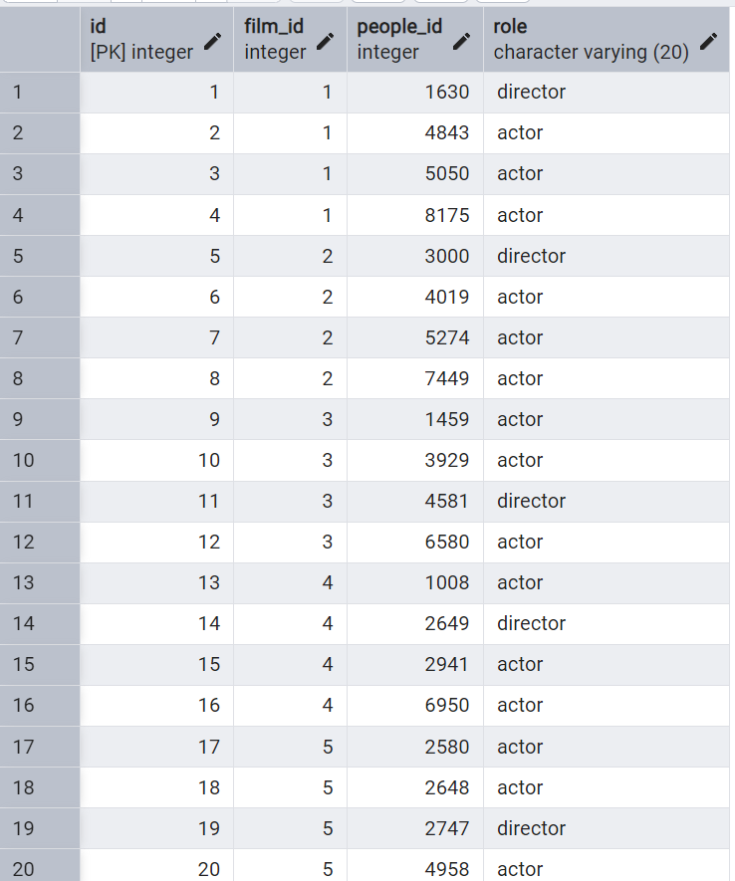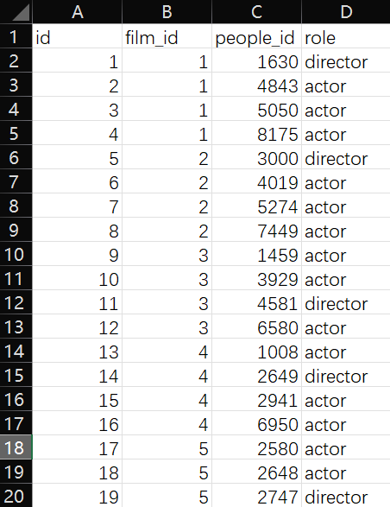
Explanation: The result well presents the dataset.

Q4:
Query1:
This combines the films and reviews tables using a JOIN on f.id = r.film_id; calculates the average IMDb score for each film and rounds it to two decimal places; groups the scores per film using GROUP BY; sorts the movies by average_score in descending order via ORDER BY; and limits the output to the top five records using LIMIT 5.
Data Output:
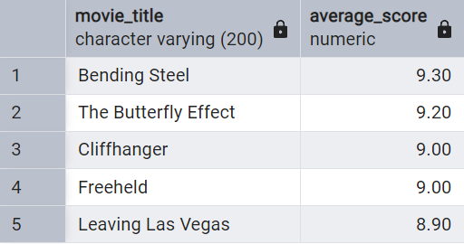

Query2:
This combines the films and reviews tables using a JOIN on f.id = r.film_id; groups reviews per film using GROUP BY; and applies a HAVING clause to include only films with more than five reviews.
Data Output (The first several rows):
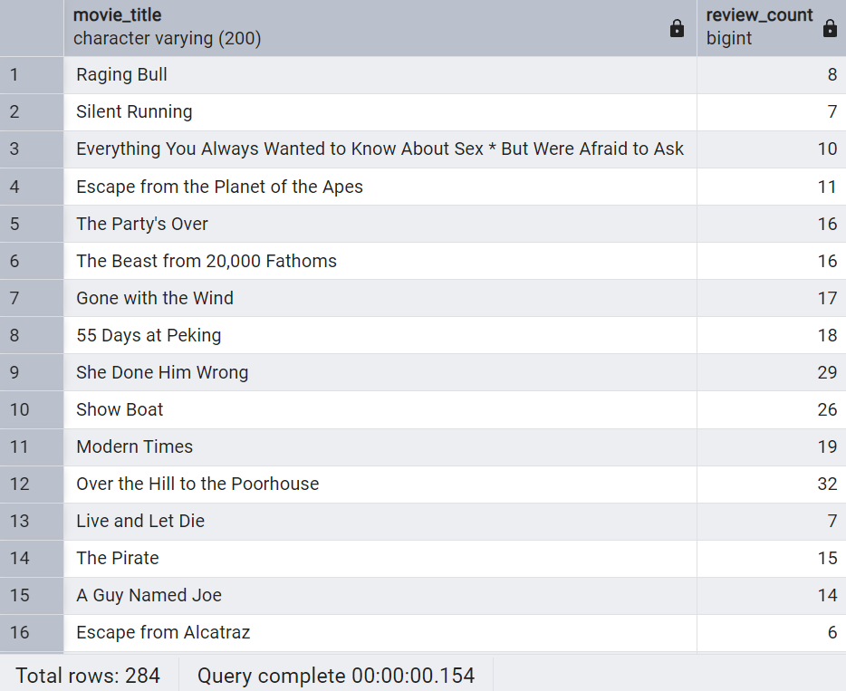
Query3:
This combines the roles, films, and people tables using JOINs on r.film_id = f.id and r.people_id = p.id; groups the roles by p.id and p.name using GROUP BY; and computes the number of distinct films each actor appears in via COUNT(DISTINCT r.film_id)
Data Output (The first several rows):
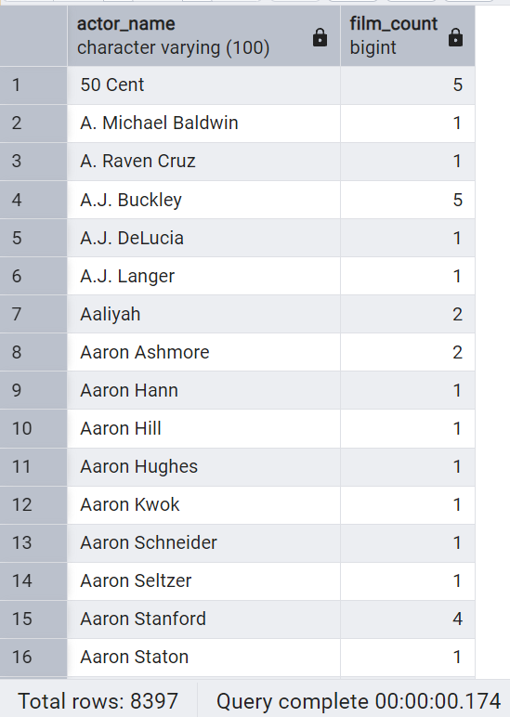

Query 1:
SQL Algebras:
Film_Reviews ← Films ⨝ Films.id=Reviews.film_id Reviews
Avg_Scores ← γ film_id,title, avg_score ←γ AVG (imdb_score) (Film_Reviews)
Ordered_Scores ←τ avg_score (Avg_Scores)
Result ← π⁵ title, avg_score (Ordered_Scores)
Explanation:
This combines the Films and Reviews tables with a ⨝ on Films.id = Reviews.film_id; groups the joined rows by film_id and title with γ, also using γ to calculate each movie’s AVG(imdb_score) as avg_score; orders the aggregated result by avg_score in descending order with τ; and finally projects just the title and avg_score columns with π⁵ (restricted projection) for output.
Query 2:
SQL Algebras:
Film_Reviews ← Films ⨝ Films.id=Reviews.film_id Reviews
Review_Counts ← γ film_id, title, review_cnt ←γ COUNT (review_id) (Film_Reviews)
Filtered ← σ review_cnt > 5 (Review_Counts)
Result ← π title, review_cnt (Filtered)
Explanation:
This combines the Films and Reviews tables via a ⨝ on Films.id = Reviews.film_id; groups the result by film_id and title with γ, using γ to compute COUNT (review_id) as review_cnt; applies a selection to retain only those groups where review_cnt > 5 with σ; and projects the title and review_cnt columns with π to produce the final list.
Reflection:
When answering question4, the most difficult part I met was writing the relational algebra. I’m ashamed that I didn’t understand it during class. However, I revised the corresponding content on week4 slide. Then I found that notation for sorting and “top-k” are not mentioned in lectures, which are used in my query2. I tried hard to look up the reference e-books on LMO and ask module leader. In the end, I followed module leader’s instructions and applied ‘τ A(R )’ and restricted projection.
Q5:
The conceptual model design part is my most memorable. Not only because it is the funniest part for me, but also because it establishes a solid foundation for both the database and further study. In this part, I acquired the basic components of a database: entity, attribute (PK, FK) and relationship. I also mastered a magic tool for building conceptual models – ERD. I think a good conceptual model can help me keep my mind clear in any subsequent conversion and construction. And I think that a person I met in class helped me a lot in understanding these concepts and their structural relationships.
In the class activity, called ‘Match the Data’, he firmly believed that his card was exactly the movie my person wanted to find, because the number was the same. I trusted him at the very beginning and waited for the other card. But there was a same person claiming the same movie_id came. I was very confused. But later, I found that the first guy misread his card, and he has a card with the same number but from a different section.
I think that was my first time understanding why the primary keys must be unique and candidate keys must identify a single row, and why foreign keys must point to exactly the right table. In a real database, a single duplicated or misassigned key can break joins or corrupt results. It also taught me a lot about cardinality. By normalizing relationships, I can find errors that are harder to see.
In one lab class, when my partner and I were doing one estate firm ERD exercise, I paid more attention to the relationship we construct. I found that a single office may list many properties, but each property must belong to exactly one office. Ensuring that made me feel more relaxed, because it is like double insurance to prevent misdirecting wrong elements with the same id. Furthermore, when I am asked to write a query in future class exercise, I always want to start with a well-structured ERD. If there is no such diagram, I am happy to draw one myself.
This awareness also helps me when writing the coursework. Firstly, I emphasize the correct identification of entities, attributes, and cardinality when designing the conceptual model. Secondly, I clearly mark the primary key of each entity and design the foreign key names in a way that is easy to identify their target entities. Thirdly, I tried my best to mark each mandatory relationship with their cardinality in the ERD. As a result, the diagram helps me a lot in coming physical model design and database construction.
(word count:441)

Q6:
When writing coursework1, I faced some challenges. For example, when I wrote DML to import data into my created database, one more decimal point could fail the process. I tried many times to make sure the data I imported fits perfectly into the pre-set data format. And it raised my worry about future work on the database. What if the datatype changes in the future? What if one attribute needs to be stored with various datatypes? A well-designed database that stores data is very difficult to modify its existing data structure or add new data with unknown datatypes while ensuring that no data is lost. It is also necessary to identify every dataset’s structure and design the exact blank for only one kind of structure-clear data. Moreover, I also found that when writing SQL to structure and search for data from different tables, it can be very complicated to write query if the relationships between the tables are complicated itself. I can imagine that programmers will have a hard time constructing query statements. when relationships are becoming more and more complex.
When update/add/delete operation is frequently required, different and uncertain types of data are supposed to be stored together, and developers want to adjust the data model at any time according to business changes with minimal negative impact, a different approach to database would be needed.
To deal with the above situations, there are several kinds of NoSQL database:
Firstly, key-value databases are designed to handle data with simple data models, large scale, and extremely high state changes. For example, during shopping seasons such as China's Double 11, e-commerce websites have huge numbers of customers, and many of them visit the e-commerce platform at the same time. The platforms bind the shopping cart content to the user's USERID key to search and locate data, ensuring that the user's shopping cart content remains consistent, and high-speed READ and WRITE.
Secondly, document-based databases are designed to store, index and manage document-oriented data, and locate documents by key. Developers can query complex nested relationships with just one statement. Moreover, in nested relationships, each document can have its own unique structure. Take the example of e-commerce platforms again. On these platforms, there are different types of products, whose attributes are also completely different. For example, the attributes of a laptop include the CPU model, the type and size of the computer graphics card, the size of the computer hard disk, etc., which can be easily stored in a document.
Thirdly, graph databases are designed to process data with large volume and complex data relationships. For example, social platforms, which involve relationships between users, personal information of each user, and users' use of the network system to conduct many queries. The amount of data is large, and the relationships are complex. The graph database applies graph theory to store relationship information between entities and uses graph structures for semantic queries, including nodes, edges, and attributes to represent and store data. It can help users easily query the information they need. Since each node in the graph database has an independent attribute list, developers can also easily adjust the data model according to business changes.
In conclusion, Relational databases, key-value databases, document-based databases, and graph databases each have their own advantages and disadvantages and cannot replace each other.
(word count:552)

