FIGURES

Supplementary figures 1–23
From: How Does the Civil Engineering Industry Economy Change under an AI Shock? The United Kingdom’s Service Links with India and China

Figure 1
Eurostat enterprise AI use, EU-27, NACE M vs F.
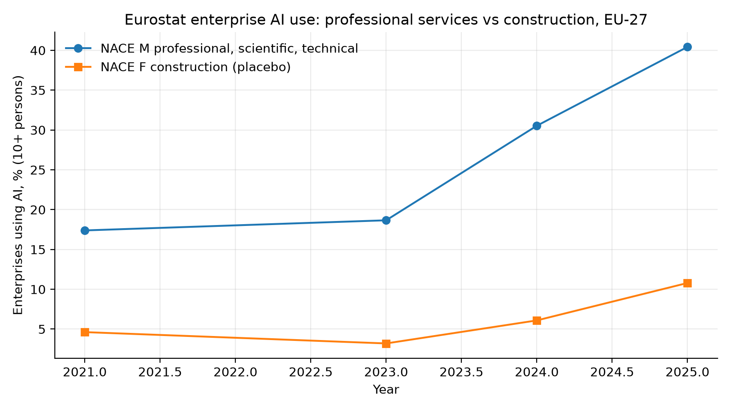

Figure 2
UK APS employment change, civil-adjacent SOC 2020.
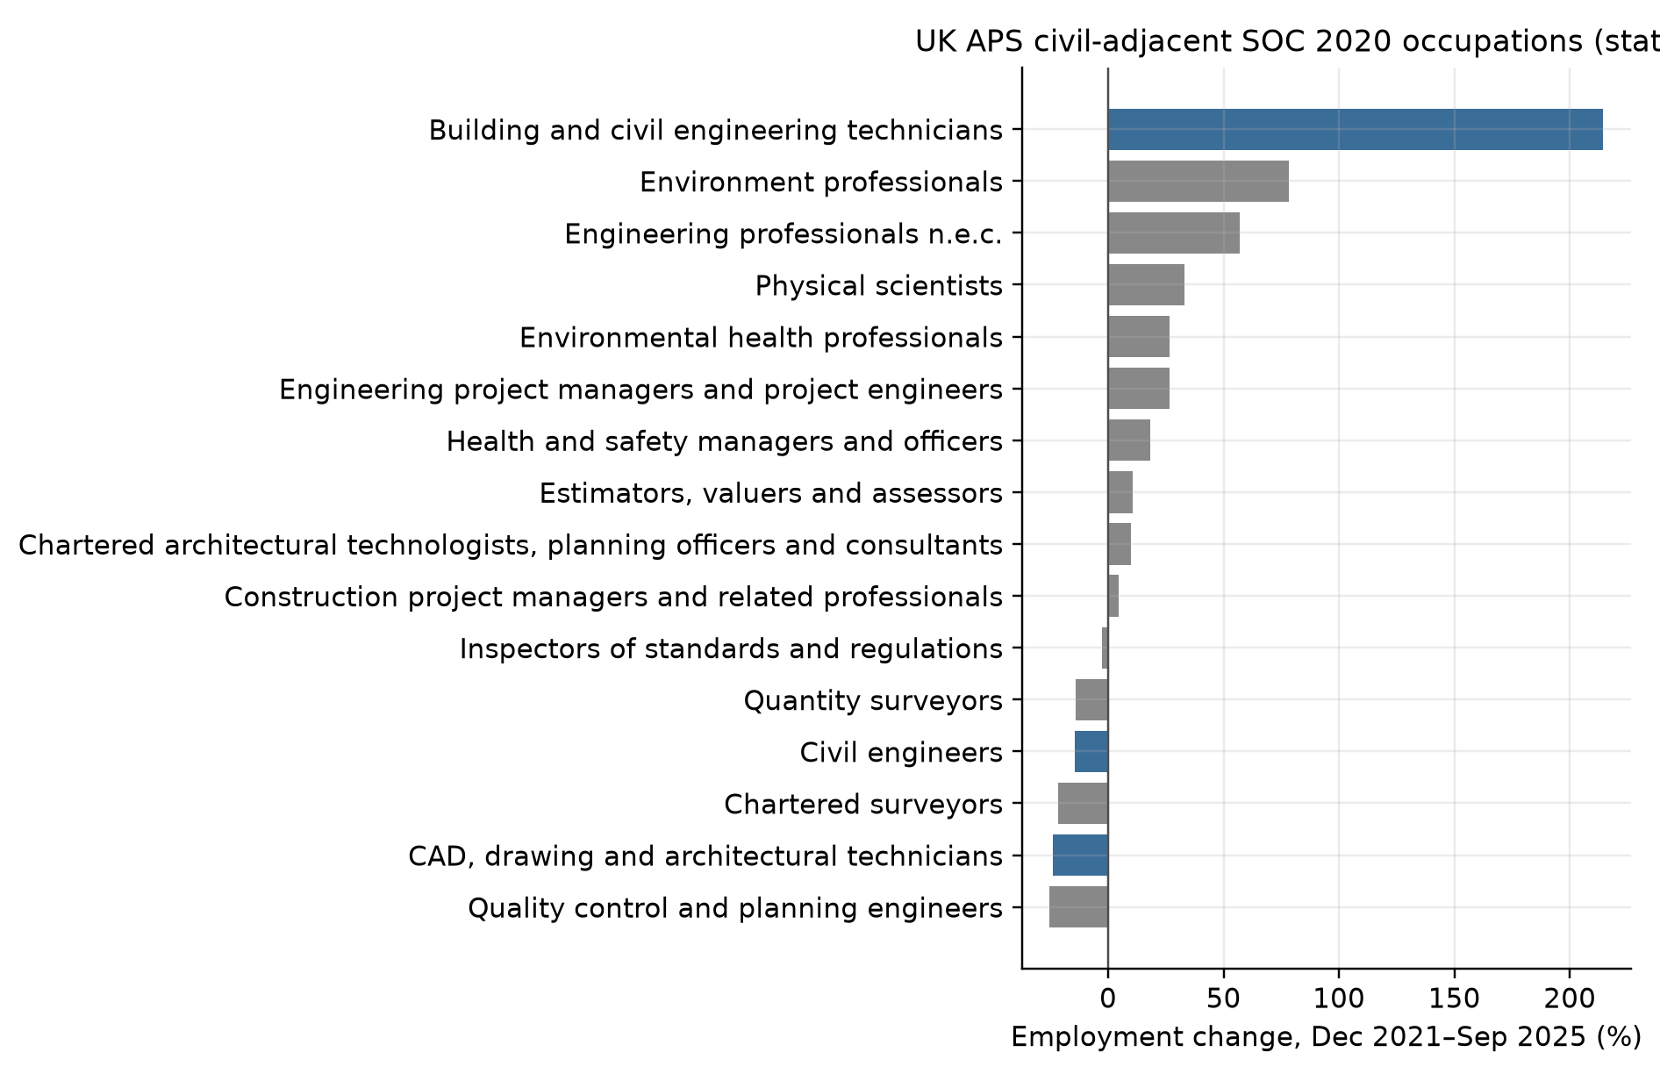

Figure 3
UK BaTIS: India SJ3, China SE, India SI.
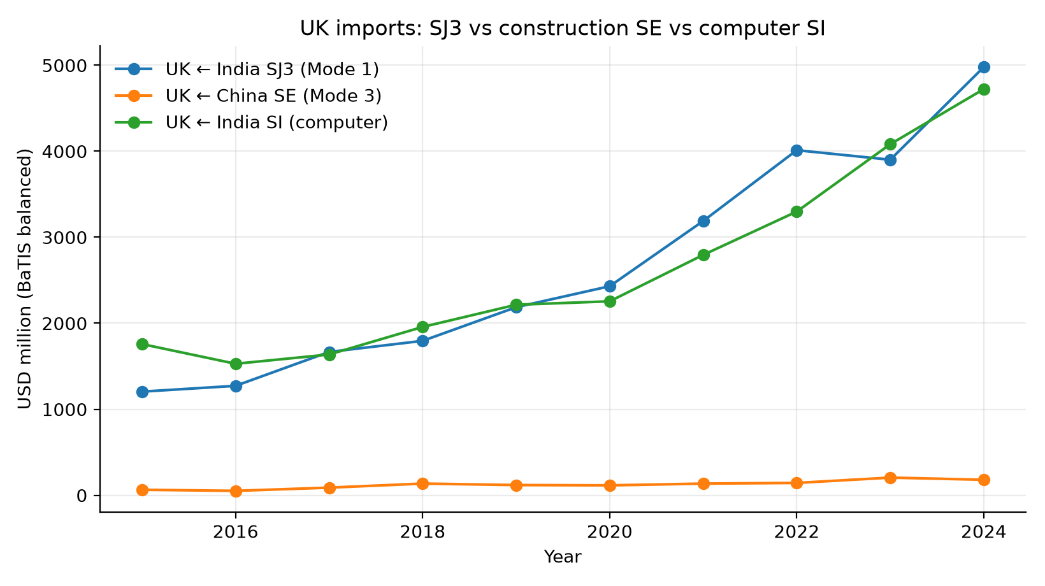

Figure 4
Event study, year × ΔM TANY.
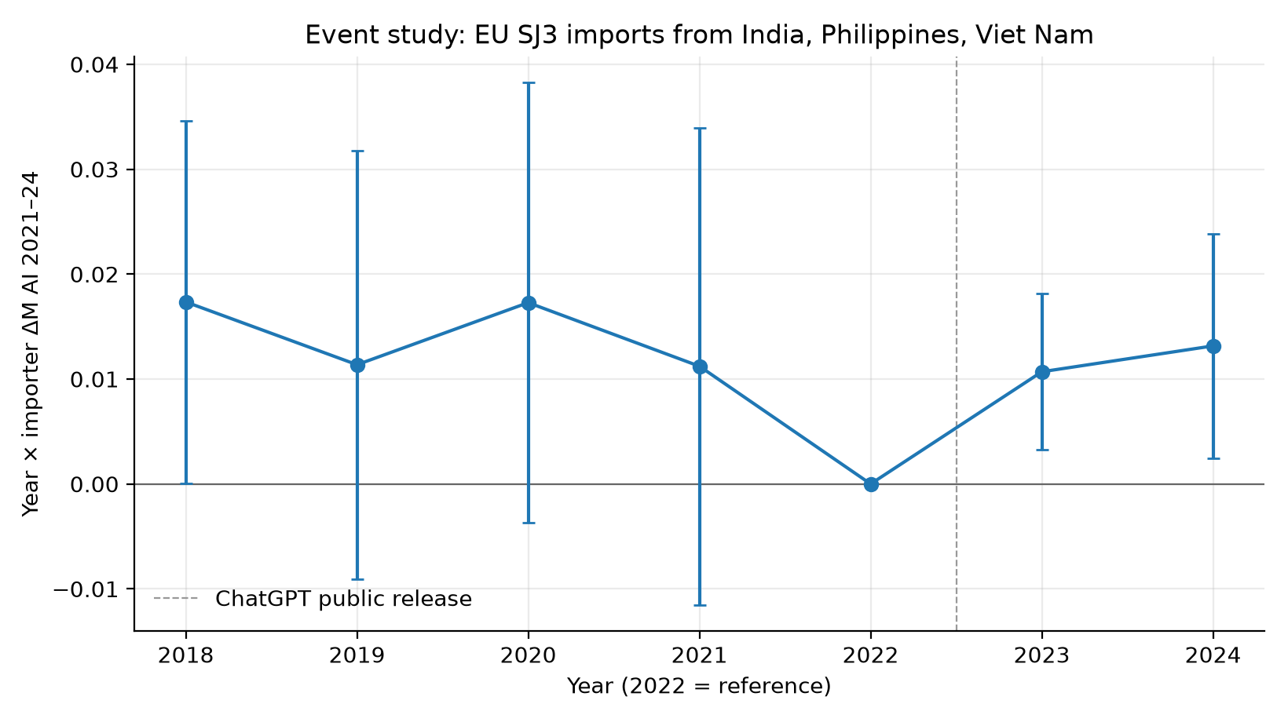

Figure 5
ILO ISIC M vs F employment growth.
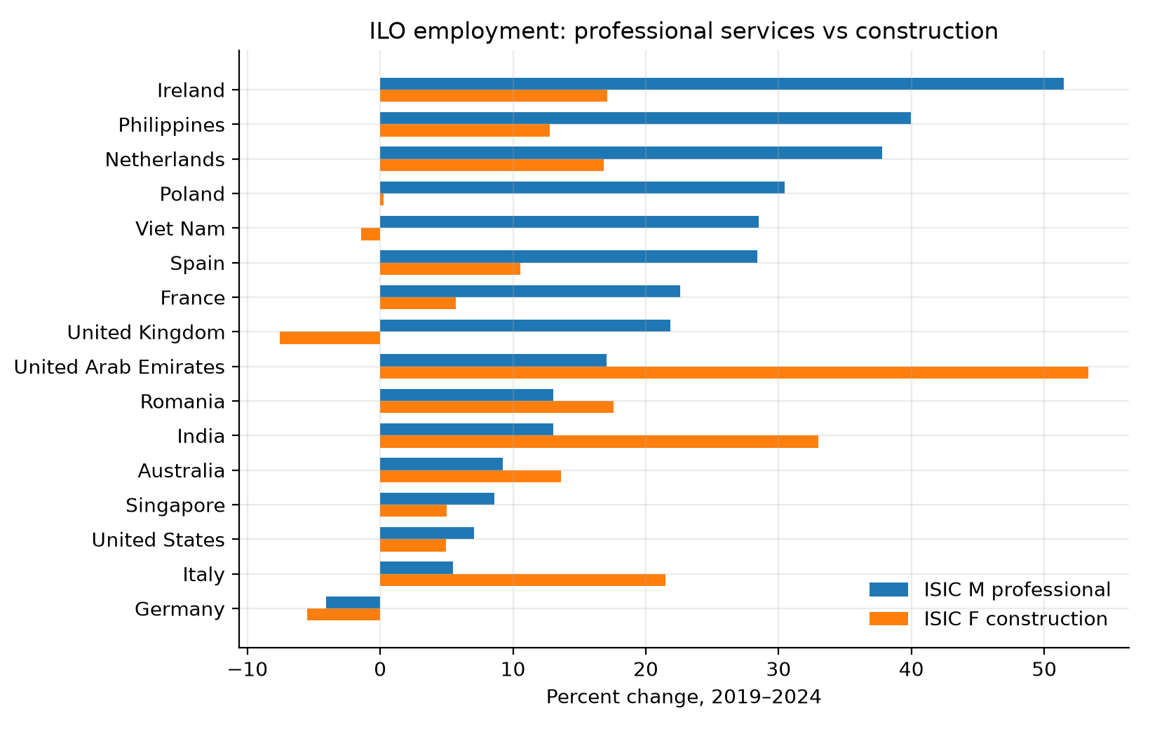

Figure 6
EU SJ3 imports vs Chinese construction services.
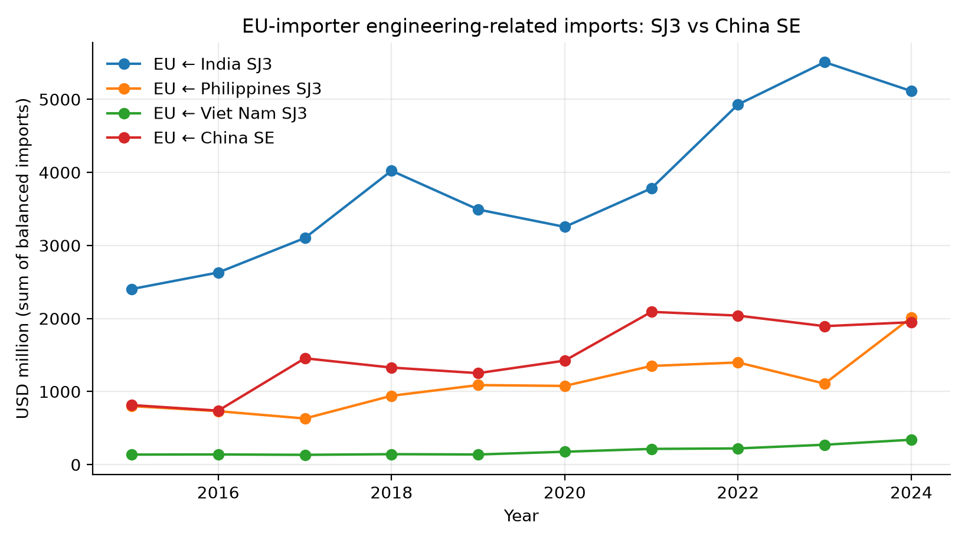

Figure 7
ΔM TANY vs Δ log India SJ3.
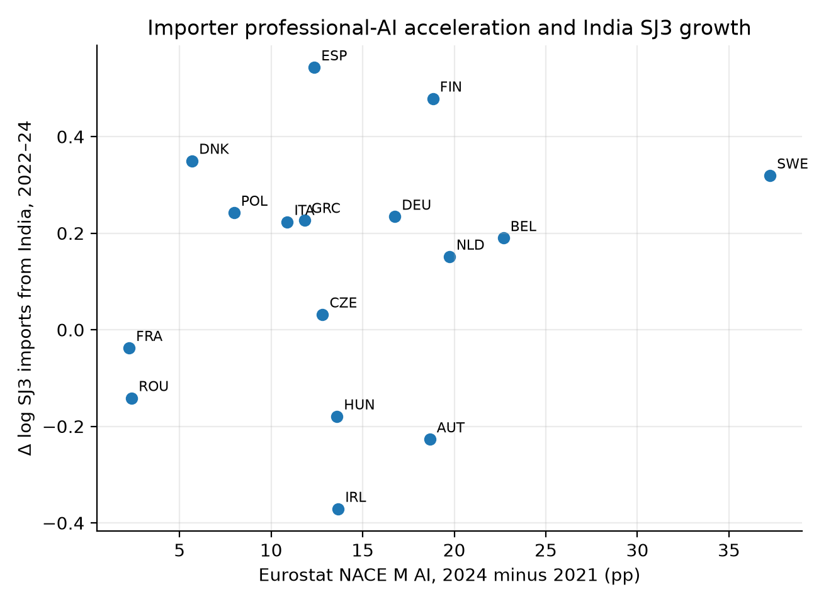

Figure 8
Leave-one-importer-out, TANY.
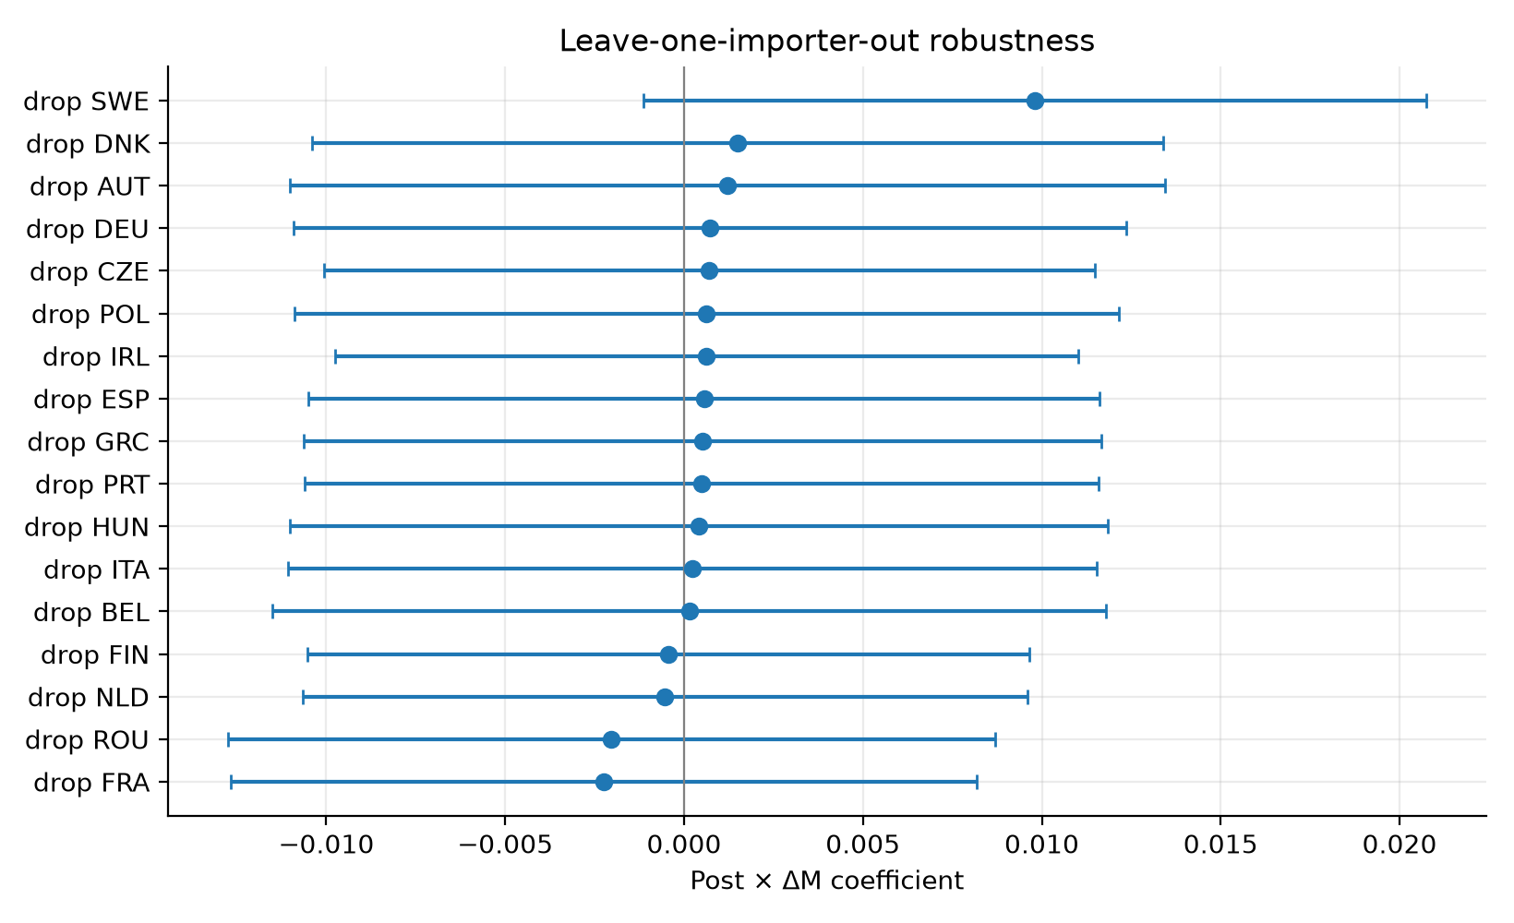

Figure 9
NACE M71 vs F GVA.
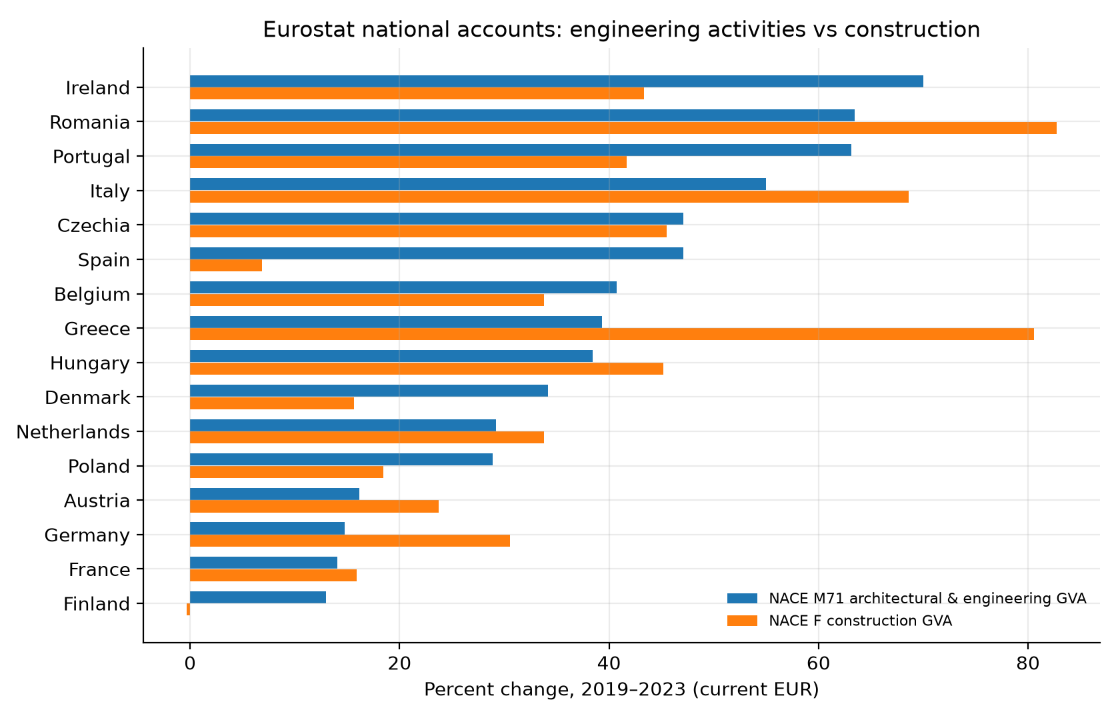

Figure 10
APS vs Eloundou and Felten AIOE.
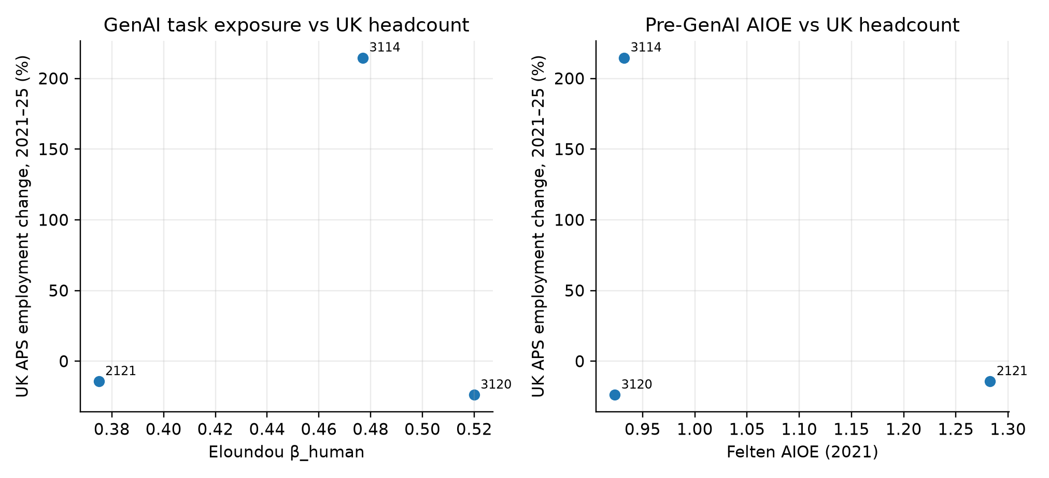

Figure 11
Felten AIIE, US construction.
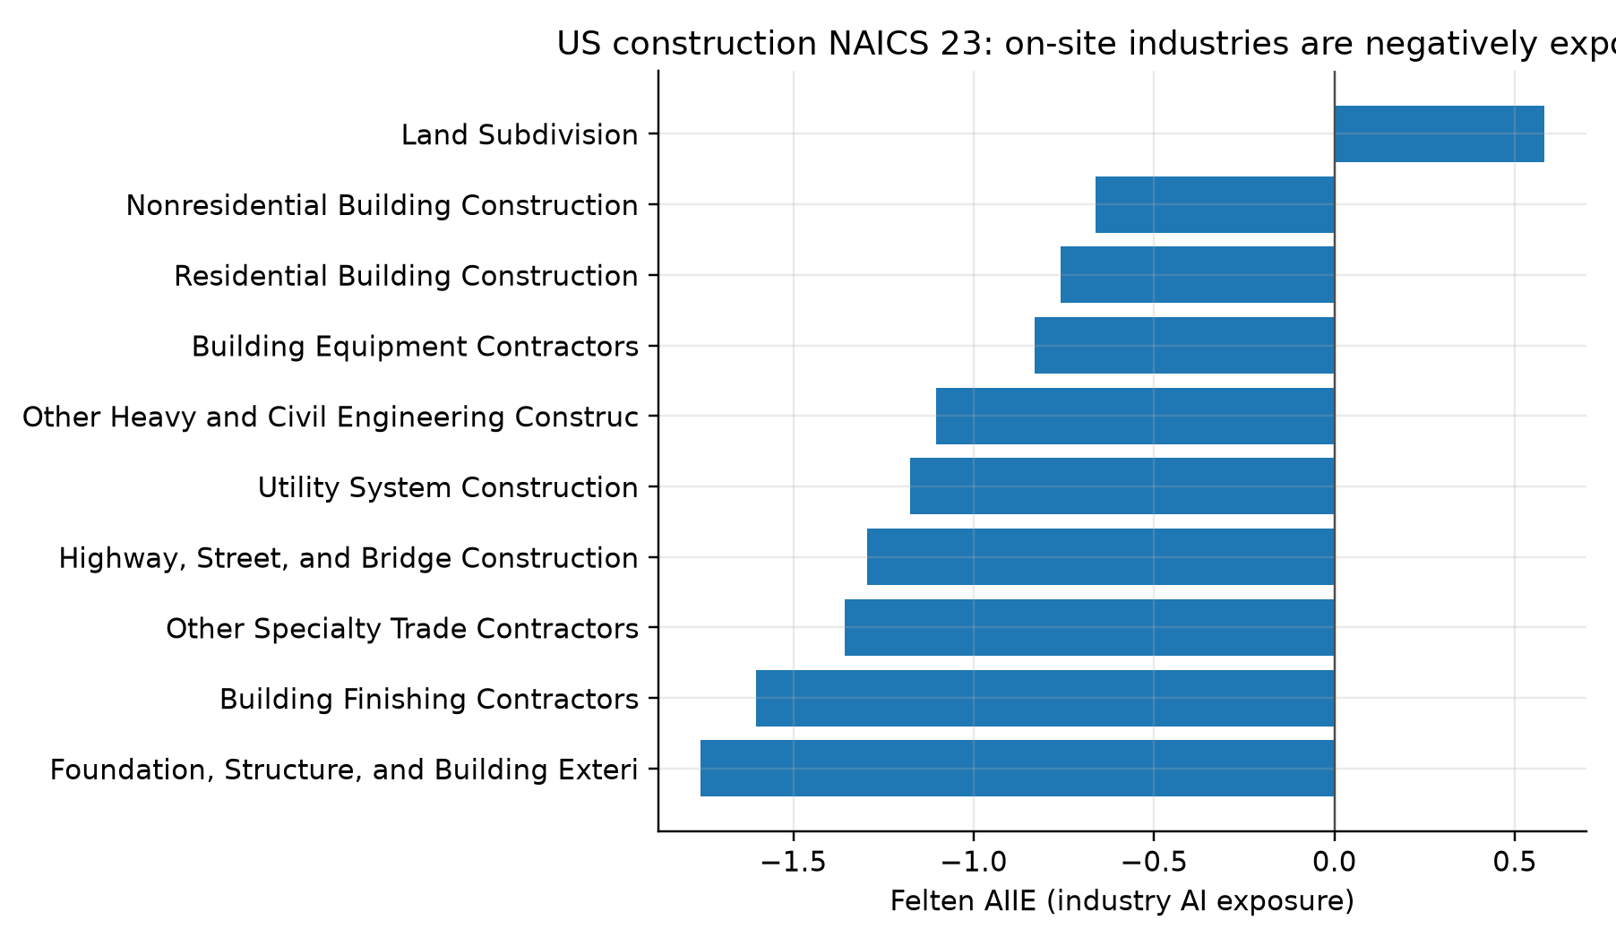

Figure 12
EU-27 NLG vs ML vs construction NLG.
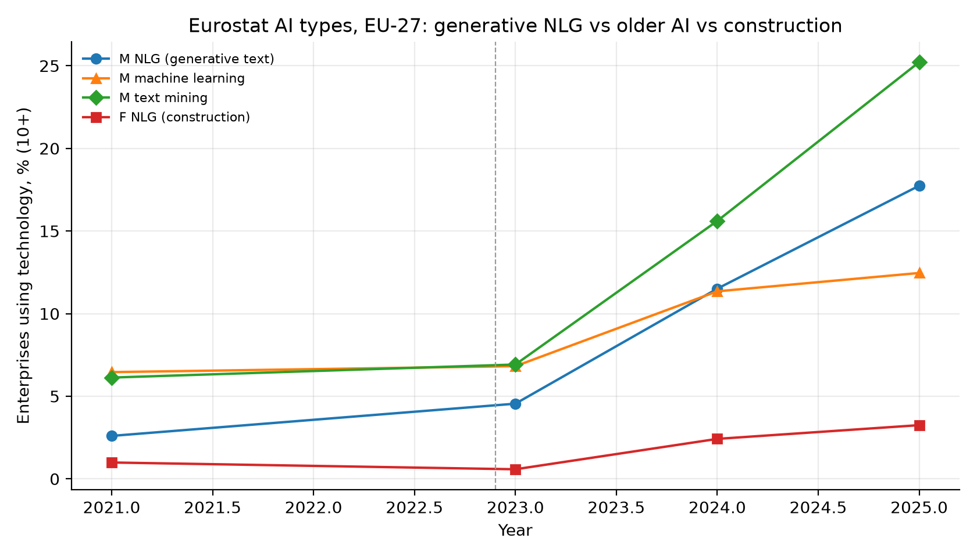

Figure 13
2024 NLG, NACE M vs F.
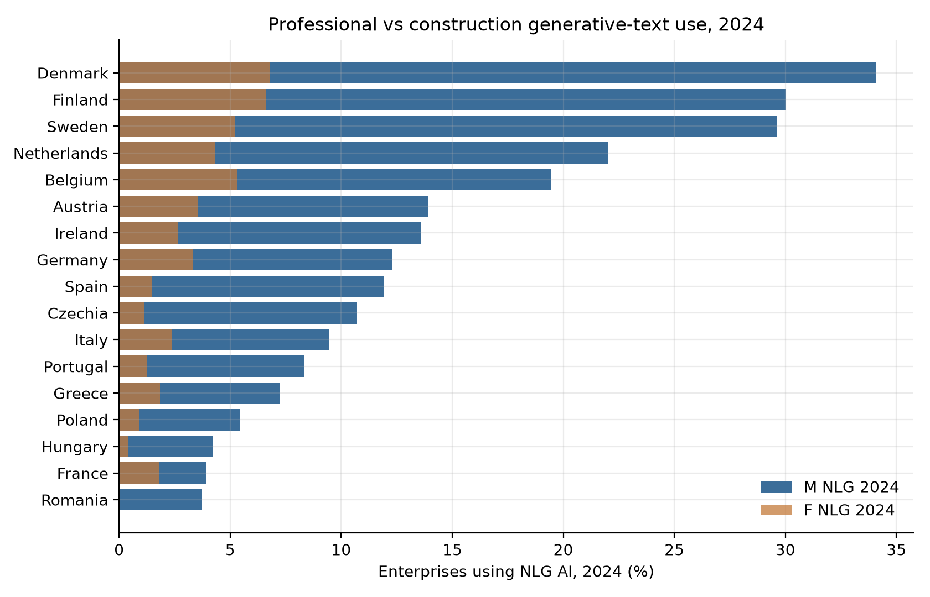

Figure 14
Event study, year × ΔM TNLG.
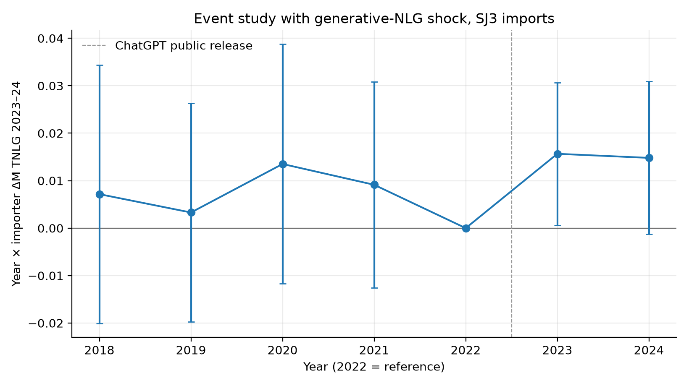

Figure 15
ΔTNLG vs Δ log India SJ3.
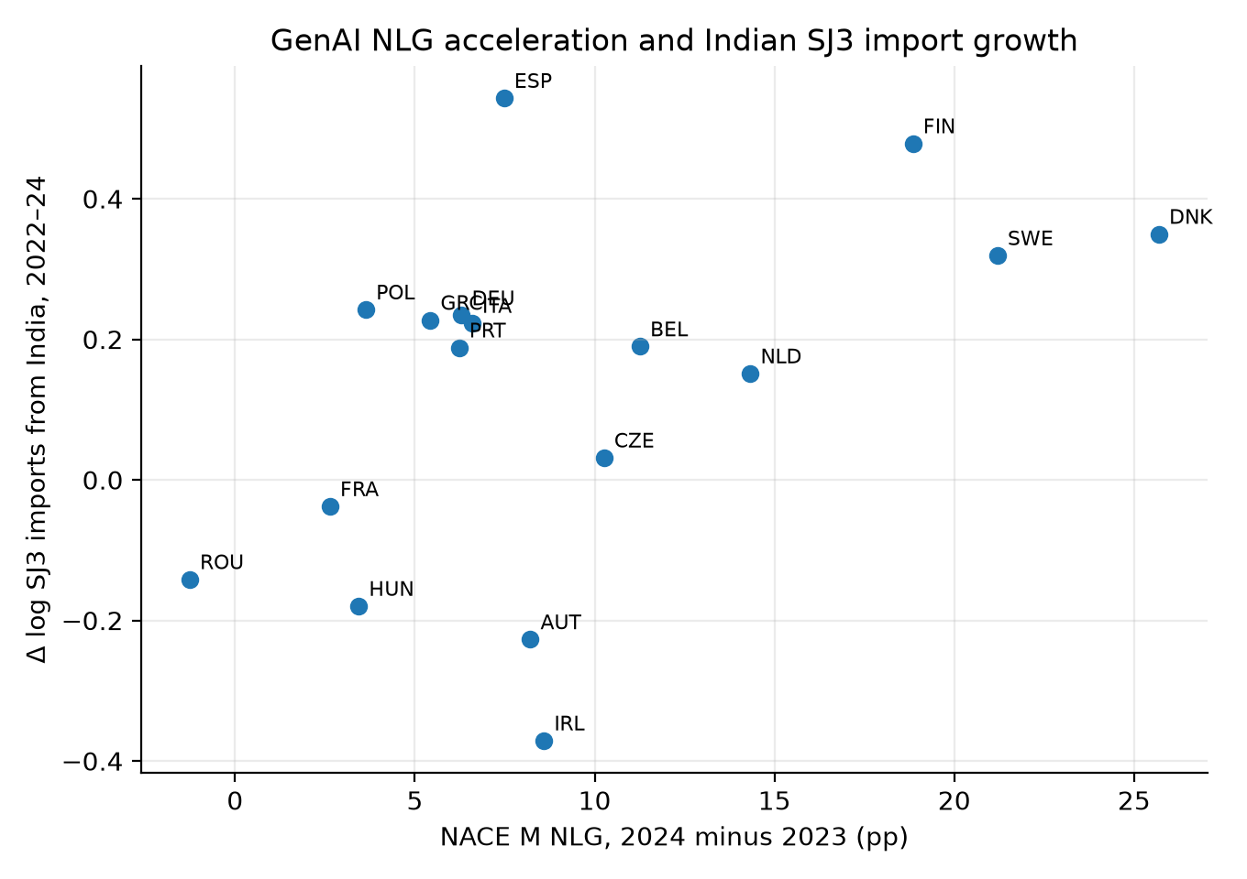

Figure 16
EU-27 NLG by NACE.
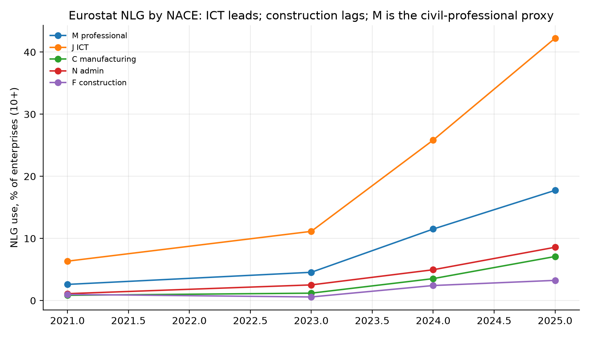

Figure 17
SBS turnover growth, M71 vs F.
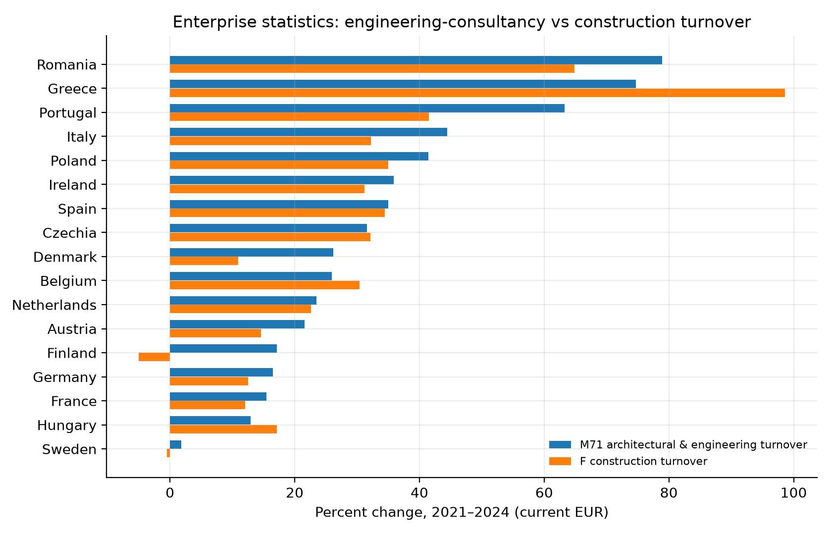

Figure 18
SBS employment growth, M71 vs F.
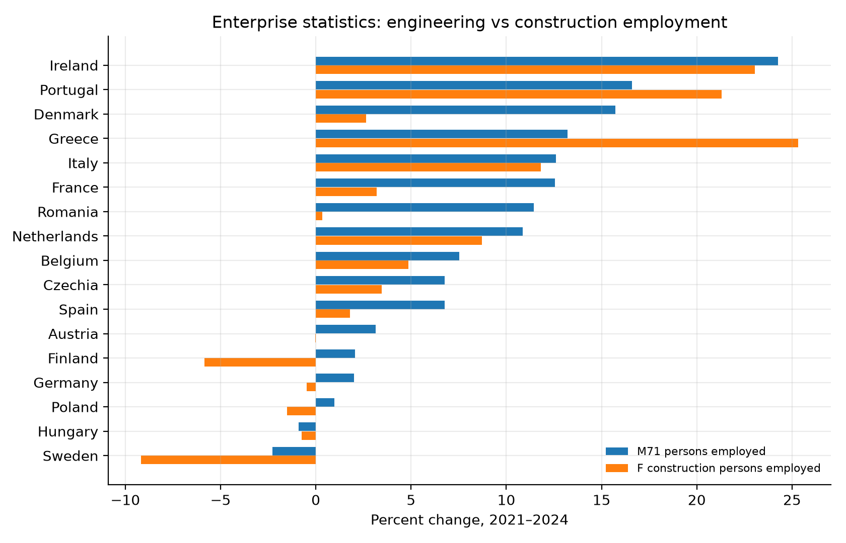

Figure 19
ΔTNLG vs M71 turnover change.
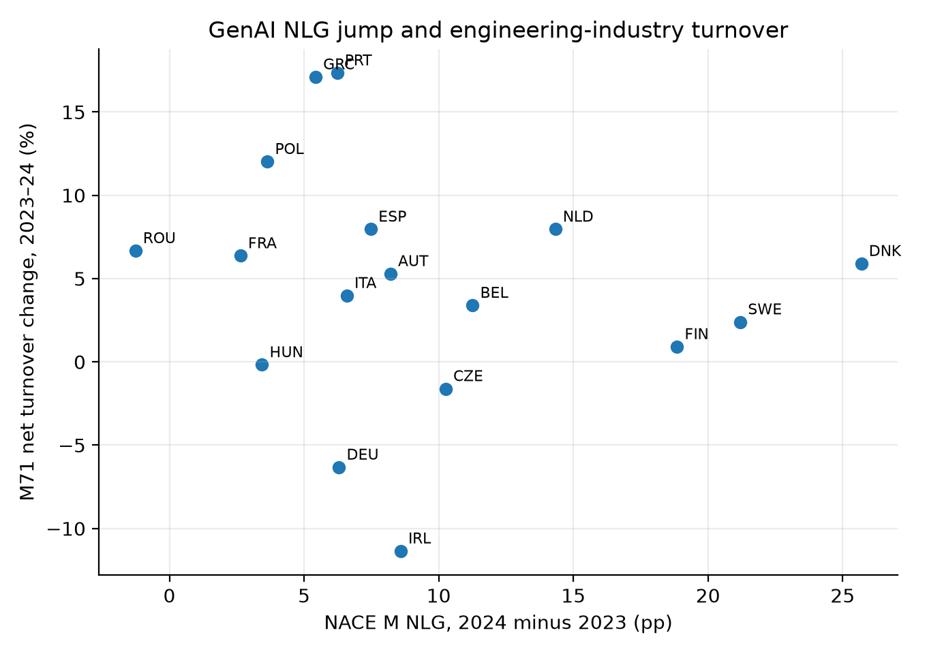

Figure 20
M71 turnover levels.
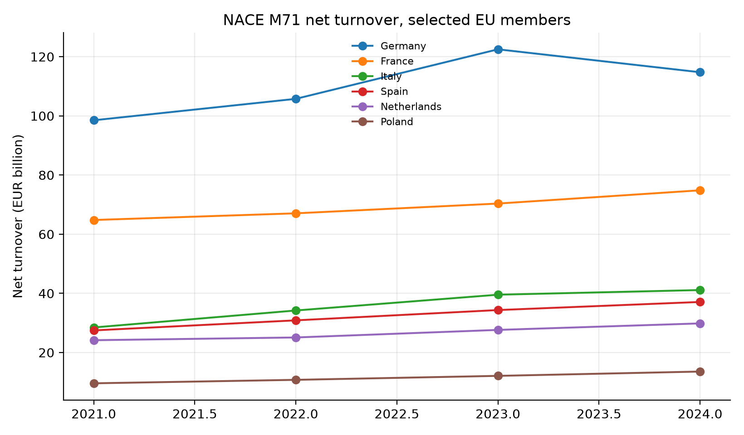

Figure 21
US CES NAICS 54 (too broad).
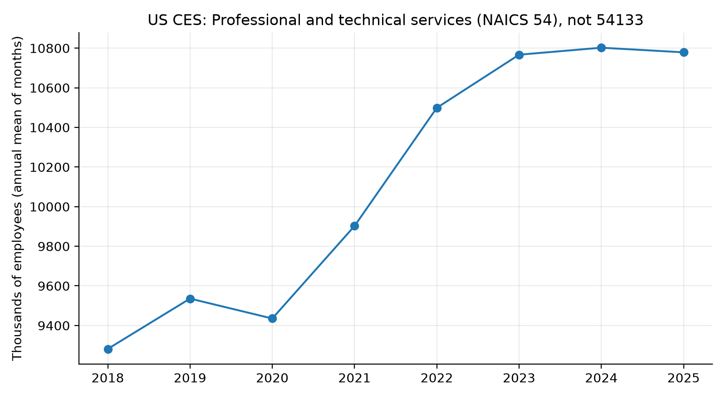

Figure 22
UK–India and UK–China SJ3 corridors, 2019 = 100.
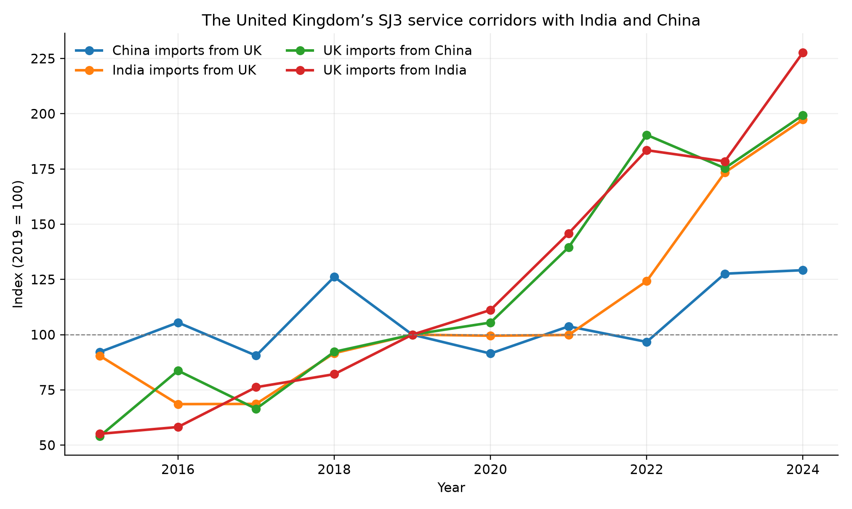

Figure 23
UK–India and UK–China service growth by category.
