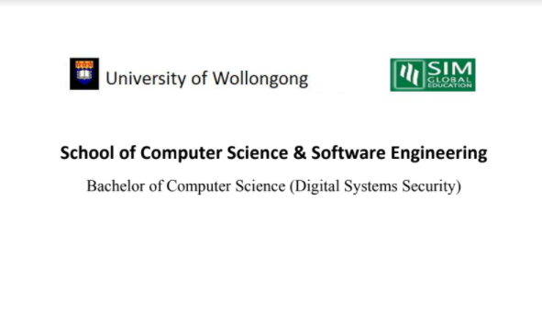

**CSCI321 – Project (Android Packet Sniffer)**

User Document

Table of Contents

Group Member List

|  |  |
| --- | --- |
| Name | Student ID |
| Soh Yu Xuan | 5498636 |
| Timothy Chin | 5498399 |
| Kenneth Huang | 5498442 |
| Kendrick Tan | 5026556 |

# 1. Document Overview

The document describes the process in which is used in using the application, it includes instruction on the steps that the user need to take to use the application as well as contain screenshots for visual assistance and clarity.

# 2. Application Overview

2.1 Application Icon

2.2 Application Home Page

(to include what each button does)

2.3 Pre-requisite Steps

(initial start-up requirement)

2.4 Application functions

2.5 Storing of Sniffing Data