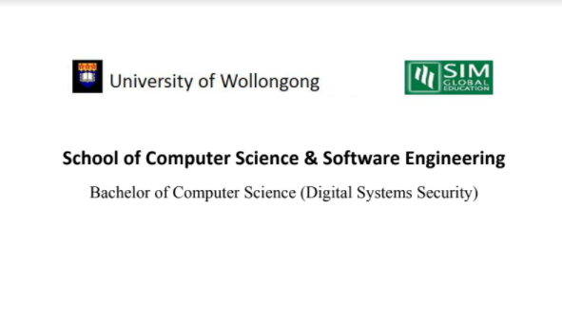

**CSCI321 – Project (Android Packet Sniffer)**

**Contribution List**

**Group SS18/2A**

**Supervisor: Tian Sion Hui**

|  |  |  |  |  |
| --- | --- | --- | --- | --- |
| Name | Student ID | Roles & Responsibilities | Contribution Index Value (%) | Signature |
| Soh Yu Xuan | 5498636 | Team Leader, Main Programmer, research | 100 |  |
| Timothy Chin | 5498399 | Sub Programmer, Sub Documenter, research | 100 |  |
| Kenneth Huang | 5498442 | Main Programmer, research | 100 |  |
| Kendrick Tan | 5026556 | Team Manager, Main Documenter, Research | 100 |  |

|  |  |  |  |
| --- | --- | --- | --- |
| Soh Yu Xuan | Timothy Chin | Kenneth Huang | Kendrick Tan |
| Proposal of Project | Proposal of Project | Proposal of Project | Proposal of Project |
| Net Sniffing Programming | Assisted with Net Sniffing Programming | Pcbin + Pcmon Programming | SRS Document |
| Technical Manual | Technical Manual | Technical Manual | Technical Manual |
| User Manual | Research | Research | User Manual |
| Research | Creation of Sequence Diagram for Sniffing | Creation of Sequence diagram for pcbin + pcmon | Research |
| Creation of Use Case Diagram | Promotional Video | Creation of Activity Diagram | Creation of Use Case Diagram |
| Assisted for Activity Diagram | Creation of Class Diagram | Creation of Data Flow Diagram | Creation of Activity Diagram |
| Demonstration Video | SRS Document |  |  |