

Technical Document

**CSCI321 – Project (Android Packet Sniffer)**

Table of Contents

1. 1. Document Overview 3
2. 2. Introduction 3

1.1 What is Packet Sniffing?

1.2 What is TCPDump?

1.2.1 How to setup TCPDump in Linux Environment

1.3 What is libpcap?

1.3.1 Creating our own Binary like TCPDump

1.3.2 Difficulties in creating the Binary

1.4 Type of IP Packets

1.4.1 IP Packet Header

1.4.2 ICMP Packet Header

1.4.3 ARP (Address Resolution Packet)

1.5 Types of Protocols

1.5.1 Transport Control Protocol (TCP)

1.5.2 User Datagram Protocol (UDP)

1. 3. Implementation libpcap that binary PCBIN uses 11

3.1 Main Functions of libpcap Library

3.2 Future Updates

1. 3. Application Description 13

3.1 Introduction

3.2 Operational Examples

3.3 System Requirements

3.4 Functional Requirements

3.4.1 Start/Stop Packet Sniffing

3.4.2 Display Information

3.4.3 Save Packets to File

3.4.4 Filter the Packets

3.5 Non-functional Requirements (Quality of life Service)

1. 4. UML Diagram 15

4.1 Use Case Diagrams

4.1.2 Second Iteration

4.2 Sequence Diagrams

4.3 Activity Diagrams

4.4 Other UML Diagrams

1. 5. User Interface Designs 21
2. 6. Software Development 22

6.1 Software Design Process

6.2 Development Tools and Environment

6.3 Schedule of Project

6.4 Roles & Responsibilities

6.5 Version Control

1. 7. Application Test 23

7.1 Test Cases

1. 8. Conclusion 23

Group Member List

|  |  |
| --- | --- |
| Name | Student ID |
| Soh Yu Xuan | 5498636 |
| Timothy Chin | 5498399 |
| Kenneth Huang | 5498442 |
| Kendrick Tan | 5026556 |

# 1. Document Overview

The document describes the design process which is used in creating the application, it also includes UML Diagrams to illustrate the design of the system that can be used to show the functionalities of the application. Some form of implementation may also be described. Other than functionalities there will also be test cases to show that the application have the appropriate quality for use.

# 2. Introduction

Computers used to be large clunky machines which were the innovation of the IT sector but now, almost everyone if not all, has a “small computer” with them all the time, a smartphone. One of the duties of a network administrator is to monitor the network. This can be done with a computer with either with an external network card or with an internal one. However, the computer was something that was needed, adding weight and hassle. What if one could monitor and sniff packets from their device whom they carried with them everywhere? One could simply be in a location, capturing packets in their vicinity for analysis, without having to lug around a laptop right into their mobile device.

## 1.1 What is Packet Sniffing?

“A sniffer (packet sniffer) is a tool that intercepts data flowing in a network. If computers are connected to a local area network that is not filtered or switched, the traffic can be broadcast to all computers contained in the same segment. This doesn’t generally occur, since computers are generally told to ignore all the comings and goings of traffic from other computers. However, in the case of the sniffer, all traffic is captured when the sniffer software commands the Network Interface Card (NIC) to stop ignoring the traffic. The NIC is put into promiscuous mode, and it reads communications between computers within a particular segment. This allows the sniffer to seize everything that is flowing in the network, which can lead to the unauthorized access of sensitive data. A packet sniffer can take the form of either a hardware or software solution.

## 1.2 What is TCPDump?

TCPDump is a free software designed by Van Jacobson, Sally Floyd,Vern Paxson and Steven McCanne in 1988. It uses the libpcap library in C to read packets from a network interface card.

## 1.2.1 How to setup TCPDump in Linux Environment

wget http://www.tcpdump.org/release/libpcap-1.8.1.tar.gz

tar -xf libpcap-1.8.1.tar.gz

sudo apt-get update

sudo apt-get install flex

sudo apt-get install bison

cd libpcap-1.8.1

./configure –prefix=/usr

Make

Sudo make install

Following the above step will compiled the libpcap giving libpcap.a and libpcap.so file.

The .a file are static libraries while .so are dynamic libraries. The difference between the two is, in a static libraries, if you used code stored inside them, it is taken from them and embedded into your own binary while in dynamic libraries, the code is not taken and embedded into your own library. It is referenced so the binary will depend on them and the code from the so file is loaded at runtime.

## 1.3 What is libpcap?

libpcap is the abbreviation of packet capture library which is an application programming interface (API ) that is used to capture network traffic. The libpcap is written in c so therefore in order for android which uses JAVA, we must use a wrapper to translate a library existing interface to the compatible interface. The wrapper enable android which uses JAVA to use libpcap C code.

Example of some wrapper program readily available would be jPcap,jNetPcap,JPcap and pcap4j.

These are all wrapper libraries made by other developers to enable C code to be use in JAVA.

## 1.3.1 Creating our own Binary like TCPDump

We planned to achieve this by using libpcap (API) and write the general code which is similar to TCPDump. After that, we cross compile it into an ARM compatible structure and use the ARM binary in our applications. Why do we use ARM? As most mobile uses ARM processors instead of intel processors. The difference between linux ARM and linux x86 is that internally their binary code is different thus software done on x86 must be pre compile to match the target architecture.

## 1.3.2 Difficulties in creating the Binary

Although these libraries are readily available for us to use in android we face one problem.

One of the problems we faced was that if we want to sniff packets in promiscuous mode, we would need root permission. Getting root permission would not be a problem if we were to work in environments such as LINUX or WINDOWS on the computer.

In android any access to protected resources or services is guarded by the application permission framework, all access in native code needs to be analyzed, and the required permissions should be identified. Whatever permissions the native code may need should be published for developers, so that they can include these permissions in their applications Manifest file. Native code should not rely on code that need access as this is not available on standard android. [4]

The above sentence is a research that we did when we came across that using a wrapper library that need route access violate that rule .Therefore we went to look for another alternative which is to use a ARM binary library for ARM architecture . If we were to use a binary in android we can give root to process and therefore bypassing the no rooting to native code problem.

The next problem would be that even though we created our own ARM binary, the binary should have no problem executing the code in the NEXUS 5 device. However, when we tried to execute the binary, it was denied permission even though the phone is rooted and ran in a rooted process. No available solution has been found for this problem for now.

## 1.4 Type of IP Packets

1. TCP/IP
2. UDP
3. ICMP (INTERNET CONTROL MESSAGE PROTOCOL)
4. IGMP (INTERNET GROUP MANAGEMENT PROTOCOL)
5. IGRP ( INTERIOR GATEWAY ROUTING PROTOCOL)
6. ESP (ENCAPSULATING SECURITY PAYLOAD)
7. AH (AUTHENTICATION HEADER)

## 1.4.1 IP Packet Header

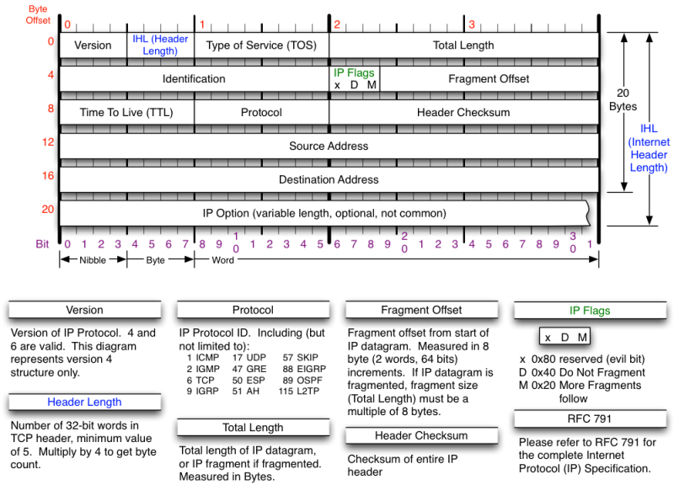**[5]**

IP header usually about 20 bytes. The source address and destination address mean from where the ip packet comes from and where the packet is trying to reach.

The identification field is used to uniquely identify the group of fragments of a single ip datagram.

The Types of service has now been redefined by RFC 2474 for Differentiated service and Explicit Congestion Notification (ECN). Differentiated service (DSCP) is used when technologies require real time data streaming is needed. ECN is defined in RFC3186 and allows end to end notification of network congestion without dropping packets. It is an optional feature which is only effective if there is underlying network.

## 1.4.2 ICMP Packet Header

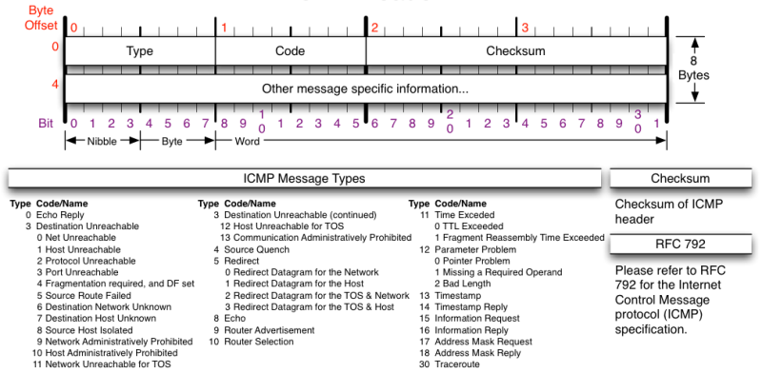**[5]**

Currently our program is unable to sniff ICMP packets due insufficient time. However, our finished application should be able to ICMP packet would be sniff with our binary, PCBIN.

ICMP is not a transport protocol that sends data between systems. It is used to troubleshoot internet connections by network admin.

**IGMP (INTERNET GROUP MANAGEMENT PROTOCOL)**

Used by host and adjacent router on IPV4 network to establish multicast group membership.

**IGRP (INTERIOR GATEWAY ROUTING PROTOCOL)**

Distance vector interior gateway protocol. Used by routers to exchange routing data within an autonomous system.

**ESP (ENCAPSULATING SECURITY PAYLOAD)**

Provides data confidentiality and authentication. Authentication mechanism authenticates only IP datagram portions of the IP packet.

**AH (AUTHENTICATION HEADER)**

Provides a mechanism for authentication only. It authenticates IP header and their payload.

## 1.4.3 ARP (Address Resolution Packet)

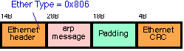**[6]**

ARP is a protocol used by Internet protocol (IP) which broadcast packet to map IP network address to MAC Address. It is used by data link protocol. The ARP request message is sent by using the ethernet broadcast address to all system. Only the person who has the request IP address will reply. The rest will silently discard the packet.

## 1.5 Types of Protocols

In the Transport Layer, there are 2 protocols that are used, Transport Control Protocol and User Datagram Protocol.

## 1.5.1 Transport Control Protocol (TCP)

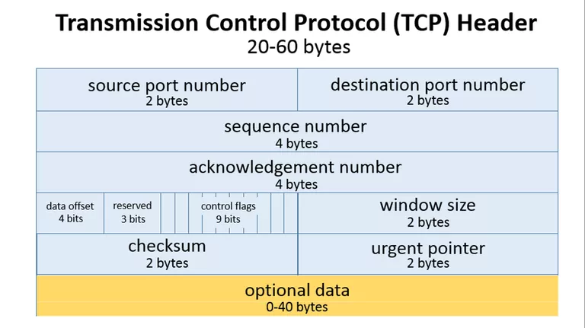[2]

TCP header usually requires a minimum of 20 bytes anything.

As shown above the source port takes up around 2 bytes, destination port takes up around 2 bytes,

Sequence number takes up 4 bytes. Sequence number is used to mark the ordering of a group of message. Acknowledgment number takes up 4 bytes are used by the sender and receiver to communicate the sequence number of messages.

Data offset field takes up 4 bits and store the total size of a TCP header in multiples of four bytes. A header using the optional TCP field has a data offset of 5, while a header using the maximum-sized optional field has a data offset of 15.

Reserved uses 3 bits and the value is always zero.

Control flags uses 9 bits and TCP use 6 standard and 3 extend control flags to manage data flow in specific situations. Each flag is 1 bit in size. The flags are SYN, ACK, FIN, URG, PSH, RST, ECE, CWR, NS flags.

SYN aka synchronous flag is used as a first step in establishing a 3 way handshake between 2 hosts.

ACK aka acknowledgment is used to acknowledge the successful receive of a packet. It is use to tell the sender it has receive the initial packet.

FIN aka as Finished. Tell the receiver that sender has no more data to send. Therefore this is the last packet sent to receiver.

URG aka urgent. This flag is to the receiver to process the urgent packet first before processing other packet.

PSH stands for push. It is similar to URG flag. It is used to tell the receiver to process the packets with PSH flag instead of buffering them.

RST stands for reset flag. This flag is sent when a packet is sent to a particular host that was no expecting it.

ECE is responsible for indicating if a TCP peer is ECN capable

CWR flag stands for Congestion window reduced is used by sending host to indicate it received a packet with ECE flag set.

NS stands for Nonce Sum, it is an experimental flag used to help protect accidental malicious concealment of packets from sender.

Window size is a value to regulate how much data is send before an acknowledgment from receiver is required. This value cannot be too small or too big as being too small will slow performance while too big will cause network link to be saturated making it unusable for other application

Checksum is used to help receiver check if the data receive has been corrupted or tempered with.

Urgent pointer field is often set to zero or ignored. [3]

## 1.5.2 User Datagram Protocol (UDP)

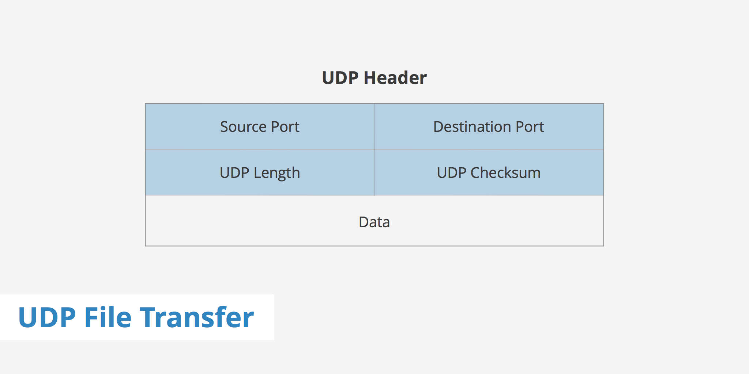

[1]

UDP header is much smaller than TCP. It consist of 8 bytes in total.

As shown above it only has four fields. Source port, Destination Port, UDP length and UDP checksum.

UDP length is used to identify the length of the header itself.

UDP checksum is the same as TCP checksum. It is used to check if a UDP packet data is corrupted or been tampered with.

# 3. Implementation libpcap that binary PCBIN uses

## 3.1 Main Functions of libpcap Library

1. pcap_lookupdev

* Finds the default device on which to capture the packet.
* Pcap_lookupdev returns a pointer to a string giving the name of a network device suitable for use with other main function to create a packet sniffer.
* However in our program we would like to use our own interface that we specified therefore this function is not needed.

1. Pcap_create(device, errbuff)

* Used to create a packet capture handle to look at the packet on the network

1. Pcap_set_promisc(handler,int )

* To set promiscuous mode on a non-activated handle. If the int is any non-zero value, promiscuous mode will be set otherwise it will not be set.

1. pcap_activate(handler)

* Using pcap_create just creates the handler in order to use the handler , we would need to activate it

1. pcap_datalink

* Get the link layer header type

1. pcap_lookupnet ()

* Get the netmask and network number of IPv4 for a device

1. pcap_compile()

* Used to compile the string str in to filter program.Program is a pointer to a bpf_program struct .optimize controls whether optimization on the resulting code is performed.
* Return 0 on success and -1 on failure.

1. pcap_setfilter()

* Used to specify a filter program which is apointer to a bpf_program struct ,usually the result of a call to pcap_compile()
* Return 0 on success -1 on failure.

1. pcap_loop()

* Loop mean that if will keep sniffing packet until it is specified to stop.
* It loops a specified function that is placed on the third argument

1. pcap_close()

* Closes the handler once it has completed its job.

## 3.2 Future Updates

* Enable sniffing of all other packet for eg (ARP packets, DNS and ICMP packets)
* Implement it together with libnet library to send packet to other device.

(Libnet is required to break wep)

# 3. Application Description

This section will give an overview of the application design, development, and Implementation

## 3.1 Introduction

## 3.2 Operational Examples

(this section will describe our application in a real scenario base)

## 3.3 System Requirements

(Requirements of our System e.g Android Platform, Version x, etc)

## 3.4 Functional Requirements

Under this section, we will be describing the functional requirements of our application.

## 3.4.1 Start/Stop Packet Sniffing

When users open the application, they will be able to select when they wish to start and stop the capturing of packets. The application works by utilizing a binary that will be started in a process with SuperUser permission. The process runs in a thread and stops only when the stop button is pressed. The packets are captured using the binary and are redirected to a text file.

## 3.4.2 Display Information

The application works by reading in the text file that is at the same time being written to by the sniffing thread. As data enters the text file, another thread is used to read in the packet data to the application. Another thread at the same time will get the data read in and display to the gui portion of the application.

Users will be able to view the packets captured by utilizing 3 threads, writing to a text file, reading a text file and updating to the display all being done concurrently.

## 3.4.3 Save Packets to File

After the user is done capturing packets, they will be able to save the data to a file which they can then use another application to view the data at their own time or for system administrators they will be able to keep records of the type of data that has been going through the network.

This packet information is saved in a ‘.pcap’ format contains more information that can be displayed on a mobile device. It would be better analyzed on a computer.

## 3.4.4 Filter the Packets

Our application would be designed to filter the types of packet that the user wishes to see, according to certain devices/websites/IP addresses/packet type.

## 3.5 Non-functional Requirements (Quality of life Service)

This section describes the non-functional requirements of our application that is designed to help users navigate through the application with as little difficulty as possible

# 4. UML Diagram

## 4.1 Use Case Diagrams

First Iteration:

First Design of Application:

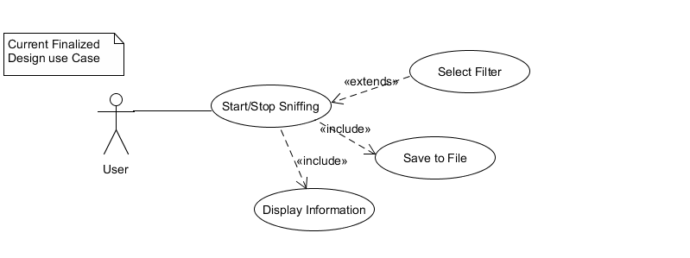

First GUI Design of Application: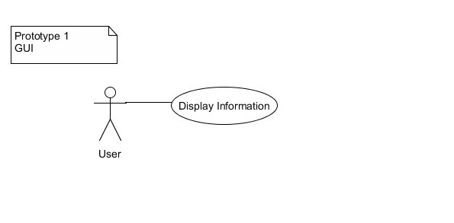

## 4.1.2 Second Iteration

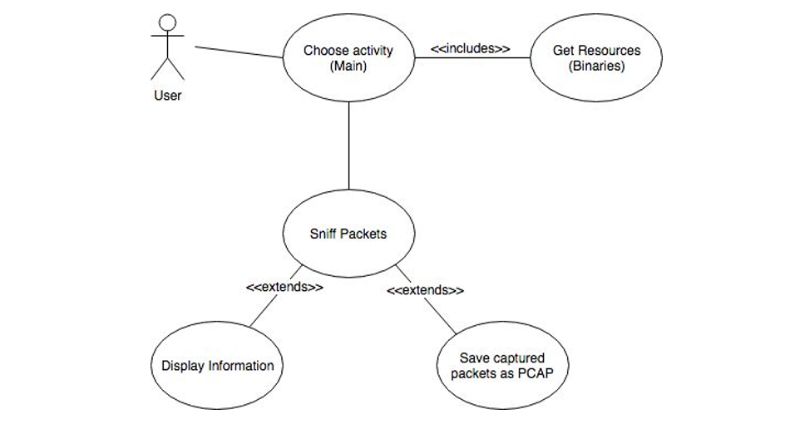

## 4.2 Sequence Diagrams

First Iteration:

App initialize sequence diagram:

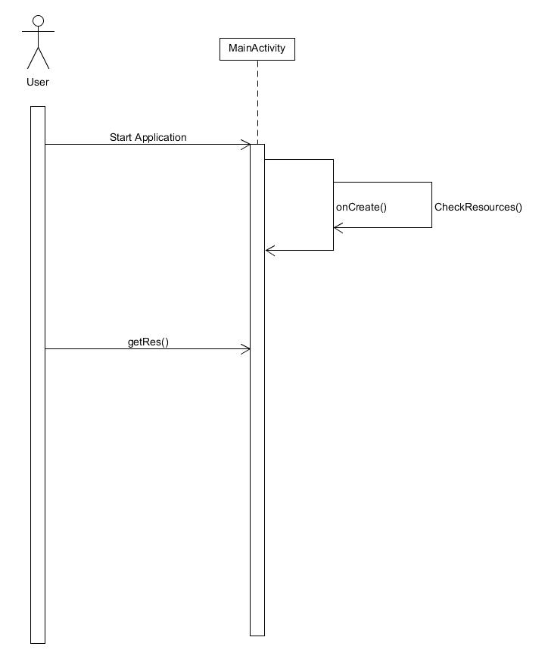

Start live sequence diagram:

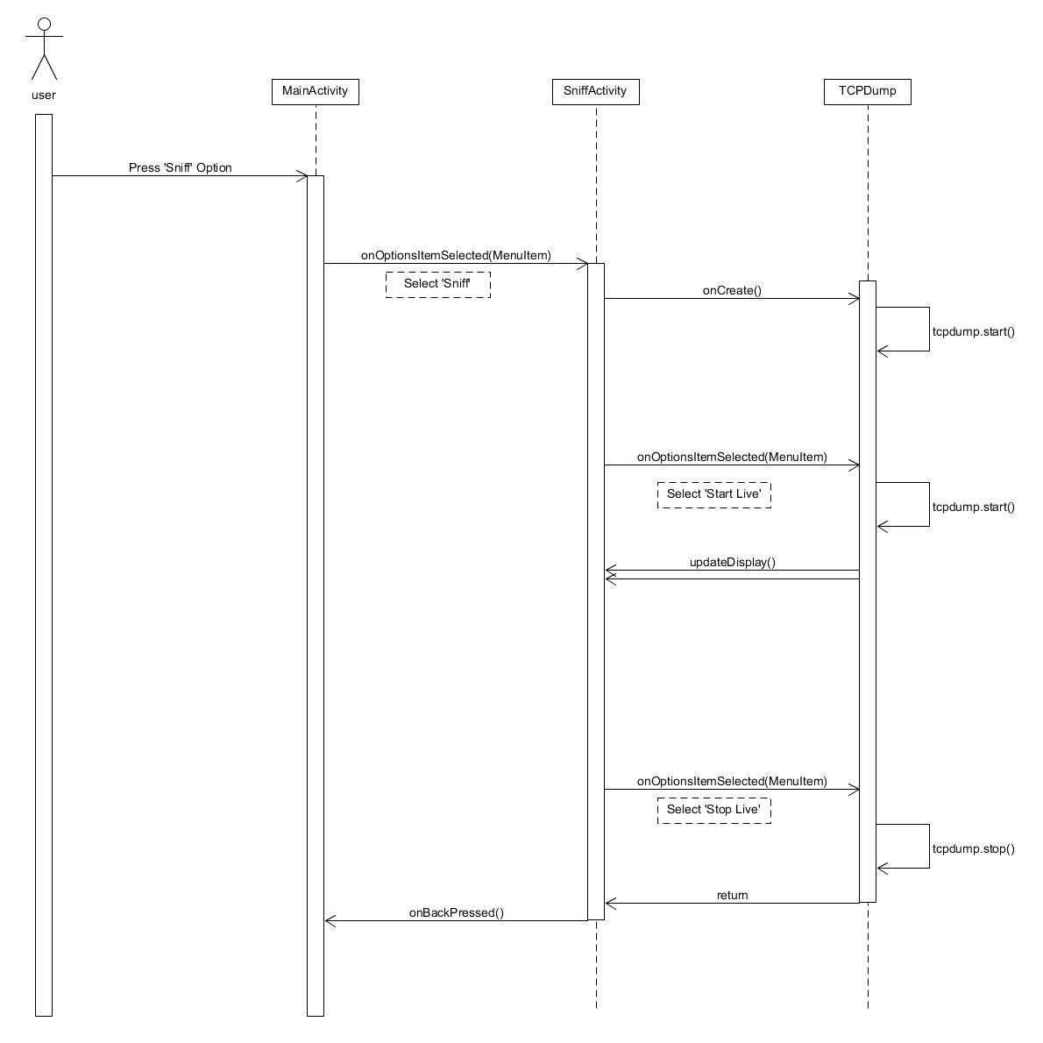

Start pcap sequence diagram:

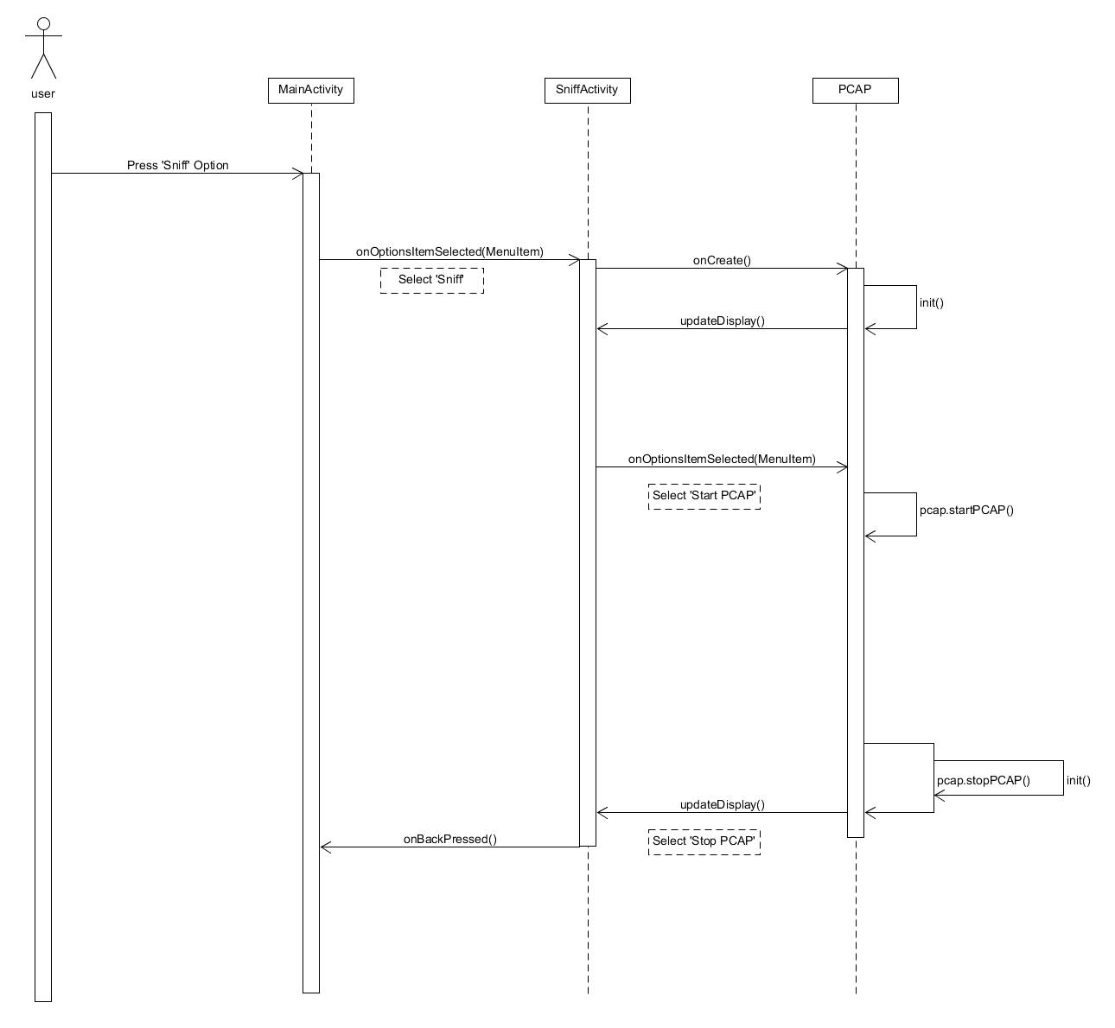

## 4.3 Activity Diagrams

First Iteration:

Android app activity diagram:

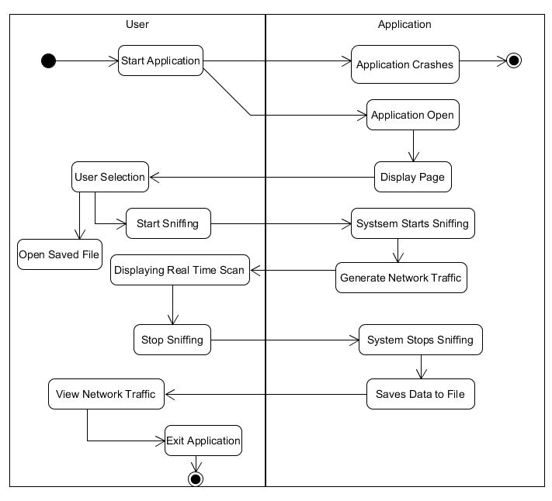

Pcbin activity diagram:

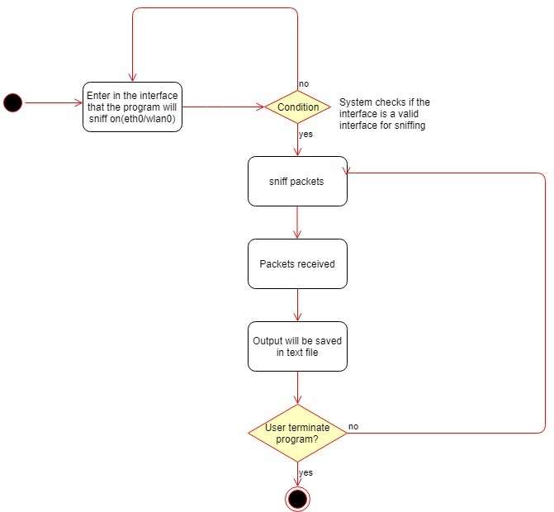

## 4.4 Other UML Diagrams

First Iteration:

Data Flow Diagram for pcbin

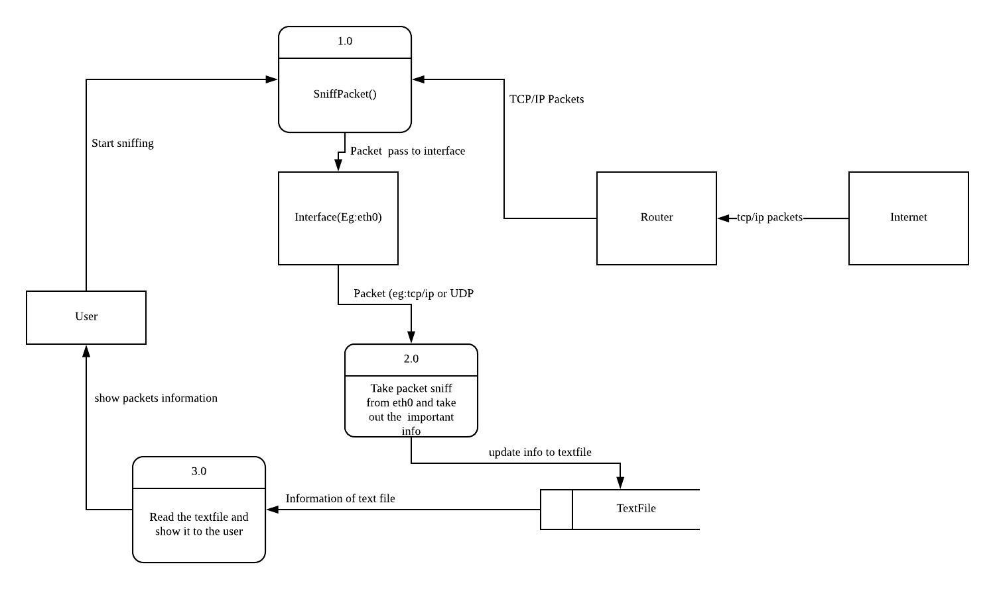

# 5. User Interface Designs

(application interface designs to be added)

# 6. Software Development

## 6.1 Software Design Process

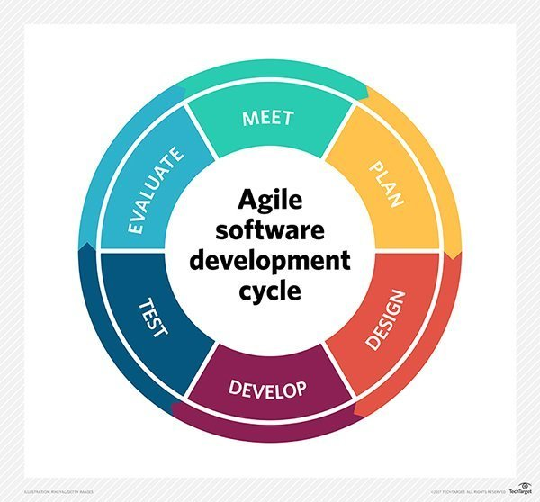

Agile (Scrum) is used to develop our application, it provides the ability to create and respond to change to succeed in an uncertain and turbulent environment. Agile is the most applicable due to the unpredictability of the application due to rooting and specific modes based on the WLAN cards of the type of devices that we plan to incorporate into. With Agile we can makes changes as and when necessary to help overcome such issues.

## 6.2 Development Tools and Environment

* Android Studio
* UMLet
* Other possible tools we used

## 6.3 Schedule of Project

## 6.4 Roles & Responsibilities

|  |  |
| --- | --- |
| Team Members | Roles |
| Soh Yu Xuan | Team Leader, Lead Programmer |
| Timothy Chin | Assistant Programmer / Lead UI |
| Kenneth Huang | Assistant Programmer / Lead Tester |
| Kendrick Tan | Project Management / Documenter |

## 6.5 Version Control

Github is used as the version control software during the development of this project. Both source code and documents were managed using Github.

# 7. Application Test

## 7.1 Test Cases

# 8. References

[1] <https://www.keycdn.com/support/udp-file-transfer/>

[2] <https://www.lifewire.com/tcp-headers-and-udp-headers-explained-817970>

[3] <https://www.keycdn.com/support/tcp-flags/>

[4] <https://opensourceforu.com/2013/09/what-a-native-developer-should-know-about-android-security/>

[5] <https://nmap.org/book/tcpip-ref.html>

[6] http://www.erg.abdn.ac.uk/users/gorry/course/inet-pages/arp.html