Group SS18/2A Android Network Sniffer Report

Team Number : <SS18/2A>

 | Student Number | Name | Email Address
1 | 5498636 | Soh Yu Xuan(Team Leader) | yxsoh004@mymail.sim.edu.sg
2 | 5498399 | Chin Tian Zhi Timothy | tztchin001@mymail.sim.edu.sg
3 | 5498442 | Huang Shun Yang Kenneth | sykhuang001@mymail.sim.edu.sg
4 | 5026556 | Tan Siyuan Kendrick | sktan024@mymail.sim.edu.sg

Table of Contents
Project Overview 3
Roles and Responsibility 5
Type chapter title (level 1) 4
Type chapter title (level 1) 4

Project Overview

Designing of an Android Network Sniffer which in our team’s understanding is to achieve real-time scanning of network traffic and recording it to a file for later use. The application would be useful for people with Networking and Security background as the people who use this application would be System Administrators, Similar Application Developers and possibly general users. As such an application is already existing on computers our implementation of it onto a device like android has its limitation but it also thrills us to try and develop an actual working version of it.

- "Vision"

- Our key feature of the application would be real time capturing of packets and being able to see them displayed on the application.
- To be able to save packet data into a file for later view.
- After being able to achieve the first objective the second one would be to filter traffic based on certain criteria’s such as type of device or maybe specific type of traffic
- If possible be able to scan the access point for devices connected to it.

- Initial Use-Case Model

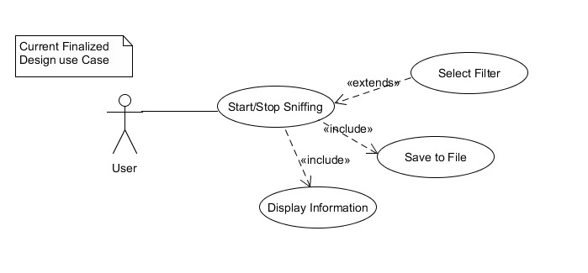
- Project Plan

- Due to the limitations of the Chipset our available device has been restricted and therefore plan to use Nexus 5 due to concerns such as device cost
- Due to the need to have root access, which may cause bricking to a phone we have opted to use older no longer in use devices
- The device needs to be in monitor/promiscuous mode our choice of device has been restricted.
- The rooting methods may or may not be suitable for our device so therefore we need to have alternate ways to get network traffic such as using VPN
- Using libraries from Pcap to assist with the project as well as tcp dump

Roles and Responsibility

Team Number : < SS18/2A >

 | Student Name | Role | Artefacts
1 | Soh Yu Xuan | Team Leader, Lead Programmer
2 | Chin Tian Zhi Timothy | Lead Programmer
3 | Huang Shun Yang Kenneth | Android UI Programmer
4 | Tan Siyuan Kendrick | Team Manager, Lead Documenter | Technical Document, Initial Use case, research on products, SRS, Report

Risk Analysis and Counter Measures

 | Impact Type | Risk Seriousness (%) | Likelihood of Occurrence (%) | Risk Description
1 | Successful Task completion | 90% | 50% | Being able to complete rooting as it is the main criteria failing to do so will result in needing alternative methods which cause re-scope of project
2 | Deadline | 90% | 10% | If deadline is not met all team members might fail the project
3 | Unable to display on phone’s application | 50% | 20% | If application does not display correctly the bulk of the project might not work needing more time to debug
4 | Unable to obtain device for project | 90% | 20% | If we are unable to have a device that meet our criteria

 | Risk Description | Proposed Mgmt Plan | (Possible) Reduction in Risk Seriousness (%)
1 | Unable to root phone | Plan 1 : Search for alternative methods like VPN | -50%
1 | Unable to root phone | Plan 2 : use alternate rooting method till successful | -25%
2 | Unable to obtain device for project | Plan 1: Buy from people who are selling old phones | 75%
3

Design Artefacts - Use Cases (Iteration 1)

Main use case diagram:

Design Artefacts - Use Cases (Iteration 2)

You may use any diagramming tool to develop your use case diagrams for the entire system.

Iteration 2 is based on your team's "LATEST" understanding of the system.

In general, the diagrams in later iterations should be more refined, more evolved, capture more details than diagrams developed in earlier iterations

Note 1 : Your diagram should be developed using standard UML symbols and notations for use case diagrams!

Note 2 : this section can span as many pages as necessary

Note 3 : If you are pasting screen-shots (from your adopted diagramming tool) into this sub- section, please ensure the wordings / text are clearly visible

Design Artefacts - Activity Workflows (Iteration 1)

Android app activity diagram:
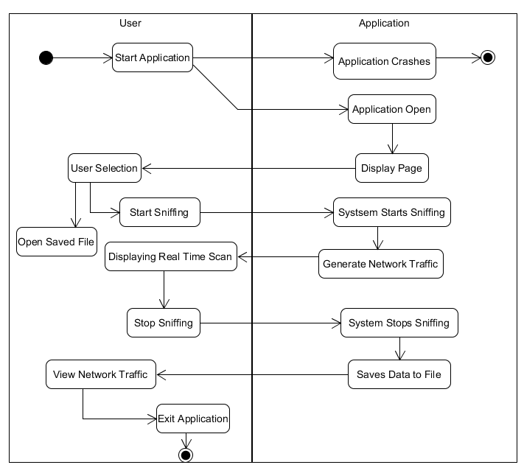

Pcbin activity diagram:
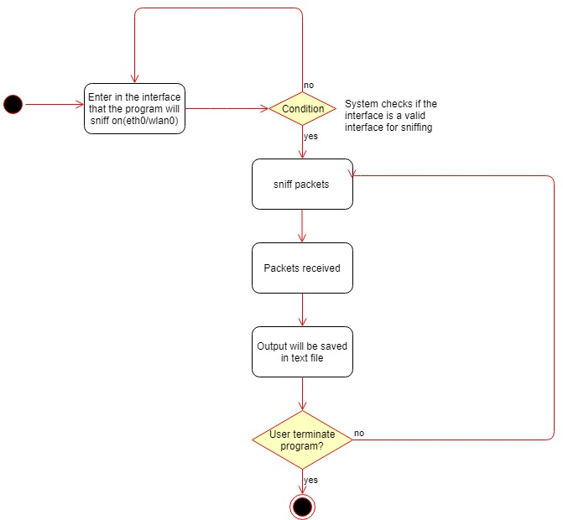

Design Artefacts - Activity Workflows (Iteration 2)

You may use any diagramming tool to develop your activity diagrams for the entire system.

Iteration 2 is based on your team's "LATEST" understanding of the system.

In general, the diagrams in later iterations should be more refined, more evolved, capture more details than diagrams developed in earlier iterations

Note 1 : Your diagram should be developed using standard UML symbols and notations for activity diagrams!

Note 2 : this section can span as many pages as necessary

Note 3 : If you are pasting screen-shots (from your adopted diagramming tool) into this sub- section, please ensure the wordings / text are clearly visible

Design Artefacts – Data Flow Diagrams (Iteration 1)

Pcbin data flow diagram:

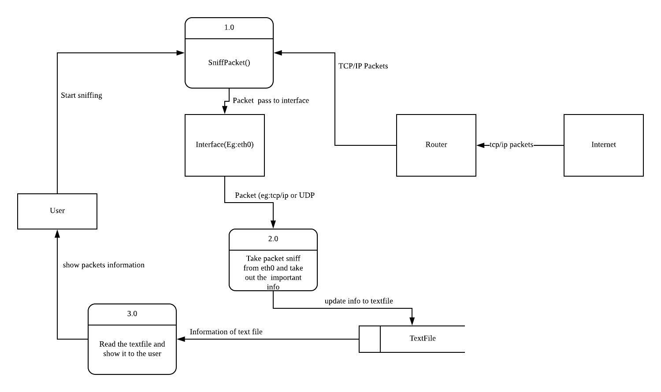

Design Artefacts - Component Diagrams (Iteration 1)

Design Artefacts - Component Diagrams (Iteration 2)

You may use any diagramming tool to develop your component diagrams for the entire system.

Iteration 2 is based on your team's "LATEST" understanding of the system.

In general, the diagrams in later iterations should be more refined, more evolved, capture more details than diagrams developed in earlier iterations

Note 1 : Your diagram should be developed using standard UML symbols and notations for component diagrams!

Note 2 : this section can span as many pages as necessary

Note 3 : If you are pasting screen-shots (from your adopted diagramming tool) into this sub- section, please ensure the wordings / text are clearly visible

Design Artefacts - Class Diagrams (Iteration 1)

Main class diagram:

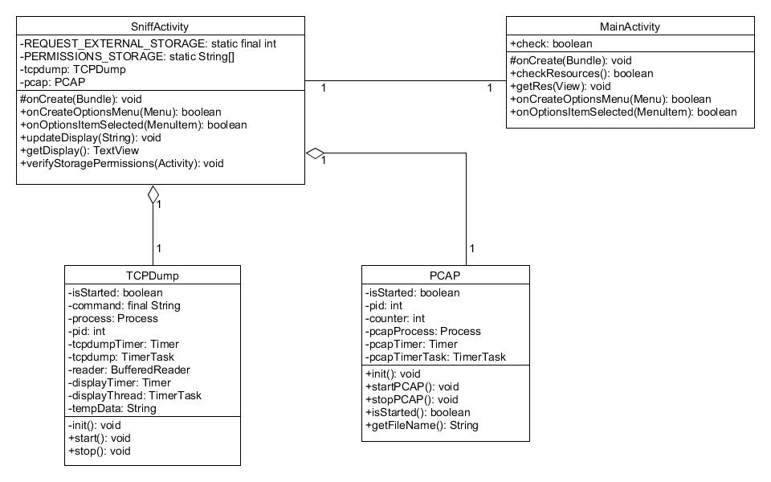

Design Artefacts - Class Diagrams (Iteration 2)

You may use any diagramming tool to develop your class diagrams for the entire system.

Iteration 2 is based on your team's "LATEST" understanding of the system.

In general, the diagrams in later iterations should be more refined, more evolved, capture more details than diagrams developed in earlier iterations

Note 1 : Your diagram should be developed using standard UML symbols and notations for class diagrams!

Note 2 : this section can span as many pages as necessary

Note 3 : If you are pasting screen-shots (from your adopted diagramming tool) into this sub- section, please ensure the wordings / text are clearly visible

Design Artefacts - Sequence Diagrams (Iteration 1)
App initialize sequence diagram:
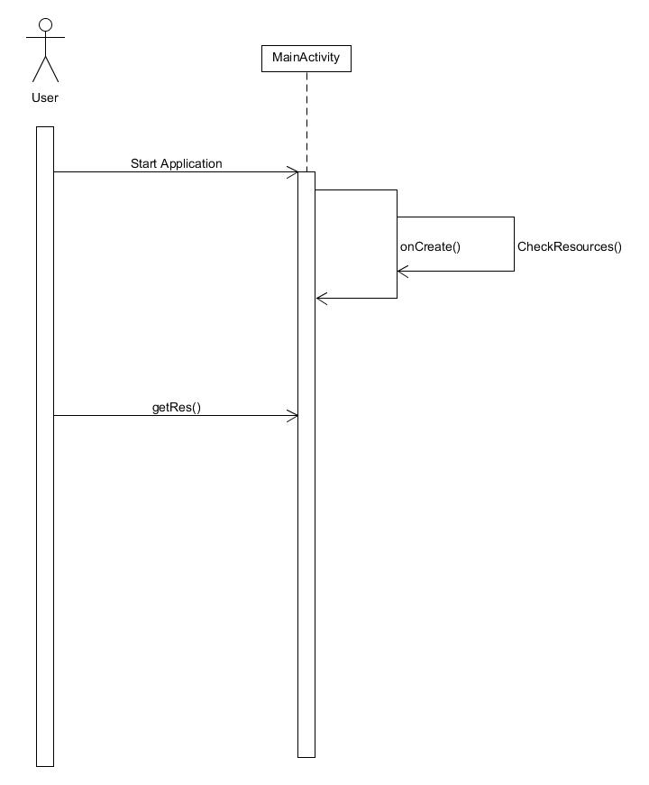

Start live sequence diagram:
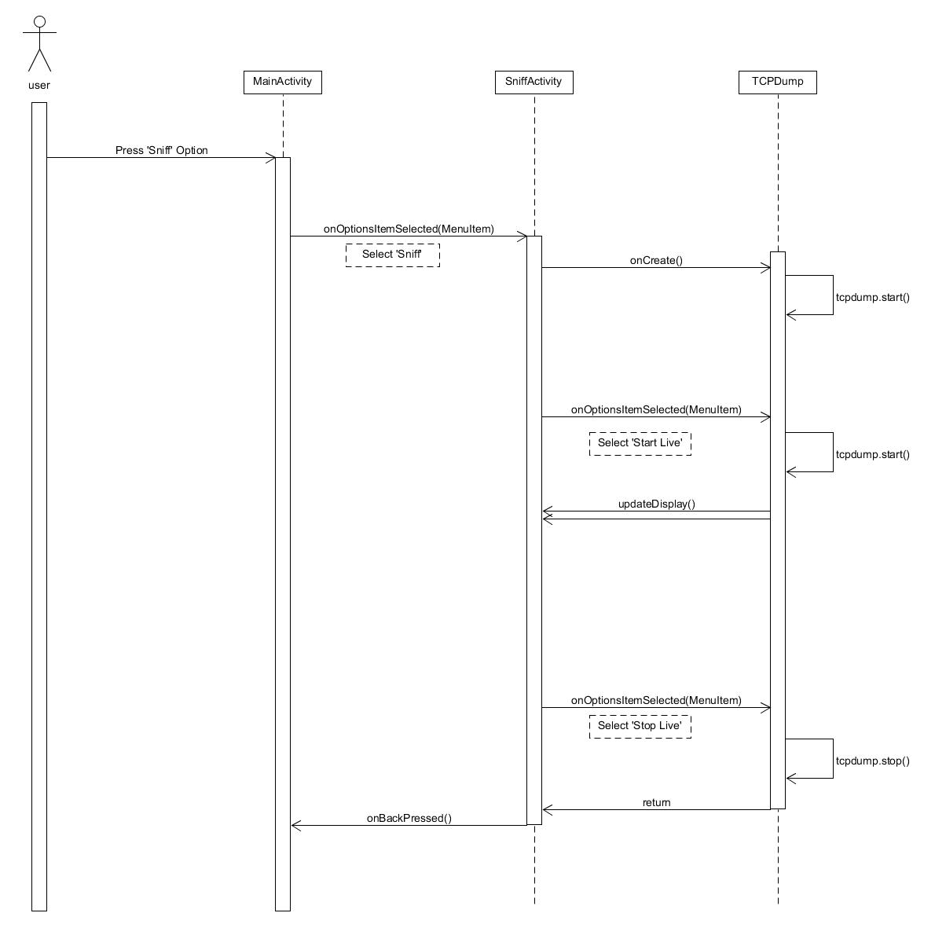

Start pcap sequence diagram:
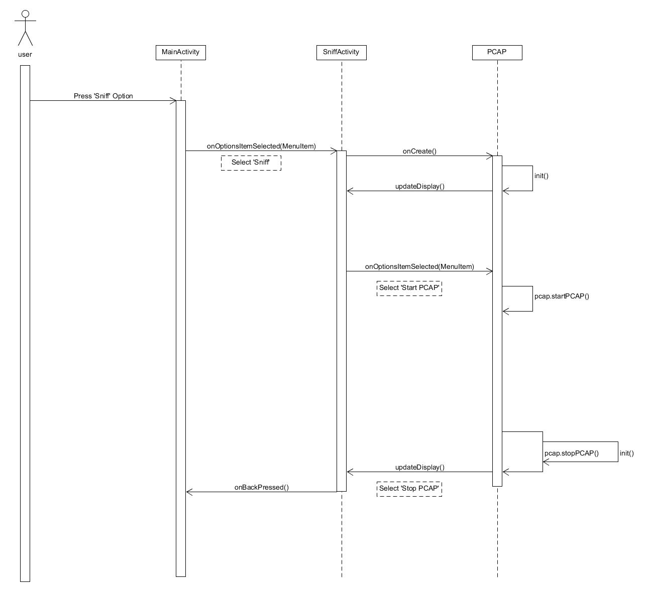

Design Artefacts - Sequence Diagrams (Iteration 2)

You may use any diagramming tool to develop your sequence diagrams for the entire system.

Iteration 2 is based on your team's "LATEST" understanding of the system.

In general, the diagrams in later iterations should be more refined, more evolved, capture more details than diagrams developed in earlier iterations

Note 1 : Your diagram should be developed using standard UML symbols and notations for sequence diagrams!

Note 2 : this section can span as many pages as necessary

Note 3 : If you are pasting screen-shots (from your adopted diagramming tool) into this sub- section, please ensure the wordings / text are clearly visible

Design Artefacts - Deployment Diagrams (Iteration 1)

You may use any diagramming tool to develop your deployment diagrams for the entire system.

Iteration 1 is based on your team's "INITIAL" understanding of the system.

Note 1 : Your diagram should be developed using standard UML symbols and notations for deployment diagrams!

Note 2 : this section can span as many pages as necessary

Note 3 : If you are pasting screen-shots (from your adopted diagramming tool) into this sub- section, please ensure the wordings / text are clearly visible

Design Artefacts - Deployment Diagrams (Iteration 2)

You may use any diagramming tool to develop your deployment diagrams for the entire system.

Iteration 2 is based on your team's "LATEST" understanding of the system.

In general, the diagrams in later iterations should be more refined, more evolved, capture more details than diagrams developed in earlier iterations

Note 1 : Your diagram should be developed using standard UML symbols and notations for deployment diagrams!

Note 2 : this section can span as many pages as necessary

Note 3 : If you are pasting screen-shots (from your adopted diagramming tool) into this sub- section, please ensure the wordings / text are clearly visible

Design Artefacts - <Any other diagrams> (Iteration 1)

Depending on your system's software architecture, there may be many other diagrams (e.g. ER-Model, State / Interaction / Activity Diagrams, etc) which are applicable and should be reflected in your Design Artefacts section of your report.

Please "reuse the same structure" you see for the earlier sections on Use Case / Class / Component diagrams, together with 2 iterations version, for your diagrams in this section.

You may use any diagramming tool to develop your diagrams.

Iteration 1 is based on your team's "INITIAL" understanding of the system.

Note 1 : Your diagram should be developed using standard UML symbols and notations that is relevant for that particular type of diagram!

Note 2 : this section can span as many pages as necessary

Note 3 : If you are pasting screen-shots (from your adopted diagramming tool) into this sub- section, please ensure all the wordings / text are clearly visible

Design Artefacts - <Any other diagrams> (Iteration 2)

Depending on your system's software architecture, there may be many other diagrams (e.g. ER-Model, State / Interaction / Activity Diagrams, etc) which are applicable and should be reflected in your Design Artefacts section of your report.

Please "reuse the same structure" you see for the earlier sections on Use Case / Class / Component diagrams, together with 2 iterations version, for your diagrams in this section.

You may use any diagramming tool to develop your diagrams.

Iteration 2 is based on your team's "LATEST" understanding of the system.

In general, the diagrams in later iterations should be more refined, more evolved, capture more details than diagrams developed in earlier iterations

Note 1 : Your diagram should be developed using standard UML symbols and notations that is relevant for that particular type of diagram!

Note 2 : this section can span as many pages as necessary

Note 3 : If you are pasting screen-shots (from your adopted diagramming tool) into this sub- section, please ensure all the wordings / text are clearly visible

Test Plan Design

Depending on your system's software architecture, there may be many different classes, with many different implemented methods(), whose functionalities need to be tested.

Your team should describe how they intend to test their functionalities to ensure the methods() work as designed.

Below table provides a sample structure, to organize your content. You can reuse this structure to cover as many other important methods() as necessary.

Test Plan for :

<Relate to fuctional requirement>

Club Membership Management - The system should allow the administrator to add new members

Test Case ID: | Description | Expected Outcome | Participating Program's Class & Method to be tested | Participating CPPUnit Test Program's Class & Method doing the testing
E.g.  CM-1 | E.g.  To test for adding a new member's name "John Anderson" | E.g.  System should output a message like "Member : John Anderson created successfully".  The last array slot in the member array should contain the string " John Anderson " | E.g.  Class Name : ManageMember  Method Name :  bool createNewMember (string name) | E.g.  CPPUnit Class Name : TestManageMember  Method Name :  void testCreateNewMember (string name)
E.g.  CM-2 | E.g.  To test for adding an EXISTING DUPLICATE member's name "John Anderson" | E.g.  System should output a message like "Error, member : John Anderson already exists".  The total no. of elements in the member array should remain the same | E.g.  Class Name : ManageMember  Method Name :  bool createNewMember (string name) | E.g.  CPPUnit Class Name : TestManageMember  Method Name :  void testAddingExistingMember (string name)

Appendix A - Formal Meeting Records

Construction Phase - Iteration 1

- Copy and Paste your formal meeting minutes for Construction Phase, iteration 1 here.
- You can refer to Assn 1 Qn Paper, Appendix B, bullet point 4 for a summary of contents to be included.
- Note: this section can span as many pages as necessary

Construction Phase - Iteration 2

- Copy and Paste your formal meeting minutes for Construction Phase, iteration 2 here.
- You can refer to Assn 1 Qn Paper, Appendix B, bullet point 4 for a summary of contents to be included.
- Note: this section can span as many pages as necessary

Construction Phase - Iteration 3 (Optional)

- Copy and Paste your formal meeting minutes for Construction Phase, iteration 3 here.
- You can refer to Assn 1 Qn Paper, Appendix B, bullet point 4 for a summary of contents to be included.
- Note: this section can span as many pages as necessary

Transition Phase - Iteration 1

- Copy and Paste your formal meeting minutes for Transition Phase, iteration 1 here.
- You can refer to Assn 1 Qn Paper, Appendix B, bullet point 4 for a summary of contents to be included.
- Note: this section can span as many pages as necessary

Transition Phase - Iteration 2 (Optional)

- Copy and Paste your formal meeting minutes for Transition Phase, iteration 2 here.
- You can refer to Assn 1 Qn Paper, Appendix B, bullet point 4 for a summary of contents to be included.
- Note: this section can span as many pages as necessary

Appendix B - Individual Work Diaries

Team Member 1 : John Anderson

Construction Phase - Iteration 1

- Copy and Paste your formal meeting minutes for Construction Phase, iteration 1 here.
- You can refer to Assn 1 Qn Paper, Appendix B, bullet point 5 for a summary of contents to be included.
- Note: this section can span as many pages as necessary

Construction Phase - Iteration 2

- Copy and Paste your formal meeting minutes for Construction Phase, iteration 2 here.
- You can refer to Assn 1 Qn Paper, Appendix B, bullet point 5 for a summary of contents to be included.
- Note: this section can span as many pages as necessary

Construction Phase - Iteration 3 (Optional)

- Copy and Paste your formal meeting minutes for Construction Phase, iteration 3 here.
- You can refer to Assn 1 Qn Paper, Appendix B, bullet point 5 for a summary of contents to be included.
- Note: this section can span as many pages as necessary

Transition Phase - Iteration 1

- Copy and Paste your formal meeting minutes for Transition Phase, iteration 1 here.
- You can refer to Assn 1 Qn Paper, Appendix B, bullet point 5 for a summary of contents to be included.
- Note: this section can span as many pages as necessary

Transition Phase - Iteration 2 (Optional)

- Copy and Paste your formal meeting minutes for Transition Phase, iteration 2 here.
- You can refer to Assn 1 Qn Paper, Appendix B, bullet point 5 for a summary of contents to be included.
- Note: this section can span as many pages as necessary

Team Member 'N' : Xxxx Xxxx

Construction Phase - Iteration 1

- Copy and Paste your formal meeting minutes for Construction Phase, iteration 1 here.
- You can refer to Assn 1 Qn Paper, Appendix B, bullet point 5 for a summary of contents to be included.
- Note: this section can span as many pages as necessary

Construction Phase - Iteration 2

- Copy and Paste your formal meeting minutes for Construction Phase, iteration 2 here.
- You can refer to Assn 1 Qn Paper, Appendix B, bullet point 5 for a summary of contents to be included.
- Note: this section can span as many pages as necessary

Construction Phase - Iteration 3 (Optional)

- Copy and Paste your formal meeting minutes for Construction Phase, iteration 3 here.
- You can refer to Assn 1 Qn Paper, Appendix B, bullet point 5 for a summary of contents to be included.
- Note: this section can span as many pages as necessary

Transition Phase - Iteration 1

- Copy and Paste your formal meeting minutes for Transition Phase, iteration 1 here.
- You can refer to Assn 1 Qn Paper, Appendix B, bullet point 5 for a summary of contents to be included.
- Note: this section can span as many pages as necessary

Transition Phase - Iteration 2 (Optional)

- Copy and Paste your formal meeting minutes for Transition Phase, iteration 2 here.
- You can refer to Assn 1 Qn Paper, Appendix B, bullet point 5 for a summary of contents to be included.
- Note: this section can span as many pages as necessary

Appendix C - Evidence of using VCS (Version Control Software)

Version Control Software used : (E.g. Netbeans subversion, TortiseSVN, etc)

Note 1 : The following screenshots can span as many pages as necessary

Note 2 : Please ensure that all the wordings / text in your screen shots are clearly visible

Screenshot #1 - Contents in the VCS's Root Folder containing all Repository Project Files

< Paste Screenshot #1 image here >

Screenshot #2 - VCS's listing of all the latest source files currently being managed

< Paste Screenshot #2 image here >

Screenshot #3 - Example using VCS's to check-out source files (it may be necessary to do >1 screen capture, depending on the software used)

< Paste Screenshot #3 image(s) here >

Screenshot #4 - Example using VCS's to check-in source files (it may be necessary to do >1 screen capture, depending on the software used)

< Paste Screenshot #4 image(s) here >

Screenshot #5 - Example using VCS's to display the change history / log (it may be necessary to do >1 screen capture, depending on the software used)

< Paste Screenshot #5 image(s) here >

