Homework 3

**Pang-Yuxuan-1901110223**

****Question 1:****

The ionization fraction is defined by:



Assume that , are shown in table below:

|  |  |  |  |  |  |  |  |
| --- | --- | --- | --- | --- | --- | --- | --- |
| Element | Ⅰ | Ⅱ | Ⅲ | Ⅳ | Ⅴ | Ⅵ | Ⅶ |
| H | 2 | 1 |  |  |  |  |  |
| C | 9 | 6 | 1 | 2 | 1 | 2 | 1 |

The ionization potential of the three elements are come from book “Physical quantity and celestial physical quantity” by Allen, as shown in table below:

|  |  |  |  |  |  |  |
| --- | --- | --- | --- | --- | --- | --- |
| Element | Ⅱ | Ⅲ | Ⅳ | Ⅴ | Ⅵ | Ⅶ |
| H | 13.598 |  |  |  |  |  |
| C | 11.260 | 24.383 | 47.887 | 64.492 | 392.08 | 489.98 |

I choose a typical , put all these parameters into Saha equation and I got the results below.

**(a)**

The plot of Hydrogen is shown in figure below:

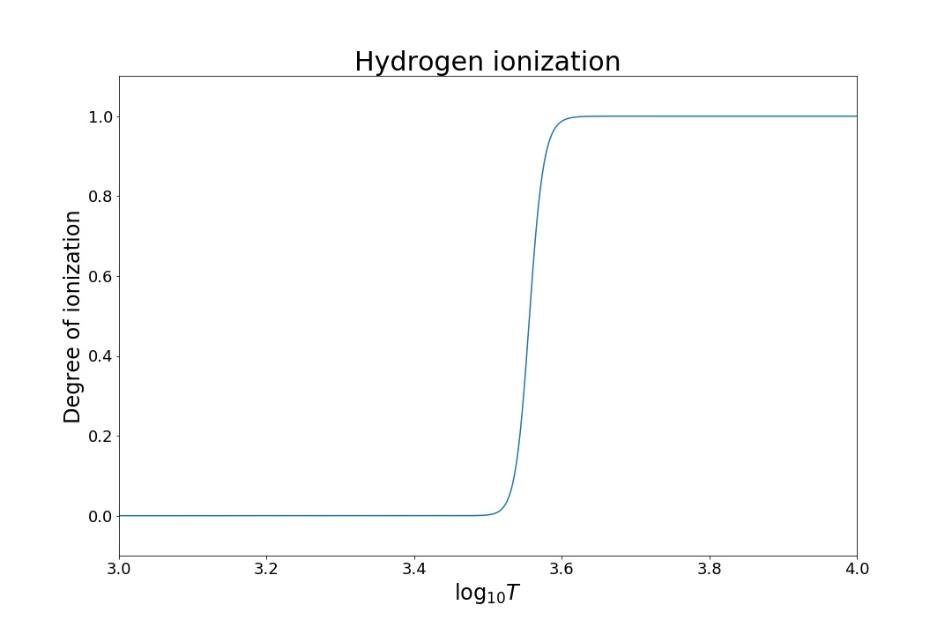

**(b)**

The plot of Carbon is shown in figure below:

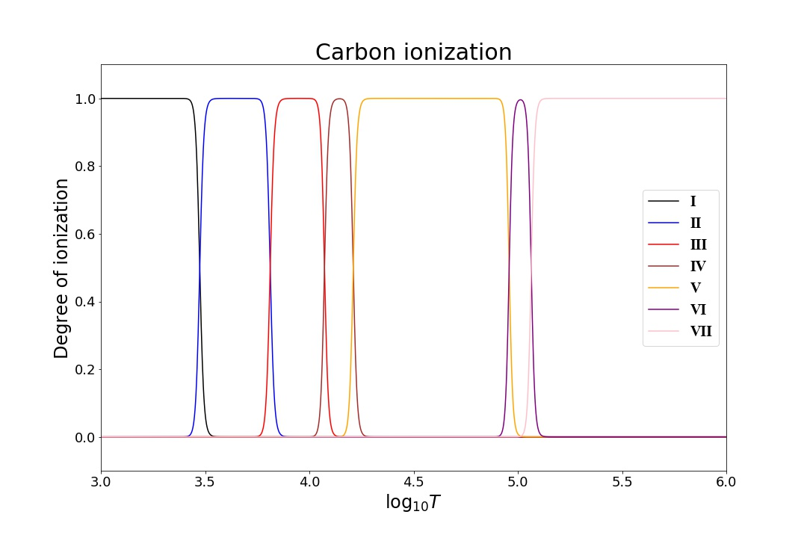

**(c)**

Saha equation writes as:



So, the degree of ionization



Thus whenisn’t match with,, thus I choose x-axis in log and y-axis with linear.

**(d)**

If the star exists CⅠ in absorption, then the stellar temperature must lower than  since higher than that temperature, all the neutral carbon has been ionized; the solar coronae can be see in CⅥ means that the temperature of solar coronae is more thansince lower than that temperature the gas doesn’t have CⅥ at all.

****Question 2:****

**(a)**

First, calculate functions of all kinds of situation:

**For ideal gas:**

Ideal gas is non-relativistic and given by Maxwell-Boltzmann distribution:



So, the pressure of non-relativistic ideal gas is:



Ascan be calculate by:



The pressure can be calculated by:



Quantum-mechanical description of the gas**:**

The number of quantum states in a spatial volume and with momenta  is given by (whereis the number of intrinsic quantum states of the particle):



Electrons are fermions with two spin states:



**For electrons or nucleons**, the fraction of states with energythat will be occupied at temperatureis given by fermion’s distribution:



Assume that electrons are complete degeneracy, then the maximum momentum:



For non-relativistic situation:



Putinto function:

For relativistic situation:



Putinto function:

**For radiation**

The fraction of states with energythat is occupied is:



Since photons are relativistic:



For ionized hydrogen:,

(i)

For non-relativistic situation:



Thus: 

For relativistic situation:



Thus: 

(ii)

Pressure is equal between radiation and ideal gas:



Thus: 

(iii) 

(iv)

The ratio of Coulomb energy to kinetic energy is usually called the Coulomb parameter:



For ionized hydrogen, and, and the criterion ofis 170:

Thus:

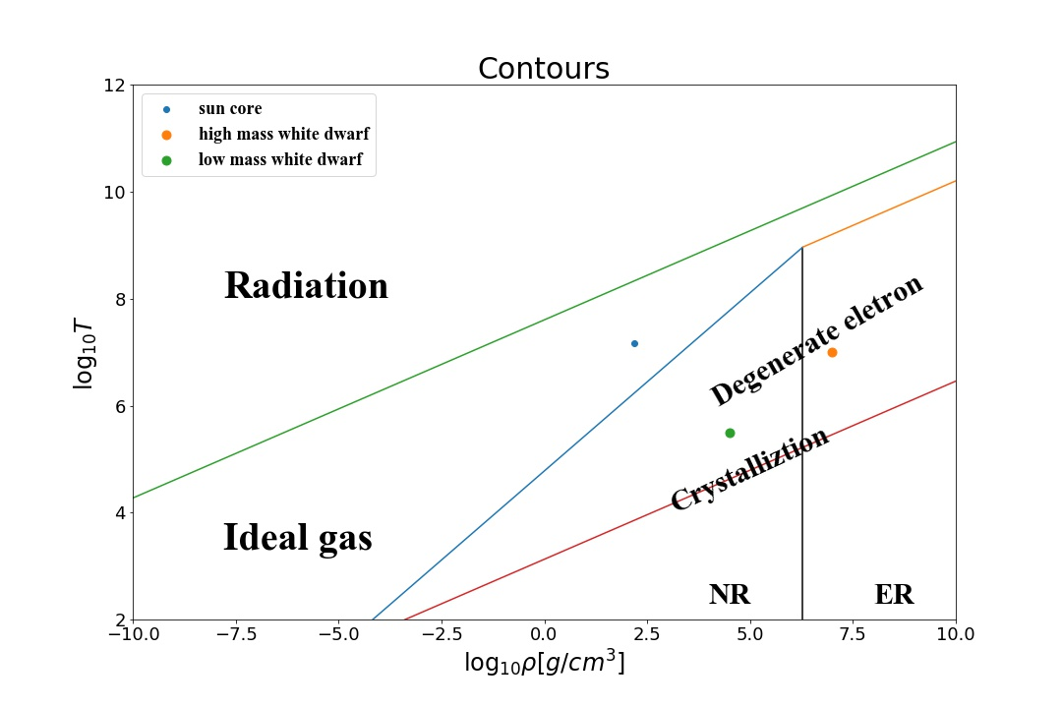

****Question 3:****

**(a)**

From question 2, we know that completely degenerate in extreme relativistic limit:



So, the parameter in polytropic relationisand.

Polytropic index

The relation betweenis:

, 

where (from book table 4-1)

Thus: 

Change it to sun mass, and finally we get:



**(b)**

Only He, the parameter of He is:

Relative quality: , electrons: , proportion: 

Thus:



**(c)**

For only C and O with proportion 3 to 1:

Relative quality: , electrons: 

proportion: 

Thus:



****Question 4:****

**(a)**

Sun’ luminosity: 

The energy come from one pp chain is nearly 

So, the number of reactions per second take place in the sun is:



**(b)**

Every pp chain produces one He atom, which mass is: 

So, the mass of He produced in the sun every second is:



**(c)**

?

**(d)**

The total number neutrino produced by the Sun per second is:



Assumed that the neutrino emission is spherically symmetrical, then the number reach the earth is:



****Question 5:****

**(a)**

**(b)**

**(1) electron scattering**

The opacity coefficient is due to the combined cross-section of all electrons in a unit mass of gas:



The temperature range is 

**(2) free-free absorption**

Summing over all ions in the mixture:



Suppose gas is completely ionized, take the Rosseland mean:



**(3) bound-free absorption**

In rough approximation the total bound-free opacity is also of the Kramers form:



Temperature range

**(4) the H ion**

The opacity is sensitive to metallicity and to temperature, a very approximate formula in the rangeandis:



Temperature range especially when

**Bound-bound absorption:**

Temperature range

**Molecules and dust**

Temperature range especially when

**Conductive opacities**

At low densities and high temperatures.

**(c)**

From the right panel of Fig. 5.2, the densities of different temperatures are shown in table below:

|  |  |  |  |
| --- | --- | --- | --- |
| Temperature (K) |  |  |  |
| Density () |  |  |  |

The mean free path of the photon is calculated by:



**(d)**

The Rosseland mean opacity is defined by:



Whereis plank function:



So 

Put the expression of  and into the function:



Let :



Assume , :



****Question 6:****

****Appendix:****

Question 1:

