Xi’an JIAOTONG-LIVERPOOL UNIVERSITY
西 交 利 物 浦 大 学

Year 4
Course Work Submission

Name | Yuxuan | Wu
ID Number | 1716309
Programme | INT301
Module Title | Biocomputation
Module Code | INT303
Assignment Title | Lab1
Submission Deadline | Time of submission:12.20.2020
Lecturer Responsible

I certify that:
- I have read and understood the University’s definitions of COLLUSION and PLAGIARISM (available in the Student Handbook of Xi’an Jiaotong-Liverpool University).
With reference to these definitions, I certify that:
- I have not colluded with any other student in the preparation and production of this work;
- this document has been written solely by me and in my own words except where I have clearly indicated and acknowledged that I have quoted or used figures from published or unpublished sources (including the web);
- where appropriate, I have provided an honest statement of the contributions made to my work by other people including technical and other support staff.
I understand that unauthorised collusion and the incorporation of material from other works without acknowledgement (plagiarism) are serious disciplinary offences.

Signature …….…吴宇轩……………………… Date …………………11.26.2020…………………

For Academic Office use: | Date Received | Days Late | Penalty

Introduction

Multilayer Perceptrons (MLPs), one of the classical types of artificial neural network, are widely used in classification prediction problems where inputs are assigned into classes or labels [1]. The simple network composed of three components: input layer, hidden layer and output layer, and with the back-propagation training algorithms, the model could automatically update each weight until convergence. Hence, in this project, I would design a MLP model with sigmoid activation function to conduct the vehicle logo classification. Additionally, I tuned and returned the hyperparameters to achieve the minimum mean squared error (MSE) model and used confusion matrix to compare the best MLP model.

Methodology

The provided dataset contains 354 samples with 168 dimensions and the corresponding labels with six categories. For the purpose of training and testing, I split the dataset into a training set (80%) and a testing set (20%). In addition, min-max normalization was followed to minimize the potential outliers’ influence. In this experiment, the MLP model contains three hidden layers with sigmoid activation function in both hidden and output layers (Figure 1). Generally, hyperparameters like number of hidden units, learning rate and momentum could have significant influence of the model performance. Therefore, I used grid search method to loop through the hyperparameters mentioned previously and return the hyperparameters which could minimize the model’s MSE value. The testing sample was then fed into the model to simulate the prediction results and undergo the reverse normalization process to return the predicted labels or categories. The density plots of testing labels and predicted labels were visualized to illustrate the distribution and confusion matrix was applied to evaluate the prediction performance.

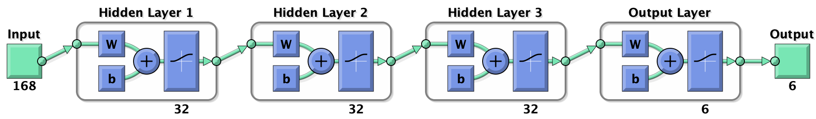
Figure 1: Components of custom MLP

Experimental results and analysis
According to Figure 2, I printed out each MSE value of the model in different combination of hyperparameters. As can be seen from the figure, when the hidden layers contain 8 neurons, learning rate set to 0.4 and momentum set to 0.9, the model could achieve the best performance, with MSE value in 0.2500.

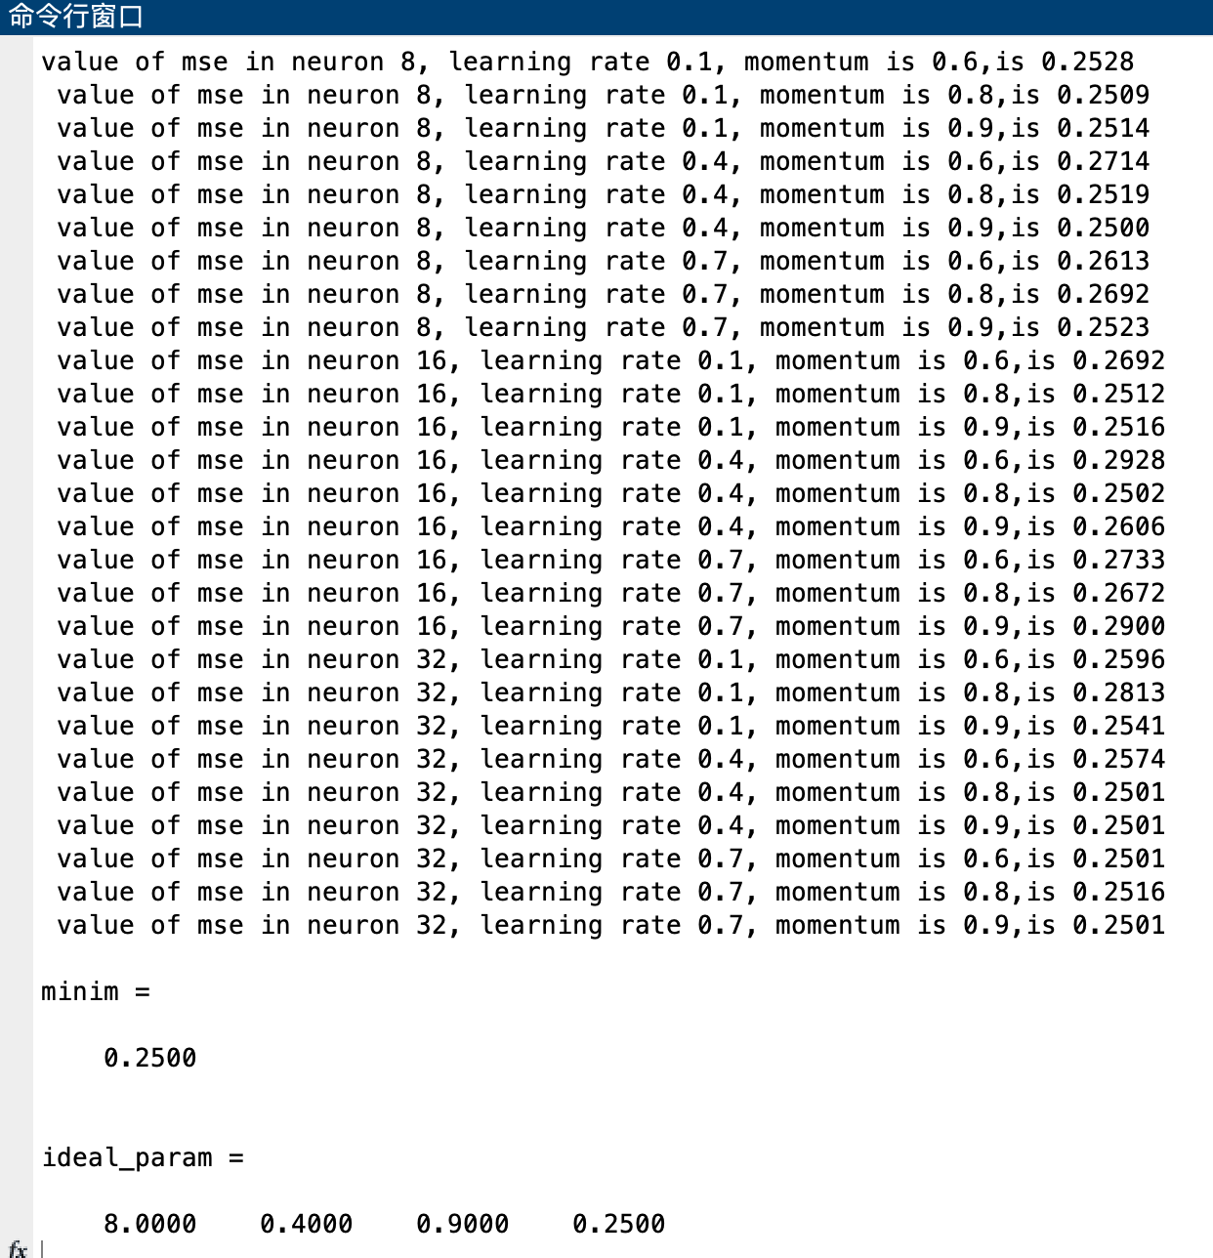
Figure 2: Grid search for the best model performance in hyperparameter tuning

Based on the optimal hyperparameters, I trained the best performance MLP model and simulated the labels on testing data. Figure 3 compares and visualizes the density plot between predicted labels and testing labels, the overall shape is similar, but the predicted labels seems to have a smaller width. We also made a confusion matrix to test the efficacy of MLP model’s prediction (Figure 4).

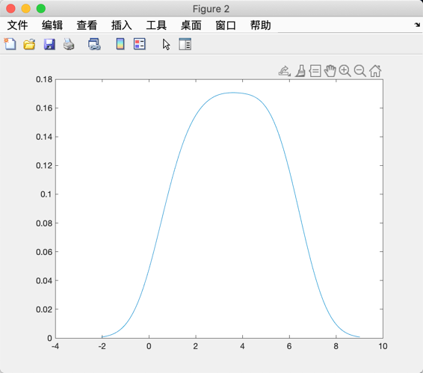
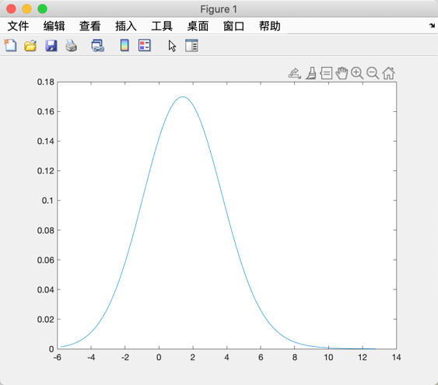
Figure 3: Density plots of predicted labels (A) and testing labels (B)
A
B

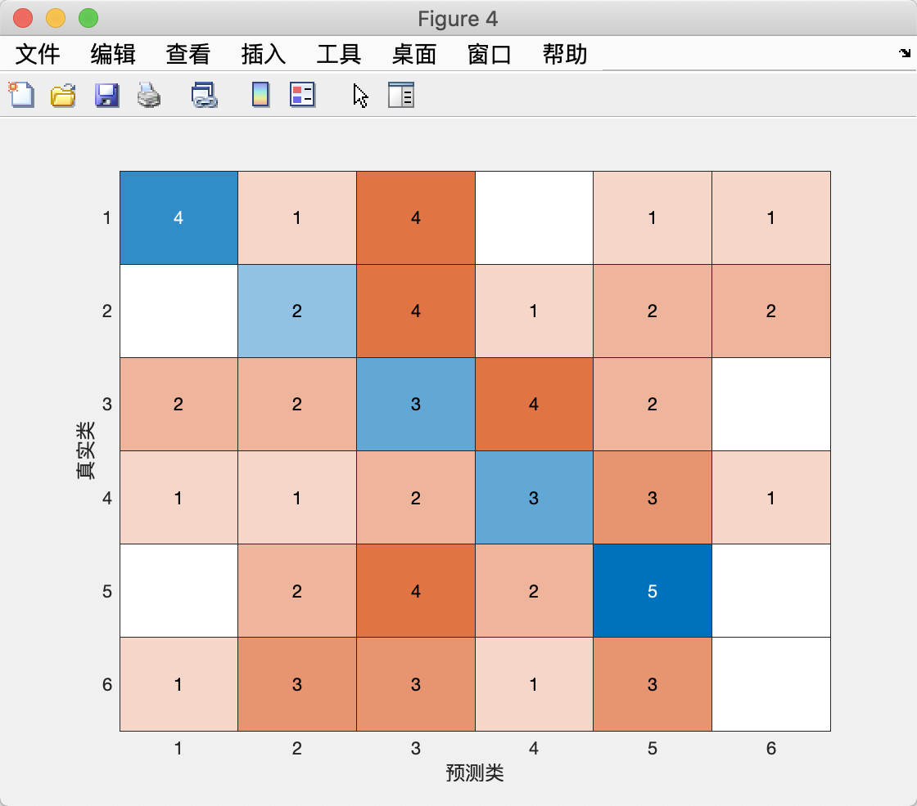
Figure 4: Confusion matrix of predicted labels and testing labels

Conclusion
In this experiment, we used grid search to return the optimal hyperparameters, and the well-trained model could successfully predict the samples into different labels. However, the overall performance was not ideal enough, only 17 out of 70 were successfully predicted. In the future, I would tune the model and incorporate other algorithms to achieve high performance.

Reference

[1] “What is a multi-layered perceptron?” https://www.educative.io/edpresso/what-is-a-multi-layered-perceptron (accessed Nov. 26, 2020).

