Introduction

Image classification, one of the applications of neural network, has gained significant importance in recent years.

Methodology

Figure preprocessing

Data partition

Convolution Neural Network (CNN)

Multi-layer Perceptron (MLP)

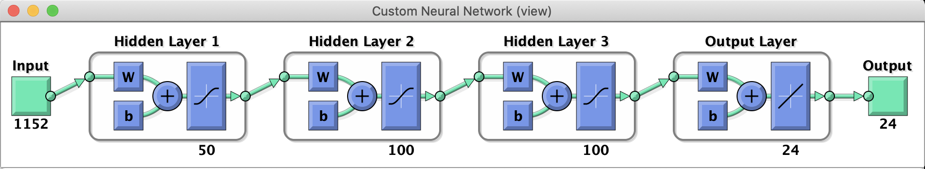

Learning Vector quantization (LVQ)

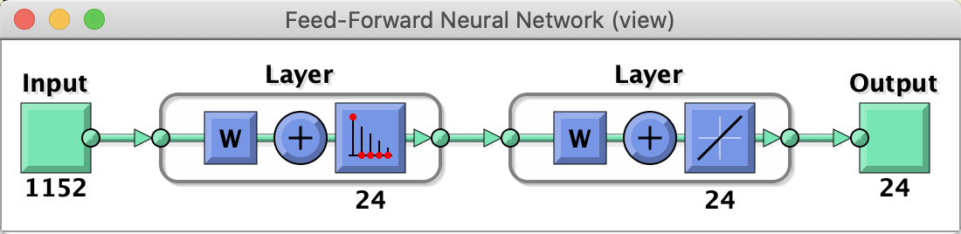

Radial Basis Function (RBF) Networks with k-means

Radial Basis Function (RBF) Networks with Self Organizing Map (SOM)

Experimental results and analysis

Convolution Neural Network (CNN)
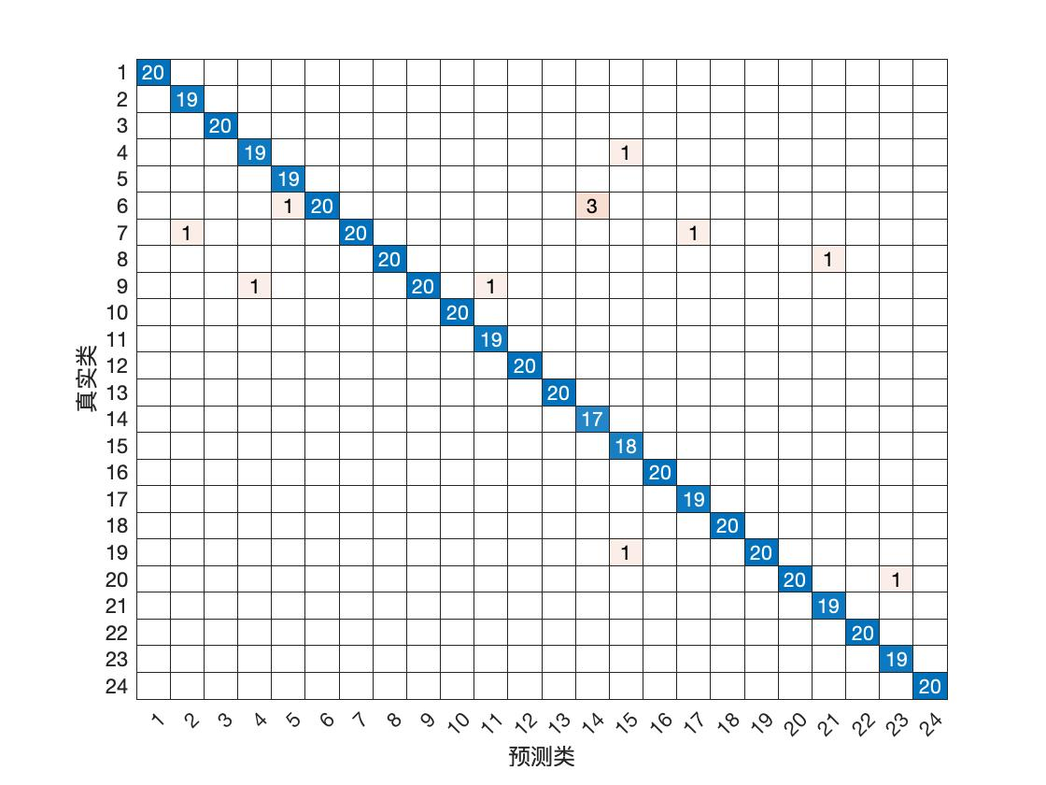
Multi-layer Perceptron (MLP)
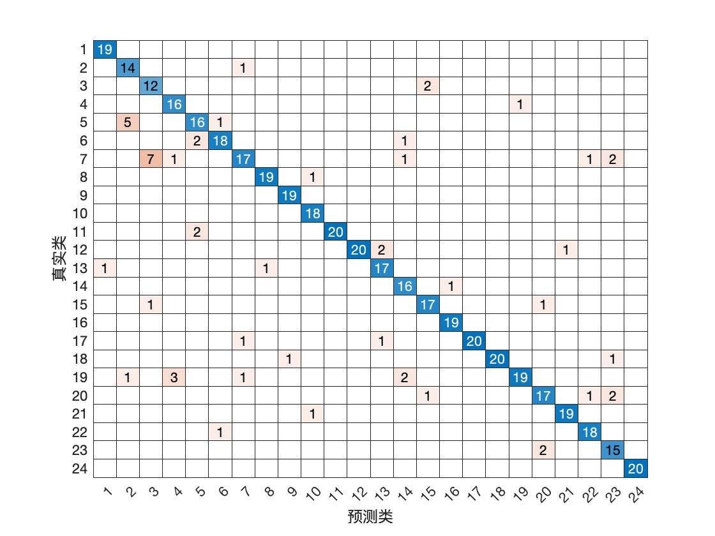
Learning Vector quantization (LVQ)

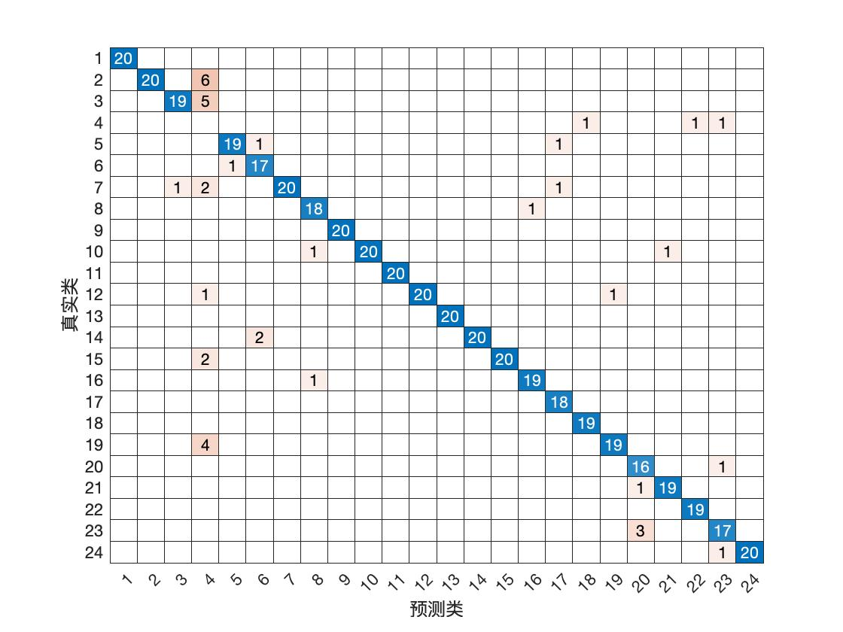

Radial Basis Function (RBF) Networks with k-means
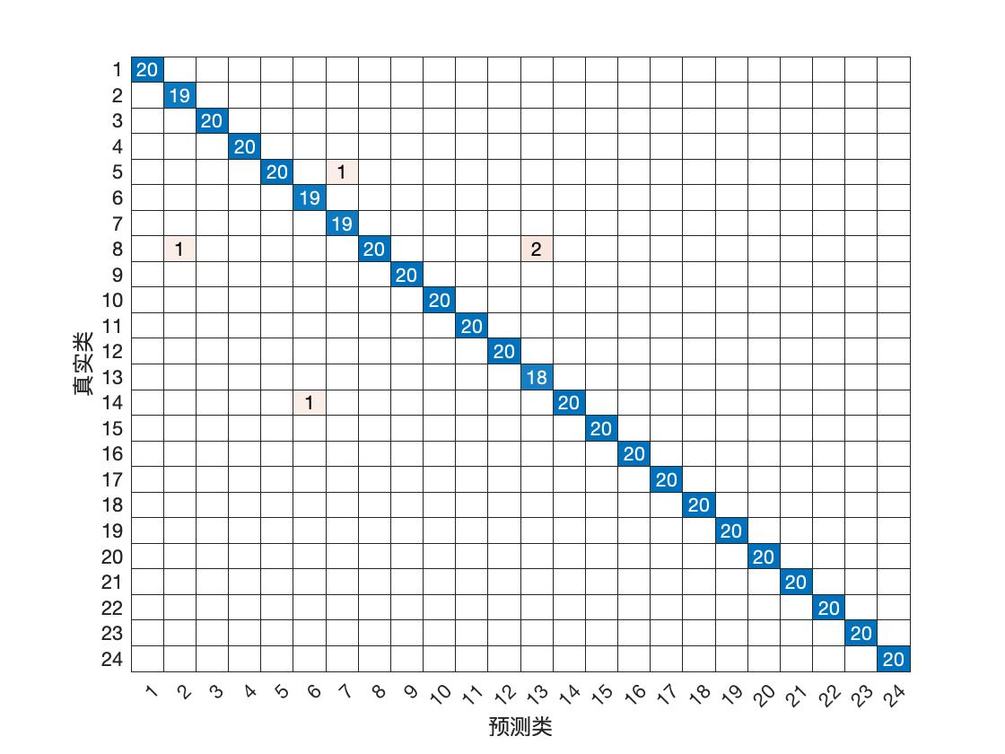

Radial Basis Function (RBF) Networks with Self Organizing Map (SOM)

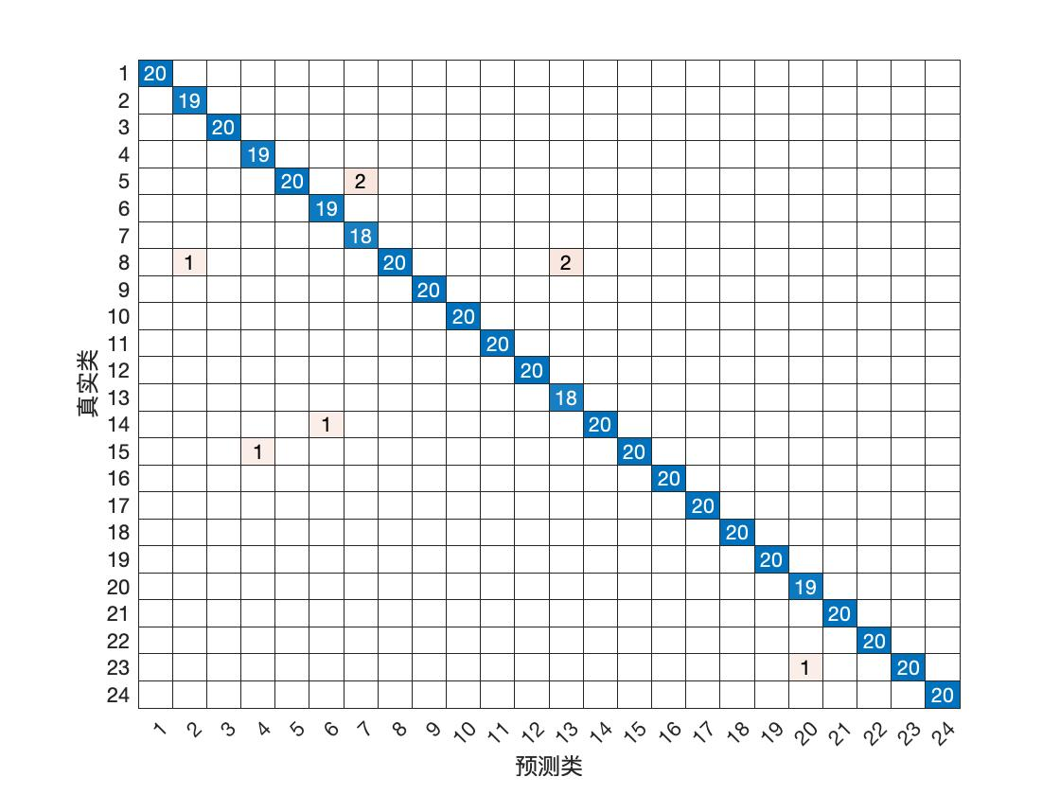

Conclusion

Reference

