**Meta-analysis for knockdown of METTL3 or METTL14 affecting N6-methyladenosine methylation level**

Yuxin Zhang  
 Department of Biological Sciences  
Xi’an Jiaotong and Liverpool University  
 Suzhou Jiangsu China  
yuxin.zhang17@student.xjtlu.edu.cn

Yuxuan Wu  
Department of Biological Sciences  
 Xi’an Jiaotong and Liverpool University  
 Suzhou Jiangsu China  
yuxuan.wu17@student.xjtlu.edu.cn

Di Zhen  
Department of Biological Sciences  
 Xi’an Jiaotong and Liverpool University  
 Suzhou Jiangsu China  
di.zhen17@student.xjtlu.edu.cn

Kunqi Chen*  
Department of Biological Sciences  
Xi’an Jiaotong-Liverpool University  
Suzhou Jiangsu China  
kunqi.chen@xjtlu.edu.cn

Jia Meng  
  Department of Biological Sciences  
Xi’an Jiaotong-Liverpool University  
Suzhou Jiangsu China  
jia.meng@xjtlu.edu.cn

ABSTRACT

N6-methyladenosine (m6A) is the most prevalent internal chemical modification present in multiple eukaryotic mRNAs, which is dynamically installed by methyltransferases (“writers”) and removed by demethylases (“erasers”). METTL3 and METTL14 are two typical m6A writers and several studies have found that knockdown or depletion of METTL3 and METTL14 genes influence the methylation level. A meta-analysis study was performed to assess the strength and quality of current evidence regarding it and assess how the knockdown of METTL3 or METTL14 affects the mRNA methylation level. Data were collected and classified. Metafor, an R package was used to generate the Random-effects meta-analysis model and calculate the risk ratios (RRs) and 95% CIs. Since the heterogeneity of the overall data is extremely high (I2 > 99%), specific samples were excluded to minimize the downgrade the heterogeneity to an acceptable level. Three and two published trails for METTL3 and METTLE14 samples, respectively, were eligible for review and analysis due to the acceptable low heterogeneity of their combination (METTL3 (Q = 12.85, I2 = 37.8%) and METTL14 (Q = 45.48, I2 = 82.9%) ). The positive relationship between knockdown of METTL3/METTL14 and methylation level was successfully verified and the difference among cell lines and gene types was identified.

CONCEPTS

• Applied computing • Life and medical sciences • Bioinformatics

KEYWORDS

Meta-analysis, m6A, Writers, Methylation level

1. Introduction

As is the case with proteins and DNA, RNA undergoes chemical modifications that can affect its metabolism, function, and localization [1]. To date, more than 100 kinds of RNA modifications have been reported with which ribosomal and transfer RNA transcripts incorporate most of the diverse chemical modifications [1, 2]. N6-methyladenosine (m6A) modification is the most prevalent internal modification in eukaryotic mRNAs, which was first discovered in the 1970s [2, 3]. The biological significance of this modification in organisms has been appreciated in recent years, involving regulating cardiac gene expression and cellular growth [4], controlling T cell homeostasis [5], aiding the UV-induced DNA damage response [6], regulating postnatal development of mouse cerebellum [7] and heat shock protein expression [8]. M6A methylation is a dynamic process achieved by the catalytic activities of methyltransferase (“writer”) and demethylase (“eraser”): it is catalyzed by “writers”, which is usually a large 1MDa RNA methyltransferase complex (MTase) composed of two catalytic subunits, namely METTL3 (Methyltransferase-like 3), METTL14 (Methyltransferase-like 14), a splicing factor (WTAP) and other subunits not yet identified [9]. Conversely, methyl groups are removed from the mRNA transcripts by RNA demethylases (“eraser”). FTO (Fat mass and Obesity-associated protein) and ALKBH5 (alkB homolog5) are two typical m6A eraser proteins [9]. It is worth noting that the impressive functional diversity of m6A sites is significantly associated with these m6A related enzymes. This dynamic RNA modification may influence biological activities analogous to the well-studied reversible DNA modifications. For example, FTO can regulate dopaminergic signaling in the brain as RNA methylase [10]

METTL3 was identified as a catalytic component of the methyltransferase complex, which is responsible for methylation of the adenosine within the substrate RNA containing a “GGACU” consensus sequence [11, 12]. METTL3 can also form a stable complex with METTL14, which contains its methyltransferase domain with a variant catalytic motif [12]. Among the methyltransferase complex, METTL3 alone is catalytically active and methylate the adenosine while METTL4 is involved in binding target mRNA transcripts [13]. For normal m6A modification to occur in cells, METTL3 and METTL4 also need to associate with additional factors such as WTAP to aid appropriate localization [10, 12]. In terms of structure, METTL3 and METTL4 share about 25% sequence identity and both of them harbor a central MTA-70-Methyltransferase domain [12, 14]. METTL3 additionally corporates an N-terminal region containing two putative motifs whereas, in METTL14, the shared domain is flanked by extra N- and C-terminal extensions harboring sequences with low complexity (about 50 aa) [12, 14]. Besides, both METTL3 and METTL14 are observed predominantly in nuclear speckles while their methyltransferase activity shas been detected in both nuclear and cytoplasmic extracts [15, 16].

In addition to participating in the m6A methylation process, METTL3 and METTL4 play significant roles in a various biological process. It is reported that METTL3 could promote oncogene expression, promotes cancer cell growth, survival, and invasion by facilitating translation in it [15, 17-19]. Moreover, the role of METTL3 in controlling myeloid differentiation of normal hematopoietic and leukemia cells [20], cardiac homeostasis and hypertrophy [16], expression of actively transcribed genes, and sustenance of oncogenic signaling [21, 22] has been uncovered. The various biological function of METTL14 has been identified as well. Researches confirmed that METTL14 could inhibit bladder TIC self-renewal and bladder tumorigenesis [23]. Furthermore, METTL14 is believed to be essential for epitranscriptomic regulation of striatal function and learning [24]. METTL3 and METTL4 can also cooperatively perform specific functions. For instance, the RNA methyltransferase complex of METTL3, METTL4, and WTAP can regulate mitotic clonal expansions in adipogenesis [25] and METTL3/METTL14 mediated mRNA methylation can modulates murine spermatogenesis [11].

Various literatures are available focusing on the consequent effect of knocking down the methyltransferase. Researches shows that the knockdown of METTL3 or METTL14 would upregulates the expression of certain transcripts such as the pluripotency factor Nanog [26]. Also, depletion of these two protein negatively affect the embryonic stem cell differentiation[27]. Knocking down of METTL3 or METTL14 genes in T cells would lead to slower mRNA decay and suppressed T-cell homeostatic proliferation and differentiation [5]. The critical role of methyltransferase on cancer development was explored as well. Studies found that METTL3 or METTL14 can induce and enhance cancer cell proliferation, survival , tumor initiation and progression. Knocking down of these two enzyme induces cell-cycle arrest, cell differentiation and apoptosis and therefore delay cancer or tumor progression [20]. A number of literatures reported that the knockdown or depletion of METTL3 or METTL14 results in decreased m6A modifications, which means the methylation level would possibly degrade[11]. Some independent also confirmed that the mRNA methylation would be influenced by the knockdown of METTL3 and/or METTL14. However, no literature has been published to systematically study the relationship between the knockdown of methyltransferase and methylation level based on published literatures or data. Therefore, we designed this project to evaluate the quality and strength of the current evidence regarding the effects of the knockdown of METTL3/METTL14 on mRNA m6A methylation levels under different cell line.

**2 Material and Methods**

**2.1 Data sets and preprocessing**

For this systematic review and meta-analysis, our discovery data cohort came from various databases including Cochrane library, EMBASE, and PubMed/MEDLINE from inception to Feb 20, 2020. Seventeen datasets of epitranscriptome-wide homo sapiens m6A sites under different cell lines screened by six different high-resolution profiling approaches were collected (Table 1). Missing and ambiguous data were further ensured and validated by the original researchers (Figure 1).



Figure 1: PRISMA flowchart for inclusion or exclusion criteria in this meta-analysis We firstly retrieved our data (n=1555) from both GEO and GSA database. In this analysis, the primary focus was on Homo sapiens, we then exclude other unrelated species, like Mus musculus and Rattus norvegicus, our sample then restricted to 242. When explored in the full-text articles, we did not consider genes other than METTL3 or METTL14, therefore, genes like FTO, ALKBH5 and WTAP were excluded, and sample number was retained to 28. Owing to the fact that some experiments shared the same control group, we then eliminated the duplication and 17 samples remained. The remained samples were used to conduct the whole meta-analysis.

**Table 1 Base-resolution or high-resolution datasets of m6A sites**

|  |  |  |  |  |
| --- | --- | --- | --- | --- |
| Dataset | Technique | Cell line | GEO | Ref. |
| S1 | miCLIP | MOLM13 | GSE98623 | [20] |
| S2 | HEK293 | GSE63753 | [28] |
| S3 | HepG2 | GSE73405 | [29] |
| S4 | HEK293T | GSE122948 | [30] |
| S5 | HepG2 | GSE121942 | [31] |
| S6 | HCT116 | GSE128699 | [32] |
| S7 | m6A-CLIP | HeLa | GSE86336 | [33] |
| S8 | CD8T | GSE71154 | [34] |
| S9 | A549 |
| S10 | MAZTER-seq | HEK293T | GSE122961 | [35] |
| S11 | ESC |
| S12 | m6A-REF-seq | HEK293 | GSE125240 | [36] |
| S13 | brain |
| S14 | kidney |
| S15 | liver |
| S16 | PA-m6A-seq | HeLa | GSE54921 | [37] |
| S17 | m6A-seq (improved protocol) | A549 | GSE54365 | [38] |

Data from the 17 datasets were collated and grouped based on their cell line and the gene knockdown (METTL3 or METTL14 gene). There are respectively 8 and 6 samples for METTL3 and METTL14 genes and each sample was further divided into control group and knockdown group (Table 2 and 3).

**Table2 METTL3 knockdown samples**

|  |  |  |  |  |  |
| --- | --- | --- | --- | --- | --- |
| ID | GSE | Cell line | Treatment | Columns | Ref. |
| 1 | GSE46705 | HeLa | Control | 8 | [39-41] |
| Mettl3 knockdown | 9 |
| 2 | GSE55572 | HEK293T | Control | 14 | [38] |
| Mettl3 knockdown | 15 |
| 3 | GSE55572 | A549 | Control | 17 |
| Mettl3 knockdown | 18 |
| 4 | GSE94808 | GSC | Control | 29 | [2] |
| Mettl3 knockdown | 30 |
| 5 | GSE94613 | MOLM13 | Control | 36 | [42] |
| Mettl3 knockdown | 37 |
| 6 | GSE110320 | HepG2 | Control | 57 | [31] |
| Mettl3 knockdown | 58 |
| 7 | GSE132306 | EndoC-bH1 | Control | 83 | [43] |
| Mettl3 knockdown | 84 |
| 8 | GSE93911 | HEC-1-A | Control | 97 | [44] |
| Mettl3 knockdown | 98 |

**Table3 METTL14 knockdown samples**

|  |  |  |  |  |  |
| --- | --- | --- | --- | --- | --- |
| ID | GSE | Cell line | Treatment | Columns | Ref. |
| 1 | GSE46705 | HeLa | Control | 8 | [39-41] |
| Mettl14 knockdown | 10 |
| 2 | GSE55572 | A549 | Control | 17 | [38] |
| Mettl14 knockdown | 19 |
| 3 | GSE94808 | GSC | Control | 29 | [2] |
| Mettl14 knockdown | 31 |
| 4 | GSE90642 | HepG2 | Control | 48 | [45] |
| Mettl14 knockdown | 49 |
| 5 | GSE110320 | HepG2 | Control | 57 | [31] |
| Mettl14 knockdown | 59 |
| 6 | GSE132306 | EndoC-bH1 | Control | 83 | [43] |
| Mettl14 knockdown | 85 |

**2.2 Data extraction and measures**

Leading authors, publication citation, GSE number, cell line, and treatment (control or knockdown of METTL3/METTL14 gene) were collected from the collected dataset. The quality and reliability of data were measured based on the journal where they published, profiling approaches used, and the appropriateness of the experiments.

Experiment groups were prepared via the RNA methylation differential analysis with MeRIP-seq data [46] and exome Peak R/Bioconductor package [47]. By calculating the difference between methylation level under different treatments, samples were categorized as "experimentally positive" or "experimentally negative". For a given sample, if its experimental group has a higher methylation level than its control group, then it would be considered as “experimentally positive” and vice versa.

**2.3 Statistical analysis**

The RNA methylation level in the experimental group and control group were compared and assessed. “metafor”, an R package[48], was used to perform a meta-analysis and calculate the risk ratios (RRs) and 95% CIs using the random-effects model.

The data within the studies were pooled and evaluated by statistical heterogeneity I 2, which is the percentage of the total variation across studies that is due to heterogeneity rather than by chance. An I 2 of 25%, 50%, and 75% were considered as low, moderate, and high, respectively. A Forest plot was made to compare and visualize the relationship between each sample, demonstrating the 95% CIs and effect sizes.

When an inconsistency was discovered between the RR for the same outcome, subgroup analysis was applied to determine the data which contribute significantly to the high heterogeneity. The potential influence of each sample was determined, ordered, and visualized by the R package introduced by Baujat [49]. Samples were eliminated by order and the heterogeneity of the left samples was analyzed until the heterogeneity was reduced to an acceptable level. Furthermore, the remaining sample was further divided into ten pieces and each piece was considered as housekeeping genes. Then data were recombined and conduct the subgroup analysis to figure out the lowest heterogeneity combination.

Funnel plots were produced to visualize the potential publication bias since researchers tend to publish strong effect sizes study. Additionally, both the rank correlation test and Egger’s regression test was used as an objective measurement of potential bias.

**3.0 Result and Discussion**

**3.1 The Basic Model**

In the basic model, eight studies of methyltransferase knockdown based on different cell lines are included. As shown in the forest plot reported in Figure 2., by knocking down the METTL3 genes, there is a high possibility (Log RR = 6.93, 95% CI = 3.63-13.25, p-value < 0.01) that the m6A methylation level increases from the level where the METTL3 genes exist. The positive association between knockdown of METTL3 and m6A methylation level is proved significant with high confidence by examining that, across all studies included, the Log Risk Ratios (RR) are far from 1 with narrow 95% confidence intervals (CI). As for the basic model of METTL14, the m6A methylation level increases from the level where the METTL14 genes exist with a high possibility (Log RR = 11.53, 95% CI = 2.96-44.95, p-value < 0.01). The significant positive association between knockdown of METTL14 and m6A methylation level is larger than that in the case of METTL3, while the 95% CI is wider in the sense of less certainty. Data from the 17 datasets were collated and grouped based on their cell line and the gene knockdown (METTL3 or METTL14 gene). There are respectively 8 and 6 samples for METTL3 and METTL14 genes and each sample was further divided into control group and knockdown group (Table 2 and 3).

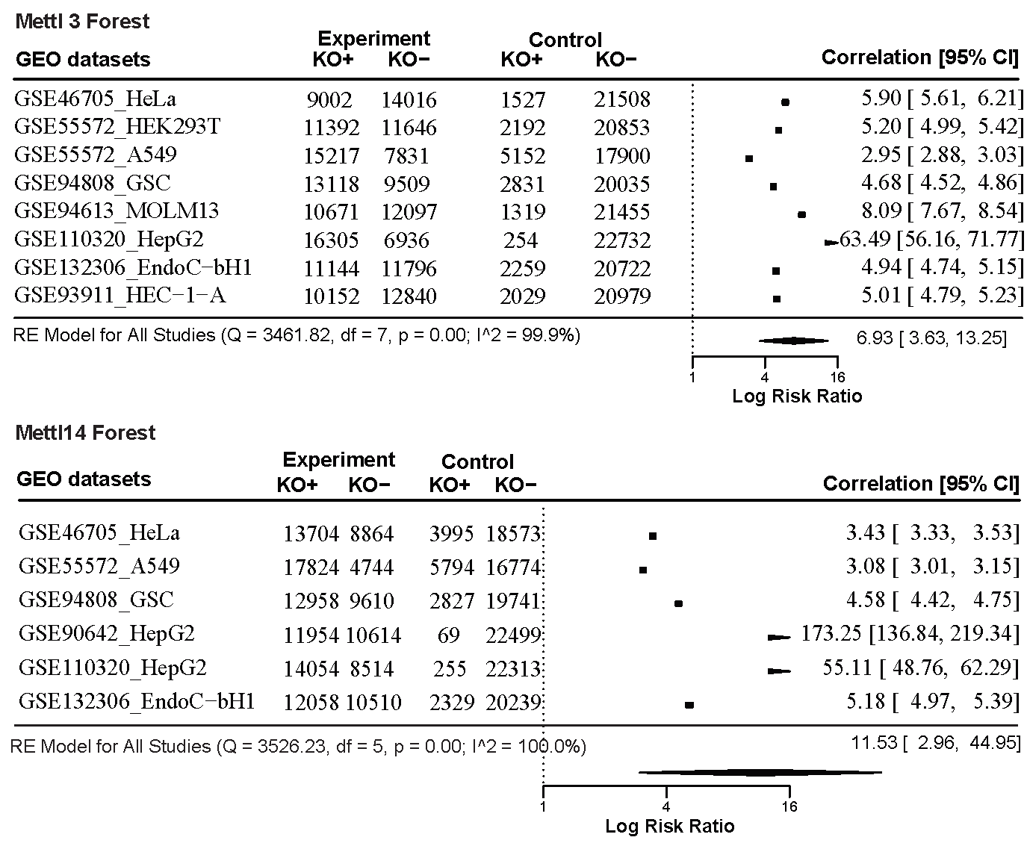

Figure 2. Forest plot of the basic model. This is a Random Effect model that accommodates differences in the study sample. Q statistic is based on the chi-square distribution, most commonly testing heterogeneity. I2 index is the total variability in a set of effect sizes due to true heterogeneity. Log Risk Ratio is a measurement of effect size.

However, strong heterogeneity or inconsistency of METTL3 (Q(df = 7) = 3461.82, I2 = 99.9%, tau2 = 0.8716) and METTL14 (Q(df = 5) = 3526.23, I2=100%, tau2 = 2.8867) samples are found among the studies, and through the visual inspection, all the CIs are indeed poorly overlapped. The inconsistent effect across the studies reflects the variability from the systematic review, and is usually caused by the difference in samples or methodology. In this case, as those studies were conducted under different cell lines, it is not surprising that analysis suffers from huge heterogeneity. The significant heterogeneity reported by the Random Effect model indicates that the discrepancy of cellular environment and activities should be considered as the source of between-study variability in meta-analysis.

**3.2 Quality Assessment**

Investigating heterogeneity is a critical feature of a meta-analysis of studies. To control over heterogeneity, we considered both exclusion rules and moderator analysis. Specifically, we first examined the Baujat plot and excluded the identified studies contributing to heterogeneity, and then we explored the source of heterogeneity by performing subgroup analysis and meta-regression relating design features to an outcome.

As shown in Figure 3, Baujat plot generated from the METTL3 study datasets identifies the influence on the overall result and the squared Pearson Residual of each study. As the 8th study is located in the top right quadrant, it has both a greater impact on the whole result and contributes most to heterogeneity; while other studies are near to the origin. Therefore, we keep all studies but the one far away on the top right. Similarly, we excluded the 4th study as it lies far top right in the Baujat plot of METTL14.

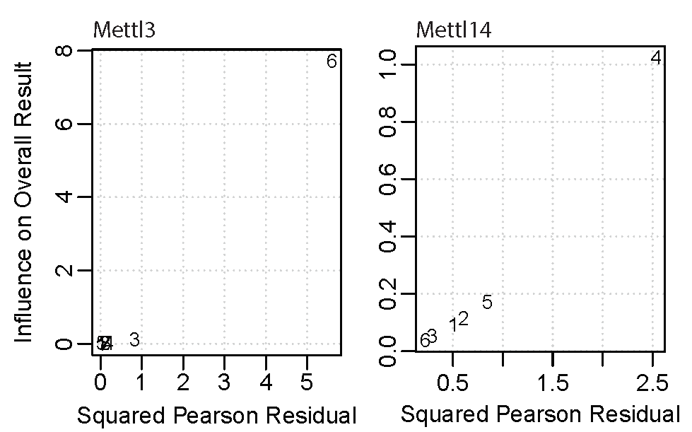

Figure 3. The Baujat plot to identify studies contributing to heterogeneity. The study ID numbers represent eight studies, respectively

Furthermore, since the inconsistency (I2) dropped but is still high enough, based on Random Effect model, we introduced design features and conducted subgroup analysis. Including the aforementioned cell lines as a source of variability, we also specified the gene type as one characteristic to serve as a design feature for subgroup analysis. We kept the numbers of characteristics to a minimum to avoid the over-complexity. Instead of analyzing two design features separately, we employed meta-regression with two predictors.

As shown in Figure 4., we can still conclude that there is a highly positive relationship (Log RR 5.66, 95% CI 5.31-6.02; p-value = 0.12) between the m6A methylation level and the knockdown of the METTL3 gene, although the p-value increases from <0.01 to 0.12 meaning less confidence. The Log RR is adjusted from 6.93 to 5.66. The CI narrows down greatly and CI of each subgroup overlaps more than the basic model, reflecting less between-study variability. As for the METTL14 model, the positive relationship (Log RR 5.39, 95% CI 4.97-5.84; p-value < 0.01) between the m6A methylation level and the absence of METTL14 gene shows similar Log RR with that of METTL3 meta-regression model. Importantly, we found no large heterogeneity or inconsistency of METTL 3 (Q(df = 8) = 12.85, I2 = 37.8%, tau2 = 0.0035) and METTL14 (Q(df = 9) = 45.48, I2= 82.9%, tau2 = 0.0140) among the studies.



Figure 4. Forest plot of moderator analysis

**3.3 Publication Bias**

Publication bias, occurring in the selective publication of studies based on magnitude and direction of findings, poses a particular threat to the validity of meta-analysis. Here, we investigate possible publication bias by visual inspection of Funnel plots. If the effect size versus standard is broadly symmetrical, the publication bias is absent. As shown in Figure 5., the Funnel plot on the left shows the points of nine studies of METTL3 knockdown evenly fall on both sides of the summary effect size and the standard error is approximately 0.075 on average. However, the vertical line representing the summary of all the studies of METTL3 knockdown lies on the right of zero, around 1.73, suggests that there is a positive effect of publication bias on the summary effect size. As for the Funnel plot on the right, points of ten studies of METTL14 knockdown evenly fall on both sides of the summary effect size. The standard error is approximately 0.050 on average and the vertical line lies on the origin meaning no publication bias on the summary effect size.

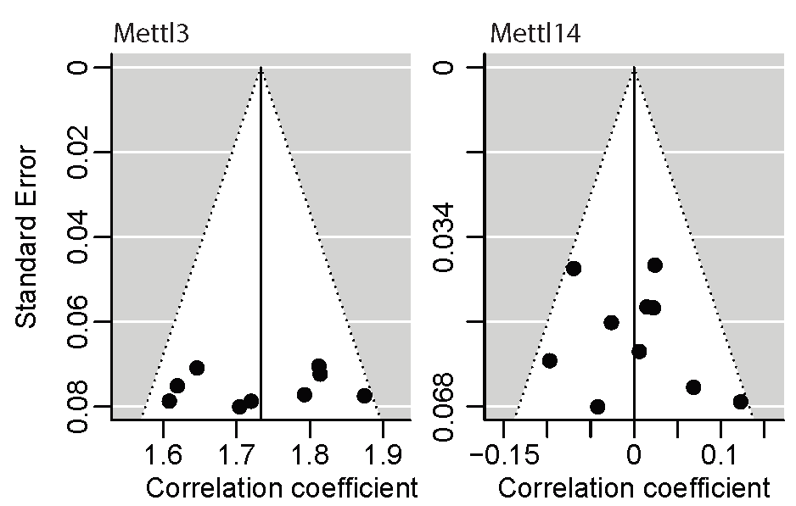

Figure 5. The Funnel plots.

4.0 Conclusion

We successfully verified the positive relationship between the knockdown of methyltransferase and methylation levels in different cell lines. Knocking down of Mettl3 or Mettl14 tends to increase the methylation level within cells and the positive relationship is common over different cell lines and gene types. However, the degree of methylation level change responding to the knockdown of methyltransferase gene varied in different cell line and gene types. To our knowledge, this is the first meta-analysis that investigate the association between methyltransferase and methylation levels, which provides an insight to their relationship.

However, there are a few limitations to this project. This meta-analysis is not generally comprehensive due to the lack of experiments or studies studying the relationship between methyltransferase and methylation levels so far. Therefore, the number of works or literature included is limited. Fortunately, the area of m6A methylation is increasingly explored and and become popular within Bioinformatics communities. Our meta-analysis model could be extended and improved by incorporating newly published studies and data. In addition, publication bias is observable from the funnel plot. More effort will be paid when review, select literature and collect data for our future meta-analysis study.

REFERENCES

[1] Lichinchi, G., Gao, S., Saletore, Y., Gonzalez, G. M., Bansal, V., Wang, Y., Mason, C. E. and Rana, T. M. Dynamics of the human and viral m(6)A RNA methylomes during HIV-1 infection of T cells. Nat Microbiol, 1 (Feb 22 2016), 16011.

[2] Cui, Q., Shi, H., Ye, P., Li, L., Qu, Q., Sun, G., Sun, G., Lu, Z., Huang, Y., Yang, C. G., Riggs, A. D., He, C. and Shi, Y. m(6)A RNA Methylation Regulates the Self-Renewal and Tumorigenesis of Glioblastoma Stem Cells. Cell Rep, 18, 11 (Mar 14 2017), 2622-2634.

[3] Baquero-Perez, B., Antanaviciute, A., Yonchev, I. D., Carr, I. M., Wilson, S. A. and Whitehouse, A. The Tudor SND1 protein is an m(6)A RNA reader essential for replication of Kaposi's sarcoma-associated herpesvirus. Elife, 8 (Oct 24 2019).

[4] Kmietczyk, V., Riechert, E., Kalinski, L., Boileau, E., Malovrh, E., Malone, B., Gorska, A., Hofmann, C., Varma, E., Jurgensen, L., Kamuf-Schenk, V., Altmuller, J., Tappu, R., Busch, M., Most, P., Katus, H. A., Dieterich, C. and Volkers, M. m(6)A-mRNA methylation regulates cardiac gene expression and cellular growth. Life Sci Alliance, 2, 2 (Apr 2019).

[5] Li, H. B., Tong, J., Zhu, S., Batista, P. J., Duffy, E. E., Zhao, J., Bailis, W., Cao, G., Kroehling, L., Chen, Y., Wang, G., Broughton, J. P., Chen, Y. G., Kluger, Y., Simon, M. D., Chang, H. Y., Yin, Z. and Flavell, R. A. m(6)A mRNA methylation controls T cell homeostasis by targeting the IL-7/STAT5/SOCS pathways. Nature, 548, 7667 (Aug 17 2017), 338-342.

[6] Xiang, Y., Laurent, B., Hsu, C. H., Nachtergaele, S., Lu, Z., Sheng, W., Xu, C., Chen, H., Ouyang, J., Wang, S., Ling, D., Hsu, P. H., Zou, L., Jambhekar, A., He, C. and Shi, Y. RNA m(6)A methylation regulates the ultraviolet-induced DNA damage response. Nature, 543, 7646 (Mar 23 2017), 573-576.

[7] Ma, C., Chang, M., Lv, H., Zhang, Z. W., Zhang, W., He, X., Wu, G., Zhao, S., Zhang, Y., Wang, D., Teng, X., Liu, C., Li, Q., Klungland, A., Niu, Y., Song, S. and Tong, W. M. RNA m(6)A methylation participates in regulation of postnatal development of the mouse cerebellum. Genome Biol, 19, 1 (May 31 2018), 68.

[8] Yu, J., Li, Y., Wang, T. and Zhong, X. Modification of N6-methyladenosine RNA methylation on heat shock protein expression. PLoS One, 13, 6 (2018), e0198604.

[9] Lichinchi, G., Zhao, B. S., Wu, Y., Lu, Z., Qin, Y., He, C. and Rana, T. M. Dynamics of Human and Viral RNA Methylation during Zika Virus Infection. Cell Host Microbe, 20, 5 (Nov 9 2016), 666-673.

[10] Li, Z., Weng, H., Su, R., Weng, X., Zuo, Z., Li, C., Huang, H., Nachtergaele, S., Dong, L., Hu, C., Qin, X., Tang, L., Wang, Y., Hong, G. M., Huang, H., Wang, X., Chen, P., Gurbuxani, S., Arnovitz, S., Li, Y., Li, S., Strong, J., Neilly, M. B., Larson, R. A., Jiang, X., Zhang, P., Jin, J., He, C. and Chen, J. FTO Plays an Oncogenic Role in Acute Myeloid Leukemia as a N(6)-Methyladenosine RNA Demethylase. Cancer Cell, 31, 1 (Jan 9 2017), 127-141.

[11] Lin, Z., Hsu, P. J., Xing, X., Fang, J., Lu, Z., Zou, Q., Zhang, K. J., Zhang, X., Zhou, Y., Zhang, T., Zhang, Y., Song, W., Jia, G., Yang, X., He, C. and Tong, M. H. Mettl3-/Mettl14-mediated mRNA N(6)-methyladenosine modulates murine spermatogenesis. Cell Res, 27, 10 (Oct 2017), 1216-1230.

[12] Wang, P., Doxtader, K. A. and Nam, Y. Structural Basis for Cooperative Function of Mettl3 and Mettl14 Methyltransferases. Mol Cell, 63, 2 (Jul 21 2016), 306-317.

[13] Wang, H., Hu, X., Huang, M., Liu, J., Gu, Y., Ma, L., Zhou, Q. and Cao, X. Mettl3-mediated mRNA m(6)A methylation promotes dendritic cell activation. Nat Commun, 10, 1 (Apr 23 2019), 1898.

[14] Sledz, P. and Jinek, M. Structural insights into the molecular mechanism of the m(6)A writer complex. Elife, 5 (Sep 14 2016).

[15] Lin, S., Choe, J., Du, P., Triboulet, R. and Gregory, R. I. The m(6)A Methyltransferase METTL3 Promotes Translation in Human Cancer Cells. Mol Cell, 62, 3 (May 5 2016), 335-345.

[16] Dorn, L. E., Lasman, L., Chen, J., Xu, X., Hund, T. J., Medvedovic, M., Hanna, J. H., van Berlo, J. H. and Accornero, F. The N(6)-Methyladenosine mRNA Methylase METTL3 Controls Cardiac Homeostasis and Hypertrophy. Circulation, 139, 4 (Jan 22 2019), 533-545.

[17] Li, T., Hu, P. S., Zuo, Z., Lin, J. F., Li, X., Wu, Q. N., Chen, Z. H., Zeng, Z. L., Wang, F., Zheng, J., Chen, D., Li, B., Kang, T. B., Xie, D., Lin, D., Ju, H. Q. and Xu, R. H. METTL3 facilitates tumor progression via an m(6)A-IGF2BP2-dependent mechanism in colorectal carcinoma. Mol Cancer, 18, 1 (Jun 24 2019), 112.

[18] Cai, J., Yang, F., Zhan, H., Situ, J., Li, W., Mao, Y. and Luo, Y. RNA m(6)A Methyltransferase METTL3 Promotes The Growth Of Prostate Cancer By Regulating Hedgehog Pathway. Onco Targets Ther, 12 (2019), 9143-9152.

[19] Yang, D. D., Chen, Z. H., Yu, K., Lu, J. H., Wu, Q. N., Wang, Y., Ju, H. Q., Xu, R. H., Liu, Z. X. and Zeng, Z. L. METTL3 Promotes the Progression of Gastric Cancer via Targeting the MYC Pathway. Front Oncol, 10 (2020), 115.

[20] Vu, L. P., Pickering, B. F., Cheng, Y., Zaccara, S., Nguyen, D., Minuesa, G., Chou, T., Chow, A., Saletore, Y., MacKay, M., Schulman, J., Famulare, C., Patel, M., Klimek, V. M., Garrett-Bakelman, F. E., Melnick, A., Carroll, M., Mason, C. E., Jaffrey, S. R. and Kharas, M. G. The N(6)-methyladenosine (m(6)A)-forming enzyme METTL3 controls myeloid differentiation of normal hematopoietic and leukemia cells. Nat Med, 23, 11 (Nov 2017), 1369-1376.

[21] Visvanathan, A., Patil, V., Abdulla, S., Hoheisel, J. D. and Somasundaram, K. N(6)-Methyladenosine Landscape of Glioma Stem-Like Cells: METTL3 Is Essential for the Expression of Actively Transcribed Genes and Sustenance of the Oncogenic Signaling. Genes (Basel), 10, 2 (Feb 13 2019).

[22] Yue, B., Song, C., Yang, L., Cui, R., Cheng, X., Zhang, Z. and Zhao, G. METTL3-mediated N6-methyladenosine modification is critical for epithelial-mesenchymal transition and metastasis of gastric cancer. Mol Cancer, 18, 1 (Oct 13 2019), 142.

[23] Gu, C., Wang, Z., Zhou, N., Li, G., Kou, Y., Luo, Y., Wang, Y., Yang, J. and Tian, F. Mettl14 inhibits bladder TIC self-renewal and bladder tumorigenesis through N(6)-methyladenosine of Notch1. Mol Cancer, 18, 1 (Nov 25 2019), 168.

[24] Koranda, J. L., Dore, L., Shi, H., Patel, M. J., Vaasjo, L. O., Rao, M. N., Chen, K., Lu, Z., Yi, Y., Chi, W., He, C. and Zhuang, X. Mettl14 Is Essential for Epitranscriptomic Regulation of Striatal Function and Learning. Neuron, 99, 2 (Jul 25 2018), 283-292 e285.

[25] Masatoshi Kobayashi, Mitsuru Ohsugi, Takayoshi Sasako, Motoharu Awazawa, Toshihiro Umehara, Aya Iwane, Naoki Kobayashi, Yukiko Okazaki, Naoto Kubota, Ryo Suzuki, Hironori Waki, Keiko Horiuchi, Takao Hamakubo, Tatsuhiko Kodama, Seiichiro Aoe, Kazuyuki Tobe, Takashi Kadowaki and Kohjiro Uekia The RNA Methyltransferase Complex of WTAP, METTL3, and METTL14 Regulates Mitotic Clonal Expansion in Adipogenesis. Molecular and Cellular Biology, 38, 16 (2018), 116-118.

[26] Geula, S., Moshitch-Moshkovitz, S., Dominissini, D., Mansour, A. A., Kol, N., Salmon-Divon, M., Hershkovitz, V., Peer, E., Mor, N., Manor, Y. S., Ben-Haim, M. S., Eyal, E., Yunger, S., Pinto, Y., Jaitin, D. A., Viukov, S., Rais, Y., Krupalnik, V., Chomsky, E., Zerbib, M., Maza, I., Rechavi, Y., Massarwa, R., Hanna, S., Amit, I., Levanon, E. Y., Amariglio, N., Stern-Ginossar, N., Novershtern, N., Rechavi, G. and Hanna, J. H. Stem cells. m6A mRNA methylation facilitates resolution of naïve pluripotency toward differentiation. Science, 347, 6225 (Feb 27 2015), 1002-1006.

[27] Wang, Y., Li, Y., Toth, J. I., Petroski, M. D., Zhang, Z. and Zhao, J. C. N6-methyladenosine modification destabilizes developmental regulators in embryonic stem cells. Nat Cell Biol, 16, 2 (Feb 2014), 191-198.

[28] Linder, B., Grozhik, A. V., Olarerin-George, A. O., Meydan, C., Mason, C. E. and Jaffrey, S. R. Single-nucleotide-resolution mapping of m6A and m6Am throughout the transcriptome. Nat Methods, 12, 8 (Aug 2015), 767-772.

[29] Meyer, K. D., Patil, D. P., Zhou, J., Zinoviev, A., Skabkin, M. A., Elemento, O., Pestova, T. V., Qian, S. B. and Jaffrey, S. R. 5' UTR m(6)A Promotes Cap-Independent Translation. Cell, 163, 4 (Nov 5 2015), 999-1010.

[30] Boulias, K., Toczydłowska-Socha, D., Hawley, B. R., Liberman, N., Takashima, K., Zaccara, S., Guez, T., Vasseur, J. J., Debart, F., Aravind, L., Jaffrey, S. R. and Greer, E. L. Identification of the m(6)Am Methyltransferase PCIF1 Reveals the Location and Functions of m(6)Am in the Transcriptome. Mol Cell, 75, 3 (Aug 8 2019), 631-643.e638.

[31] Huang, H., Weng, H., Zhou, K., Wu, T., Zhao, B. S., Sun, M., Chen, Z., Deng, X., Xiao, G., Auer, F., Klemm, L., Wu, H., Zuo, Z., Qin, X., Dong, Y., Zhou, Y., Qin, H., Tao, S., Du, J., Liu, J., Lu, Z., Yin, H., Mesquita, A., Yuan, C. L., Hu, Y. C., Sun, W., Su, R., Dong, L., Shen, C., Li, C., Qing, Y., Jiang, X., Wu, X., Sun, M., Guan, J. L., Qu, L., Wei, M., Müschen, M., Huang, G., He, C., Yang, J. and Chen, J. Histone H3 trimethylation at lysine 36 guides m(6)A RNA modification co-transcriptionally. Nature, 567, 7748 (Mar 2019), 414-419.

[32] van Tran, N., Ernst, F. G. M., Hawley, B. R., Zorbas, C., Ulryck, N., Hackert, P., Bohnsack, K. E., Bohnsack, M. T., Jaffrey, S. R., Graille, M. and Lafontaine, D. L. J. The human 18S rRNA m6A methyltransferase METTL5 is stabilized by TRMT112. Nucleic Acids Res, 47, 15 (Sep 5 2019), 7719-7733.

[33] Ke, S., Pandya-Jones, A., Saito, Y., Fak, J. J., Vågbø, C. B., Geula, S., Hanna, J. H., Black, D. L., Darnell, J. E., Jr. and Darnell, R. B. m(6)A mRNA modifications are deposited in nascent pre-mRNA and are not required for splicing but do specify cytoplasmic turnover. Genes Dev, 31, 10 (May 15 2017), 990-1006.

[34] Ke, S., Alemu, E. A., Mertens, C., Gantman, E. C., Fak, J. J., Mele, A., Haripal, B., Zucker-Scharff, I., Moore, M. J., Park, C. Y., Vågbø, C. B., Kusśnierczyk, A., Klungland, A., Darnell, J. E., Jr. and Darnell, R. B. A majority of m6A residues are in the last exons, allowing the potential for 3' UTR regulation. Genes Dev, 29, 19 (Oct 1 2015), 2037-2053.

[35] Garcia-Campos, M. A., Edelheit, S., Toth, U., Safra, M., Shachar, R., Viukov, S., Winkler, R., Nir, R., Lasman, L., Brandis, A., Hanna, J. H., Rossmanith, W. and Schwartz, S. Deciphering the "m(6)A Code" via Antibody-Independent Quantitative Profiling. Cell, 178, 3 (Jul 25 2019), 731-747.e716.

[36] Zhang, Z., Chen, L. Q., Zhao, Y. L., Yang, C. G., Roundtree, I. A., Zhang, Z., Ren, J., Xie, W., He, C. and Luo, G. Z. Single-base mapping of m(6)A by an antibody-independent method. Sci Adv, 5, 7 (Jul 2019), eaax0250.

[37] Chen, K., Lu, Z., Wang, X., Fu, Y., Luo, G. Z., Liu, N., Han, D., Dominissini, D., Dai, Q., Pan, T. and He, C. High-resolution N(6) -methyladenosine (m(6) A) map using photo-crosslinking-assisted m(6) A sequencing. Angew Chem Int Ed Engl, 54, 5 (Jan 26 2015), 1587-1590.

[38] Schwartz, S., Mumbach, M. R., Jovanovic, M., Wang, T., Maciag, K., Bushkin, G. G., Mertins, P., Ter-Ovanesyan, D., Habib, N., Cacchiarelli, D., Sanjana, N. E., Freinkman, E., Pacold, M. E., Satija, R., Mikkelsen, T. S., Hacohen, N., Zhang, F., Carr, S. A., Lander, E. S. and Regev, A. Perturbation of m6A writers reveals two distinct classes of mRNA methylation at internal and 5' sites. Cell Rep, 8, 1 (Jul 10 2014), 284-296.

[39] Liu, J., Yue, Y., Han, D., Wang, X., Fu, Y., Zhang, L., Jia, G., Yu, M., Lu, Z., Deng, X., Dai, Q., Chen, W. and He, C. A METTL3-METTL14 complex mediates mammalian nuclear RNA N6-adenosine methylation. Nat Chem Biol, 10, 2 (Feb 2014), 93-95.

[40] Niu, Y., Zhao, X., Wu, Y. S., Li, M. M., Wang, X. J. and Yang, Y. G. N6-methyl-adenosine (m6A) in RNA: an old modification with a novel epigenetic function. Genomics Proteomics Bioinformatics, 11, 1 (Feb 2013), 8-17.

[41] Wang, X., Lu, Z., Gomez, A., Hon, G. C., Yue, Y., Han, D., Fu, Y., Parisien, M., Dai, Q., Jia, G., Ren, B., Pan, T. and He, C. N6-methyladenosine-dependent regulation of messenger RNA stability. Nature, 505, 7481 (Jan 2 2014), 117-120.

[42] Barbieri, I., Tzelepis, K., Pandolfini, L., Shi, J., Millán-Zambrano, G., Robson, S. C., Aspris, D., Migliori, V., Bannister, A. J., Han, N., De Braekeleer, E., Ponstingl, H., Hendrick, A., Vakoc, C. R., Vassiliou, G. S. and Kouzarides, T. Promoter-bound METTL3 maintains myeloid leukaemia by m(6)A-dependent translation control. Nature, 552, 7683 (Dec 7 2017), 126-131.

[43] De Jesus, D. F., Zhang, Z., Kahraman, S., Brown, N. K., Chen, M., Hu, J., Gupta, M. K., He, C. and Kulkarni, R. N. m(6)A mRNA Methylation Regulates Human β-Cell Biology in Physiological States and in Type 2 Diabetes. Nat Metab, 1, 8 (Aug 2019), 765-774.

[44] Liu, J., Eckert, M. A., Harada, B. T., Liu, S. M., Lu, Z., Yu, K., Tienda, S. M., Chryplewicz, A., Zhu, A. C., Yang, Y., Huang, J. T., Chen, S. M., Xu, Z. G., Leng, X. H., Yu, X. C., Cao, J., Zhang, Z., Liu, J., Lengyel, E. and He, C. m(6)A mRNA methylation regulates AKT activity to promote the proliferation and tumorigenicity of endometrial cancer. Nat Cell Biol, 20, 9 (Sep 2018), 1074-1083.

[45] Huang, H., Weng, H., Sun, W., Qin, X., Shi, H., Wu, H., Zhao, B. S., Mesquita, A., Liu, C., Yuan, C. L., Hu, Y. C., Hüttelmaier, S., Skibbe, J. R., Su, R., Deng, X., Dong, L., Sun, M., Li, C., Nachtergaele, S., Wang, Y., Hu, C., Ferchen, K., Greis, K. D., Jiang, X., Wei, M., Qu, L., Guan, J. L., He, C., Yang, J. and Chen, J. Recognition of RNA N(6)-methyladenosine by IGF2BP proteins enhances mRNA stability and translation. Nat Cell Biol, 20, 3 (Mar 2018), 285-295.

[46] Meng, J., Lu, Z., Liu, H., Zhang, L., Zhang, S., Chen, Y., Rao, M. K. and Huang, Y. A protocol for RNA methylation differential analysis with MeRIP-Seq data and exomePeak R/Bioconductor package. Methods, 69, 3 (Oct 1 2014), 274-281.

[47] Chen, K., Wei, Z., Zhang, Q., Wu, X., Rong, R., Lu, Z., Su, J., de Magalhães, J. P., Rigden, D. J. and Meng, J. WHISTLE: a high-accuracy map of the human N6-methyladenosine (m6A) epitranscriptome predicted using a machine learning approach. Nucleic Acids Res, 47, 7 (Apr 23 2019), e41.

[48] Viechtbauer, W. Conducting Meta-Analyses in R with the metafor Package. Journal of Statistical Software, 36, 1 (2010).

[49] Baujat, B., Mahé, C., Pignon, J. P. and Hill, C. A graphical method for exploring heterogeneity in meta-analyses: application to a meta-analysis of 65 trials. Stat Med, 21, 18 (Sep 30 2002), 2641-2652.