From Factor Signals to Investable Strategies
A Machine-Learning Equity Research Framework with Two Early-Stage Pilots
BMF5360 Machine Learning in Investments
Midterm Report
Group #
[Member name, NUS e-number] · [Member name, NUS e-number] · [Member name, NUS e-number]
Semester 1, AY2026/27 · Week 5

AI tool declaration. We used OpenAI Codex and Claude Code to draft data-collection and modelling scripts, run audits, and improve the clarity of this report. All design decisions, data-processing approvals, and interpretations are our own, and we are responsible for the content and quality of the submitted work.

1. Project idea

1.1 Motivation and strategy
Predicting which stocks will outperform is a central problem in quantitative equity investing. Decades of evidence show that characteristics such as momentum, volatility, liquidity, and earnings news carry information about future returns, but each signal is weak on its own, unstable across market regimes, and partly redundant with the others. Traditional factor models combine a handful of these signals with fixed linear weights; machine learning can combine many more of them and capture their interactions; Gu, Kelly and Xiu (2020) report that tree and neural-network models raise out-of-sample predictive R² well above that of linear benchmarks on US stocks. The same flexibility makes it easy to fit noise, and a model that sees data unavailable at decision time will look excellent in a backtest and fail in trading. The value of ML in investing therefore depends as much on the evaluation protocol as on the model, and that protocol is what this project sets out to build and test.
The strategy we are developing is a factor-based US large-cap equity fund. On a point-in-time S&P 500 universe, it ranks stocks by their predicted excess return over SPY across the next 21 trading sessions and converts the ranking into a beta-hedged portfolio under rules fixed before the backtest runs. The research approach is factor analysis. We construct candidate factors ourselves from three sources, daily prices and quotes, quarterly earnings events, and company fundamentals, evaluate each factor family under one protocol, and let a supervised model combine them into a single prediction. The final fund may be long-only with a hedge or long-short; that choice, the universe, and the holding rule will be frozen at the next stage.
Table 1 lists the three factor families. Market factors describe a stock's recent price and trading state. Event factors come from earnings announcements and include cross-company transfer, in which one company's surprise is propagated to statistically or economically linked companies. Fundamental and thematic exposure factors describe what a company does and how strongly it loads on a theme; they also define thematic sub-universes, such as the AI supply chain used in one of the pilots below. Standard controls (size, book-to-market, profitability, investment, and leverage) will join the library once the fundamentals are cleaned.
Table 1. Factor families in the research library
Family | Source | Factors constructed (status)
Market | Daily prices, volume, quotes | Momentum (1 to 60 sessions), realised and idiosyncratic volatility, beta, volume, dollar volume, quoted spread; SPY and sector-ETF state, breadth, dispersion (built and audited)
Event | 28,995 earnings announcements, consensus snapshots | Standardised surprise vs last pre-announcement consensus, sign and size, announcement timing, transfer to linked companies via return-residual or shared-analyst graphs (built; transfer tested)
Fundamental / thematic | Original-filing segment revenue, R&D, balance sheet | R&D intensity, AI segment-revenue share, residual beta to a theme basket after SPY; size, value, profitability, investment, leverage controls (fields probed; cleaning in progress)

1.2 Why machine learning, and how the idea was chosen
Predicting whether a stock beats SPY over 21 sessions is a supervised classification problem, and a model can weigh dozens of factors jointly under a fixed protocol. Regularised linear models (Ridge, Logistic Regression) are the transparent benchmarks; Random Forest and gradient boosting are the matched non-linear comparisons. The ML contribution is measured as a pre-specified improvement over the simpler model with dependence-aware uncertainty, never as the best number found by searching the validation set.
We screened ten candidate strategies against LSEG Workspace data access on 7 September 2026, from asset allocation and post-earnings drift to FX carry and the volatility risk premium. Event-driven and factor-based equity strategies passed the data gate with the fewest open questions, so we built two pilots to test the framework end to end. The first tests event factors on the full universe. The second tests a daily stock-selection pipeline on a small thematic sub-universe, the AI supply chain, where membership discipline is the main methodological problem. A list of today's AI names would use 2026 knowledge to choose 2015 holdings.
Figure 1 summarises the pipeline that the rest of this report follows, from the universe through the factor library and the two research panels to the models and the portfolio rule, with one calendar shared by every step.
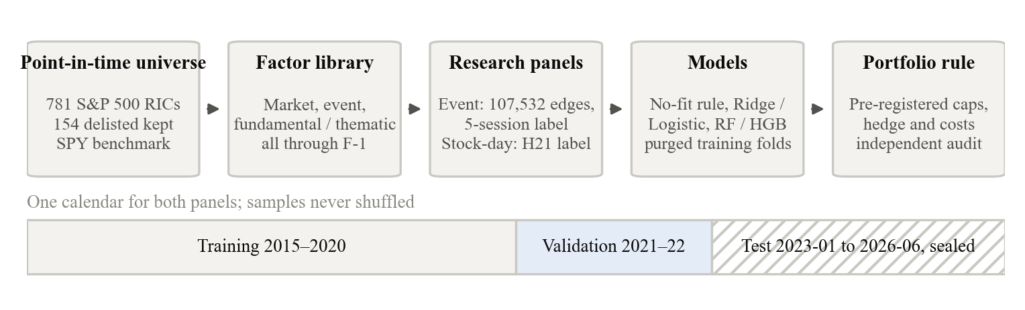
Figure 1. Research pipeline. Every stage uses only information available before the decision session; the test period is sealed until the design is frozen.

2. Data

2.1 Sources and point-in-time universe
Every result in this report depends on whether the data reproduce what an investor could have known on the decision date, so we built the data layer before any model, on two rules. The universe must include companies that later left the index or were delisted, and every field must carry the date on which it became public. Market and company data come from LSEG Workspace. We rebuilt a point-in-time S&P 500 universe of 781 RICs, including 154 delisted identifiers, by rolling the 7 September 2026 constituent list backwards through 751 index-change records. The cleaned daily panel holds about 2.08 million company-day rows of adjusted prices, volume, and bid/ask quotes from 2015 to 2026. The event layer holds 28,995 earnings announcements with timestamps, matched actual EPS, and 424,101 weekly consensus snapshots. Segment revenue, R&D, and balance-sheet items carry their original announcement dates. Macro data come from FRED (seven series covering VIX, Treasury yields, the broad dollar index, and credit spreads), and sector-ETF prices (SOXX, XLK, AIQ, BOTZ, IGV) describe industry state.

2.2 Two research panels
A factor is only testable once it is attached to a decision date and a label, so we organised the data into two research panels, one for each pilot.
In the event panel, one row is one earnings announcement paired with one linked stock: company A announces, and the row asks what happens next to company B. Links are identified before the event from the correlation of A's and B's market-adjusted return residuals over the previous 126 sessions. A pair counts as linked when the absolute correlation is at least 0.3, each event keeps at most five such neighbours, and both companies must be index members on the announcement day. A's surprise is its actual EPS against the last consensus snapshot published before the announcement for the same fiscal quarter and no more than 14 days old; when analysts' forecasts show zero dispersion, the standardised surprise is left missing rather than set to zero. Positions enter at the close of the first SPY session after the announcement day, and the label is B's 5-session return minus SPY's. The panel holds 107,532 such rows, of which 54,241 training, 19,392 validation, and 33,637 test rows are eligible for supervised use.
The stock-day panel is the daily selection pipeline itself. To test it before scaling up, we ran it on a 49-company AI supply-chain subset (110,829 company-day rows), chosen by economic role in seven supply-chain groups from GPUs and memory to data-centre power and robotics, using segment disclosures and company descriptions. Returns and model output played no part in the selection, and delisting is not an exclusion. Only 9 of the 49 companies have dated point-in-time segment evidence; the other 40 rest on current descriptions, so we treat the subset as exploratory and read its results as a test of the pipeline, not as a statement about the AI theme.

2.3 Targets, splits, and leakage controls
Both panels share one calendar. Training covers 2015-2020, validation 2021-2022, and the test period from 1 January 2023 to 30 June 2026 is sealed; its labels have not been opened, predicted, or scored. Every feature uses information available through the session before the decision point, and samples are never shuffled. In the event panel, all edges of one event stay in one split, and an event whose label window crosses a split boundary is purged. In the stock-day panel, the target is y = 1 when the stock's 21-session total return from the formation close exceeds SPY's, and each company keeps at most one anchor per 21-session block (2,334 training anchors over 444 formation dates; 992 validation anchors over 89 dates, 50.7% positive).

2.4 Processing rules
Every action that changes data was listed, approved, and logged before it ran. Empty alignment cells created by the wide-format price download (167,134) and vendor padding rows after a delisting were quarantined with reason codes, not deleted. Pre-market announcements enter at the same-day close and after-market announcements at the next close. Missing values stay missing in every source table; the only imputation is inside the model pipeline, a median fitted on training rows with a missing indicator, and there is no zero fill, forward fill, or winsorization anywhere in the data layer.

3. Baseline models
The baselines are deliberately simple. Their job is to set the bar that any later model must clear on the same sample, so each family starts from a no-fit rule or a regularised linear model before a non-linear model is tried. Event-factor baselines predict the receiver's 5-session excess return with event-equal sample weights, with the training-weighted mean as the floor. A simple transfer rule multiplies the source's standardised surprise by the signed pre-event correlation and needs no fitting. Receiver-only Ridge uses 22 of the receiver's own market factors. Network Ridge adds 23 event and source-company factors (the surprise, the link strength, and the source's own market factors) for 45 in total. A histogram gradient-boosting model (HGB) uses the same 45 factors. Ridge alphas and HGB settings were chosen by forward cross-validation inside the training period.
Stock-selection baselines run on the stock-day panel as fixed scikit-learn pipelines. Logistic Regression uses a training-fitted median imputer with missing indicators, a standard scaler, C = 1.0, balanced class weights, and the lbfgs solver. Random Forest uses 200 trees and an 18-point grid over depth, leaf size, and feature fraction, selected by mean ROC-AUC across purged folds ending in 2018, 2019, and 2020. Four factor sets were registered before any validation score was read, namely market only (21 factors), market plus macro (41), market plus industry state (42), and all three (62). Variables with no coverage in the early training years (six credit spreads and 18 ETF-based variables) were excluded beforehand so that their missingness could not act as a calendar label. The validation period was used once, for the final comparison.

4. Preliminary results
All results below are validation-period comparisons on frozen samples. They are evidence about the factors and the pipeline, not a performance claim for the fund.

4.1 Event factors on the full universe
Table 2. Event-panel validation, 2021-2022 (19,392 edges, 3,957 events)
Model | Factors | Weighted R² | Direction accuracy | Pooled Spearman | Mean within-event Spearman
Training weighted mean | 0 | -0.0071 | 54.4% | n/a | n/a
Simple transfer rule | 1 | -0.0072 | 54.4% | 0.0115 | 0.0099
Receiver-only Ridge | 22 | 0.0012 | 53.1% | 0.0960 | 0.0159
Network Ridge | 45 | -0.0007 | 52.6% | 0.0743 | 0.0172
Network HGB | 45 | -0.0136 | 50.2% | 0.0209 | -0.0017

The receiver's own market factors carry a small cross-sectional signal. Their pooled Spearman correlation of 0.096 is mostly between events; within an event it is only 0.016. Adding the earnings-surprise and transfer factors raises the within-event correlation by 0.001 and lowers R², and the non-linear model is worse than the linear one on every metric. A second graph built from shared analyst coverage gave a within-event correlation of -0.0040 against 0.0199 for the control model, with a paired difference of -0.0239 and a 95% block-bootstrap interval of [-0.0523, 0.0081]. We therefore do not treat earnings-event transfer as a standalone alpha source. Earnings surprise stays in the library as a candidate factor for the stock-level model.

4.2 Stock selection on the pilot sub-universe
Table 3. Stock-day panel validation, 2021-2022, 992 anchors, same sample for every row (all-factor Random Forest, AUC 0.5349, omitted)
Factor set | Model | ROC-AUC | PR-AUC | Brier | Accuracy | Pooled rank IC | Mean daily rank IC
Market | Logistic | 0.5395 | 0.5421 | 0.2511 | 51.61% | 0.140 | 0.078
Market | Random Forest | 0.5231 | 0.5511 | 0.2543 | 51.92% | 0.074 | 0.063
Market + macro | Logistic | 0.5616 | 0.5524 | 0.2508 | 56.45% | 0.174 | 0.086
Market + macro | Random Forest | 0.5362 | 0.5454 | 0.2496 | 52.92% | 0.096 | 0.036
Market + industry state | Logistic | 0.5799 | 0.5745 | 0.2476 | 54.54% | 0.187 | 0.089
Market + industry state | Random Forest | 0.5391 | 0.5422 | 0.2520 | 54.84% | 0.104 | 0.087
All three | Logistic | 0.5820 | 0.5456 | 0.2700 | 55.65% | 0.186 | 0.093

The market-plus-industry-state Logistic model is the current primary selection model. Its ROC-AUC of 0.5799 is 0.0405 above the market-only Logistic benchmark, and a paired bootstrap clustered by formation date (2,000 draws) gives a 95% interval of [0.0007, 0.0801] for that lift; the AUC is 0.5906 in 2021 and 0.6213 in 2022. The all-factor Logistic model has a slightly higher AUC but a worse Brier score (0.2700 against 0.2476). Random Forest is below Logistic in every factor set. Pooled AUC also mixes two claims, because 27 of the 41 market-plus-macro variables are constant within a formation date. Restricted to same-date pairs, the macro lift in within-date AUC is 0.0062 with a 21-session block-bootstrap interval of [-0.0066, 0.0218], and the within-date rank-IC lift is 0.0082 with an interval of [-0.0074, 0.0240]. We therefore do not claim that macro factors improve stock selection; they may help with timing.

4.3 Pre-registered validation portfolio
To test whether the ranking converts into returns, we fixed a portfolio rule before running it. Every 21 sessions the primary model scores all eligible stocks, and those with predicted probability of at least 0.55 are held, subject to a 10% single-stock cap, a 30% group cap, a 10% volatility target, a 50% one-way turnover cap per rebalance, and a SPY beta hedge, with half the quoted spread charged on every trade; a date with fewer than five qualifying stocks is skipped.
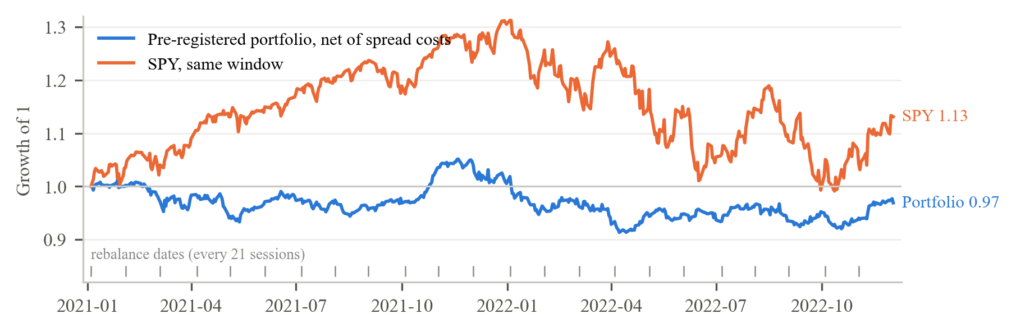
Figure 2. Validation portfolio versus SPY, 2021-2022, growth of 1 net of spread costs. Cumulative -3.10%, annualised volatility 9.78%, Sharpe -0.119, maximum drawdown -13.15%, beta 0.064, one-way turnover 4.54x a year, spread cost 0.24%; SPY +13.11%.
Figure 2 shows the outcome. The portfolio lost money while the classifier's validation metrics improved, and the 0.24% spread cost does not explain the loss. The near-zero beta confirms that the hedge worked as designed; the loss came from the long sleeve. An independent daily re-accounting of cash, positions, trades, and costs passed 13 of 14 checks with one non-blocking warning. Re-tuning the threshold or the caps on validation data would turn the validation period into a second training set, so the next step is attribution on the frozen rule, not a search for a better-looking number.

5. Limitations and next stage
The two pilots have established that the framework runs end to end, from a point-in-time universe to a pre-registered portfolio rule with an independent audit. They have not established a tradable signal. Four limitations govern how the numbers should be read. Event-transfer results are weak in both graph versions and reverse sign between 2021 and 2022. The 49-company pilot subset lacks dated membership evidence for 40 companies, so survivorship bias is possible there. Validation rows share market shocks across stocks on the same date, so all intervals use date or block resampling. Probabilities are not calibrated (expected calibration error 0.057 overall, 0.125 in 2022), so the portfolio rule uses ranks and a fixed threshold.
The next stage has five steps. First, complete the fundamental factor family and the standard controls, and add earnings surprise to the stock-level factor set, so that all three families are evaluated on one sample by rank IC, quantile spreads, and turnover. Second, attribute the negative validation return to the long sleeve, the hedge, the skipped dates, and the individual names. Third, extend the stock-level pipeline from the pilot subset to the full point-in-time universe. Fourth, pre-register a second portfolio rule (fixed monthly rebalance, top 20% by score at equal weight, one-way costs of 0 to 25 basis points) with settings chosen on training data only. Fifth, choose the final fund strategy on six written criteria (economic mechanism, point-in-time feasibility, sample adequacy, pre-specified ML contribution, an implementable rule with costs, and one untouched test period), and only then open the sealed test once.

References
Cohen, L., and Frazzini, A. (2008). Economic links and predictable returns. Journal of Finance, 63(4), 1977-2011.
Gu, S., Kelly, B., and Xiu, D. (2020). Empirical asset pricing via machine learning. Review of Financial Studies, 33(5), 2223-2273.
López de Prado, M. (2018). Advances in Financial Machine Learning. Wiley. (Purged cross-validation and embargo.)
Pedregosa, F., et al. (2011). Scikit-learn: Machine learning in Python. Journal of Machine Learning Research, 12, 2825-2830.
Federal Reserve Bank of St. Louis. FRED economic data: VIXCLS, DGS3MO, DGS2, DGS10, DTWEXBGS, BAMLH0A0HYM2, BAMLC0A0CM.
LSEG Workspace and LSEG Data Library for Python. Daily prices, quotes, index constituents, earnings events, consensus estimates, and segment fundamentals.

