# Lecture Notes 2/5/28 - Accessibility and Responsiveness

## Course Logistics

* **Badges:**
  + You do not need to submit badges
  + If there is an issue with the time stamp, take a screen shot
  + If you have a question about grades, please see us during office hours or discussion (not lecture) to check on the grades.
  + I have added “Advanced Badges”
    - THESE ARE REALLY DIFFICULT!!!



* **Competencies**
  + <https://docs.google.com/document/d/1r7e9Mkkq2JY3oqJOJOmlmcAPQZB8s-HPrCxuepi4HWY/edit>



* **Portfolio**
  + <https://docs.google.com/document/d/1vXAoTAXw5M0E_OyKF3wzcW22Ie-c1vhjhcqvlxnBgig/edit>



* **Other Questions?**

## Accessibility

Stock Ticker Symbols

1. **FB         - $190.28**
2. **AMZN  - $1492.67**
3. **AAPL    - $160.5**

## Sketching/Wireframes

1. Sketching is getting your ideas down on paper - What matters most is understanding what the user will see on each screen that will lead them to the desired result.
3. Wireframes focus  more on how the User Interface will work at a pixelated grayscale level.   Higher detail is needed and sizing, placement, and relations are nailed down.    This is where you start to think about your different mediums.

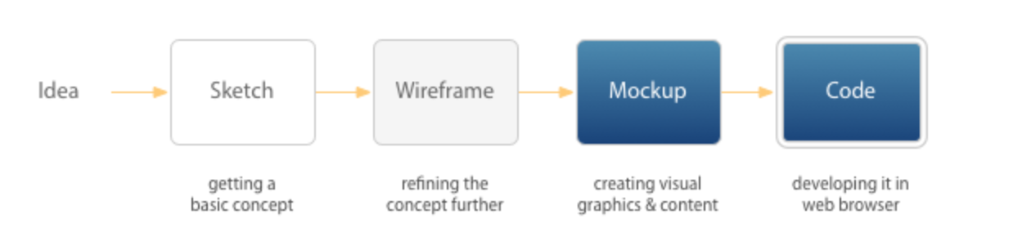

References:

<http://uxmovement.com/wireframes/why-its-important-to-sketch-before-you-wireframe/>

Sketches are fast, they look bad (and that is okay!), they faciliate brainstorming, and they get the dirty work done before the wire-framing starts.  (You should not be coming up with many “new” ideas at the wireframe stage).

1. Wireframe Tips: <https://www.dtelepathy.com/blog/design/learning-to-wireframe-10-best-practices>
2. Cool Wireframe example: <http://www.wireframeshowcase.com/>

***For the Portfolio Assignment you need to hand in SKETCHES for three different viewports - not a wireframe.  You will lose points if you hand in a sketch, and you will get NO points for a screenshot.***

 Tools I have **NOT** vetted:

* + <https://marvelapp.com/pop/?popref=1>
  + <https://www.creativebloq.com/wireframes/top-wireframing-tools-11121302> (free ones are on the 2nd page)
  + <https://www.invisionapp.com/>

## Responsive Design?

“Bad” examples:

* + <https://www.dteenergy.com>
  + <https://www.a2schools.org/forsythe>
  + <http://www.csszengarden.com/>
  + <https://searchspring.com/blog/responsive-sites-gone-bad.html>

“Good” examples:

* + <http://mediaqueri.es/>
    - <https://mediaqueri.es/pac/>
    - <https://mediaqueri.es/jpn/>
  + <https://www.mockplus.com/blog/post/best-responsive-web-design>

Loop back to sketches and wireframes.