資料庫期末作業

組員：411077015陳彥宇、411077022姚芃睿

以下範例使用411077022的資料庫

1. ER圖一張含有 寫生, 白色, 圖表, 樣式 的圖片

   自動產生的描述
2. 實體關聯圖

1. 建表

Bank:

CREATE TABLE bank (

bank_id int(11) NOT NULL AUTO_INCREMENT,

bank_code varchar(256) NOT NULL,

bank_name varchar(256) NOT NULL,

PRIMARY KEY (`bank_id`),

UNIQUE KEY bank_code_UNIQUE (`bank_code`)

) ENGINE=InnoDB AUTO_INCREMENT=47 DEFAULT CHARSET=utf8mb4 COLLATE=utf8mb4_general_ci

Cart:

CREATE TABLE cart (

id int(11) NOT NULL,

specification_id int(11) DEFAULT NULL,

group_name varchar(256) DEFAULT NULL,

amount int(11) NOT NULL DEFAULT 1,

cost int(11) NOT NULL DEFAULT 0,

KEY id_idx (`id`),

CONSTRAINT id FOREIGN KEY (`id`) REFERENCES user (`id`) ON DELETE CASCADE ON UPDATE CASCADE

) ENGINE=InnoDB DEFAULT CHARSET=utf8mb4 COLLATE=utf8mb4_general_ci

Item:

CREATE TABLE cart (

id int(11) NOT NULL,

specification_id int(11) DEFAULT NULL,

group_name varchar(256) DEFAULT NULL,

amount int(11) NOT NULL DEFAULT 1,

cost int(11) NOT NULL DEFAULT 0,

KEY id_idx (`id`),

CONSTRAINT id FOREIGN KEY (`id`) REFERENCES user (`id`) ON DELETE CASCADE ON UPDATE CASCADE

) ENGINE=InnoDB DEFAULT CHARSET=utf8mb4 COLLATE=utf8mb4_general_ci

Item_group:

CREATE TABLE item_group (

group_name varchar(256) NOT NULL,

specification_id int(11) NOT NULL,

group_price int(11) DEFAULT NULL,

group_amount int(11) NOT NULL,

KEY specification_id_fkey_idx (`specification_id`),

CONSTRAINT specification_id_fkey FOREIGN KEY (`specification_id`) REFERENCES specification (`specification_id`) ON DELETE CASCADE ON UPDATE CASCADE

) ENGINE=InnoDB DEFAULT CHARSET=utf8mb4 COLLATE=utf8mb4_general_ci

Itme_order:

CREATE TABLE item_order (

specification_id int(11) DEFAULT NULL,

group_name varchar(256) DEFAULT NULL,

amount int(11) NOT NULL,

order_id int(11) NOT NULL,

KEY specification_id_idx (`specification_id`),

KEY order_id_idx (`order_id`),

KEY group_name_fkey_idx (`group_name`),

CONSTRAINT order_id FOREIGN KEY (`order_id`) REFERENCES order (`order_id`) ON DELETE CASCADE ON UPDATE CASCADE,

CONSTRAINT specification_id FOREIGN KEY (`specification_id`) REFERENCES specification (`specification_id`) ON DELETE NO ACTION ON UPDATE CASCADE

) ENGINE=InnoDB DEFAULT CHARSET=utf8mb4 COLLATE=utf8mb4_general_ci

Item_type:

CREATE TABLE item_type (

item_id int(11) NOT NULL,

type_id int(11) NOT NULL,

KEY item_id_fkey_idx (`item_id`),

KEY type_id_fkey_idx (`type_id`),

CONSTRAINT item_id_fkey FOREIGN KEY (`item_id`) REFERENCES item (`item_id`) ON DELETE CASCADE ON UPDATE CASCADE,

CONSTRAINT type_id_fkey FOREIGN KEY (`type_id`) REFERENCES type (`type_id`) ON DELETE CASCADE ON UPDATE CASCADE

) ENGINE=InnoDB DEFAULT CHARSET=utf8mb4 COLLATE=utf8mb4_general_ci

Manufacturer:

CREATE TABLE manufacturer (

manufacturer_id int(11) NOT NULL AUTO_INCREMENT,

manufacturer_name varchar(256) NOT NULL,

PRIMARY KEY (`manufacturer_id`)

) ENGINE=InnoDB AUTO_INCREMENT=10 DEFAULT CHARSET=utf8mb4 COLLATE=utf8mb4_general_ci

Order:

CREATE TABLE order (

order_id int(11) NOT NULL AUTO_INCREMENT,

sum int(11) NOT NULL,

paying_id int(11) NOT NULL,

paying_status_id int(11) NOT NULL,

paying_date datetime DEFAULT NULL,

order_status_id int(11) NOT NULL,

PRIMARY KEY (`order_id`),

KEY paying_id_fkey_idx (`paying_id`),

KEY paying_status_id_fkey_idx (`paying_status_id`),

KEY order_status_id_fkey_idx (`order_status_id`),

CONSTRAINT order_status_id_fkey FOREIGN KEY (`order_status_id`) REFERENCES order_status (`order_status_id`) ON DELETE NO ACTION ON UPDATE CASCADE,

CONSTRAINT paying_id_fkey FOREIGN KEY (`paying_id`) REFERENCES paying_type (`paying_id`) ON DELETE NO ACTION ON UPDATE CASCADE,

CONSTRAINT paying_status_id_fkey FOREIGN KEY (`paying_status_id`) REFERENCES paying_status (`paying_status_id`) ON DELETE NO ACTION ON UPDATE CASCADE

) ENGINE=InnoDB AUTO_INCREMENT=5 DEFAULT CHARSET=utf8mb4 COLLATE=utf8mb4_general_ci

Order_status:

CREATE TABLE order_status (

order_status_id int(11) NOT NULL AUTO_INCREMENT,

order_status_name varchar(256) NOT NULL,

PRIMARY KEY (`order_status_id`)

) ENGINE=InnoDB AUTO_INCREMENT=5 DEFAULT CHARSET=utf8mb4 COLLATE=utf8mb4_general_ci

Pay_status:

CREATE TABLE order_status (

order_status_id int(11) NOT NULL AUTO_INCREMENT,

order_status_name varchar(256) NOT NULL,

PRIMARY KEY (`order_status_id`)

) ENGINE=InnoDB AUTO_INCREMENT=5 DEFAULT CHARSET=utf8mb4 COLLATE=utf8mb4_general_ci

Paying_type:

CREATE TABLE paying_type (

paying_id int(11) NOT NULL AUTO_INCREMENT,

paying_name varchar(256) NOT NULL,

PRIMARY KEY (`paying_id`)

) ENGINE=InnoDB AUTO_INCREMENT=5 DEFAULT CHARSET=utf8mb4 COLLATE=utf8mb4_general_ci

Specification:

CREATE TABLE specification (

specification_id int(11) NOT NULL AUTO_INCREMENT,

specification_name varchar(256) NOT NULL,

specification_price int(11) DEFAULT NULL,

specification_amount int(11) NOT NULL,

item_id int(11) NOT NULL,

PRIMARY KEY (`specification_id`)

) ENGINE=InnoDB AUTO_INCREMENT=17 DEFAULT CHARSET=utf8mb4 COLLATE=utf8mb4_general_ci

Stock:

CREATE TABLE stock (

stock_id int(11) NOT NULL AUTO_INCREMENT,

item_id int(11) NOT NULL,

import_time datetime NOT NULL DEFAULT current_timestamp(),

stock_amount int(11) NOT NULL,

manufacturer_id int(11) NOT NULL,

stock_address varchar(256) NOT NULL,

PRIMARY KEY (`stock_id`),

KEY item_id_idx (`item_id`),

KEY manufacturer_id_idx (`manufacturer_id`),

CONSTRAINT item_id FOREIGN KEY (`item_id`) REFERENCES item (`item_id`) ON DELETE NO ACTION ON UPDATE CASCADE,

CONSTRAINT manufacturer_id FOREIGN KEY (`manufacturer_id`) REFERENCES manufacturer (`manufacturer_id`) ON DELETE NO ACTION ON UPDATE CASCADE

) ENGINE=InnoDB AUTO_INCREMENT=19 DEFAULT CHARSET=utf8mb4 COLLATE=utf8mb4_general_ci

Type:

CREATE TABLE type (

type_id int(11) NOT NULL AUTO_INCREMENT,

type_name varchar(256) NOT NULL,

PRIMARY KEY (`type_id`),

UNIQUE KEY type_name_UNIQUE (`type_name`)

) ENGINE=InnoDB AUTO_INCREMENT=13 DEFAULT CHARSET=utf8mb4 COLLATE=utf8mb4_general_ci

User:

CREATE TABLE user (

id int(11) NOT NULL AUTO_INCREMENT,

name varchar(256) NOT NULL,

mail varchar(256) NOT NULL,

phone varchar(256) NOT NULL,

bank_id int(11) DEFAULT NULL,

bank_account varchar(256) DEFAULT NULL,

PRIMARY KEY (`id`),

UNIQUE KEY mail_UNIQUE (`mail`),

KEY bank_id_idx (`bank_id`),

CONSTRAINT bank_id_fkey FOREIGN KEY (`bank_id`) REFERENCES bank (`bank_id`) ON DELETE SET NULL ON UPDATE CASCADE

) ENGINE=InnoDB AUTO_INCREMENT=6 DEFAULT CHARSET=utf8mb4 COLLATE=utf8mb4_general_ci

User_order:

CREATE TABLE user_order (

id int(11) NOT NULL,

order_id int(11) NOT NULL,

shipment_trace_code varchar(256) DEFAULT NULL,

KEY id_idx (`id`),

KEY order_id_fkey_idx (`order_id`),

CONSTRAINT id_fkey FOREIGN KEY (`id`) REFERENCES user (`id`) ON DELETE CASCADE ON UPDATE CASCADE,

CONSTRAINT order_id_fkey FOREIGN KEY (`order_id`) REFERENCES order (`order_id`) ON DELETE CASCADE ON UPDATE CASCADE

) ENGINE=InnoDB DEFAULT CHARSET=utf8mb4 COLLATE=utf8mb4_general_ci

1. 對每個表進行COUNT(*)

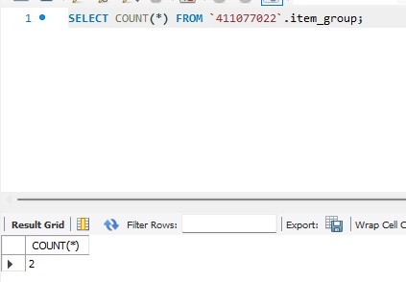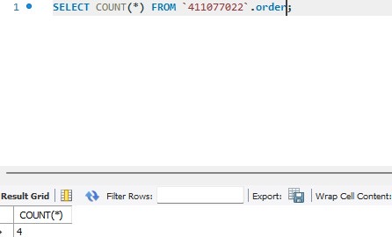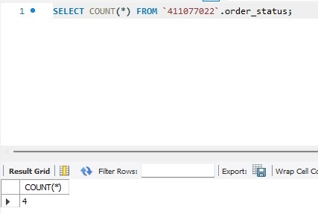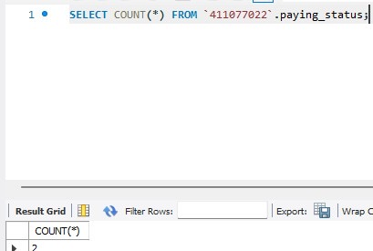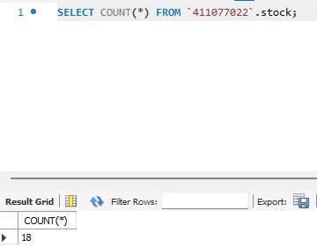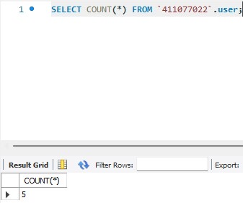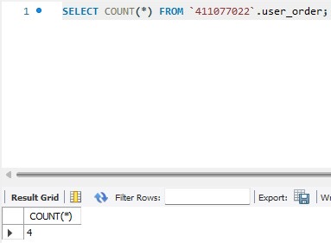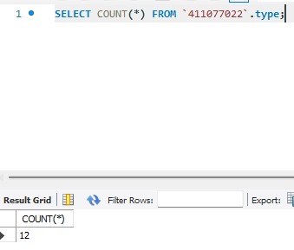

1. 查詢

查找過去一年中以價格計算購買金額最高的客戶。

查找過去一年中按銷售金額計算的前2個產品。

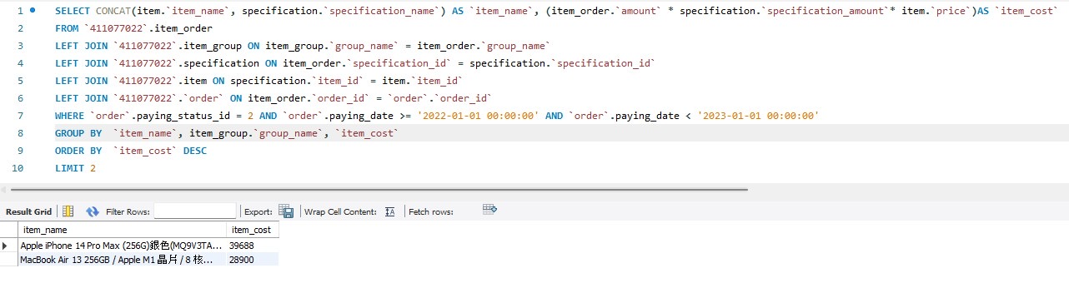

查找高雄市每家店鋪都缺貨的產品。

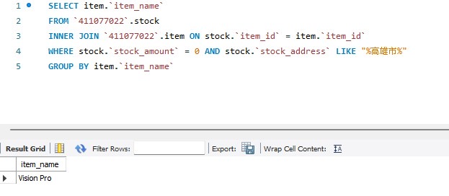

假設由USPS運送的追蹤號碼為123456的包裹據報導在事故中被摧毀。查找該顧客的聯繫信息。

查找未按照承諾時間交付的套餐。

