A Sleep Monitoring Belt–Based Sleep Staging Method via EEG-Guided Label Transfer and Deep Learning
Xinran Lin#, Shangle Ye#, Jian Zhan, Shuibin Liu, Heng Wu, Maojin Liang*, Chunhua He*

Abstract—Polysomnography (PSG) is recognized as the gold standard for sleep staging; however, its high cost, operational complexity, and reliance on laboratory settings limit its applicability for long-term home-based monitoring. Although non-wearable sleep monitoring belts offer advantages such as cost-effectiveness and enhanced comfort, their performance is constrained by the lack of reliable expert annotations and insufficient algorithmic accuracy in real-world scenarios. To address these limitations, a label transfer–based approach for non-invasive sleep staging is proposed in this study. Initially, a deep learning model is pre-trained on single-channel EEG (Fpz–Cz) signals derived from the Sleep-EDF dataset. Subsequently, synchronized EEG and inertial measurement unit (IMU) data are collected from 10 participants overnight. The pre-trained model is applied to the EEG signals to generate high-accuracy sleep stage labels, which are then transferred to temporally aligned IMU data via precise time synchronization to train a target-domain model. Experi-mental results indicate that an accuracy of 98.64% and an F1-score of 98.63% are achieved by the RNN-LSTM model in the EEG source domain. In the IMU target domain, an accuracy of 89.77% and an F1-score of 89.76% are attained by the CNN-RNN hybrid model. These results demonstrate that EEG-guided label transfer, facilitated by synchronous multimodal recording, effectively addresses the critical challenge of label scarcity in non-invasive sensing, thereby providing a practical and scalable solution for accurate home-based sleep monitoring.
Index Terms—Sleep staging, sleep monitoring belt, label transfer, deep learning, inertial measurement unit (IMU).

INTRODUCTION
Sleep disorders have emerged as a significant public health concern [1]. According to relevant epidemiological studies [2-4], approximately 27% of adults worldwide experience insomnia symptoms [5-7], with chronic insomnia affecting 10%–15% of the general population [8-9]. These prevalence rates are notably higher among older adults, women, and individuals with chronic medical conditions [10-12]. Persistent deterioration in sleep quality substantially impairs daytime functioning and quality of life [13-15], and is strongly associated with a range of chronic diseases, including cardiovascular disorders [16-17], depression [18-19], cognitive decline [20-21], and Alzheimer’s disease [22-23]. Accurate assessment and effective intervention for sleep disorders hinge on the evaluation of sleep duration and the fine-grained analysis of sleep architecture [24-25]. Nocturnal sleep is characterized by distinct stages that cycle periodically throughout the night, which are commonly categorized in macro-architecture analysis as Wake (W), Light Sleep (N1 + N2), Deep Sleep (N3), and Rapid Eye Movement (REM) sleep [25]. The relative proportions and transition dynamics among these stages reflect the regulatory and restorative capacity of the central nervous system [26-27]. Consequently, precise identification of each sleep stage holds substantial clinical and scientific value [28].
Polysomnography (PSG) is internationally recognized as the gold standard for sleep staging [29-30]. Multimodal physiological signals are simultaneously recorded, including electroencephalography (EEG), electrooculography (EOG), electromyography (EMG), electrocardiography (ECG), respiratory airflow, blood oxygen saturation, and body position [31-32]. Based on manual scoring by certified technicians in accordance with the American Academy of Sleep Medicine (AASM) guidelines [33-34], these signals are originally classified into five stages (W, N1, N2, N3, and REM). For automated sleep staging tasks, they are commonly regrouped into four classes: Wake, Light Sleep (N1+N2), Deep Sleep (N3), and REM sleep. Owing to its high temporal resolution and comprehensive physiological correlation [33], PSG plays a critical role in the diagnosis of conditions such as insomnia, obstructive sleep apnea, and narcolepsy [35]. However, significant limitations that hinder broader application are associated with PSG [36-37]. A specialized sleep laboratory and expensive equipment are required, resulting in high operational costs. The necessity of attaching numerous sensors is highly intrusive and uncomfortable for participants [38], often triggering the "first-night effect," which distorts natural sleep architecture [39]. Moreover, PSG provides only a snapshot assessment and is unsuitable for long-term, continuous monitoring in home settings [40-41]. These constraints severely limit its feasibility for large-scale population screening and routine health management.
Although various non-wearable sleep monitoring approaches have been proposed in recent years, such as photoplethysmography (PPG)-based wristbands [41], millimeter-wave radar [42], and mattress-embedded sensors, existing literature indicates that significant challenges remain in achieving clinical-grade four-stage sleep staging [43]. Key limitations include indirect physiological signal representation, high sensitivity to environmental noise, or relatively high system costs. Among available solutions, sleep monitoring belts demonstrate superior performance in terms of both accuracy and deployability. Accordingly, a self-developed, non-wearable sleep monitoring belt, established in prior research, is adopted as the sensing platform in this study [44]. The device integrates a triaxial accelerometer and a triaxial gyroscope and is simply placed on the mattress surface, enabling contactless, continuous acquisition of whole-night body movement and postural change signals without requiring user compliance. However, current sleep staging with this belt relies primarily on statistical rules or simple threshold-based models, yielding an accuracy of approximately 78%, which is insufficient for clinical applications or precision health management. The primary bottleneck lies in the absence of EEG-based gold-standard expert labels [45], which prevents the development and training of high-performance deep learning models. This label scarcity has become a critical barrier to the advancement of non-invasive, home-based sleep staging systems [46].
Therefore, a non-invasive sleep staging method based on label transfer is proposed in this paper to introduce medical-grade supervisory signals for the aforementioned sleep monitoring belt. First, multiple machine learning and deep learning models, including K-Nearest Neighbors (KNN), Decision Trees, Convolutional Neural Networks (CNN), Recurrent Neural Networks (RNN), Long Short-Term Memory networks (LSTM), and a hybrid RNN-LSTM, are systematically evaluated on single-channel frontal EEG (Fpz–Cz) from the publicly available Sleep-EDF dataset [47]. Experimental results show that the best performance in the four-stage sleep staging task is achieved by the RNN-LSTM model, which is thus selected as the source-domain label generator. Next, overnight EEG and inertial measurement unit (IMU) data are simultaneously recorded from 10 healthy participants using a validated portable EEG acquisition system and the aforementioned non-wearable sleep monitoring belt. The raw neurophysiological signals from the portable EEG system are converted into Fpz–Cz-like EEG waveforms via a physics-informed mathematical inversion model. The pre-trained RNN-LSTM model is then applied to these reconstructed EEG signals to automatically generate high-confidence sleep stage labels. Through hardware-level time synchronization (alignment error < 10 ms), these pseudo-labels are precisely mapped to the corresponding IMU data segments, thereby constructing a labeled target-domain dataset. Finally, lightweight deep learning architectures, including CNN, RNN, LSTM, and a hybrid CNN-RNN, are trained and evaluated on this transferred dataset. The highest performance is achieved by the CNN-RNN model, attaining an accuracy of 89.77% in the four-class sleep staging task, significantly outperforming the statistical baseline (~78%) commonly used in existing non-wearable systems. This result demonstrates that label transfer guided by synchronized, EEG-derived supervision enables accurate, unobtrusive, and scalable home-based sleep staging without requiring direct physiological contact.
The main contributions of this study are as follows:
(1) A novel EEG-guided label transfer paradigm is proposed, leveraging single-channel frontal EEG (Fpz–Cz) to reliably transfer clinically interpretable sleep stage labels from a mask-integrated portable EEG system [48] to a fully non-wearable, mattress-based IMU device [44]. This approach effectively addresses the long-standing “data-rich but label-poor” challenge in contactless sleep monitoring.
(2) The RNN-LSTM is validated as a high-precision source-domain label generator on the Sleep-EDF dataset [47]. An accuracy of 98.64% is achieved in the four-class sleep staging task using only Fpz–Cz EEG, providing robust and reliable supervisory signals for subsequent label transfer.
(3) High-accuracy sleep staging is achieved using only inertial signals: with only triaxial acceleration and angular velocity inputs, the lightweight CNN-RNN model attains a four-class accuracy of 89.77%, significantly outperforming conventional rule-based methods (~78%). This result confirms the feasibility of low-cost, unobtrusive, and accurate home-based sleep monitoring using non-wearable sensing.

System design and process
The overall technical framework of this study is illustrated in Fig. 1, which comprises two key stages: source-domain model construction and target-domain label transfer, with the goal of enabling high-accuracy sleep staging using non-wearable sensors.
As shown in Fig. 1(a), the publicly available Sleep-EDF dataset provides single-channel frontal EEG signals (Fpz–Cz lead, sampled at 100 Hz) along with expert-annotated sleep stage labels. First, the raw EEG waveforms are decomposed into multiple characteristic frequency bands, Delta (0.5–4 Hz), Theta (4–8 Hz), Alpha (8–13 Hz), Beta (13–30 Hz), and Gamma (30–40 Hz), as illustrated in Fig. 1(b); these bands are utilized to reflect the physiological characteristics of different sleep stages. Subsequently, as illustrated in Fig. 1(c), the original six-class sleep annotations (W, N1, N2, N3, N4, R) are merged into four clinically common stages, Wake, Light Sleep (N1+N2), Deep Sleep (N3), and REM, to mitigate class imbalance and improve model generalization.
On this basis, time-domain features (mean, standard deviation, maximum/minimum, root mean square) and frequency-domain features (relative energy in each band) are extracted from each 30-second EEG epoch to form a complete input representation. As shown in Fig. 1(d), these features are fed into multiple candidate models, including KNN, Decision Tree, CNN, RNN, LSTM, and RNN-LSTM, for systematic evaluation. It is observed that the best performance on the balanced Sleep-EDF dataset is achieved by the RNN-LSTM hybrid model, with an accuracy of 98.64%; consequently, this model is selected as the source-domain label generator.
Meanwhile, multimodal data were simultaneously collected from 10 healthy participants in a simulated home environment [Fig. 1(e)]. The experimental platform integrates a previously validated mask-integrated portable EEG system (hereafter referred to as the portable EEG system) [48] and a non-wearable sleep monitoring belt placed on the mattress surface. Raw physiological pulse signals coupled with brain activity are captured by the EEG system [Fig. 1(f)], which are then converted into Fpz–Cz-like EEG waveforms via a physics-informed mathematical inversion model. Simultaneously, triaxial acceleration ($a_{x}$ ,$a_{y}$ ,$a_{z}$) and triaxial angular velocity ($g_{x}$ ,$g_{y}$ ,$g_{z}$) signals are continuously recorded by the sleep monitoring belt [Fig. 1(g)].
Through a hardware-level time synchronization mechanism (alignment error < 10 ms), automatic sleep staging is performed by the pre-trained RNN-LSTM model on the converted EEG signals [Fig. 1(h)], and high-confidence sleep stage labels are generated. These labels are mapped to the synchronized IMU data segments via precise timestamps [Fig. 1(i)], by which a labeled target-domain dataset of "IMU–sleep stage" pairs is constructed. Finally, lightweight deep learning architectures, including CNN, RNN, LSTM, and CNN-RNN, are trained and compared on this dataset. As shown in Fig. 1(j), the best performance is achieved by the CNN-RNN hybrid model, with a four-class accuracy of 89.77%, demonstrating its ability to effectively integrate local body movement features with cross-epoch temporal dependencies. This model provides high accuracy with low computational overhead, rendering it suitable for real-world home deployment scenarios.

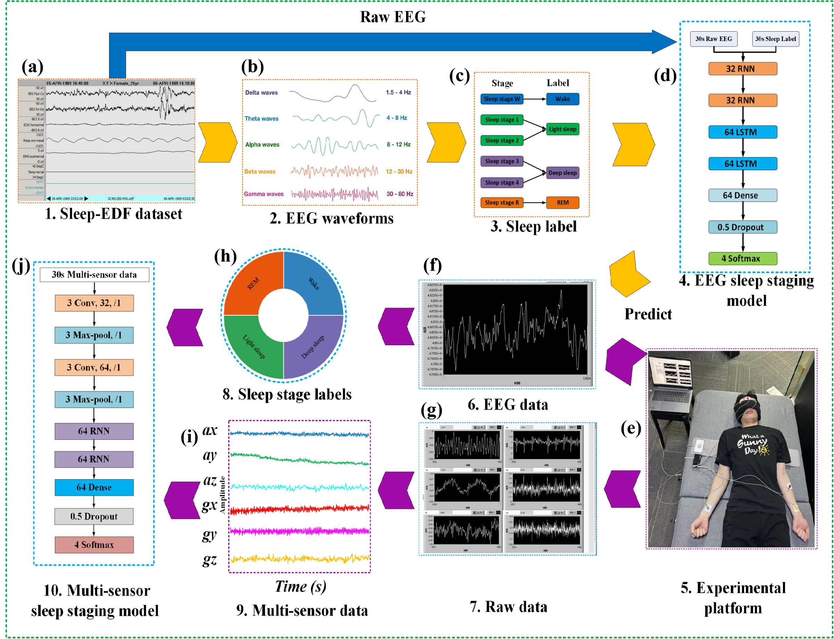
Fig. 1. The overall technical framework of this study, comprising two key stages: source-domain model construction using the Sleep-EDF dataset, and target-domain label transfer based on synchronous multimodal recording.

Data preprocessing
In this study, the publicly available extended Sleep-EDF dataset [47] (Sleep Cassette Studies, SC* subset) is utilized as the source-domain training data. This dataset comprises overnight polysomnographic recordings from healthy participants in a home setting, sampled at 100 Hz, which exhibit strong clinical representativeness.
To balance data diversity and computational efficiency, data from 80 participants were randomly selected from this dataset for model development. Regarding signal selection, only the EEG Fpz–Cz channel (according to the international 10–20 system) was extracted. This frontal single-lead configuration is widely employed in portable sleep monitoring devices, as the setup complexity is significantly reduced while relatively high staging accuracy is maintained. More importantly, strong sensitivity to key sleep features, such as slow waves (Delta) and sleep spindles (Sigma), is demonstrated by the Fpz–Cz channel, which has been validated in multiple studies as suitable for single-channel automated sleep staging tasks [45].
The raw signals were segmented into standard 30-second epochs, and the original six-class sleep labels (W, N1, N2, N3, N4, R) were merged into a four-class scheme:
- Wake (W) → 0
- Light Sleep (N1 + N2) → 1
- Deep Sleep (N3 + N4) → 2
- REM (R) → 3
For each 30-second EEG epoch, we extract a comprehensive feature vector $x∈R^{10}$ to represent the physiological characteristics of the sleep stage. This feature vector is formally defined as:
(1)
where the components are derived from time-domain and frequency-domain analyses as follows:
- Time-domain features: including mean ($μ$), standard deviation ($σ$), maximum ($x_{max}$), minimum ($x_{min}$), and sum of squares ($E$).
- Frequency-domain features: relative power ($P_{B}$) calculated for the five frequency bands (Delta, Theta, Alpha, Beta, and Gamma). $P_{B}$ is defined as the ratio of the integrated power of a specific band to the total power across all bands, as shown in:
(2)
where $f$ denotes the frequency, and $P(f)$ represents the power spectral density at frequency $f$. This normalized representation $P_{B}∈[0, 1]$ effectively mitigates the impact of individual variations in total EEG signal amplitude, thereby enhancing the consistency of feature inputs across different subjects.
To mitigate class imbalance caused by the overrepres-entation of Deep Sleep (>50%) in the original data, sample balancing was applied to the training set. Subject sequences with relatively balanced distributions across the four classes were prioritized; furthermore, for individuals with severe imbalance, an undersampling strategy was employed to remove redundant N2 samples. A balanced dataset with an approximately 1:1:1:1 ratio among the four sleep stages was thereby obtained, by which the learning capability and generalization performance of the model on minority classes (e.g., REM and Deep Sleep) were effectively enhanced. The RNN-LSTM model trained on this balanced dataset achieved the optimal performance.

Data collection
To enable reliable label transfer from EEG signals to non-wearable sensor signals, a synchronized multimodal data acquisition experiment was designed in this study.
Participant Recruitment: A total of 10 healthy adult volunteers (7 males, 3 females; aged 22–35 years, mean age 26.4 ± 3.8 years) were recruited. The inclusion criteria were as follows: no known sleep disorders (e.g., insomnia, sleep apnea), no history of neurological or psychiatric conditions, and no recent use of medications affecting the central nervous system. Written informed consent was provided by all participants, and approval was obtained from the institutional ethics committee. This study serves as an initial feasibility validation; a sample size of 10 participants is considered sufficient to demonstrate the technical feasibility of the label transfer approach. The cohort is intended to be expanded to 50 participants, including individuals with obstructive sleep apnea (Apnea-Hypopnea Index, AHI ≥ 15) and older adults (≥ 60 years), in future work to further evaluate the generalizability of the model.
Experimental Equipment: The portable EEG system [48] was employed to capture weak scalp physiological pulse signals synchronized with cortical electrical activity. These signals are converted into frontal single-channel EEG-like time-series waveforms via a validated physics-informed mathematical inversion model. The resulting signals are output in a bipolar Fpz–Cz montage (in accordance with the international 10–20 system) at a sampling rate of 100 Hz, and are further processed to extract the time-domain and frequency-domain features described in Section II.A.
Target Device: A non-wearable sleep monitoring belt [44] was utilized, which integrates a triaxial accelerometer and a triaxial gyroscope with a total sampling rate of 100 Hz. The device is placed on the mattress surface beneath the torso of the participant, requiring no attachment, and continuously records whole-body micromotion and posture change signals throughout the night.
The two systems were synchronized via a hardware-level trigger signal, by which a time alignment accuracy of < 10 ms was achieved. Each participant completed a full-night sleep recording (approximately 7–8 hours) in a quiet, temperature-controlled laboratory environment. The raw EEG data were fed into the pre-trained RNN-LSTM model (described in Section II.A) to automatically generate four-class sleep stage labels. Following confidence-based filtering, these labels were transferred to the temporally aligned IMU data segments using precise timestamps, by which a high-quality paired "IMU–sleep stage" training dataset was ultimately constructed.

Label transfer and target model training
The pre-trained RNN-LSTM model was applied to the EEG-like signals recorded from the 10 participants during the data collection phase. For each 30-second epoch, sleep stage labels with prediction probabilities exceeding 0.95 were retained as high-confidence pseudo-labels, by which manual expert annotation was effectively replaced. Owing to the hardware-level time synchronization (< 10 ms alignment error) between the portable EEG system [48] and the non-wearable sleep monitoring belt [44], these EEG-derived labels were accurately mapped, via precise timestamps, to their corresponding IMU segments, and a paired target-domain dataset, $D_{target}$ was constructed:
(3)
where $x_{i}^{IMU}$ denotes the i-th 30-second segment of triaxial acceleration and angular velocity signals, and $y_{i}^{EEG}∈\{0, 1, 2, 3\}$ represents the corresponding sleep stage label transferred from the EEG-derived pseudo-labels.
The IMU signals were subjected to preprocessing to enhance signal quality and prepare the data for subsequent modeling. Specifically, a sliding-window median filter was applied to suppress high-frequency noise, followed by segmentation into standard 30-second epochs. Unlike the EEG source domain, explicit manual feature extraction is not required for the IMU target domain, as deep learning models can inherently learn spatiotemporal representations. Therefore, the raw time-series data from the triaxial accelerometer ($a_{x}$ ,$a_{y}$ ,$a_{z}$) and triaxial gyroscope ($g_{x}$ ,$g_{y}$ ,$g_{z}$) were directly utilized as inputs. To accelerate model convergence and ensure stable training, these 6-dimensional synchronized motion signals were standardized using Z-score normalization. For each sensing channel $c∈\{a_{x}, a_{y}, a_{z}, g_{x}, g_{y}, g_{z}\},$ the normalized signal $x_{c}'$ is calculated as:
(4)
where ${\text{x}}_{\text{c}}$ represents the raw sensor data points within the channel, while ${\text{μ}}_{\text{c}}$ and ${\text{σ}}_{\text{c}}$ denote the mean and standard deviation of that specific channel across the training set, respectively.
Using the high-confidence EEG-derived labels transferred via precise time alignment, a fully labeled IMU dataset was constructed. Four lightweight deep learning architectures, CNN, RNN, LSTM, and a hybrid CNN-RNN, were trained and compared on this dataset. To evaluate the models, an 80/20 train-test split was applied to ensure robust performance evaluation. Model performance was assessed using accuracy as the primary overall metric, while precision, recall, and F1-score were reported for each sleep stage to provide a detailed evaluation of classification effectiveness across all four classes (Wake, Light Sleep, Deep Sleep, and REM).

Results Analysis

Model performance comparison on the Sleep-EDF dataset
To facilitate the construction of a reliable source-domain label generator, multiple classification models were systematically evaluated on a balanced version of the Sleep-EDF dataset. By applying an undersampling strategy to the original data for class balancing, a four-class dataset, comprising Wake (W), Light Sleep (N1+N2), Deep Sleep (N3), and REM, was constructed, in which each class accounts for approximately 25% of the samples. This effectively mitigates the model bias typically caused by the overrepresentation of the N2 stage.
Performance comparisons among six models, KNN, Decision Tree, CNN, RNN, LSTM, and RNN-LSTM, are summarized in Fig. 2(a). The same input features (a combination of time-domain and frequency-domain features) were utilized by all models, and training and evaluation were performed under a 5-fold cross-validation framework. It is observed that the optimal performance in the four-class sleep staging task is achieved by the RNN-LSTM hybrid model (illustrated in Fig. 3), which attains an accuracy of 98.64% and an F1-score of 98.63%. In contrast, significantly lower performance is exhibited by traditional machine learning methods (e.g., KNN and Decision Tree) due to their inherent inability to model the temporal dependencies of sleep signals. While local or short-term dynamic features can be captured by single-architecture deep learning models (e.g., CNN, RNN, and LSTM), limitations remain in modeling long-range transitions across sleep cycles.
To further analyze the fine-grained classification performance of the RNN-LSTM model, the normalized confusion matrix on the Sleep-EDF test set is presented in Fig. 2(b). Excellent recognition accuracy is demonstrated by the model for sleep stages with distinct physiological charac-teristics; specifically, prediction accuracies of 99.6% and 96.7% are attained for Deep Sleep and REM, respectively. The primary misclassifications are observed between REM and Light Sleep, with mutual confusion rates of approximately 3%–4%. This observation is consistent with clinical practice, as similar EEG patterns characterized by low-amplitude mixed-frequency activity are often exhibited by these two stages, resulting in inherently ambiguous boundaries that may be interpreted subjectively even by expert human scorers. Consequently, this level of error is considered to fall within a reasonable range for automated sleep staging systems and does not compromise the overall reliability of sleep stage classification.

Model classification results of sleep monitoring unit (IMU) data
The target-domain dataset constructed via label transfer exhibits a sleep stage distribution highly consistent with the typical macrostructure of nocturnal sleep in healthy adults: Light Sleep (N1+N2) occupies the highest proportion, Deep Sleep (Deep Sleep/N3) is primarily concentrated in the first half of the night, and the REM duration progressively increases across successive sleep cycles. The overall proportions align with established physiological norms, N1+N2 accounts for approximately 50%–60%, N3 for 15%–25%, REM for 20%–25%, and Wake time is typically below 10%. In this study, stage proportions within these normal ranges were observed for all 10 participants, with low inter-subject variability (standard deviation < 5%). This indicates that the label transfer approach, guided by synchronized EEG signals and enabled by high-precision temporal alignment, is not only technically feasible but also effectively preserves the authentic architecture of natural sleep cycles, thereby providing physiologically plausible and reliable supervisory labels for subsequent target-model training. To quantitatively evaluate the classification performance across different sleep stages, we employ Accuracy and F1-score as the primary metrics, defined as follows:

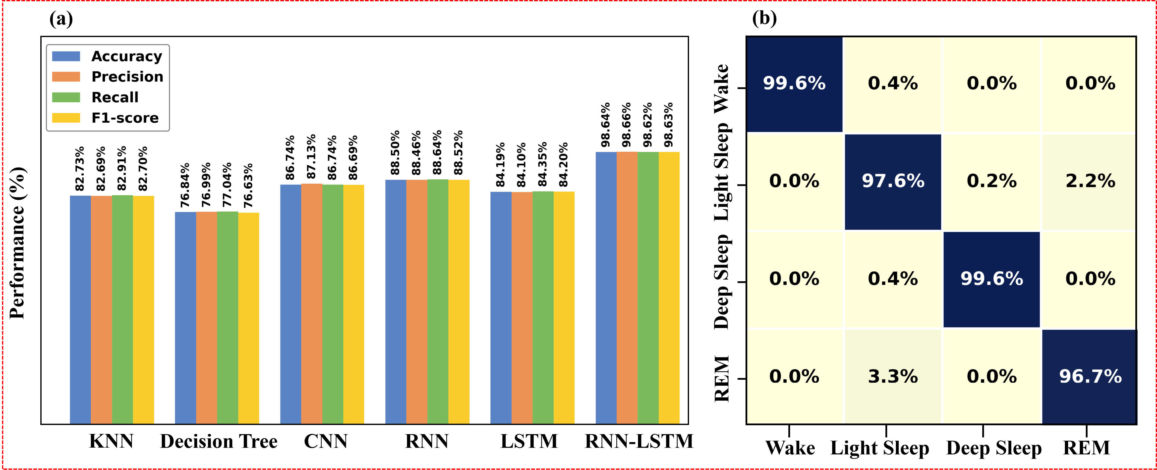
Fig. 2. (a) Performance comparison of six different classification models on the Sleep-EDF dataset (accuracy, precision, recall, and F1-score). (b) Normalized confusion matrix of the RNN-LSTM model on the Sleep-EDF test set.
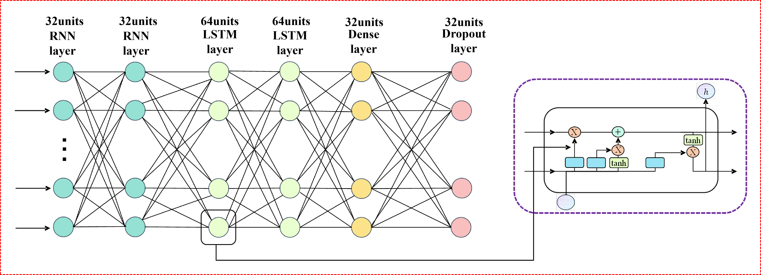
Fig. 3. Schematic illustration of the RNN-LSTM network architecture.

(5)
where ${TP}_{c}$, $P_{c}$, and $R_{c}$ denote the true positives, precision, and recall for stage $c$, respectively, $K=4$ is the number of sleep stages, and $N$ is the total number of samples. The performance comparison of the evaluated models is summarized in Table I.
Table I. Performance Comparison of IMU Sleep Staging Models Based on EEG Label Transfer
Model | Accuracy | Precision | Recall | F1-score
CNN | 89.34% | 89.46% | 89.34% | 89.30%
RNN | 89.23% | 89.26% | 89.23% | 89.18%
LSTM | 86.99% | 86.94% | 86.99% | 86.86%
CNN-RNN | 89.77% | 89.86% | 89.77% | 89.76%
Four deep learning models, CNN, RNN, LSTM, and CNN-RNN, were systematically trained and evaluated on this high-quality labeled IMU dataset. As shown in Table I, the best performance was achieved by the CNN-RNN hybrid architecture (illustrated in Fig. 4), attaining an accuracy of 89.77% and an F1-score of 89.76% in the four-class sleep staging task. In comparison, while local body movement features were effectively captured by the CNN, modeling of sleep state transitions across epochs was constrained by its fixed receptive field. Furthermore, although short-term dynamics and long-term dependencies were captured by the RNN and LSTM, respectively, the multi-scale temporal characteristics inherent in sleep stage transitions were not fully represented by their single-structure designs.
These results clearly demonstrate that, even when relying solely on non-invasive inertial sensing signals (triaxial acceleration and angular velocity), clinically viable automatic sleep staging can be achieved by introducing an EEG gold-standard-based label transfer mechanism. This provides a reliable technical pathway for developing unobtrusive, low-cost, and long-term deployable home sleep monitoring systems, and validates the practical potential of the proposed approach in real-world applications.

Conclusion
A novel non-invasive sleep staging framework based on synchronized EEG-guided label transfer is presented in this paper, which is specifically designed to overcome a critical bottleneck in non-wearable sleep monitoring: the lack of medical-grade annotations that has historically hindered accurate four-stage (Wake, Light Sleep, Deep Sleep, REM) automatic classification using only inertial signals. The proposed pipeline operates in four key stages. First, a high-performance RNN-LSTM hybrid model is pre-trained on the publicly available Sleep-EDF dataset using single-channel frontal EEG (Fpz–Cz). Second, multimodal data are simultaneously recorded overnight from 10 healthy participants in a simulated home environment, leveraging two custom-developed devices: the mask-integrated portable EEG system [48] that captures EEG-like neurophysiological signals, and a non-wearable, mattress-placed IMU-based sleep monitoring belt [44] that continuously records triaxial acceleration and angular velocity. Third, owing to hardware-level time synchronization (alignment error < 10 ms), high-confidence pseudo-labels generated by the pre-trained EEG model, filtered by a prediction probability threshold (> 0.95), are precisely mapped via exact timestamps onto the corresponding 30-second IMU segments. This high-precision synchronization serves as the cornerstone of our label transfer paradigm, enabling the robust training of target-domain models while effectively bypassing the bottleneck of requiring concurrent expert manual annotations. Finally, multiple lightweight deep learning architectures (CNN, RNN, LSTM, and CNN-RNN) are trained and evaluated on this dataset, with the CNN-RNN hybrid model emerging as optimal. Experimental results demonstrate that the framework achieves 98.64% accuracy in the source domain (EEG) and 89.77% accuracy with an F1-score of 89.76% in the target domain (IMU) for four-class sleep staging, substantially outperforming conventional rule-based or amplitude-threshold approaches (which typically achieve only ~78% accuracy). This performance approaches the lower bound of clinical acceptability for automated sleep scoring, despite relying solely on unobtrusive, contactless sensing. These findings validate that our EEG-guided label transfer framework effectively bridges the modality gap between gold-standard neurophysiology and low-cost inertial sensing, providing a practical, scalable, and clinically viable solution for long-term home-based sleep monitoring.

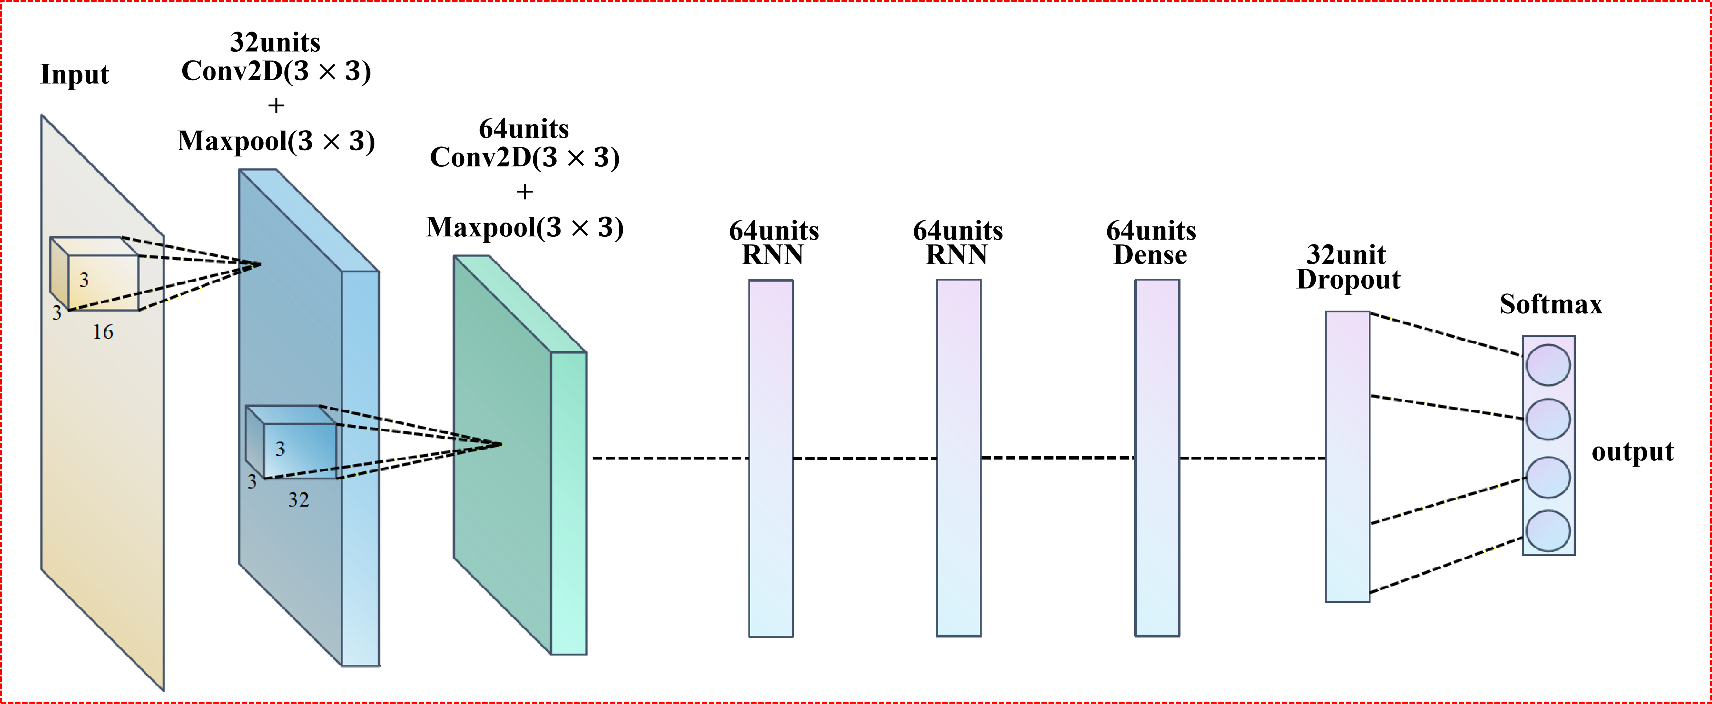
Fig. 4. Schematic illustration of the CNN-RNN hybrid model architecture for IMU-based sleep staging.

Nevertheless, this study has several important limitations that warrant acknowledgment and further investigation. First, the participant cohort is relatively small (N = 10) and exclusively composed of healthy young adults (mean age 26.4 ± 3.8 years), which significantly restricts the generalizability of the proposed framework. Critically, the dataset does not include clinically relevant populations such as older adults, whose sleep architecture exhibits reduced slow-wave activity and increased fragmentation, or individuals with common sleep disorders like obstructive sleep apnea (OSA), chronic insomnia, or restless legs syndrome. These conditions often alter both physiological signatures (e.g., frequent arousals in OSA) and body movement patterns, potentially degrading model performance. Therefore, the robustness and transferability of the label transfer mechanism and the downstream IMU-based classifier across diverse pathophysiological profiles remain unverified. Second, while the current work systematically evaluates established deep learning architectures, including CNN, RNN, LSTM, and their hybrid variants, it does not leverage state-of-the-art temporal modeling techniques that have recently shown promise in biosignal analysis, such as Temporal Convolutional Networks (TCNs), Transformer-based architectures, or neural differential equations. These models may better capture complex, multi-scale dynamics in sleep transitions, especially subtle micro-architectural features that are critical for distinguishing REM from wake or N1 from light artifact-contaminated segments.
To address these gaps, future work will pursue two key directions:
- Expand the cohort to at least 50 participants, explicitly including older adults (≥ 60 years) and patients with moderate-to-severe OSA (AHI ≥ 15) and primary insomnia, thereby enabling subgroup analysis and domain adaptation studies;
- Integration of self-supervised pre-training on large-scale unlabeled IMU data (e.g., using contrastive learning or masked signal modeling) to learn robust representations without relying solely on transferred labels.
Collectively, these enhancements are expected to transform the current proof-of-concept system into a clinically deployable solution capable of delivering reliable, personalized sleep assessment in real-world home environments.
References
- M. M. Ohayon, "Epidemiology of insomnia: What we know and what we still need to learn," Sleep Med. Rev., vol. 6, no. 2, pp. 97–111, 2002.
- T. Roth, "Insomnia: Definition, prevalence, etiology, and consequences," J. Clin. Sleep Med., vol. 3, no. 5 Suppl, pp. S7–S10, 2007.
- D. Riemann et al., "The neurobiology, investigation, and treatment of chronic insomnia," Lancet Neurol., vol. 14, no. 5, pp. 547–558, 2015.
- D. E. Ford and D. B. Kamerow, "Epidemiologic study of sleep disturbances and psychiatric disorders. An opportunity for prevention?," JAMA, vol. 262, no. 11, pp. 1479–1484, 1989.
- S. Bhaskar, D. Hemavathy, and S. Prasad, "Prevalence of chronic insomnia in adult patients and its correlation with medical comorbidities," J. Family Med. Prim. Care, vol. 5, no. 4, pp. 780–784, 2016.
- M. L. Perlis et al., "The incidence and temporal patterning of insomnia: A 2nd study," J. Sleep Res., vol. 23, no. 5, pp. 499–507, 2014.
- M. LeBlanc, C. Mérette, J. Savard, H. Ivers, L. Baillargeon, and C. M. Morin, "Incidence and risk factors of insomnia in a population-based sample," Sleep, vol. 32, no. 8, pp. 1027–1037, 2009.
- D. Foley, S. Ancoli-Israel, P. Britz, and J. Walsh, "Sleep disturbances and chronic disease in older adults: Results of the 2003 National Sleep Foundation Sleep in America Survey," J. Psychosom. Res., vol. 56, no. 5, pp. 497–502, 2004.
- A. N. Vgontzas, D. Liao, S. Pejovic, S. Calhoun, M. Karataraki, and E. O. Bixler, "Insomnia with objective short sleep duration is associated with type 2 diabetes: A population-based study," Diabetes Care, vol. 32, no. 11, pp. 1980–1985, 2009.
- A. D. Krystal, A. A. Prather, and L. H. Ashbrook, "The assessment and management of insomnia: An update," World Psychiatry, vol. 18, no. 3, pp. 337–352, 2019.
- N. Breslau, T. Roth, L. Rosenthal, and P. Andreski, "Sleep disturbance and psychiatric disorders: A longitudinal epidemiological study of young adults," Biol. Psychiatry, vol. 39, no. 6, pp. 411–418, 1996.
- G. E. Simon and M. VonKorff, "Prevalence, burden, and treatment of insomnia in primary care," Am. J. Psychiatry, vol. 154, no. 10, pp. 1417–1423, 1997.
- M. Daley, C. M. Morin, M. LeBlanc, J.-P. Grégoire, and J. Savard, "The economic burden of insomnia: Direct and indirect costs for individuals with insomnia syndrome, insomnia symptoms, and good sleepers," Sleep, vol. 32, no. 1, pp. 55–64, 2009.
- S. D. Kyle, K. Morgan, and C. A. Espie, "Insomnia and health-related quality of life," Sleep Med. Rev., vol. 14, no. 1, pp. 69–82, 2010.
- T. Roth and S. Ancoli-Israel, "Daytime consequences and correlates of insomnia in the United States: results of the 1991 National Sleep Foundation Survey. II," Sleep, vol. 22, pp. S354–S358, 1999.
- S. Javaheri and S. Redline, "Insomnia and risk of cardiovascular disease," Chest, vol. 152, no. 2, pp. 435–444, 2017.
- K. L. Knutson, K. Spiegel, P. Penev, and E. Van Cauter, "The metabolic consequences of sleep deprivation," Sleep Med. Rev., vol. 11, no. 3, pp. 163–178, 2007.
- C. Baglioni et al., "Insomnia as a predictor of depression: A meta-analytic evaluation of longitudinal epidemiological studies," J. Affect. Disord., vol. 135, no. 1-3, pp. 10–19, 2011.
- A. G. Harvey, "Sleep and circadian rhythms in bipolar disorder: Seeking synchrony, harmony, and regulation," Am. J. Psychiatry, vol. 165, no. 7, pp. 820–829, 2008.
- A. S. Lim, M. Kowgier, L. Yu, A. S. Buchman, and D. A. Bennett, "Sleep fragmentation and the risk of incident Alzheimer's disease and cognitive decline in older persons," Sleep, vol. 36, no. 7, pp. 1027–1032, 2013.
- Y. E. Ju et al., "Sleep quality and preclinical Alzheimer disease," JAMA Neurol., vol. 70, no. 5, pp. 587–593, 2013.
- L. Xie et al., "Sleep drives metabolite clearance from the adult brain," Science, vol. 342, no. 6156, pp. 373–377, 2013.
- J. R. Winer et al., "Sleep as a potential biomarker of tau and β-amyloid burden in the human brain," J. Neurosci., vol. 39, no. 32, pp. 6315–6324, 2019.
- M. Hirshkowitz et al., "National Sleep Foundation’s sleep time duration recommendations: Methodology and results summary," Sleep Health, vol. 1, no. 1, pp. 40–43, 2015.
- M. A. Carskadon and W. C. Dement, "Monitoring and staging human sleep," in Principles and practice of sleep medicine, 5th ed., M. H. Kryger, T. Roth, and W. C. Dement, Eds. St. Louis: Elsevier Saunders, pp. 16–26, 2011.
- L. Besedovsky, T. Lange, and J. Born, "Sleep and immune function," Pflügers Arch., vol. 463, no. 1, pp. 121–137, 2012.
- G. Tononi and C. Cirelli, "Sleep and the price of plasticity: From synaptic and cellular homeostasis to memory consolidation and integration," Neuron, vol. 81, no. 1, pp. 12–34, 2014.
- M. M. Ohayon, M. A. Carskadon, C. Guilleminault, and M. Vitiello, "Meta-analysis of quantitative sleep parameters from childhood to old age in healthy individuals: Developing normative sleep values across the human lifespan," Sleep, vol. 27, no. 7, pp. 1255–1273, 2004.
- V. K. Kapur et al., "Clinical practice guideline for diagnostic testing for adult obstructive sleep apnea: An American Academy of Sleep Medicine clinical practice guideline," J. Clin. Sleep Med., vol. 13, no. 3, pp. 479–504, 2017.
- C. V. Senaratna et al., "Prevalence of obstructive sleep apnea in the general population: A systematic review," Sleep Med. Rev., vol. 34, pp. 70–81, 2017.
- R. B. Berry et al., "Rules for scoring respiratory events in sleep: Update of the 2007 AASM manual for the scoring of sleep and associated events," J. Clin. Sleep Med., vol. 8, no. 5, pp. 597–619, 2012.
- D. Moser et al., "Sleep classification according to AASM and Rechtschaffen & Kales: Effects on sleep scoring parameters," Sleep, vol. 32, no. 2, pp. 139–149, 2009.
- R. B. Berry et al., The AASM Manual for the Scoring of Sleep and Associated Events: Rules, Terminology and Technical Specifications. Darien, IL, USA: American Academy of Sleep Medicine, 2012.
- R. S. Rosenberg and S. Van Hout, "The American Academy of Sleep Medicine inter-scorer reliability program: Sleep stage scoring," J. Clin. Sleep Med., vol. 9, no. 1, pp. 81–87, 2013.
- S. Schutte-Rodin, L. Broch, D. Buysse, C. Dorsey, and M. Sateia, "Clinical guideline for the evaluation and management of chronic insomnia in adults," J. Clin. Sleep Med., vol. 4, no. 5, pp. 487–504, 2008.
- J. M. Kelly, R. E. Strecker, and M. T. Bianchi, "Recent developments in home sleep-monitoring devices," ISRN Neurol., vol. 2012, no. 1, pp. 768-794, 2012.
- N. A. Collop et al., "Clinical guidelines for the use of unattended portable monitors in the diagnosis of obstructive sleep apnea in adult patients. Portable Monitoring Task Force of the American Academy of Sleep Medicine," J. Clin. Sleep Med., vol. 3, no. 7, pp. 737–747, 2007.
- M. Tamaki, J. W. Bang, T. Watanabe, and Y. Sasaki, "Night watch in one brain hemisphere during sleep associated with the first-night effect in humans," Curr. Biol., vol. 26, no. 9, pp. 1190–1194, 2016.
- H. W. Agnew, W. B. Webb, and R. L. Williams, "The first night effect: An EEG study of sleep," Psychophysiology, vol. 2, no. 3, pp. 263–266, 1966.
- M. T. Bianchi, "Sleep devices: wearables and nearables, informational and interventional, consumer and clinical," Metabolism, vol. 84, pp. 99–108, 2018.
- Z. Beattie et al., "Estimation of sleep stages in a healthy adult population from optical plethysmography and accelerometer signals," Physiol. Meas., vol. 38, no. 11, pp. 1968–1979, 2017.
- D. Krauss, R. Richer, N. Albrecht, J. Jukic, C. H. Krebber, and P. Zwiessele, "Contactless sleep staging with radar: A transfer learning approach," IEEE Open J. Eng. Med. Biol., vol. 5, pp. 725–734, 2024.
- M. Migliorini et al., "Automatic sleep staging based on ballistocardiographic signals recorded through bed sensors," in Proc. Annu. Int. Conf. IEEE Eng. Med. Biol. Soc. (EMBC), pp. 3273–3276, 2010.
- C. H. He, J. W. Tan, X. L. Jian, G. X. Zhong, L. L. Cheng, and J. Z. Lin, "A smart flexible vital signs and sleep monitoring belt based on MEMS triaxial accelerometer and pressure sensor," IEEE Internet Things J., vol. 9, no. 15, pp. 14126–14136, 2022.
- E. Eldele, Z. Chen, C. Liu, M. Wu, C.-K. Kwoh, and X. Li, "An attention-based deep learning approach for sleep stage classification with single-channel EEG," IEEE Trans. Neural Syst. Rehabil. Eng., vol. 29, pp. 809–818, 2021.
- H. Phan et al., "Towards more accurate automatic sleep staging via deep transfer learning," IEEE Trans. Biomed. Eng., vol. 68, no. 6, pp. 1787–1798, 2020.
- B. Kemp, A. H. Zwinderman, B. Tuk, H. A. C. Kamphuisen, and J. J. L. Oberyé, "Analysis of a sleep-dependent neuronal feedback loop: The slow-wave microcontinuity of the EEG," IEEE Trans. Biomed. Eng., vol. 47, no. 9, pp. 1185–1194, 2000.
- C. H. He et al., "A smart flexible sleep-aid eye mask based on acupoint electric pulse stimulation combined bioelectrical signal feedback," IEEE Internet Things J., vol. 11, no. 4, pp. 7228–7240, 2023.

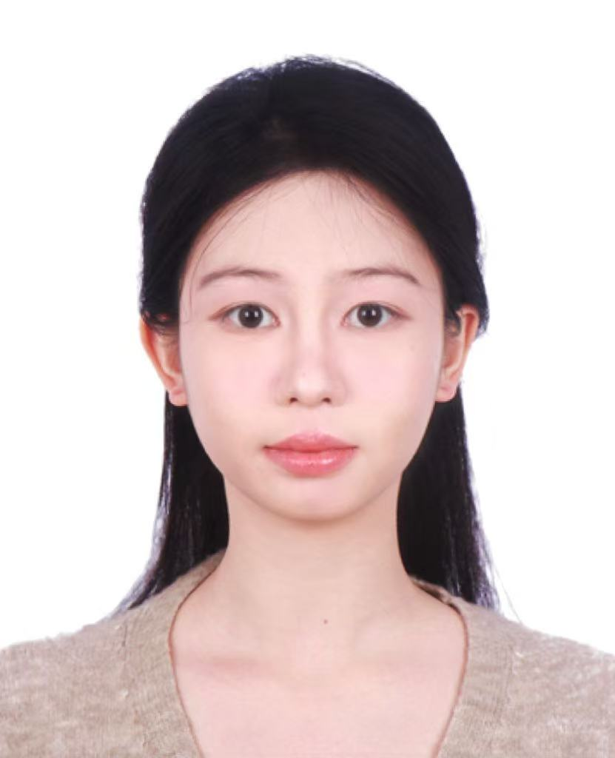
Xinran Lin is currently an undergraduate student in the School of Computer, Guangdong University of Technology, Guangzhou, China, and she is expected to receive her B.S. degree in 2027. Her research interests include machine learning and sleep health management.


SHANGLE YE received the B.S. degree in Mechatronics Engineering from Wuhan University of Technology, Wuhan, China, in 2017, and he is currently pursuing the M.S. degree in Software Engineering at the School of Computer Science at Guangdong University of Technology. His research interests include artificial intelligence and sleep health management.

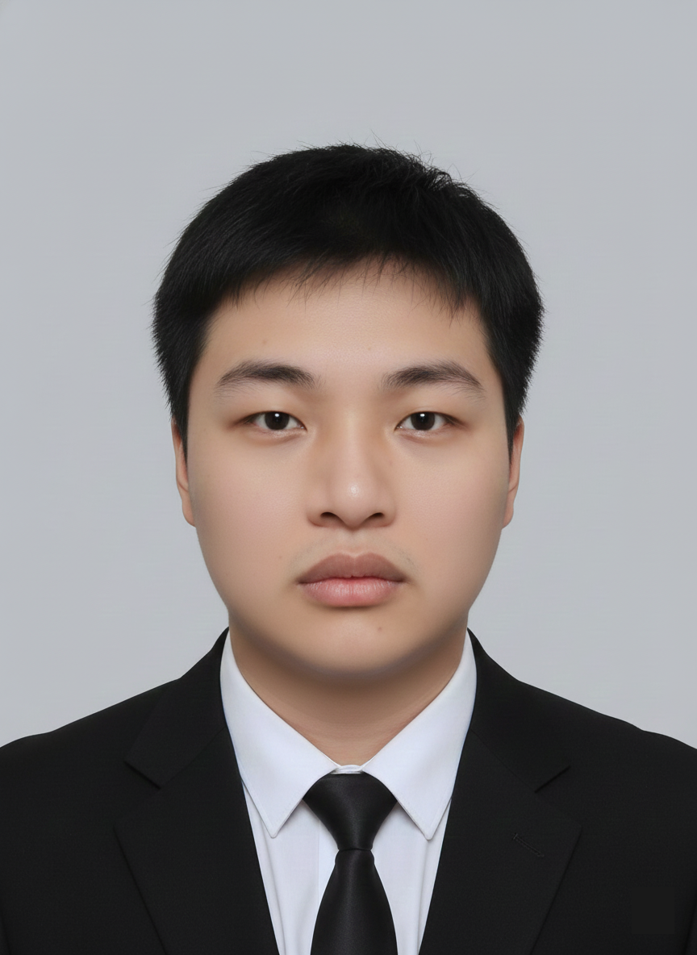
Jian Zhan received the B.S. degrees in Industrial Design from Guangdong University of Technology, Guangzhou, China, in 2024, and he is currently pursuing the M.S. degree in Computer Technology at the School of Computer, Guangdong University of Technology. His research interests include machine learning and sleep health management.

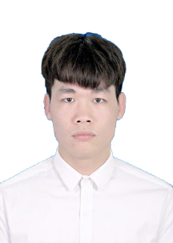
SHUIBIN LIU received the B.S. degree in Computer Science and Technology from Guangzhou University Sontan College, Guangzhou, China, in 2022, and the M.S. degree in Artificial Intelligence from the School of Computer, Guangdong University of Technology, in 2025. His research interests include sleep detection, MEMS application, snore recognition, pattern recognition, knowledge graph and prognostics health management.


HENG WU received the B.S. degree in electronic and information engineering from the Wuhan University of Science and Technology, Wuhan, China, in 2009, and received the M.S. and Ph.D. degrees in optics and mechanical manufacture and automation from the South China University of Technology, Guangzhou, China, in 2012 and 2017, respectively.
He is currently an associate professor at the School of Automation at Guangdong University of Technology. His research interests are in the fields of optical measurement, machine vision, and image processing.

MAOJIN LIANG received the Master degree (7-year program) in 2009 and the M.D. degree in 2015, from Sun Yat-sen University, Guangzhou, China.
Since 2009, he has been working in the Sun Yat-sen Memorial Hospital of Sun Yat-sen University, where he is currently a Deputy Chief Physician, Master Supervisor. Now he is specialized in Otology and Neurotology. His clinical and research interest includes development and influencing factors of auditory centers, middle ear related diseases, eustachian tube related diseases, and deaf children. He is also interested in ADHD and insomnia treatment and the application of AI in health management.


CHUNHUA HE received the B.S. degree in microelectronics from Sun Yat-sen University, Guangzhou, China, in 2010, and the M.S. degree and Ph.D. degree in microelectronics and solid-state electronics from Peking University, Beijing, China, in 2013 and 2018, respectively.
From 2013 to 2017, he was an Engineer with the No.5 Electronics Research Institute, Ministry of Industry and Information Technology, Guangzhou, China. From 2017 to 2019, he was an Engineer with Midea Group, Foshan, China. From 2019 to 2021, he was a Senior Engineer with Guangzhou 37 Degree Smart Home Co., Ltd., Guangzhou, China. He joined the School of Computer, Guangdong University of Technology in 2021, Guangzhou, China, where he is currently an Associate Professor. His current research interests include the design and application of MEMS sensors and artificial intelligence algorithms for biomedical engineering.

Manuscript received March 25, 2026; revised xxxx xx, 2026; accepted xxxx xx, 2026. This work was partially supported by the National Natural Science Foundation of China (Grant No. U22A2012), Guangdong Basic and Applied Basic Research Foundation (Grant Nos. 2024A1515220127 and 2024A1515011168), and Guangzhou Key Research and Development Program (Grant No. 2024B03J1251). (#These authors contributed equally: Xinran Lin, Shangle Ye) (*Corresponding author: Chunhua He). Xinran Lin, Shangle Ye, Jian Zhan, Shuibin Liu, and Chunhua He are with the School of Computer, Guangdong University of Technology, Guangzhou 510000, China. (e-mail: 3223004513@mail2.gdut.edu.cn, yeshangle@mails.gdut.edu.cn, 2112405121@mail2.gdut.edu.cn, 2112 205258@mail2.gdut.edu.cn, hechunhua@pku.edu.cn). Heng Wu is with the School of Automation, Guangdong University of Technology, Guangzhou 510000, China. (e-mail: heng.wu@gdut.edu.cn). Maojin. Liang is with the Department of Otolaryngology, Sun Yat-Sen Memorial Hospital of Sun Yat-Sen University, Guangzhou, 510120, China (e-mail: liangmj3@mail.sysu. edu.cn).

