<!DOCTYPE html>
<html lang="en">
<head>
<meta charset="UTF-8">
<meta name="viewport" content="width=device-width, initial-scale=1.0">
<title>Explore the World - Travel Website</title>
<style>
a {
color: #0066cc; /* Default link color (blue) */
text-decoration: none;
}

a:visited {
color: #800080; /* Visited link color (purple) */
}

a:hover {
color: #ff6600; /* Hover color (orange) */
text-decoration: underline;
}

a:active {
color: #cc0000; /* Active/clicked link color (red) */
}
ul{
list-style: "\128540";
}
ol{
list-style: "\246A";
}
</style>
</head>
<body bgcolor="#fff8fo">
<!-- ===== Header Section ===== -->
<h1>Explore the World</h1>
<hr>

<!-- ===== Introduction Section ===== -->
<h2>Welcome to Your Next Adventure!</h2>
<p>
Traveling is not just about <strong>visiting places</strong>, it's about <em>creating memories</em>.
Our tours offer a <u>unique blend</u> of culture, adventure, and relaxation.
<br><br>
Don't wait to explore — <del>procrastinate</del> <ins>participate</ins>!
</p>

<p>
Whether you're dreaming of sandy beaches or mountain hikes, we have it all.
<strong><em>Book your trip today</em></strong> and start a journey of a lifetime!
</p>
<hr>

<!-- ===== Images Section ===== -->
<h2>Destination Highlights</h2>
<img src="https://ignitetravelsolution.com/wp-content/uploads/2024/10/Top-10-Must-Visit-Places-in-Paris.jpg" alt="Paris" width="400">
<br><br>
<img src="https://encrypted-tbn0.gstatic.com/images?q=tbn:ANd9GcS6ffHXvjH1pWsz98fMfigchsgcsq9yXaH0ew&s" alt="Scuba Diving" width="400" >
<hr>

<!-- ===== Hyperlinks Section ===== -->
<h2>Useful Links</h2>
<table border="1" cellpadding="8" cellspacing="0" >
<tr>
<th>Click on the link</th>
</tr>
<tr>
<td><a href="#contact">Go to Contact Us Section (Internal Link)</a></td>
</tr>
</table>
<hr>
<br>
<table border="1" cellpadding="8" cellspacing="0" >
<tr>
<th>Click on the link</th>
</tr>
<tr>
<td><a href="https://www.lonelyplanet.com/">Visit Lonely Planet (External Link)</a></td>
</tr>
</table><hr>
<br>
<table border="1" cellpadding="8" cellspacing="0" >
<tr>
<th>Click on the link</th>
</tr>
<tr>
<td><a href="travel.html">Know more about those places to chose your favourite Destinations</a></td>
</tr>
</table><hr>
<br>

<!-- ===== Lists Section ===== -->
<h2>Travel Tips</h2>

<!-- Ordered List -->
<h3>Top 5 Travel Destinations</h3>
<ol>
<li>Paris, France</li>
<li>Kyoto, Japan</li>
<li>Banff, Canada</li>
<li>Rome, Italy</li>
<li>New York, USA</li>
</ol>

<!-- Unordered List -->
<h3>Travel Essentials to Pack</h3>
<ul>
<li>Passport & ID</li>
<li>Travel Adapter</li>
<li>Comfortable Shoes</li>
<li>Camera</li>
<li>Travel Insurance</li>
</ul>

<!-- Definition List -->
<h3>Travel Terms</h3>
<dl>
<dt>Itinerary</dt>
<dd>A detailed plan for a journey.</dd>
<dt>Jet Lag</dt>
<dd>Fatigue caused by travel across time zones.</dd>
<dt>Backpacking</dt>
<dd>Traveling or hiking while carrying your belongings in a backpack.</dd>
</dl>
<hr>

<!-- ===== Table Section ===== -->
<h2>Our Travel Packages</h2>
<table border="1" cellpadding="8">
<thead>
<tr>
<th>Destination</th>
<th>Price</th>
<th>Duration</th>
</tr>
</thead>
<tbody>
<tr>
<td>Paris</td>
<td>$1,200</td>
<td>5 Days</td>
</tr>
<tr>
<td>Bali</td>
<td>$950</td>
<td>7 Days</td>
</tr>
<tr>
<td>New York</td>
<td>$1,500</td>
<td>4 Days</td>
</tr>
<tr>
<td>Rome</td>
<td>$1,100</td>
<td>6 Days</td>
</tr>
</tbody>
</table>
<hr>

<!-- ===== Contact Section ===== -->
<h2 id="contact">Contact Us</h2>
<p>
Have questions? Reach out at <a href="mailto:info@travelworld.com">info@travelworld.com</a> or call +123-456-7890.
</p>

<!-- ===== Footer ===== -->
<hr>
<footer>
<p>&copy; 2025 Explore the World. All rights reserved.</p>
</footer>

</body>
</html>
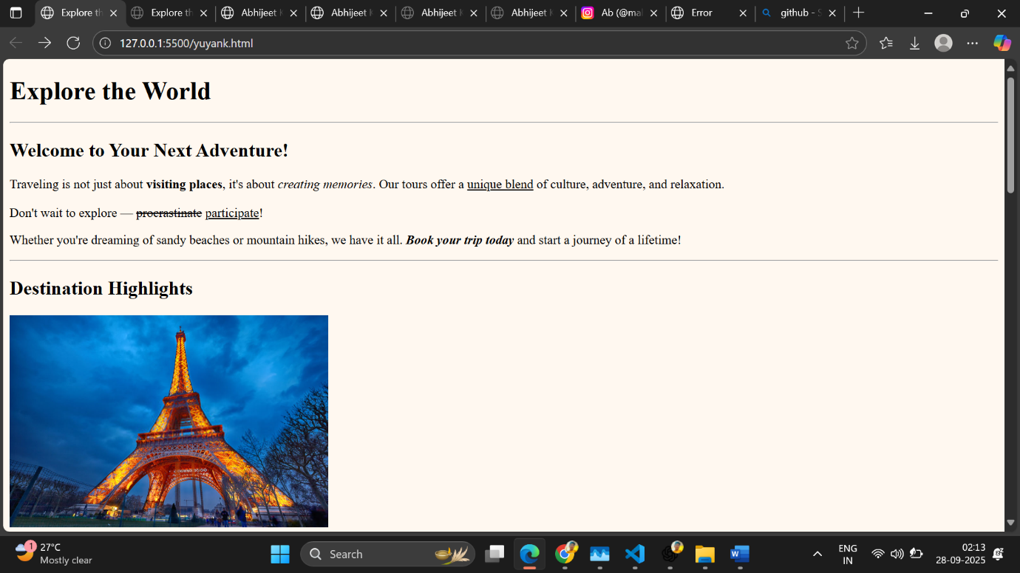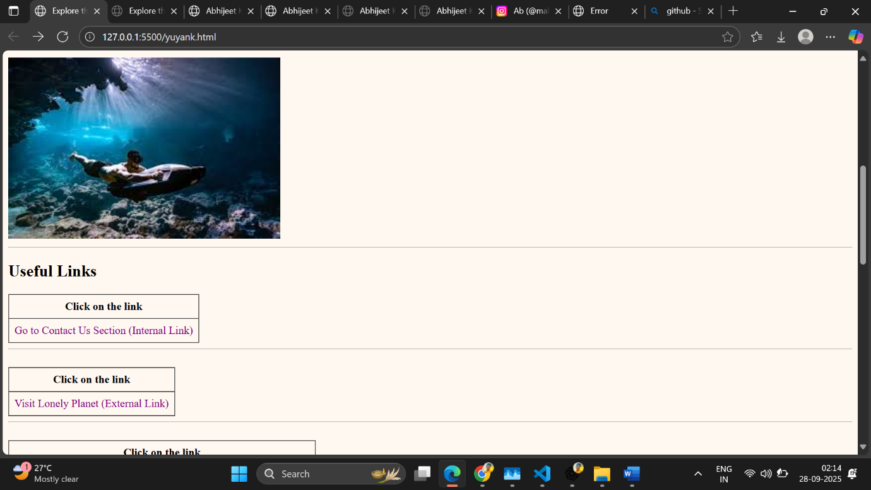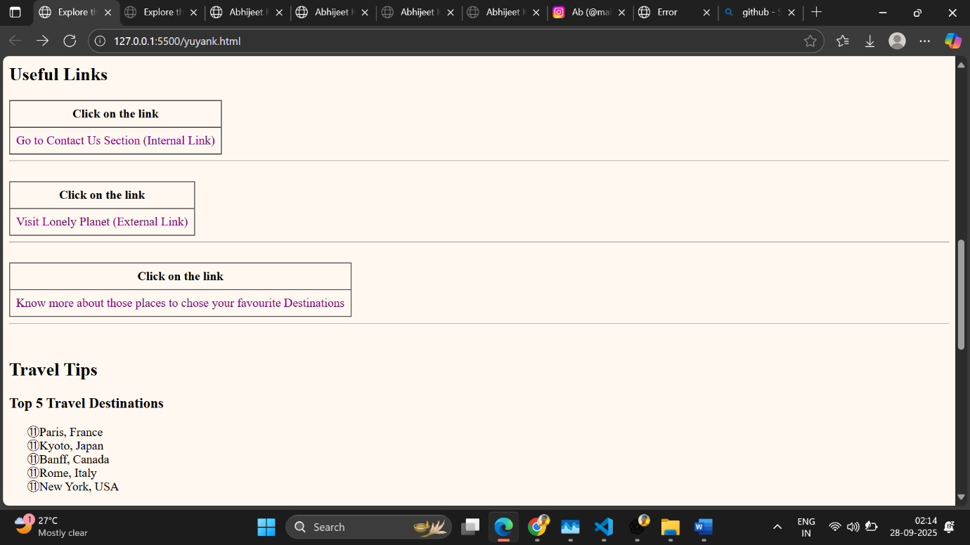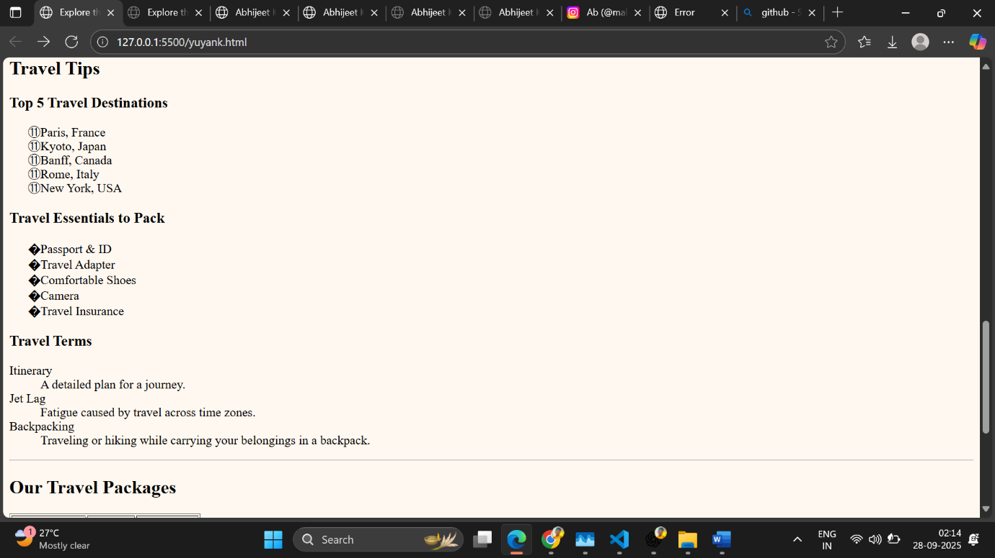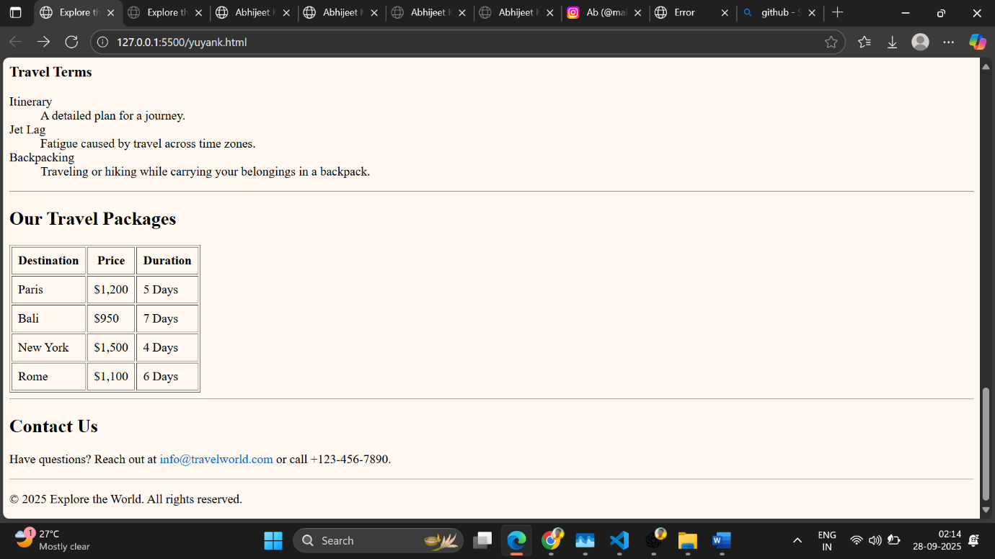
<!DOCTYPE html>
<html lang="en">
<head>
<meta charset="UTF-8" />
<meta name="viewport" content="width=device-width, initial-scale=1" />
<title>Top 5 Travel Destinations & Essentials</title>
<style>
a {
color: #0066cc; /* Default link color (blue) */
text-decoration: none;
}

a:visited {
color: #800080; /* Visited link color (purple) */
}

a:hover {
color: #ff6600; /* Hover color (orange) */
text-decoration: underline;
}

a:active {
color: #cc0000; /* Active/clicked link color (red) */
}
ul{
list-style: "\128540";
}
ol{
list-style: "\246A";
}
</style>
</head>
<body>

<h1>Top 5 Travel Destinations & What's Important to Pack</h1>

<!-- Paris, France -->
<section>
<h2>Paris, France</h2>
<img src ="https://thumbs.dreamstime.com/b/alexander-iii-bridge-across-seine-river-paris-france-cityscape-sunny-day-41235739.jpg?w=768" width="400" height="400">
<p>Known as the "City of Light," Paris is famous for its art, fashion, and iconic landmarks like the Eiffel Tower.</p>
<h3>Important Essentials:</h3>
<ul>
<li>Comfortable walking shoes for exploring museums and streets</li>
<li>Travel adapter (Type C, E, or F plugs)</li>
<li>French phrasebook or translation app</li>
<li>Light jacket for cooler evenings</li>
</ul>
</section>

<hr>

<!-- Kyoto, Japan -->
<section>
<h2>Kyoto, Japan</h2>
<img src="https://thumbs.dreamstime.com/b/japanese-women-walk-unhill-autumn-maple-tree-tunnel-to-visit-shinnyodo-temple-kyoto-japan-famous-travel-destination-392227810.jpg?w=768" width="400" height="400">
<p>Kyoto is famous for its traditional temples, beautiful gardens, and rich cultural heritage.</p>
<h3>Important Essentials:</h3>
<ul>
<li>Comfortable shoes for walking temple grounds</li>
<li>Respectful attire (cover shoulders and knees in temples)</li>
<li>Portable Wi-Fi or SIM card</li>
<li>Cash (many places don't accept cards)</li>
</ul>
</section>

<hr>

<!-- Banff, Canada -->
<section>
<h2>Banff, Canada</h2>
<img src="https://thumbs.dreamstime.com/b/rocky-mountains-banff-national-park-canada-beautiful-turquoise-waters-moraine-lake-snow-covered-peaks-above-103938603.jpg?w=992" width="400" height="400">
<p>A stunning natural destination with mountain landscapes, hiking trails, and wildlife.</p>
<h3>Important Essentials:</h3>
<ul>
<li>Hiking boots and outdoor gear</li>
<li>Layered clothing for changing weather</li>
<li>Bear spray or awareness of wildlife safety</li>
<li>Camera for capturing nature</li>
</ul>
</section>

<hr>

<!-- Rome, Italy -->
<section>
<h2>Rome, Italy</h2>
<img src="https://thumbs.dreamstime.com/b/rome-italy-ruins-roman-forum-capitoline-hill-61131826.jpg?w=768 " width="400" height="400">
<p>Rome is full of history, famous ruins, delicious cuisine, and vibrant street life.</p>
<h3>Important Essentials:</h3>
<ul>
<li>Comfortable shoes for cobblestone streets</li>
<li>Sun protection (hat, sunglasses, sunscreen)</li>
<li>Reusable water bottle (many public fountains)</li>
<li>Guidebook or app for historical sites</li>
</ul>
</section>

<hr>

<!-- New York, USA -->
<section>
<h2>New York, USA</h2>
<img src="https://thumbs.dreamstime.com/b/new-york-cityscape-skyline-night-nyc-usa-12560890.jpg?w=768" width="400" height="400">
<p>The city that never sleeps, known for its skyline, Broadway shows, and diverse neighborhoods.</p>
<h3>Important Essentials:</h3>
<ul>
<li>Comfortable walking shoes</li>
<li>MetroCard for public transport</li>
<li>Portable phone charger</li>
<li>Weather-appropriate clothing (varies seasonally)</li>
</ul>
</section>
<section>
<table border="1" cellpadding="8" cellspacing="0" >
<tr>
<th>Click on the link</th>
</tr>
<tr>
<td><a href="yuyank.html">Go Back to Previous Page</a></td>
</tr>
</table>
</section>
</body>
</html>
