#### DATA 23700 Autumn 2023

## Exercise 3: Design critique

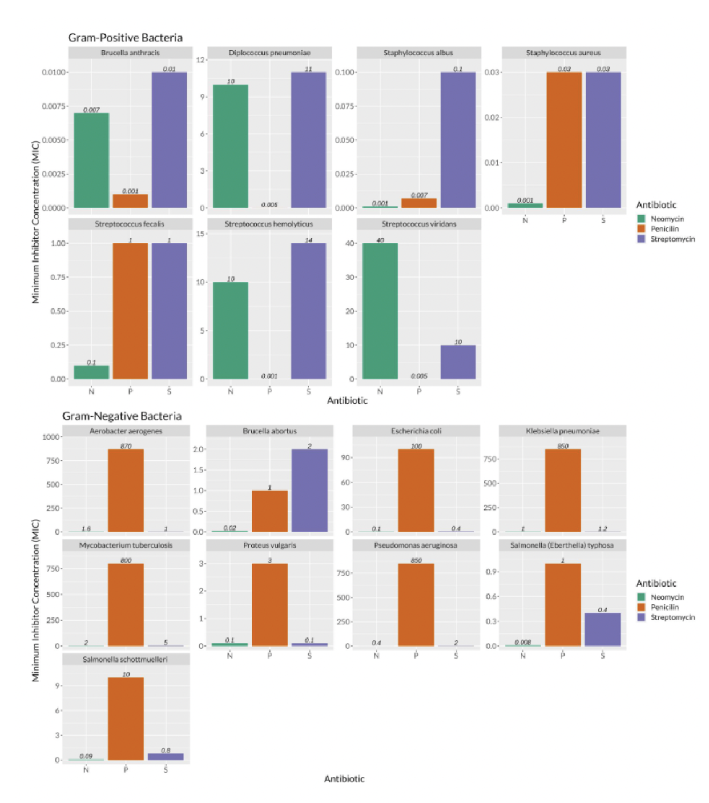

I like the structure of the design, which separates the data by the different bacteria and also by the fact that they are either gram positive or negative. Having different plots that are visually separated allows easy target of the MICs of the bacteria that one can be looking for.

I also like the choice of using bar chart instead of points or other means of representing the value of the MICs. It really makes the visualization more straight forward.

I like the fact that the exact values are above each bar, it work very well specially in cases where the range of values is high and it is difficult to notice the small value differences.

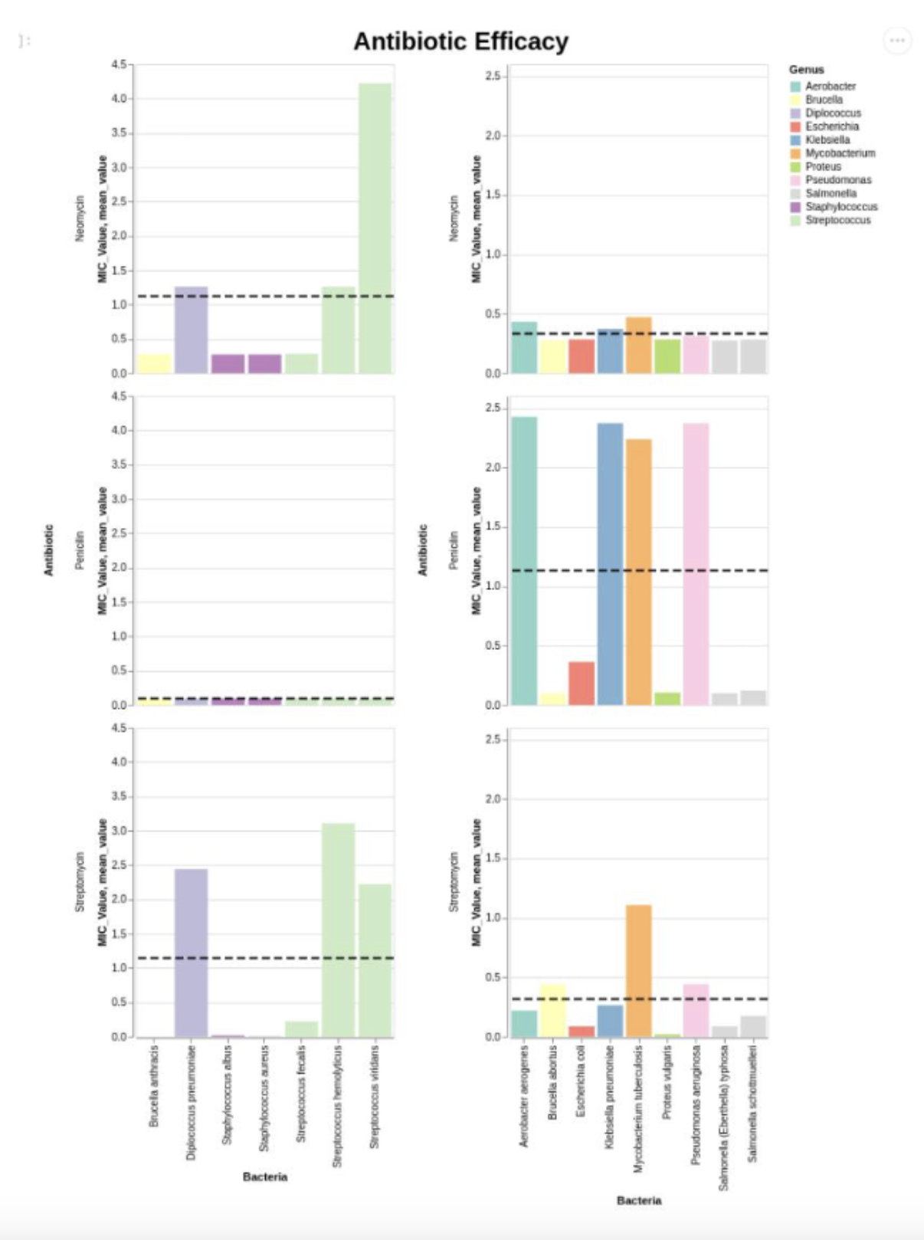

I like the decision of drawing a line that represents the average of MICs of each antibiotic. It makes it easy to compare between the effectiveness of each antibiotic on gram positive or negative bacteria.

I like the use of different colors for different bacteria genus. It makes the whole graph more visually appealing.

I wish some of the graphs had different scales or value ranges for the y axis, since it is hard sometimes to observe the little differences between the MIC values.

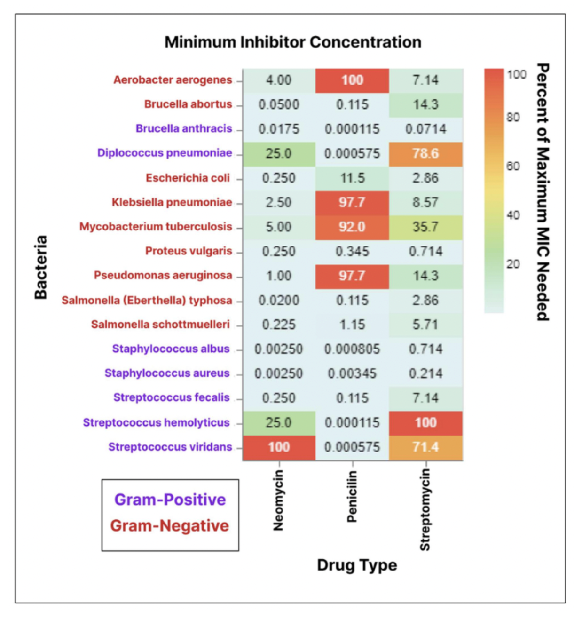

I like the use of setting the values as a percentage of the maximum MIC needed, it is really an interesting point of view to represent the numerical values.

What if the percentages were applied by bacteria and not by drug type? Would that also be representative and convey other type of information? What if the values are not represented with plain text and colors?

I wish there were less text or numbers in the plot, since it might be visually tiring and not that attactive.

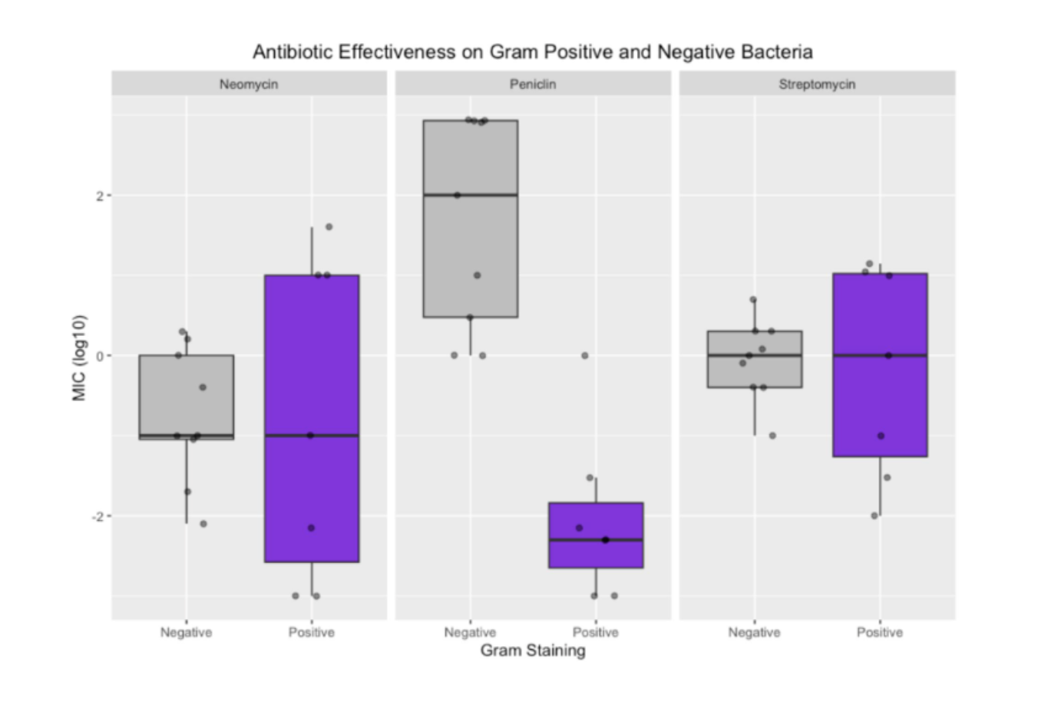

I like to use of box plot to represent the data, it gives an detailed overall view of how each antibiotic works according to gram positive or negative bacteria.

I wish there could be a way to distinguish or recognise which dot corresponds to which bacteria type; since I consider that as a really important part of the dataset provided.

What if the color for the left boxes were different (not gray)? In such way the purple boxes wouldn’t stand out that much and express equivalence of important when considering gram staining.

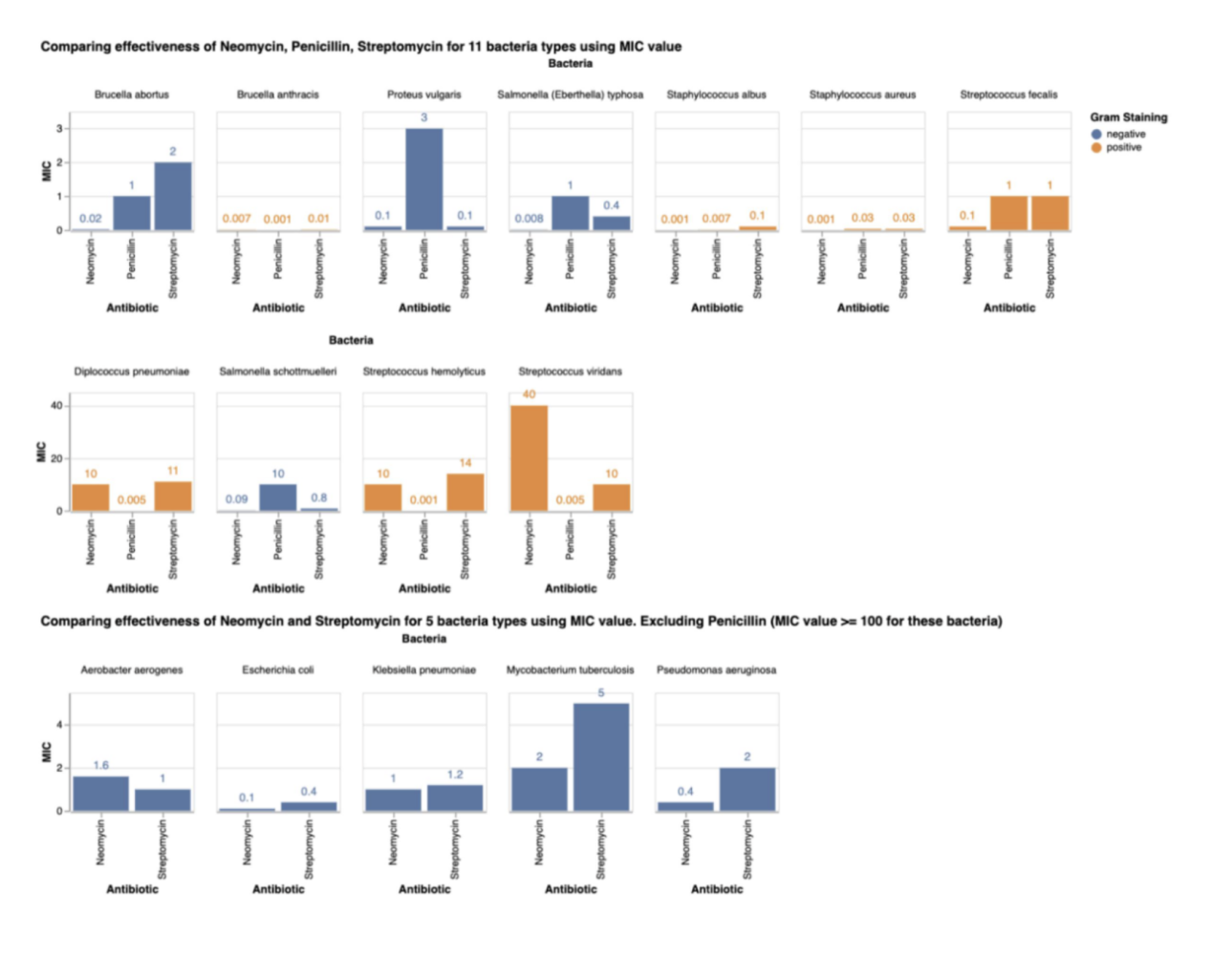

I like the way in which the different plots are separated: there’s one plot per each bacteria type and not all of them have 3 bars for each antibiotic.

What if each plot had its own value range for the y axis? The visualization would improve for those plots that have small MIC values.

I like the use of colors to represent the gram staining of each bacteria. It makes it easy to visually differenciate them.