**Digital Ocean vs AWS pricing compare**

Digital Ocean is a mid-sized hosting provider that is primarily focused on cloud hosting technologies.

Amazon Web Services is one of the largest companies in the world, and also offer great cloud hosting services. When looking at them side by side, it is clear that AWS keeps their customers happier, offers a better list of features, and is generally better in just about every way.

While Digital Ocean may be slightly cheaper, the extra quality you get from AWS makes it worth every penny.

All this combined makes it clear that AWS is the winner in this comparison.

<https://hostadvice.com/tools/web-hosting-comparison/amazon-web-services-vs-digital-ocean/>

# Server specification

|  |  |  |  |  |
| --- | --- | --- | --- | --- |
| Spec | Memory | CPU | SSD | Transfer |
| 16GB | 8 | 160GB | 6TB |

# Digital Ocean vs AWS monthly price compare

## Digital Ocean

|  |  |  |  |  |
| --- | --- | --- | --- | --- |
| Digital Ocean | Server  ($/mo) | Other Service | | **Sum**  **($/mo)** |
| LoadBalancer  ($/mo) | Godaddy Certificate  ($/mo) |
| 160 | 20 | 74.99 | 254.99 |

## AWS

|  |  |  |  |  |
| --- | --- | --- | --- | --- |
| AWS | Server(EC2)  ($/mo) | CloudFront  ($/mo) | Business Support  ($/mo) | **Sum**  **($/mo)** |
| 8 | 32.26 | 200 | 240.26 |

# Reference url and data

## Digital Ocean

### Storage price site

<https://www.digitalocean.com/pricing/#storage>

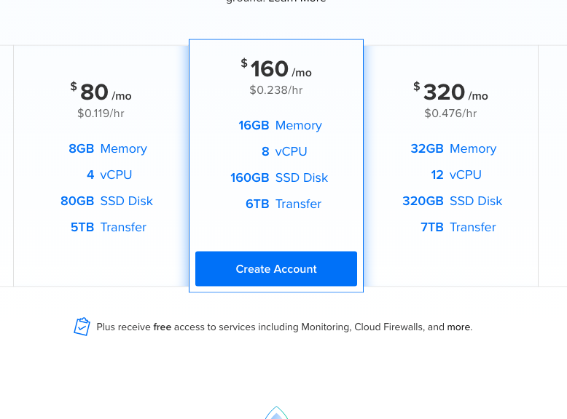

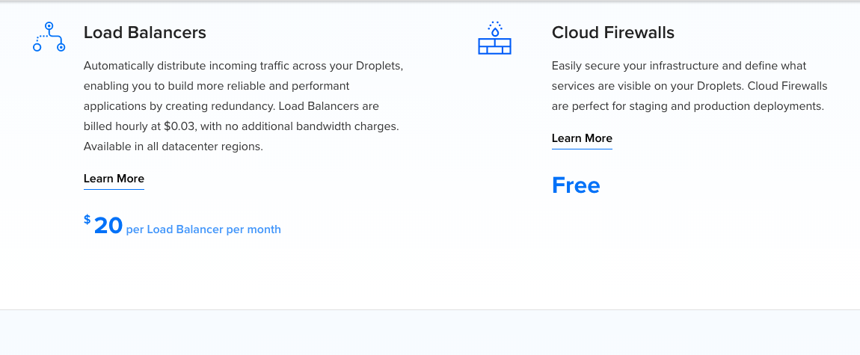

### Certificate price site

<https://www.godaddy.com/ssl/ssl-certificates.aspx>.

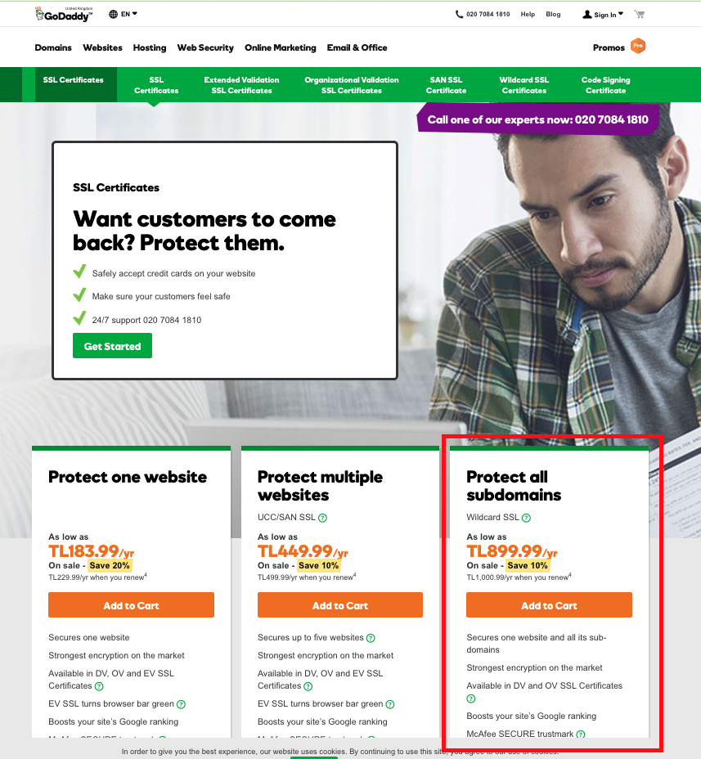

## AWS

<https://console.aws.amazon.com/billing/home?region=us-east-2#/>

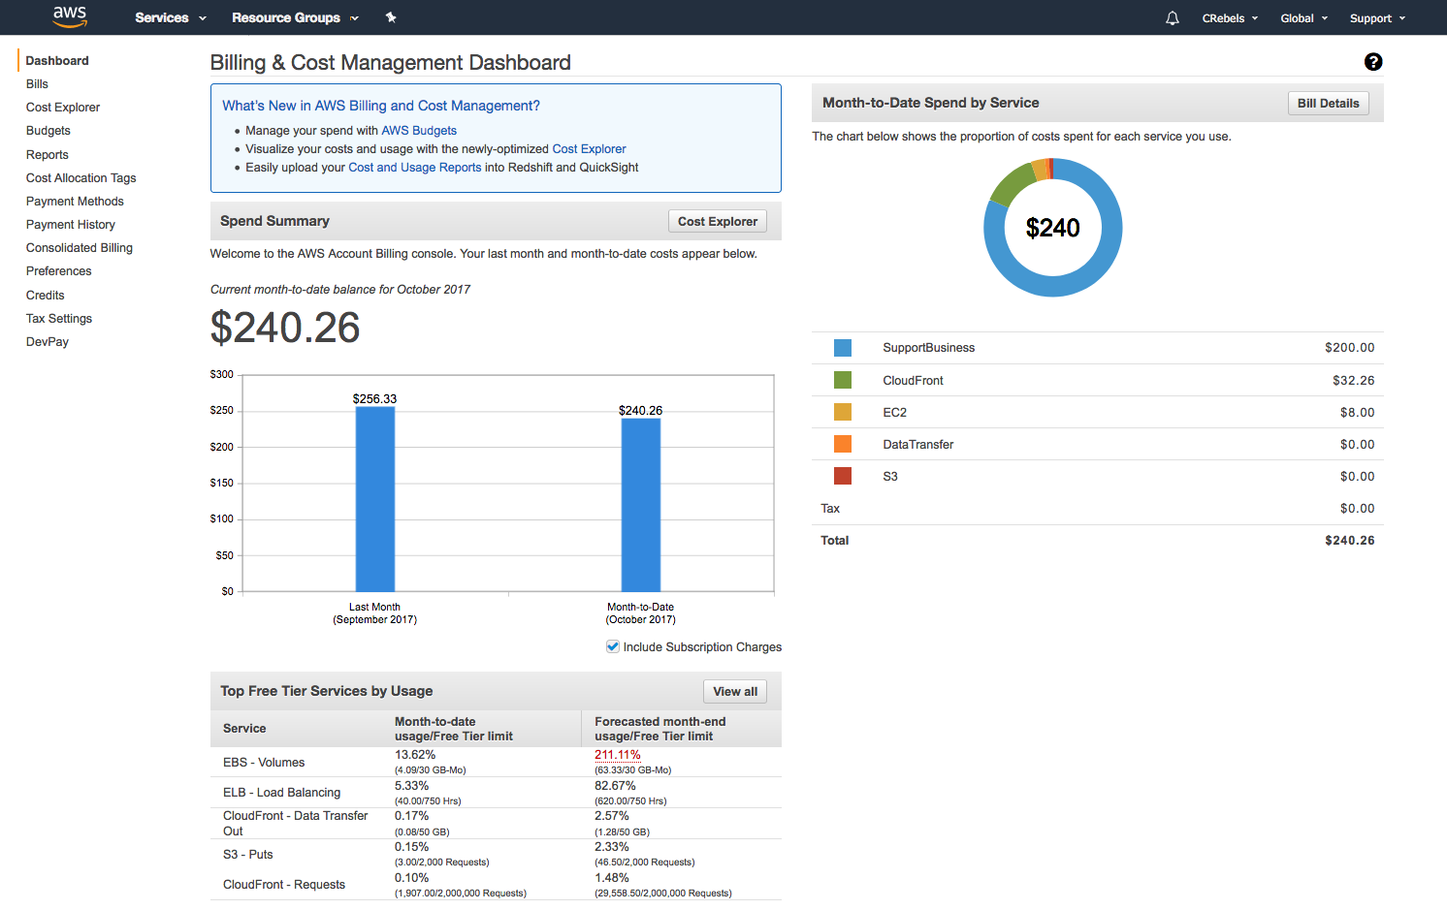

<https://console.aws.amazon.com/billing/home?region=us-east-2#/bill?year=2017&month=10>

