Title in Bold Helvetica 16 pt

A. N. AuthorOne¹, A. N. AuthorTwo², A. N. AuthorThree²

¹Institution A, Postal address
Email: name1@not.as.a.hyperlink.please

²Institution B, Postal address
Email: {name2; name3}@not.as.a.hyperlink.please

Abstract
An abstract for short peer-reviewed papers should be presented in Times New Roman typeface, 12 pt font. The abstract should not exceed 200 words.

1. Introduction
This document provides a template for your final project. It follows the template of short-papers for GIScience conference. By preparing this report, you will learn how to format a scientific paper for publication.
The report should include the following sessions.
- Introduction (~ 0.5 page): Background information and motivation of study
- Related work (~ 0.5 page): Brief discuss related work to your project
- Methodology (1 page): Workflow of your study
- Results (1 page): Interpretation of the result
- Discussion (~ 0.5 page): Limitation of your study
- Conclusions and Future Work ( ~ 0.5 page).
The above page number for each section is just an example of text, which excludes figures and tables. You can extend or shorten sections as needed. The total report must not exceed 10 pages including figures, tables and references.
The title should be Helvetica and 16 pt with mixed capitalization. The author names must be in Times New Roman (12 pt) and the affiliations Times New Roman (8 pt). You can include anyone that have given advice, provided data or helped in other means for your project as co-authors. If multiple authors share the same affiliation, “share” the affiliation and list e-mail addresses as {persona; personb}@email.com. Email address should not be listed as hyperlinks.
The page size must be US Letter with margins of 2.54cm (1 in) on all sides. Each section of the paper (except the Acknowledgements and References sections) should be numbered, as shown in this example. The section heading should be left-aligned with bold Helvetica 14 pt.
The main text is set in Times New Roman 12 pt. The main text should just be justified. The first line of the first paragraph in each section or subsection should not be indented. The rest of the paragraphs should be indented by 0.635cm (0.25 in), as in this example. Use only one space between sentences.

1.1 Subsections and Their Formatting
Subsections should be numbered as shown in this example. The subsection heading should be left-aligned with bold Helvetica 12 pt.

2. Equations, Figures and Tables

2.1 Equations
Equations should be centred on the page and numbered consecutively in the right-hand margin as (1), (2), etc. They should be referred to in the text as follows: “Equation 1 is applied to compute ...” or “Weighted correlation coefficient (2) is used for ...”.

2.2 Figures
Figures should be presented at relevant locations in the text and not at the end of the paper. They should be referred to in the text (e.g., “Figure 1 shows the venue for what will be a highly geotagged conference”). The figure caption should centred and placed below the figure. It should end with a full stop. As can be seen with Figure 1, figures are centred on the page.
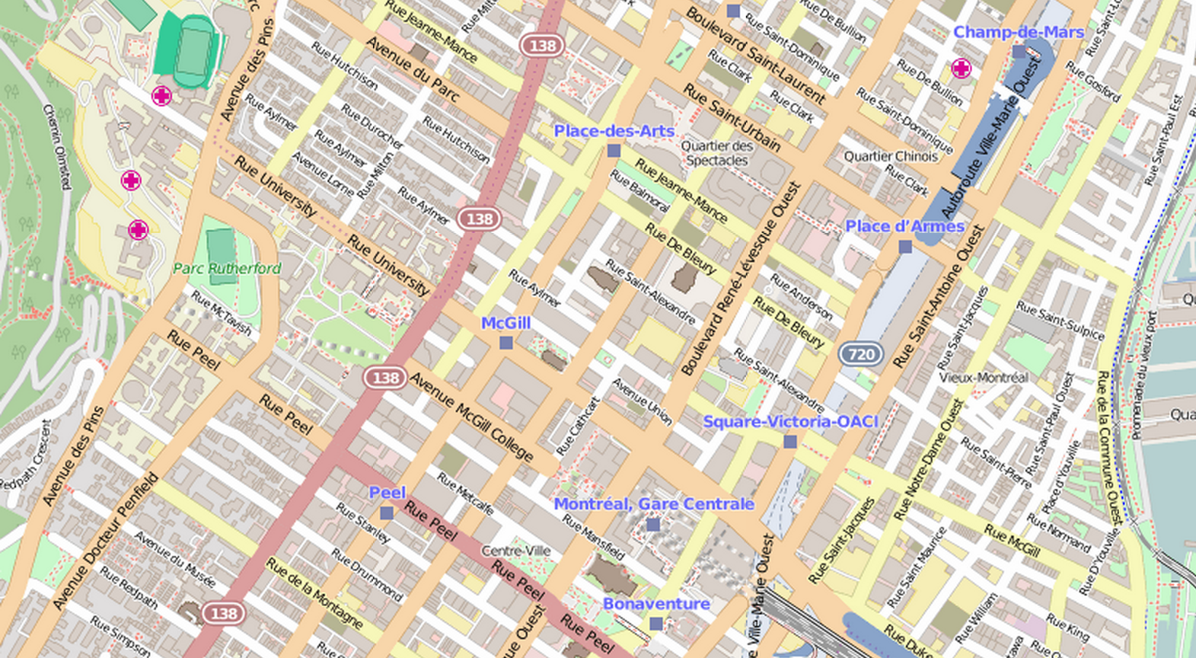
Figure 1. The venue of GIScience 2016.

2.3 Tables
Tables should be in the style shown below and should be referred to in the text using table numbers such as Table 1. The table caption must be bolded, centred and placed above the table. The lines at the top and the bottom end of the table are 1 pt. Similar to figures, tables are centred on the page. Please minimize whitespace in your paper with suitable placement of figures, tables, and text.

Table 1. Venues of GIScience conferences 2000-2016.
Year | Location | Country
2000 | Savannah | USA
2002 | Boulder | USA
2004 | Adelphi | USA
2006 | Muenster | Germany
2008 | Park City | USA
2010 | Zurich | Switzerland
2012 | Columbus | USA
2014  2016 | Vienna  Montreal | Austria  Canada

3. References and Citations
A list of references cited must be provided at the end of the paper. Citations within the text should be given as follows.
There are several good papers in this area (Authority 1973; Learned and Expert 1982), although the work by Fudgit et al. (1997) is an exception.
Note that “et al.” is italicised. Do not insert a comma between author(s) and year. A citation with page number should be made as in Learned and Expert (1982: 121).
The reference list should be formatted as in the example below, using 10 pt Times New Roman, aligned to both left and right margins, and 0.635cm (0.25 in) hanging paragraphs for each reference. Do not use abbreviations of journal titles.

Acknowledgements
Acknowledgements may be made of any funding bodies who have supported the work reported in the paper, of those who have given permission for their work to be reproduced, or of individuals whose particular assistance is due recognition.

References
Authority F, 1973, Stating the obvious: An interdisciplinary approach. Journal of Entirely Predictable Results, 63(2):1037–1068.
Fudgit B, Publish HWP and Writer AB, 1997, Looming deadlines and how to deal with them. Partridge & Co, Norwich, UK.
Learned C and Expert M, 1982, Reworking previous publications for fun and profit. In: Doctor K and Professor B (eds), Proceedings of the 2nd International Conference on Something You Thought Was Relevant But Isn’t Really, Los Angeles, USA, 120–149.

