**GEOG489 Lab #3 – Land Cover Change Modeling**

(Due date: Mar. 3rd, 2017)

Before you begin with the exercise make sure you have downloaded all the data from:

<https://github.com/qiang-yi/GEOG489/blob/master/labs/lab3_data/lab3_data.zip>

Unzip the files into your U drive. Remember to change file paths accordingly in the exercises

**Background Information**

In this exercise you will learn to use ArcGIS to detect and analyze land cover change in [Hammond City, Louisiana](https://www.google.com/maps/place/Hammond,+LA/@30.5044447,-90.5275698,12z/data=!3m1!4b1!4m5!3m4!1s0x862722b86526da5f:0xdef4bf97f4e2b2ed!8m2!3d30.5043583!4d-90.4611995). As one of the most coastal areas in the U.S., coastal Louisiana have endured multiple threats in the past years, including hurricane, flood, wetland erosion and oil spill. Hammond City is located in the north shore of Lake Pontchartrain and 60 miles away from both New Orleans and Baton Rouge, the two largest cities in Louisiana. The population of Hammond been growing rapidly in the past 20 years due to influx of immigrants from the south after Hurricane Katrina and its adjacency to major highways, which have caused significant wetland erosion and deforestation. In return, the degrading environment may intensify environmental stresses to human communities such as storm surge, flooding and sea level rise. Meanwhile, being through several major disasters, the residents in this area have adapted their way of living to be less vulnerable and more resilience to the environmental stresses. The dynamic interaction, competence, and evolvement of different environmental and human systems can be observed from land cover changes in remotely sensed images. This exercise will demonstrate how to use a time series of land cover images to analyze land cover changes and urban growth pattern near Hammond City from 1996 to 2010.

**Visual Detection**

Open the lulc.mxd file. lulc96, lulc01, lulc06, lulc10 land use land cover data from NOAA C-CAP database. These raster images were classified from Landsat images, include 7 land cover types under Anderson Level-1 classification (http://www.pbcgis.com/data_basics/anderson.pdf). The Value of each pixel represents a specific land cover type (1: urban, 2: agriculture, 3: grassland, 4: forest, 5: water, 6: wetland and 7: barren).

The numerical values of pixels are not easy to understand. You can add a new text field in the attribute table to document land cover types for different pixel values. To edit attribute table, you should first start editing model by right-click the raster -> edit feature -> start editing. Then, edit the attribute table and input corresponding land cover types in the new field (like below). Remember to stop and save after editing. Please add the land cover field for all land cover rasters.

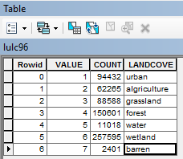

You can check and uncheck different rasters in Table of Content to visually observe the land cover changes in different years.

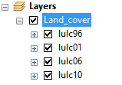

Click View -> Graphs -> Create Graph… in ArcMap. You can create a bar chart for lulc96 to show the amounts of different land cover types in 1996 (like below). However, the unit in this bar chart is number of pixels, which is difficult to communicate. Please create a bar chart showing the amounts of land cover types in km2. Note the pixel size is 30m by 30m in this raster. You may need to add a new field in the attribute table in order to create the diagram. Create a same diagram for lulc10 too and compare the major land cover changes between the two years.

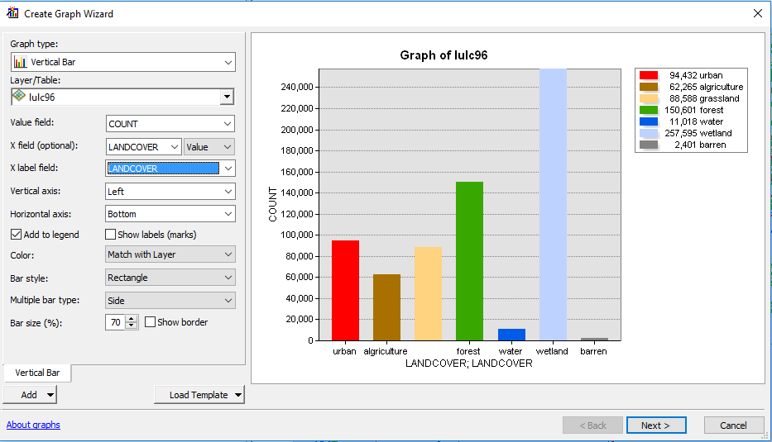

**Question 1** (2pt) **:** Take screenshots of bar charts of lulc96 and lulc10 using km2 as unit and paste them here.

**Time Series Analysis**

Other than comparing two years, you can analyze the changing trend from time series of the four years. Right click on lulc96, and click ‘Joins and Relates’ – ‘Joins’. Join lulc96 with lulc01 based on Value field and click OK. Repeat the same procedure to join lulc96 with the other 2 land cover rasters.

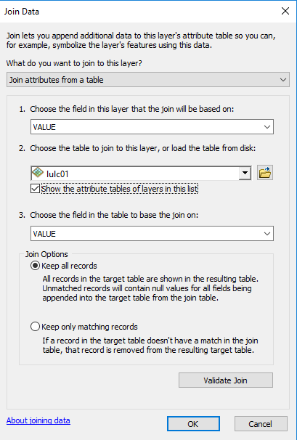

After Joining all other rasters with lulc96, open the attribute table of lulc96 and click Export in the menu.

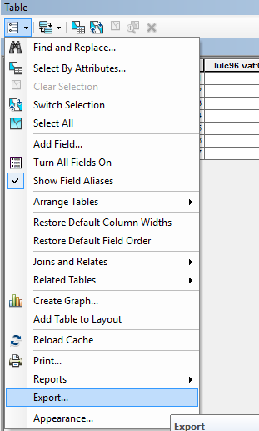

Navigate to LULC folder and export the attribute table as a text file **joined_lulc.csv** (note the suffix is csv not txt) in your exercise folder. Now, the time series of amounts of the 7 land cover types are stored in the csv file.

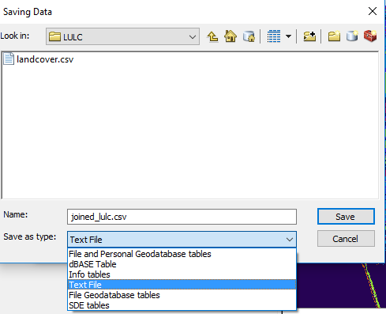

**Question 2:**

1. (3pt) Create a bar chart (similar to the following chart, but use km2 as unit) to show the time series of the 7 land cover types in km2 in the four years. You can choose any tools to create the graph, for example Excel or R. Paste the bar chart here.

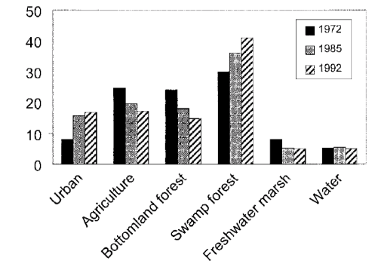

1. (2pt) Calculate the annual urban growth rate and deforestation rate (% per year) during the 3 periods and average rates of the entire period. Then fill the following table.

|  |  |  |  |  |
| --- | --- | --- | --- | --- |
|  | 1996-2001 | 2001-2006 | 2006-2010 | Avg. 1996-2010 |
| Urban growth rate |  |  |  |  |
| Deforestation rate |  |  |  |  |

**Transition Matrix**

Now we use transition matrix to analyze transition frequencies of different land cover transitions between 1996 and 2010. Search ‘Combine (Spatial Analysis)’ tool in the search window of ArcGIS and open it. Use this tool to combine lulc96 and lulc10 into a new raster lulc9610.

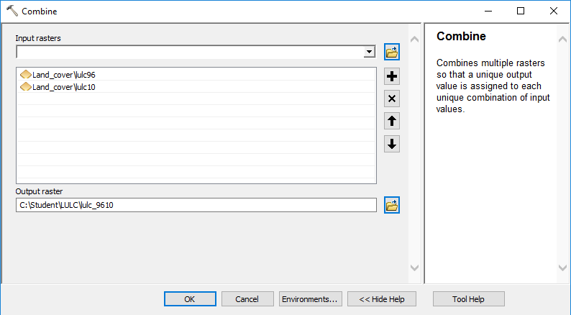

Export the attribute table of lulc9610 into lulc9610.csv. Use Excel or other tools to create a transition matrix (like below) for the land cover changes (in km2) between 1996 and 2010.  
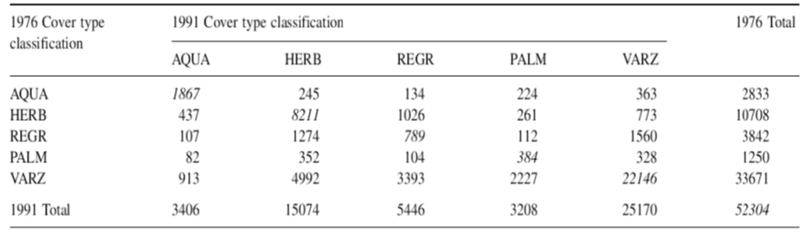

**Question 3:**

1. (3pt) Copy and paste a screenshot of the transition matrix between lulc96 and lulc10 here
2. (1pt) Find the most frequent transition (transition with the largest amount in km2). Select this transition in the attribute table and take a screenshot of ArcGIS in which the selected pixels are highlighted.
3. (1pt) Which land cover type is most likely to convert to urban?

**Urban Growth Analysis**

After analyzing transitions between different land cover types, we now focus on urban growth (i.e. non-urban pixels become urban). Unlike shapefile (vector data) where you can select features from attribute table and export the selected features to a new shapefile, you cannot export selected pixels in a raster into a new raster.

One of the most frequently used tool for raster analysis is Raster Calculator, where you can program different map algebra using very simple syntax. For example, the expression in the following figure converts all non-1 (non-urban) pixels in lulc01 into 0 while keeping 1-pixels the same. ‘==’ means equal to. You can always find ESRI documentation of the operators and examples by googling ‘TOOLNAME ArcGIS’.

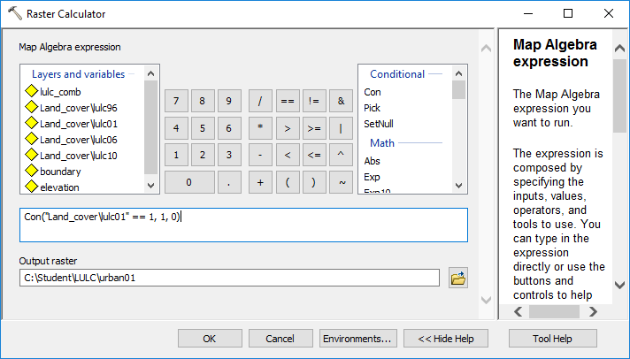

You don’t need to type the name of the raster in the expression box. You can double-click the data you want to use in the ‘Layers and variable’ box and the variable will appear in the expression box. Run the tool to convert lulc01 into urban01 which is a binary urban/non-urban raster.

Although you can do the same task using Reclassify tool, getting to know Raster Calculator will help you more in your future work.

In the same way, convert urban06 and urban10 into urban06 and urban10. Instead of opening a new Raster Calculator and re-write the expression, you can modify from an already-run process in Geoprocessing->Results.

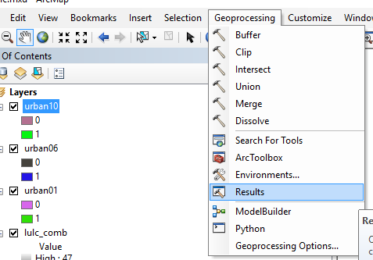

Then you will see all run geoprocessing tool in the Results window. You can double-click to open a previously run tool, modify parameters and run again. This can save your time.

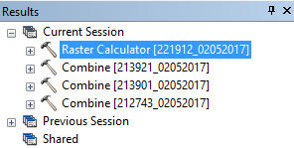

**Question 4** (3pt): Use Raster Calculator to create urban growth (decay) rasters in the two time periods: 2001-2006 and 2006-2010. Assign 1 to urban growth pixels (other types -> urban), -1 to urban decay pixels (urban -> other types), and 0 to unchanged pixels. Copy&paste the attribute tables of the two rasters here.

*Tips: 1) You can subtract one raster from the other in Raster Calculator to detect the changes between them; 2) Names of raster files cannot be longer than 13 characters.*

In addition to detecting urban growth and decay pixels, you can also analyze their relations with other variables. For instance, we can compare average elevation of urban growth (1-pixels) in the two periods. On August 29, 2005, the most destructive Hurricane in the U.S. History was landed in Gulf Coast. The Hammond city was impacted too. After the Hurricane, a large amount of residents in New Orleans (the most damaged city) have relocated in Hammond City, which boosted the urban growth there. Meanwhile, people have adapted their planning guideline and building code to make the new development less vulnerable to future storm surge and inundation. Comparing urban growth between the two periods can test a simple hypothesis: have people adapted by developing in higher elevation regions after Katrina?

To get average elevation of urban growth, you will use urban growth pixels (1-pixels) to clip the elevation raster and then calculate the average elevation in the clipped pixels. First, select urban growth pixels from urbgr0106 and set all other pixels to Null (no data) using Raster Calculator with the following expression, name the output urbgr0106_c. You may need to change the expression if your file has a different named. Use the same approach to select urban growth pixels in urbgr0610 and name the output urbgr0610_c.

SetNull("%urbgr0106%" , 1 , "VALUE <> 1 ")

Then, use ‘Extract by Mask’ tool to clip the elevation raster using the two rasters of only urban growth pixels, name the outputs gr_elv0106 and gr_elv0610. These two rasters are urban growth pixels with elevation. In ArcMap, you can find the statistics of the two rasters in their Properties, the Source tab. Please compare their means to see how the change of average development elevation. Then, input their statistics into the following website to test if they are significantly different (assuming elevations in both periods are normally distributed).

https://www.graphpad.com/quickcalcs/ttest1.cfm

**Question 5**:

1. (3pt) Copy and paste a screenshot of the t-test result here
2. (2pt) Based on the background information, use a couple of sentences to interpret the t-test result.