**GEOG489 Lab #4 – Terrain Analysis**

**(Due date: Mar. 17th, 2017)**

Before you begin with the exercise make sure you have downloaded all the data from:

<https://github.com/qiang-yi/GEOG489/blob/master/labs/lab4_data/lab4_data.zip>

Unzip the files into your U drive. Remember to change file paths accordingly in the exercises

# 1. Terrain Visualization

A hillshade is a 3D representation of the surface, with the sun's relative position taken into account for shading the image. This function uses the altitude and azimuth properties to specify the sun's position. Hillshade can enhance the visualization of a surface for analysis or graphical display, which has been frequently used in terrain mapping.

First, use the Hillshade tool to create a hillshade map for the DEM raster. Place the hillshade layer on top of the DEM. Next, right-click on the hillshade map, go to Properties -> Display. Set ‘Resample during display using’ as ‘Bilinear Interpolation’. Then change the transparency of the hillshade map as 55%, and click OK.

Then, go to Symbology of the DEM data. Right-click on a color ramp and uncheck Graphic View and select Elevation #1 color scheme. Now, you have a hillshade enhanced visualization of the DEM.

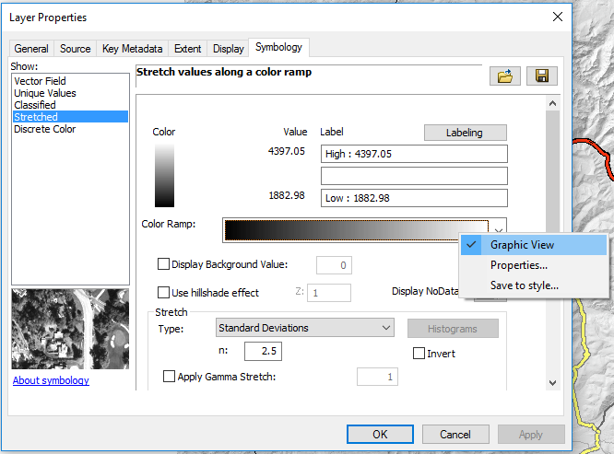

**To include in your report (1pt)**: paste the screenshot of hillshade enhanced DEM here.

# 2. Surface Adjusted Distance

The distance of a polyline measured in a 2D flat plane is different from that measured in a 3D terrain. In ArcGIS, you can use ‘Calculate geometry’ in the attribute table to calculate flat-plane length of polyline and use ‘Add Surface Information’ tool in ArcToolbox to calculate length of polyline adjusted to a 3D terrain surface. Please compute both flat-plane distance and surface-adjusted lengths of roads and compare their difference.

**To include in your report**:

1. Paste the screenshot of the attribute table of roads including the two calculated lengths (only a part of the table is OK) (0.5pt)
2. Paste the screenshot of the terrain map with the steepest road selected. It can be a zoomed-in view if the road is short. (0.5pt)

# 3. Suitability Modeling Based on Terrain Analysis

Estimates suggest that Colorado, with more than 250 sunny days per year, could generate as much as 83 000 000 MW-hours of electricity from solar technologies on a yearly basis. The governors in CO have shown strong interest in exploring clean and renewable energy, and plan to build a solar farm in an area in the Rocky Mountains. This area is between Eagle County and Summit County along the I-70 interstate. Many tourist towns or ski resorts are scattered in this area. The location of solar farm need to minimize the environment impacts and construction cost. Please use terrain analysis tools in ArcGIS to identify suitable locations for the solar farm in this area. The suitability modeling should consider the following criteria:

1. Close to roads (easy to construct and maintain)
2. Not visible from cities (avoid reflective light pollution to local residents and destruction of the scenic view). Consider using viewshed tool. Running this tool may take a few minutes, so be patient.
3. High area solar radiation, which is the solar insolation across a landscape. It can be calculated using the Area Solar Radiation tool. Running this tool on the original DEM can take a long time (a few hours). You can resample the original DEM into 300m*300m resolution and then run the area solar radiation tool on the resampled DEM. You can keep default values for all optional parameters.
4. High Direct Normal Solar Irradiance (DNI) (atmospheric condition for solar radiation, use annual DNI). Note: this is a national data layer and you will need to clip into the extent of the DEM. Clip a large dataset to a smaller area is an important skill for your project. Consider using Raster Domain and Clip tools to do this.
5. Must be < 20% slope and the flatter the better.
6. A solar farm has to be larger than 100m2. You need to filter out isolated suitable pixels, keeping only contiguous areas that are larger than 100m2. Check Focal Statistics tool for possible solutions.
7. Criteria importance: Area solar radiation > DNI > Proximity to road > Slope

***Recall some principles of suitability modeling- no need to answer:*** *1) identify binary (constraint) criteria and continuous criteria; 2) think about whether to use vector or raster approach before start building the model; 3) how to represent binary and continuous criteria, whether to convert to 0/1 or reclassify to multiple suitability ranks; 4) all criteria have to be in the same data type (either raster or vector) when combined together; 5) the criteria may have different resolutions (cell sizes) – please make sure the final output is in the same resolution as the original DEM map. You can go to Environment parameters -> Raster analysis to control the output cell size.*

**To include in your report**:

1. Briefly explain how you modelled each criteria and how did you combined them into final suitability map (less than 400 words in total). (2pt)
2. Paste the screenshot of the model in ModelBuilder and final suitability map. The suitability map should be more presentable, consider using appropriate color scheme, adding some cartographic elements, e.g., legend, north arrow, scale and title. (3pt)

# 4. Watershed Analysis

1. Fill Sinks

The first step of watershed delineation is removing sinks (and peaks) in elevation data. Sinks (and peaks) are often errors due to the resolution of the data or rounding of elevations to the nearest integer value. If the sinks are not filled, a derived drainage network may be discontinuous. First, please use Fill tool to remove sinks and peaks of the DEM.

2. Flow Direction

A flow direction grid assigns a value to each cell to indicate the direction of flow – that is, the direction that water will flow from that particular cell based on the underlying topography of the landscape. This is a crucial step in hydrological modeling, as the direction of flow will determine the ultimate destination of the water flowing across the surface of the land. Please create flow direction using the filled DEM. You can use Aspect color scheme to visualize flow direction.

3. Flow Accumulation

The Flow Accumulation tool calculates the flow into each cell by identifying the upstream cells that flow into each downslope cell. In other words, each cell’s flow accumulation value is determined by the number of upstream cells flowing into it based on landscape topography. Please create flow accumulation using the flow direction raster. You can set output data type as integer to save time and space. This tool may run for 1-2 min. So be patient.

In the flow accumulation map, you can vaguely observe some streams with high accumulation value. Then, extract those vague streams into polylines. To do this, you can first reclassify the flow accumulation map into a binary raster: 0 - 200,000 → 1; > 200,000 → 0. Then, convert the binary raster to polylines (Raster To Polyline tool). Observe whether the streams derived from flow accumulation match the actual streams. If you zoom in, you can see some difference. There are many factors for the difference, for instance, man-made hydrologic structures and deflecting force of earth rotation (Google if you don’t know what it is)

4. Watershed Delineation

Pour point placement is an important step in the process of watershed delineation. A pour point should exist within an area of high flow accumulation because it is used to calculate the total contributing water flow to that given point. In many cases you will already have a file containing the locations of your pour points, whether they are sampling sites, hydrometric stations, or another data source. However, in some cases, it may be necessary or preferable to create pour points manually, which is the case of this exercise.

Open the ArcCatalog window and create a new point file in your working directory (right-click the directory in the Catalog tree and select New > Feature Class if you are working from a geodatabase, or New > Shapefile if you are working from a folder). Give the file a descriptive name. Click OK to add the new point layer to the map document.

Use the Identify tool to examine the values of the grid. The chosen pour point must be on a high flow accumulation path, and should be a natural outlet for the upstream cells. Your choice essentially determines the ‘end’ of your catchment area; everything upstream from the point that you create will define a single watershed.

When you are satisfied with your choice, add the point by starting an editing session (Editor > Start Editing). If you are asked which layer you would like to edit, select the empty point layer and click OK.

Open the Create Features window and highlight the pour point file in the list.

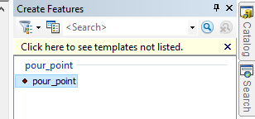

Move your cursor onto the map and add a pour point by clicking in the center of the cell you have chosen as the location of your outlet point. Make sure to place the points directly in the center of the chosen cells and place the points at least one or two cells away from stream confluences. Add a couple of pour points in different streams. Save the edit.

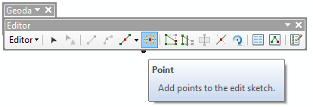

Next, snap the pour points (Snap pour point tool) to the flow accumulation map. This step accomplishes two things; it snaps the pour point/s created in Step 5 to the closest cell of high flow accumulation to account for any error during placement, and it converts the pour points to raster format for input to the Watershed tool.

Finally, delineate watersheds using the Watershed tool. Use flow direction and snapped pour points as input. The watershed map shows the areas in which all water flows to the pour points.

**To include in your report:** a snapshot of the watershed delineations. (3pt)