**Lab #5 – Sea Level Rise Analysis**

**(Due date: April 7, 2016)**

Coastal areas are threatened by flooding due to storms (e.g., by hurricane or tsunami) or gradual sea level rise caused by global warming. This lab asks you to use precise digital elevation data models generated from airborne lidar data to conduct an inundation analysis in the coastal area of Honolulu.

Data sources for this lab:

* 1m resolution DEM data (
* Land use and land cover data (from NOAA C-CAP database)
* Census block population (From TIGER products of the U.S. Census)

Please download the data at:

<https://drive.google.com/file/d/0Bx_ZBBgZC-9-ZllXVEVYd3VYUjQ/view?usp=sharing>

**Part 1: Inundation Mapping**

In this part, you are asked to use the DEM to identify the potential inundated areas under two different sea-level rise scenarios (e.g., **1 m and 1.4 m).** You can use raster calculator to extract these areas. Note inundated areas are **land** areas that are below sea level **after** sea level rise. You should use land cover data to eliminate the existing water bodies (in land cover data) from the inundated areas.

If your result is raster, please convert all inundated areas into 1 and else into NoData.

**To include in report:** snapshots of inundated land areas in the two sea level rise scenarios (1pts).

If you use raster calculator to find the inundated areas, some of those areas are not connected to the ocean, so they will not be inundated even if their elevations are below the hypothetically risen sea level. You need to remove these areas that are disconnected to the ocean by taking the following steps.

1. Convert the DEM into a binary raster where areas below the sea level (after sea level rise) are 1 and above the sea are 0.
2. Convert the binary raster to a polygon shapefile use Value as the field value. Manually select areas that you think are the sea surface (hold shift key you can select multiple polygons). Sea surface are typically large contiguous areas outside of the coast line. Export the selected polygons into a new shapefile.
3. Convert the inundated areas created in the previous step into a polygon shapefile. Use ‘select by attribute’ tool to select inundated areas (polygons) that are connected (intersect) to the sea surface (polygons). Export the selected polygons into a new shapefile, which contains all inundated areas connected to the ocean. You need to repeat the same procedure for the other sea level rise scenarios.

Do you remember a question about raster and vector approaches in a previous assignment? This example demonstrates that vector supports topological relations that allow us to ‘select by location’, which is not possible in raster data. This is an advantage of the vector data type and the reason why we convert raster inundated areas into vector.

**To include in report:**

1. A map of inundated areas in the two scenarios excluding areas disconnected to the ocean. Use appropriate approach (e.g. color, legend) to display the two scenarios in one map. (4pts)

**Part 2: Impacted Population Mapping**

Intersecting the inundated areas derived in the previous step and population in census blocks, we can estimate the number of population that will be affected by sea level rise. An assumption of this operation is that population is evenly distributed within each census block. Here, only the 1.4m scenario needs be analyzed.

1. Use the Tabulation Intersection tool to intersect the inundation areas (1.4m scenario) and the census block data. Set census block as the input zone feature. Zones fields is FID. Set the inundation area layer as input class features. Use default values for other parameters and run the tool. The output is a table of the total and ratio of inundated area in each block.
2. Join the output table with the census block layer, using FID as the joining field.
3. Add a new field (floating type) in the census block layer, name it IN_POP. Then, multiply ratio of inundated area with block population to calculator affected population in each block. Finally, use an appropriate color scheme to display affected population in blocks.

**To include in report:**

1. A map of affected population in census blocks in the 1.4m sea level rise scenario. (2pts)
2. Which component of disaster risk (disaster risk = extreme event*exposure*vulnerability) does this map describe? (1pt)
3. Discuss a couple of flaws of this analysis and possible improvement (<200 words). (1.5pts)
4. Discuss what further analysis can be done based on this analysis (<200 words). (1.5pts)

**Part 3: Sea Level Rise Animation**

ArcScene is a 3D analysis module of ArcGIS. In this part, you will practice to create a 3D animation to simulate sea level rise in the coastal area of Honolulu using ArcScene. This analysis needs 3 layers: 1: DEM, 2: Water surface, 3: Hillshade (optional, only for visual enhancement).

1. Use raster calculator with an expression Int(“dem” * 0) to create a water surface (sea leve) layer from the DEM raster.
2. Create a hillshade layer for DEM.
3. Load DEM, water surface and hillshade into ArcScene. Change the color of water layer to blue.
4. Go to the Properties of DEM, color code DEM using Elevation #1 color scheme. Make the DEM layer 50% transparent. In the Base Height tab, change the setting as below. ArcScene is a bit slow when setting base height, so be patient.

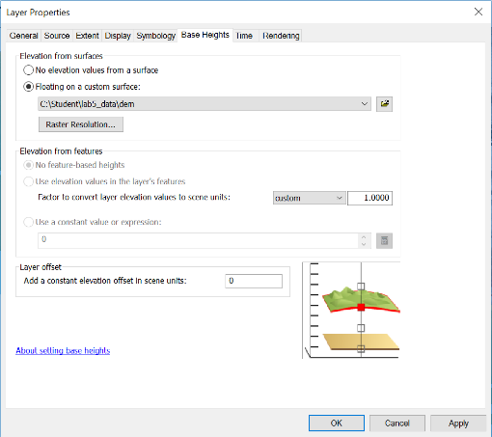

1. Go to the hillshade layer, change its Height Base tab as below. Note Layer offset is -1.

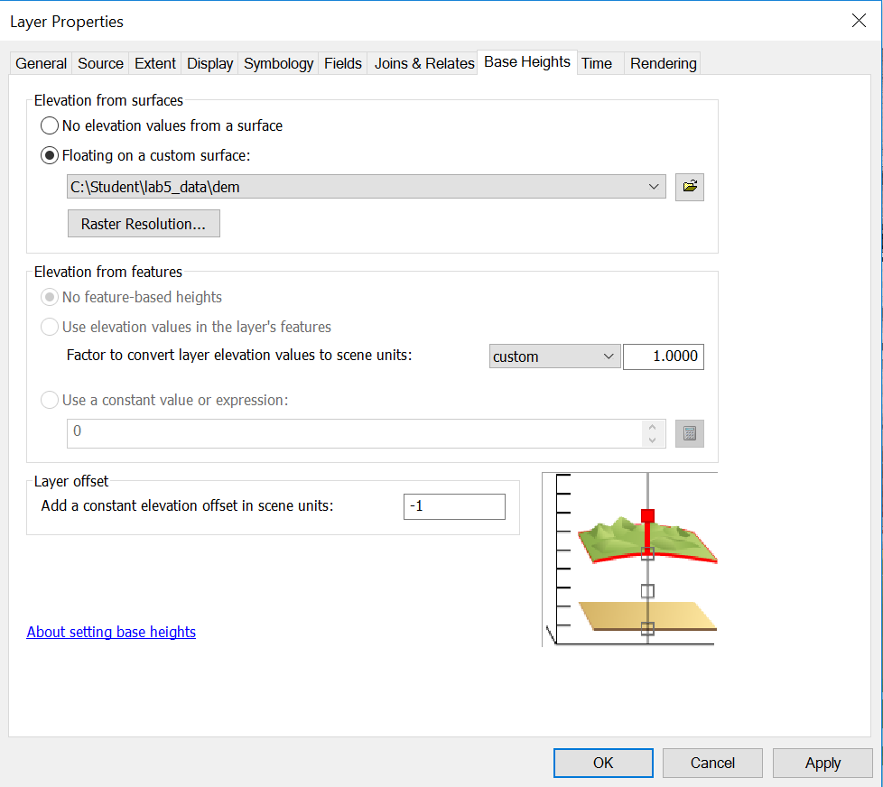

1. In table of contents, put DEM above hillshade, which is above water.
2. Right click on the menu bar of ArcScene, enable the Animation tab. 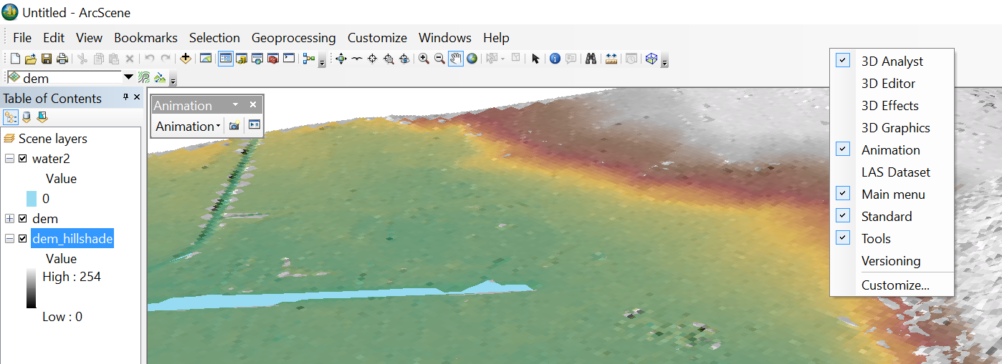
3. In the Animation tab, go to animation manager, and click Create… Set water as the source object. Click ‘Create’ for 10 times to create 10 frames. Then, click close.

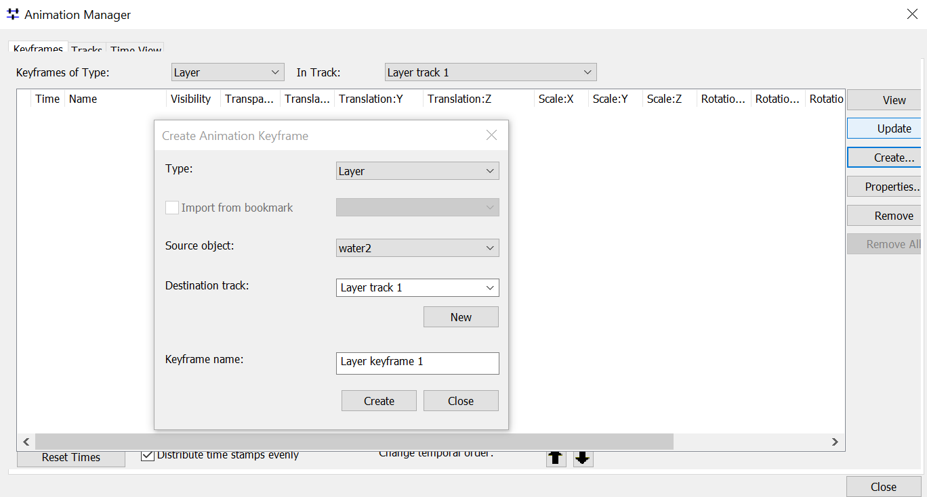

1. In animation manager, change ‘Translation: Z’ of the frames into 0.5, 1, 1.5 … 5, and close.

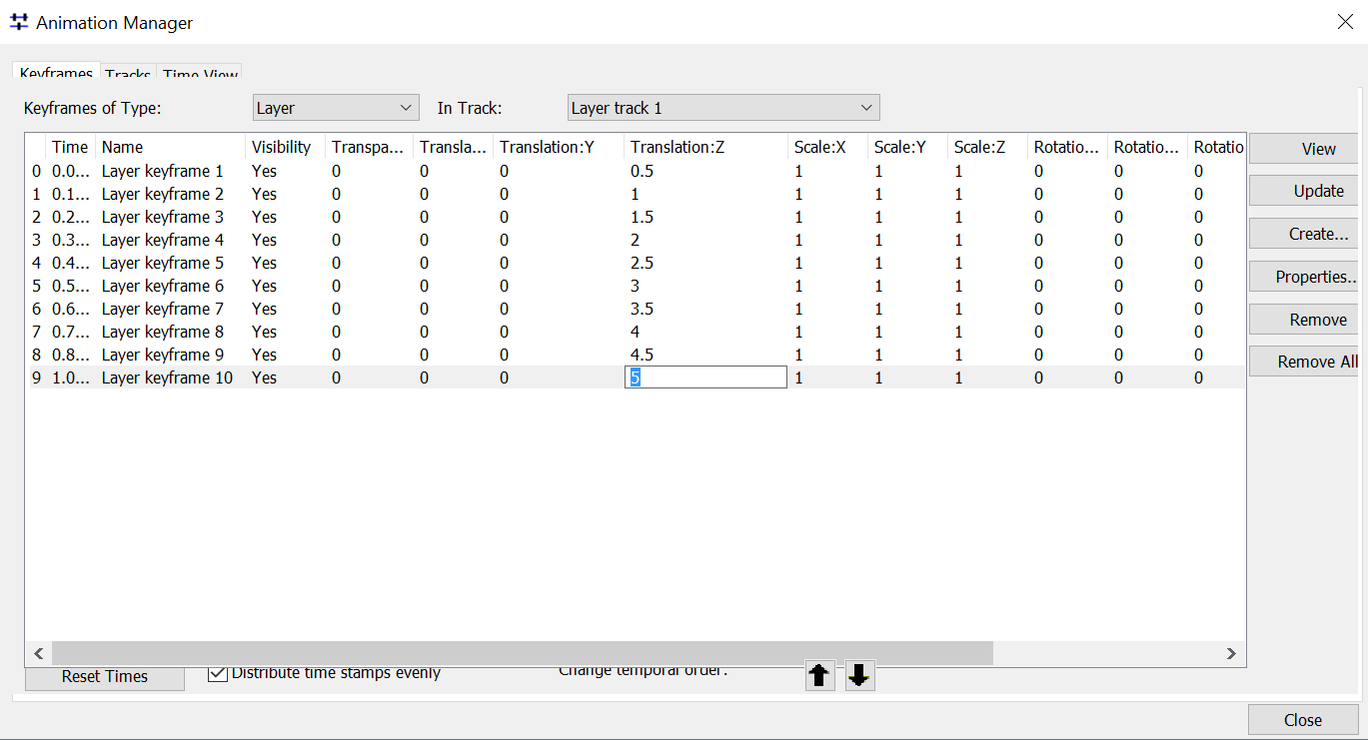

1. In the Animation tab, click ‘Open animation controls’, and then click ‘Play’ to play the animation. Export the animation into an avi file.

**To include in report:** Submit the animation (avi) file together with the report in Laulima. If the file is too large to send through Laulima, share it using Google drive and paste the link here. (3pts)