Owen Shriver & Yuying Mao

716 Computational Geometry

Instructor: Reynold Bailey

October 27, 2020

**Assignment #3 Report**

In this assignment, we are using the “ym9064.txt” as the input file for our program. The input file is:

4

0 0 100 100

5 40 55 20

30 60 70 60

60 55 95 15

40 5 95 15

The plot graph generated by our program is (Labels are manually labeled) shown in Figure 1.

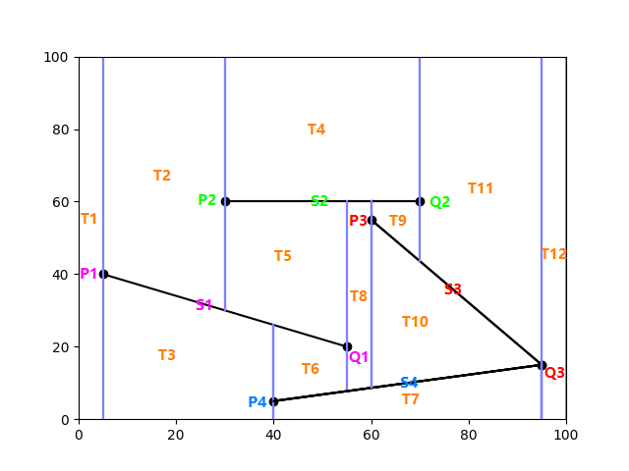

Figure 1: (Manually Labeled) Plot Graph Generated from “ym9064.txt”

The matrix generated by our program is shown in Figure 2.

The corresponding rooted directed acyclic graph looks like Figure 3.

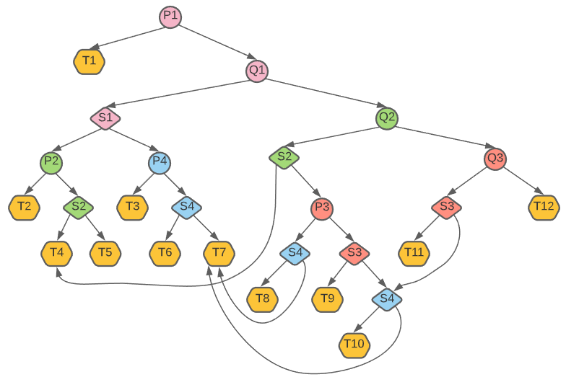

Figure 3: Rooted Directed Acyclic Graph