C

Drug use at different ages

By: Hannah Toth

CMSE 381

Final Project

**1 Introduction**

Drug use is a widely discussed topic throughout the world. With changing laws, a drug that was once considered to be a paramount crime is now nothing more than something one could pick up on their regular errand run. In recent years, it has become increasingly easier to obtain drugs resulting in an increased use among all age groups. Most of the views on drugs from these groups are based on how they were raised. More specifically, events that happened to them that either improved or objected to their views on drugs. The main focus of this project is to determine if specific events altered the view on drugs among the younger age groups.

**2 Related Work**

There is an article, titled “How Baby Boomers Get High,” that does a decent job at describing the use of drugs throughout the Baby Boomers. The article begins with showing a bar graph of the percentage of usage for a variety of different drugs from people ages 50-64, also known as the Baby Boomer generation.

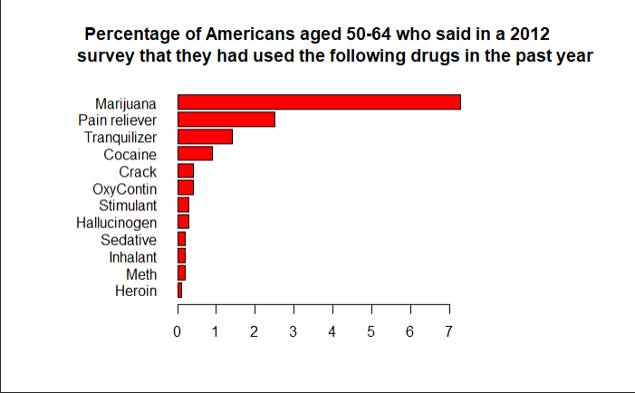

The use of alcohol was omitted from the graph as it has an exceedingly large value of 67% which would make viewing the other drugs with vastly smaller values on the graph more difficult. Using this graph, the article than briefly goes into topics as to why these values may be as high as they are. For instance, the Baby Boomers were around for Woodstock and may have picked up the “’Woodstock Mentality.’” This mentality may have increased the social acceptance of marijuana usage. If this generation were to keep that same mentality until present times, then that would make for a larger marijuana usage, which can be seen in the graph.

Another factor that could lead to these types of values, especially the alcohol usage value, is something as simple as old age. Being 50-64, their bodies are no longer what they once were and many forms of drugs, like the ones above, can be used to help alleviate the pain. Also, this generation had to deal with several negative experiences, such as the Vietnam War, so they may be using the drugs listed above, especially alcohol, as coping method to deal with the memories of that. While this article does not say that these factors are a direct cause of the larger values for the Baby Boomer generation, it does suggest that these factors may be possible causes.

This article does a good job at describing the possible causes for the values obtained for each drug based on the Baby Boomer generation. The graph at the top is useful to the reader as they can quickly go back to it to reference when a specific drug is being discussed in the article. The article’s focus on the Baby Boomer generation meant that the descriptions and data analysis for that generation was more prominent than any other generation. While other generations were discussed in comparison to the Baby Boomer’s there was a very large lack in visualization for these comparisons. Visualizations for younger generations was where this article lacked. The article did compare the values, but with a lack of visualization it may be harder for the reader to visualize why the comparison between the two generations is significant.

**3 Extra Models**

While the above article does a good job in discussing the events that may have led to Baby Boomers drug use in 2012, it does not discuss anything for the younger generations. Therefore, more models will be needed to try and understand the drug usage for these other generations.

One generation that should have had a drug use impact was any individual that took part in the D.A.R.E. program when they were in 5th grade. This program, which was founded in 1983, was meant to show children the risks of using drugs and alcohol. One would expect that with such a program, the generations that went through it would have a significantly lower alcohol/drug usage value than generations that did not go through the program. Since the data we are given was taken from a 2012 survey and most 5th graders are about ten years old, the oldest age that would have gone through the D.A.R.E. program is 39. Since the data is provided with certain age groups being clumped together in ranges, 39 falls into the 35-49 range, which contains too many ages that would not have participated in the program. Due to this, it would be more beneficial to use the age group below that, 30-34, as the new max age to look at.

A model that can help determine the effectiveness of the program in an unsupervised cluster of drug usage values for drugs that were focused on in the program. The drugs that were a major focus in the program were alcohol, tobacco, marijuana, and hallucinogens, since tobacco is not within the dataset, that can be omitted from the models. Once the ages have been clustered on the graph, it can be determined how the D.A.R.E. program affected those age groups.

**4 Results**

One would expect that from the ages of 12-34, with the implementation of the D.A.R.E. program that those ages would be on the lower end of the usage values for the three drugs that were taught about in the program. However, looking at the results of the models this does not appear to be the case.

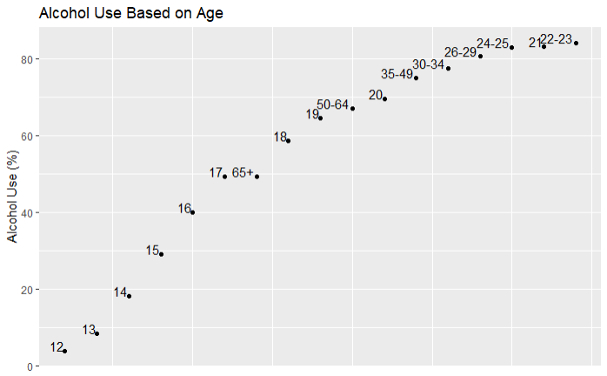

Looking at the above model, the ages from 12-17 are on the lower end of the spectrum, but the rest of the ages that had supposedly gone through the D.A.R.E. program were actually among the highest percentages within the dataset. For one of the programs main focuses, it would appear that the program had almost no effect on its participants.

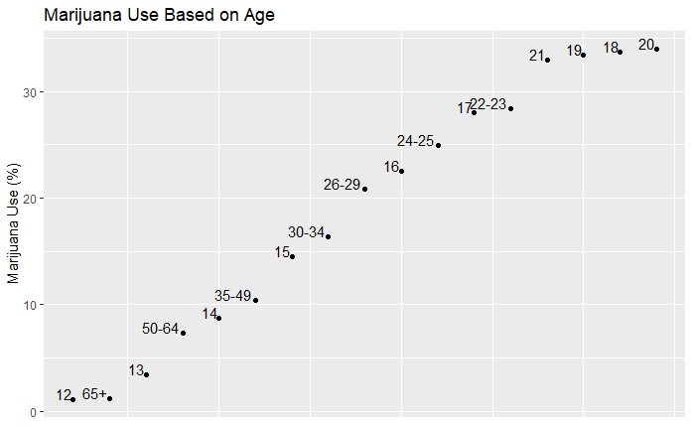

With the marijuana use model it would appear that the same issue has occurred. The largest values were those of the age groups that had gone through the D.A.R.E. program, once again making it seem like the program had no effect.

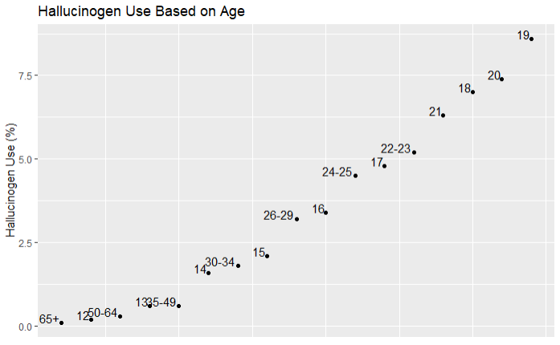

This last model also shows that the age groups that had gone through the D.A.R.E. program and were taught to avoid these types of substances, have once again had the largest usage percentages out of all of the age groups.

**5 Conclusions and Future Work**

When trying to figure out what shaped the views on drugs of younger generations, one might think that the D.A.R.E. program would cause these views to become more subdued. However, looking at the above models, it is clear to see that this is not the case. Rather than being on the lower end of the spectrum, like the program would suggest, the age groups that went through the program are actually among the highest percentages in each model. In short, the percentages did not behave how they should have if the D.A.R.E. program were to have had an effect. Upon further research, the program has started to take a new approach on how they are teaching kids. It appears that they are taking a more modern/realistic approach instead of creating exaggerated scenarios. If I were to continue working on this topic, I would want to find some data that was taken from the years that the new format was implemented, as well as from participants that actually participated in the new format.

Since the above event did not have an impact on the percentages of younger generations, the original question still stands. If D.A.R.E. was unable to prevent these larger percentages, than what events caused this? An event that may have led to this could have been the introduction of Coachella in 1999. Similar to Woodstock in 1969, Coachella may have created a positive increase in the public’s opinion on drugs, as well as providing a place for quick distribution of said drugs. Similar to Coachella, but more spread out was the increase in raves throughout America in the 1990s. Raves resulted in places where anyone could obtain drugs that would not have been as easily obtainable beforehand. This may be a reason as to why younger generations have higher percentages in the more unconventional drugs. If I were to further investigate these accusations, I would want to obtain data from the 90s and recent times to see if there was a spike in those types of drugs. If there is, then these events may be possible explanations as to the usage percentages for younger generations.

**References**

Annabarryjester. “How Baby Boomers Get High.” *FiveThirtyEight*, FiveThirtyEight, 23 Apr. 2015, fivethirtyeight.com/features/how-baby-boomers-get-high/.

Fivethirtyeight. “Fivethirtyeight/Data.” *GitHub*, 16 Mar. 2014, github.com/fivethirtyeight/data/tree/master/drug-use-by-age.

Nordrum, Amy. “The New D.A.R.E. Program-This One Works.” *Scientific American*, Scientific American, 10 Sept. 2014, www.scientificamerican.com/article/the-new-d-a-r-e-program-this-one-works/.