Task 5 – Hands-On Lab
MQTT-Based Temperature & Humidity Data Pipeline using M5Core2 and Raspberry Pi
Objective
The objective of this lab is to demonstrate an end-to-end IoT data pipeline using the MQTT protocol. In this task, an M5Stack Core2 device publishes temperature and humidity data to an MQTT broker running on a Raspberry Pi Zero W2. A Python MQTT client subscribes to the data, logs it into a CSV file, and visualizes the results.
Learning Outcomes
After completing this lab, students will be able to:
- Understand the MQTT publish/subscribe communication model
- Configure an MQTT broker using Mosquitto on Raspberry Pi
- Program the M5Core2 to publish sensor data via Wi-Fi
- Develop a Python MQTT subscriber
- Store and visualize IoT data
Hardware Requirements
- M5Stack Core2
- Raspberry Pi Zero W2
- Micro-USB / USB-C cable
- Laptop (Windows/Linux/macOS)
- Wi-Fi network (same network for Pi and M5Core2)

Software Requirements
- Arduino IDE
- ESP32 Arduino Core (version 2.0.11)
- M5Core2 Arduino Library
- PubSubClient Arduino Library
- Raspberry Pi OS (Headless)
- Mosquitto MQTT Broker
- Python 3
- Python libraries: paho-mqtt, matplotlib

System Architecture
- M5Core2 → Wi-Fi → MQTT Broker (Raspberry Pi) → Python Subscriber → CSV + Plot

TASK 1: AHT20+M5Core2 > RPI ZeroW2 (T & H)
M5Core2_AHT20_MQTT.ino > mqtt_loc_consumer.py

Part A: MQTT Broker Setup on Raspberry Pi

Step 1: Update Raspberry Pi
- sudo apt update
- sudo apt upgrade -y

Step 2: Install Mosquitto
- sudo apt install mosquitto mosquitto-clients -y
Enable and start the broker:
- sudo systemctl enable mosquitto
- sudo systemctl start mosquitto
Verify:
- systemctl status mosquitto

Step 3: Enable Remote MQTT Access
- Edit the configuration file:
- sudo nano /etc/mosquitto/mosquitto.conf
- Add the following lines at the end:
- listener 1883
- allow_anonymous true
- Save and exit, then restart Mosquitto:
- sudo systemctl restart mosquitto
Verify broker is listening:
- ss -tulpn | grep 1883
- 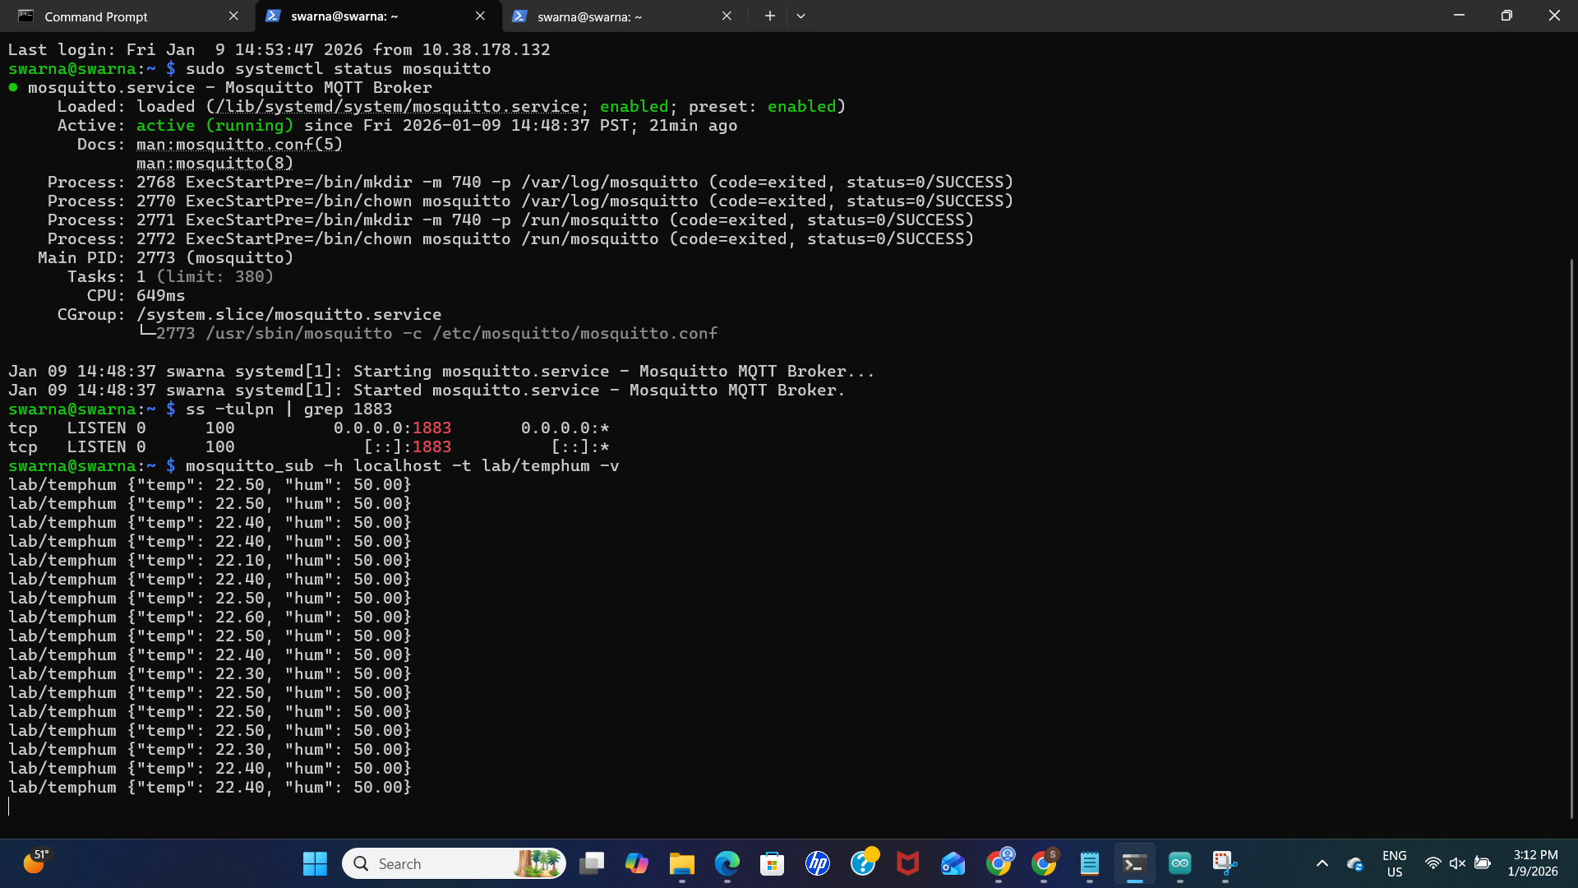

Step 4: Test MQTT Broker
- Open two terminals on the Raspberry Pi.
- Terminal 1 (Subscriber):
- mosquitto_sub -h localhost -t lab/temphum
- Terminal 2 (Publisher):
- mosquitto_pub -h localhost -t lab/temphum -m '{"temp":25.5,"hum":60.2}'
- The message should appear in Terminal 1.

Part B: M5Core2 MQTT Publisher
Step 5: Arduino IDE Configuration
- Board: M5Stack-Core2
- Port: Select correct COM port
- M5Core Board version: 3.2.5
Step 6: M5Core2 Firmware
Upload a sketch that:
- Connects to Wi-Fi
- Connects to Raspberry Pi MQTT broker
- Publishes JSON messages to topic lab/temphum
Example payload:
{"temp":22.8,"hum":50.0}

Connection Diagram: AHT20 to M5Core2 (Port A)
The M5Core2 uses Port A (the Red Grove port usually located on the side of the device) for I2C connections. The internal mapping for this port is SDA = GPIO 32 and SCL = GPIO 33.

Wiring Table
If you are using a standard Grove Cable (M5Stack Unit):
- Simply plug the 4-pin connector into the Red Port A on the M5Core2.
M5Core2 (Port A) | Wire Color (Standard Grove) | AHT20 Sensor Pin | Description
GND | Black | GND | Ground
5V | Red | VIN / VCC | Power (2.0 - 5.5V)
G32 | White | SDA | I2C Data
G33 | Yellow | SCL | I2C Clock
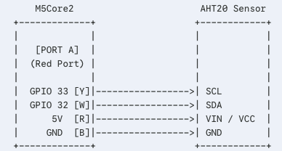
Install Arduino Library
• Adafruit AHTX0 (by Adafruit)
• PubSubClient (by Nick O'Leary)
• ArduinoJson (by Benoit Blanchon)

Step 7: Verify M5Core2 Output
Open Serial Monitor (115200 baud) and verify:
- Wi-Fi connected
- MQTT connected
- JSON messages printed periodically

Part C: Python MQTT Subscriber on Raspberry Pi
Step 8: Python Environment Setup
cd day8
python3 -m venv venv
source venv/bin/activate
pip install paho-mqtt matplotlib

Step 9: Run MQTT Consumer
python mqtt_consumer.py
Expected output:
temp=22.8 hum=50.0
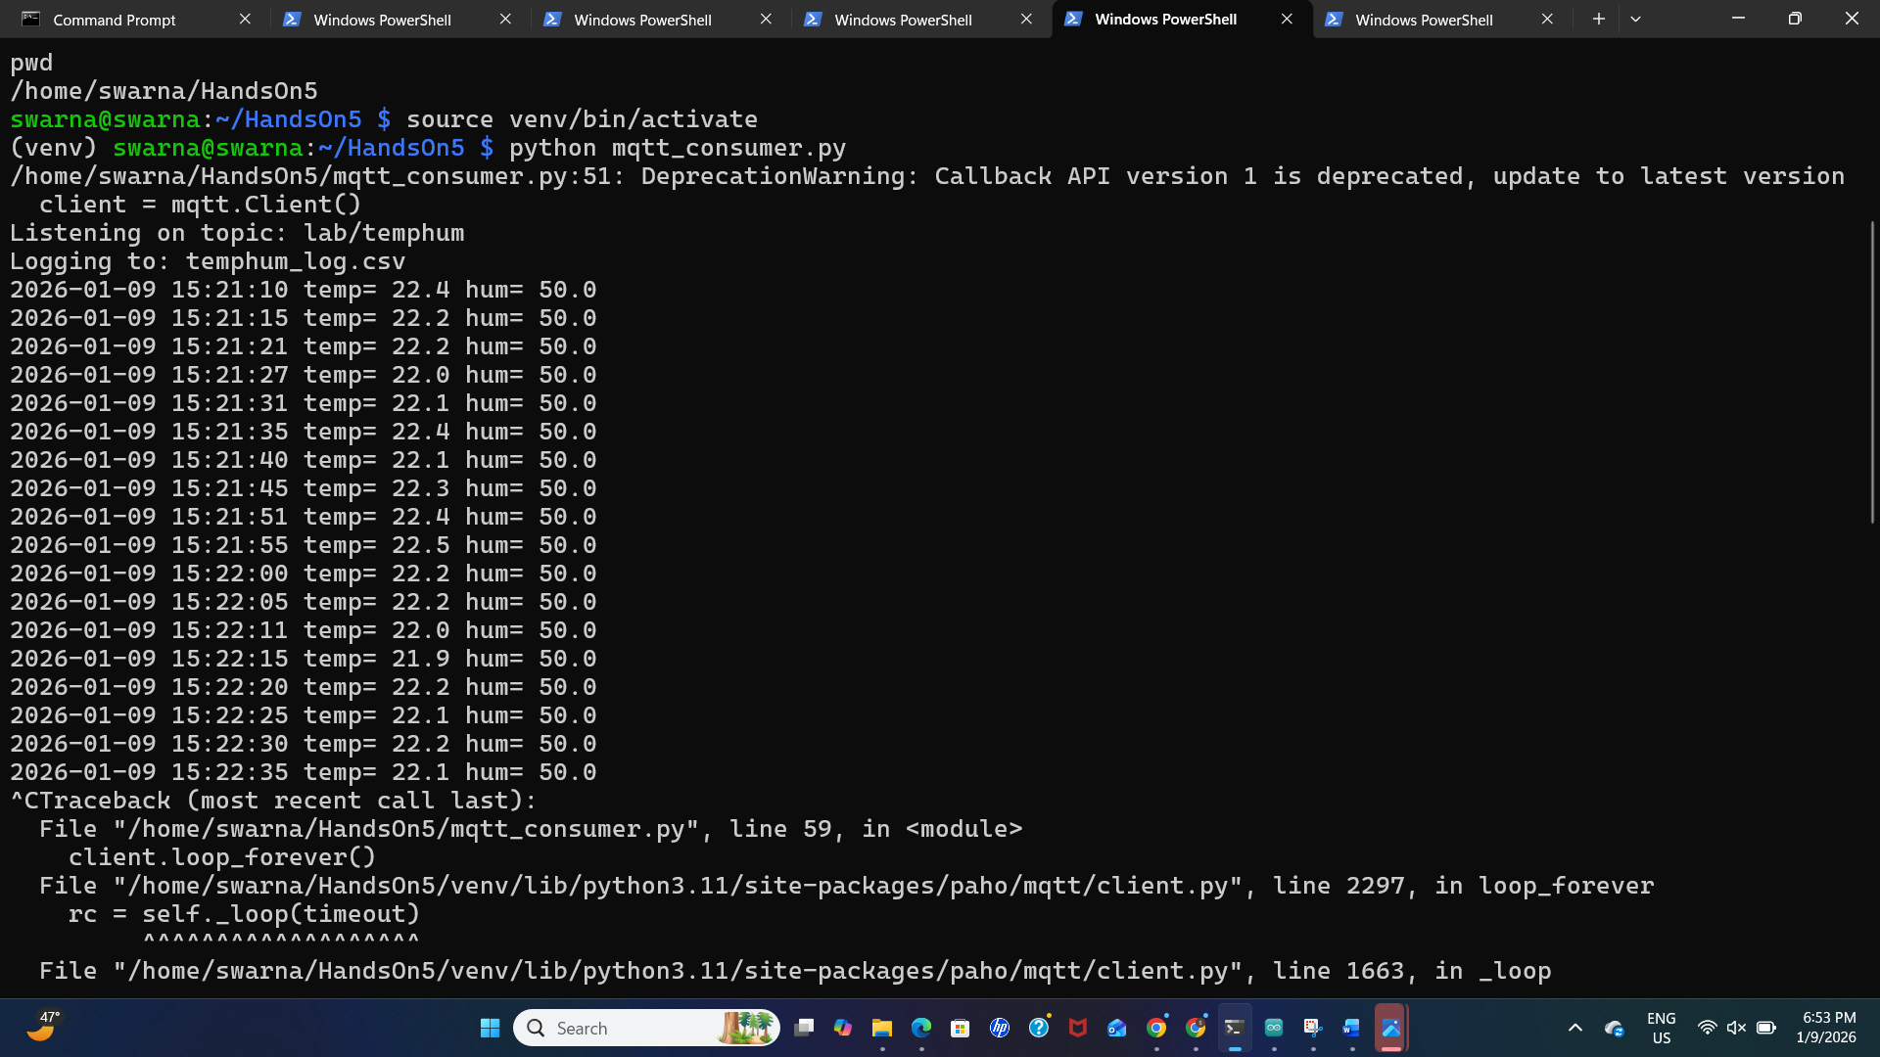

Step 10: CSV Data Logging
Verify CSV file:
ls -lh temphum_log.csv
head temphum_log.csv
The file should contain timestamped temperature and humidity values.
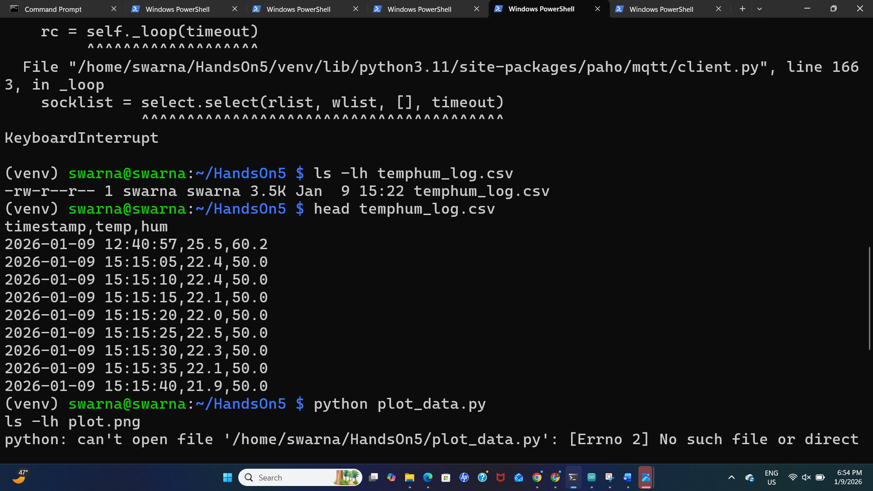

TASK 2: M5Core2 using Unified library to interface the AHT20 sensor to transmit MQTT data of Location, temperature and humidity. Average received data from single end-device
Arduino/M5Core2: No Changes
RPi Zero W2 (local master): Run mqtt_consumer_avg.py

TASK 3: RPI with PCT2075
M5Core2 using Unified library to interface the AHT20 sensor to transmit MQTT data of Location, temperature and humidity. Average received data from multiple end-device, and local master on the global master.
PCT2075 is a temperature-only sensor, the code includes a placeholder None (null) for humidity to ensure the data structure remains compatible with your Master Node's expectation of "Location, Temperature, and Humidity."

Prerequisites
- Enable I2C: Run sudo raspi-config → Interface Options → I2C → Yes.
- Install Libraries: You will need the Adafruit CircuitPython driver and the MQTT client.
pip3 install adafruit-circuitpython-pct2075 paho-mqtt
Raspberry Pi Zero W2 Pin | PCT2075 Pin | Function
Pin 1 (3.3V) | VCC / VIN | Power (2.7V - 5.5V)
Pin 3 (GPIO 2) | SDA | I2C Data Line
Pin 5 (GPIO 3) | SCL | I2C Clock Line
Pin 6 (GND) | GND | Ground

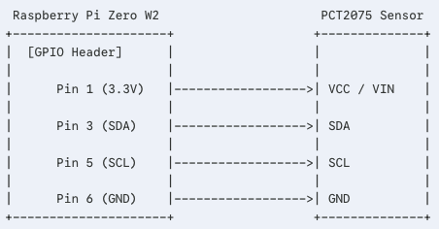
Arduino/M5Core2: (change mqtt address)
RPi Zero W2: Run rpi_publisher_pct2075.py (need to change the mqtt address)

