Feature-Enhanced Material Composition Multimodal Fusion Network

Yeyong Yu1, Xing Wu1,2,3,4, Quan Qian1,2,3,4[1]*

1 School of Computer Engineering and Science, Shanghai University, Shanghai, 200444, China；

2 Materials Genome Institute, Shanghai University, Shanghai, 200444, China；

3 Shanghai Institute for Advanced Communication and Data Science, Shanghai University, Shanghai, 200444, China

4 Zhejiang Laboratory, Hangzhou, 311100, Zhejiang, China

**EXTENDED ABSTRACT:** High-performance materials' complexity makes it hard to understand their composition-process-structure-performance relationship. Data-driven approaches have been regarded as the fourth paradigm of new materials R&D. However, the complexity of constituent elements in many material datasets leads to very sparse compositional features, posing a tremendous challenge to machine learning. In this study, we use a data mapping scheme, based on atomic features, to visualize chemical composition as two-dimensional grayscale images. A material composition visualization network (MCVN) is proposed, predicting steel properties and classifying amorphous alloys. MCVN had a 4% average 𝑅2 improvement on four targets in NIMS's steel dataset (compared to 0.92 for other models) and achieved an 𝑅2 of 0.835 in SRIM's dataset (vs. 0.64 for others). For unbalanced amorphous alloy datasets, MCVN improved the average 𝑅𝑒𝑐𝑎𝑙𝑙 of small-class CRA from 0.58 to 0.78. This method offers a new material property prediction paradigm.

**Keywords：**Visualization of material composition; Modal Translation; Multimodal learning;

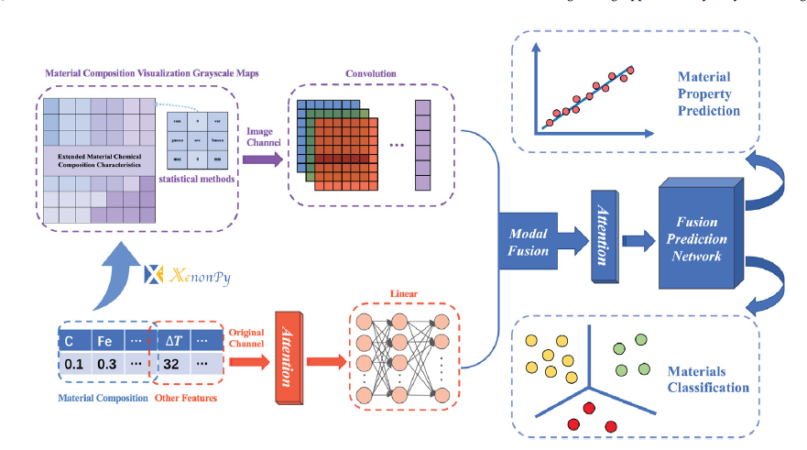

**References**

[1] Yu Y, Wu X, Qian Q. Better utilization of materials’ compositions for predicting their properties: Material composition visualization network[J]. Engineering Applications of Artificial Intelligence, 2023, 117: 105539.

**BIOGRAPHY**

Professor Qian Quan, graduated from the University of Science and Technology of China with a major in Computer Applications, is currently the head of the Intelligent Science Department at the School of Computer Science, Shanghai University. He has long been engaged in research on material big data, machine learning and industrial applications, network security, and privacy computing, and has presided over the completion of more than 30 national key R&D programs and provincial and ministerial level scientific research projects. He has published more than 100 academic papers and owns more than 50 invention patents and software copyrights.

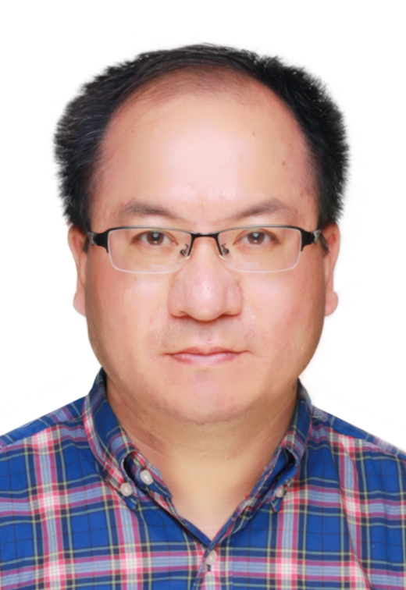

**Figure 1**. Material Composition Enhancement and Modal Fusion Network

1. * Corresponding author: qqian@shu.edu.cn.