USER’S MANUAL

FOR

“PSYCHIATRIC HOSPITAL RECORDS”

A program that simplifies the process of going through the diagnostic criteria for disorders, keeps a database of patients, and allows for analysis of data regarding patients.

CONTENTS

* About ………………………………………….……………………………………………………. 3
* Instructions …..………………………………………………………………….……………… 5
* Improvements ...………………………………………………………………….…………… 20
* Next Steps ………………………………………………………………………………………… 20

About

Psychiatric Hospital Record was designed and built after our realization that the diagnostic procedure for psychiatric patients is inefficient due to a lack of practical means to go through the extensive criteria. Each disorder comes with a diagnostic criteria that holds multiple criterion from A to D, F or H depending on the disorder, all of which need to be fulfilled for a diagnosis to be made. At the initial stages of our project, we hoped to build a program that would go through the criteria and diagnose the patient with a certain disorder after taking in the necessary information. However, while the diagnostic criteria are essential in diagnosing the patient, they are not the sole determining factors and a lot of the decision lies with the clinician’s experience and knowledge. Hence, we changed our focus from directly diagnosing the patient to making the process of diagnosis easier for the clinician.

Currently, allowing the clinician to go through the diagnostic criteria and automatically update the patient’s file is one of the three main functionalities of the Psychiatric Hospital Program. Instead of inputting the symptoms into the program and getting the diagnosis of the patient as an output, our program takes in the most probable diagnosis from the clinician’s point of view as a string variable and brings the criteria one criterion at a time to the clinician’s attention, serving, in a way, as a double-checking mechanism. This approach allows us to have a more realistic program, replicating the real life procedure with a practical twist. After making this decision, the user of our program more definitely became the clinician since decisions no longer lie with the program and patients do not have the required knowledge to go through with it.

With another attempt to make our program more realistic, we wanted to combine the criteria functionality with the context in which it would be used so we also extended our project to include a hospital that holds a database of patient files holding demographical and medical information regarding the patient. This way, the usage of the criteria is less abstract, and the process includes patients. Finally, another functionality of our program is that it allows the clinician to look up for certain information or characteristics regarding the patients and receive a list of patients fitting the said characteristics. This makes space for conducting research and simplifies possible office work.

Instructions

The GUI opens up to the ‘Patient Files’ tab, which contains two main sections. The top of the frame contains a welcome message and a prompt to use the program. The left side of the frame contains the section where the clinician will enter information, whereas the right side of the frame contains the scroll display of patients in the hospital. At this initial stage, the panel is empty.

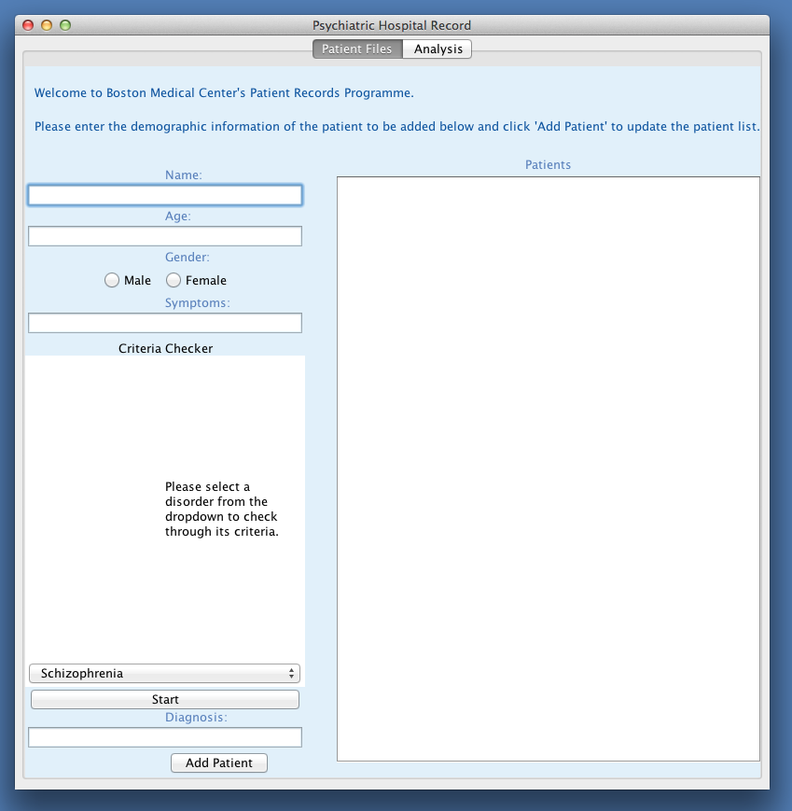

This tab would be used as follows:

The user (the clinician) gets demographical information from the patient such as their name and age and inputs this information into the text fields. After selecting a gender from the radio buttons, the clinician would ask the patient what their presenting symptoms are. These symptoms would be inputted to the text field. Then, the clinician would discuss other information that might have led to the presentation of said symptoms with the patient, which are not captured within the diagnostic criteria (ex. could weight loss be a symptom of major depressive disorder, or is it actually due to a medical condition or excessive dieting?). After the necessary discussions, the clinician can either choose to enter the diagnosis they have in mind into the text field or go through the checklist for the probable disorder to make sure that all criteria is fulfilled and this disorder can actually be diagnosed. This decision is left to the clinician as, while the checklist serves the purpose of making sure that the criteria is met, it is not necessary to go through it if the clinician is sure about their diagnosis.

If the clinician does decide to use the checklist, they would first select which disorder they have in mind from the drop down menu in the Criteria Checker section. After selecting the suspected disorder, they would click the ‘Start’ button to start the checker for that specific disorder, which will take them through all the criteria.

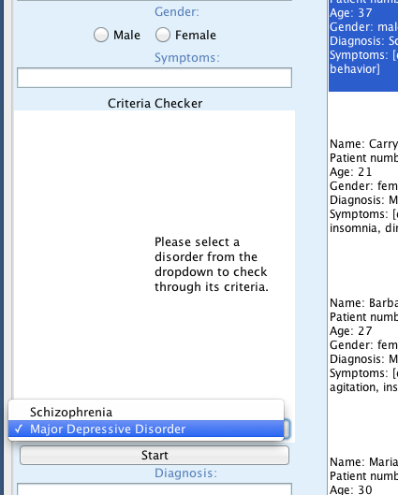

After the specific disorder is selected, the first panel will be one with a checklist of symptoms that might satisfy the criteria. After checking off which ones the patient presents with, the clinician would advance through the criteria by clicking the ‘Next’ button.

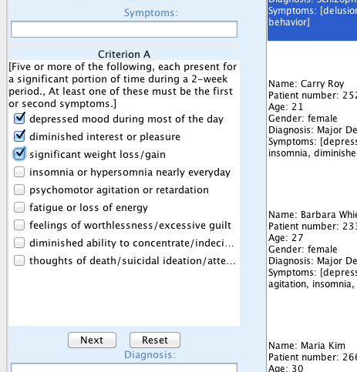

After clicking ‘Next’, the Criteria Checker will display the next criteria, based on if the criteria holds true for the patient, the clinician will either select true or false button. If the criteria is fulfilled, when the clinician clicks ‘Next’, the Criteria Checker will continue advancing through the criteria for the disorder until either a criteria is not fulfilled (the patient cannot be diagnosed with the disorder) or all criteria is fulfilled (the patient can be diagnosed with the disorder).

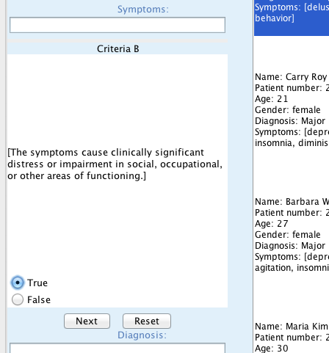

At any point during checking the criteria, the clinician can click the ‘Reset’ button and go back to the first criteria, erasing what they have checked off or selected so far (for instance, if they made a mistake with checking off symptoms or marked a criteria as fulfilled when it was not). If the patient ends up fulfilling the criteria for the disorder, the following will be displayed:

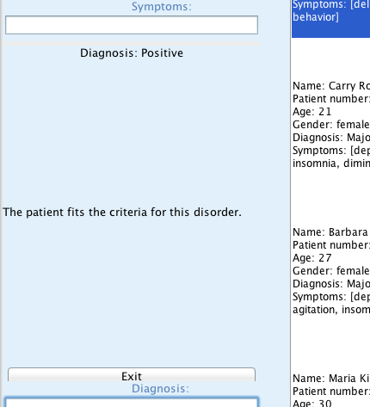

If the patient ends up not fulfilling the criteria for the disorder, the following will be displayed:

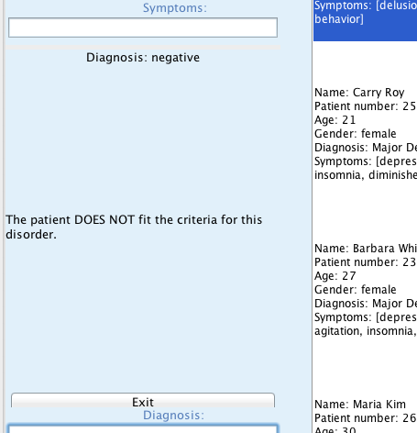

After this, the clinician can click ‘Exit’ to get back to the first display with the drop down menu of disorders again. Now knowing the patient’s disorder or lack thereof, the clinician can input this into the diagnosis box. The clinician can choose to input no diagnosis, the diagnosis given by the Criteria Checker, or another diagnosis, for instance, if they have previous information about what the diagnosis is or have already checked through the criteria before.

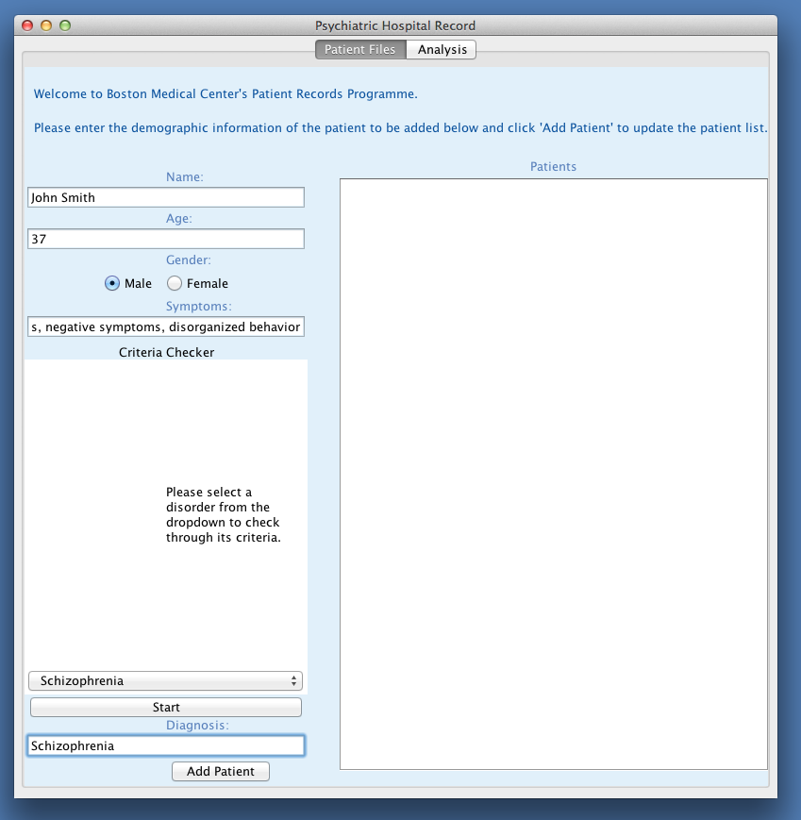

After all the fields have been filled, clicking the ‘Add Patient’ button adds the first patient to the ‘Patients’ panel. All text fields and radio button selections on the left side of the frame are cleared and the checklist returns to the initial panel.

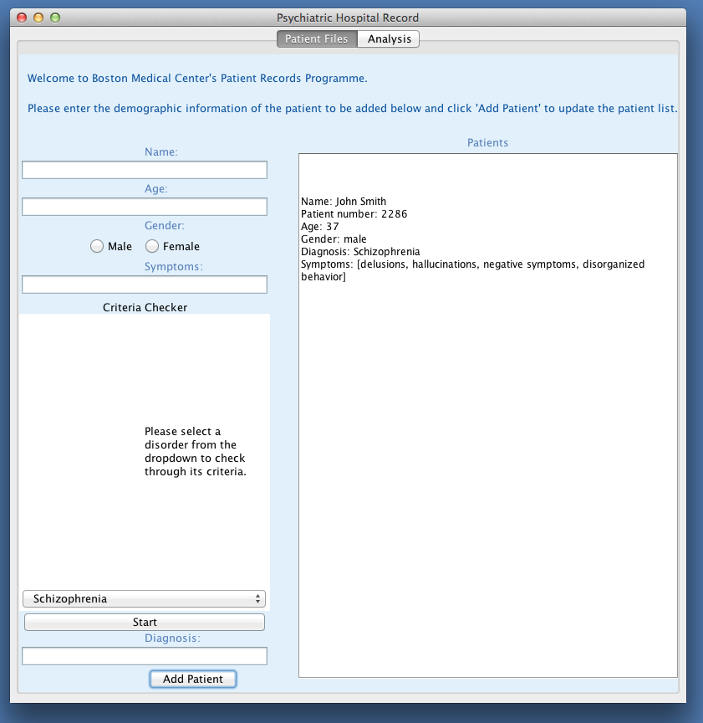

To add additional patients would require the same procedure. Each time ‘Add Patient’ is clicked (given that all fields are filled with valid information) the patient file list gets updated to display the additional patient. When enough patients are added such that they do not fit into the display of the Patients panel, a scroll bar appears, allowing for easy viewing.

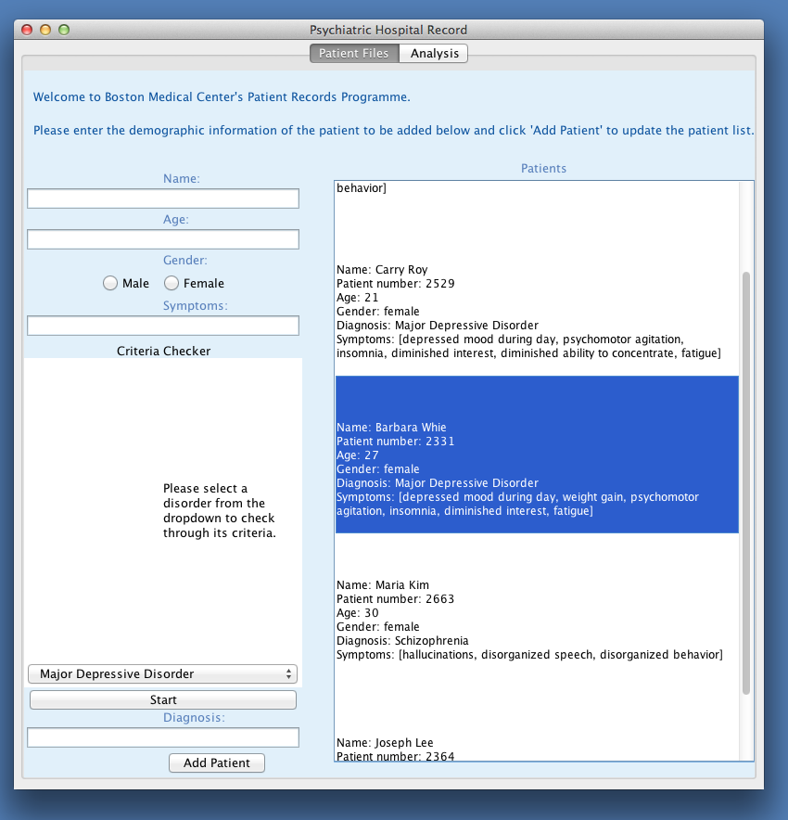

However, while being able to view all of the patients at once has its advantages, the clinician may also want to filter the patient files such that only patient files of a certain common characteristic is displayed instead of the whole hospital. The ‘Analysis’ tab allows for such filtering.

When Analysis tab is selected, the initial frame contains informational text and a drop down menu of modes of search. When at this tab, the user can select from a variety of choices, including ‘Patient with disorder X’, ‘Patients of age (…),(…)’, ‘Female patients’ and ‘Male patients’.

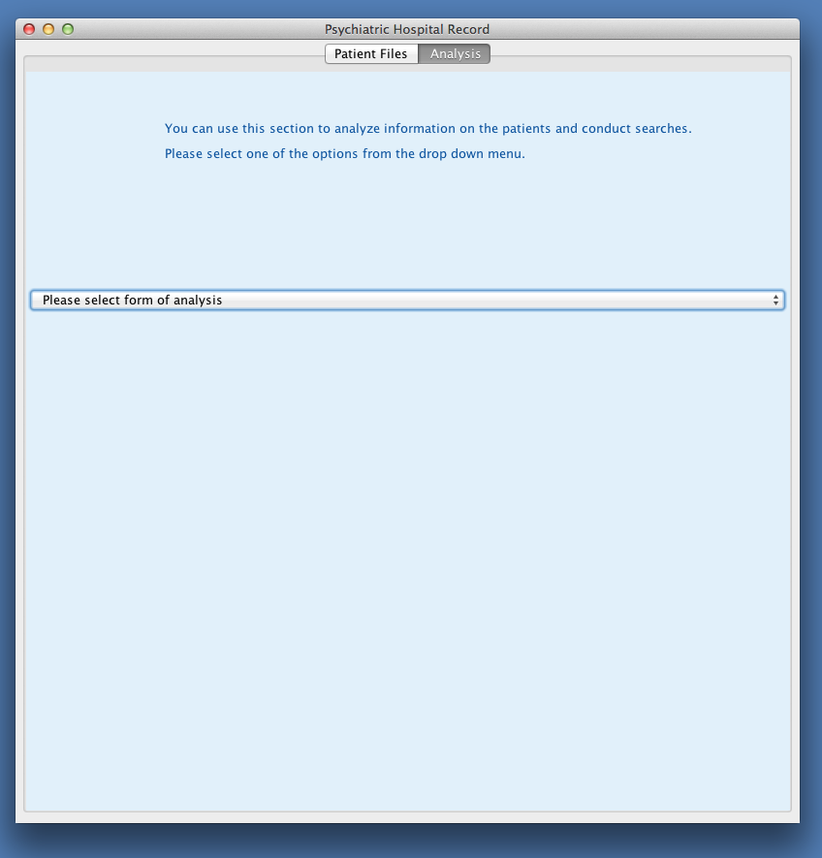

When the user selects ‘Patient with disorder X’, he/she is prompted to enter the name of a disorder.

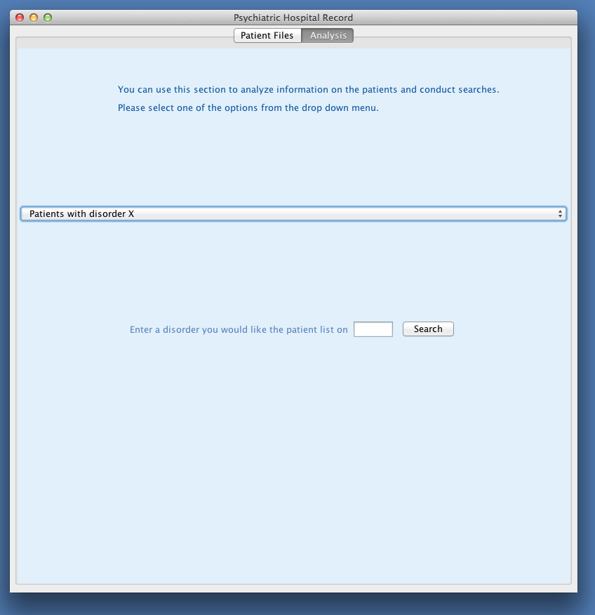

After a disorder name is entered, and the ‘Search’ button is clicked, a scroll panel that displays the filtered patient file list appears below the drop down menu.

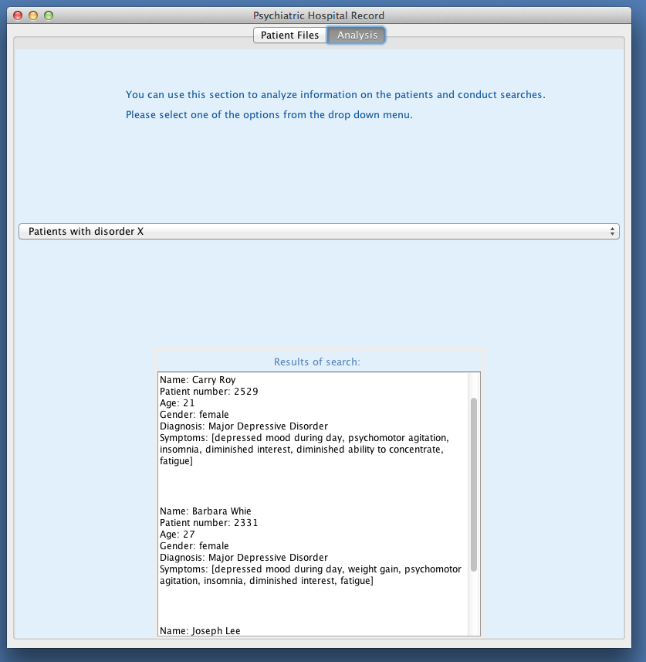

When the user selects ‘Patients of age (…), (…)’, he/she is prompted to provide boundaries of age. Upon clicking on search, the user will be shown a scroll display of all patients fitting said criterion.

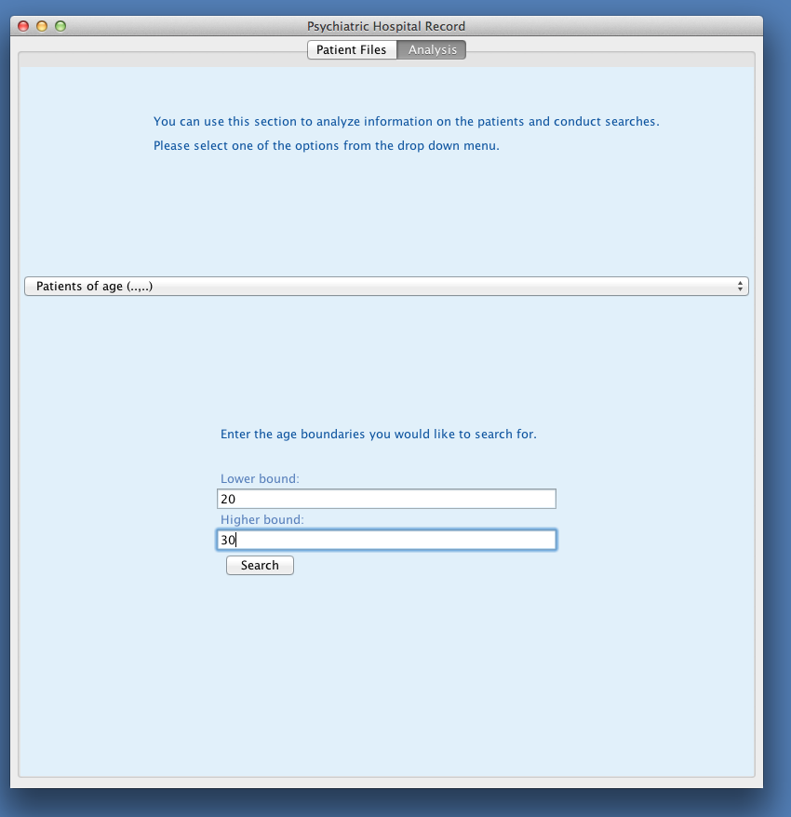

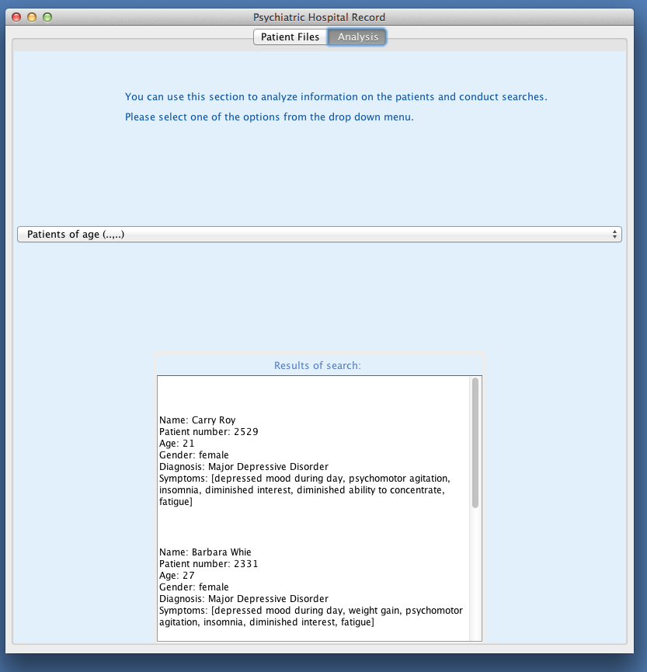

When the user selects ‘Female patients’ or ‘Male patients’, a panel with the patient files with the said gender displayed appears below the drop down menu.

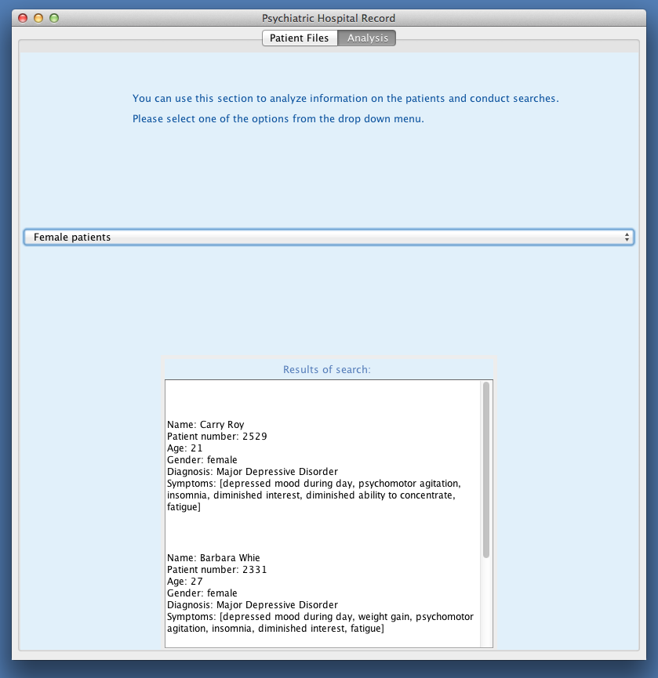

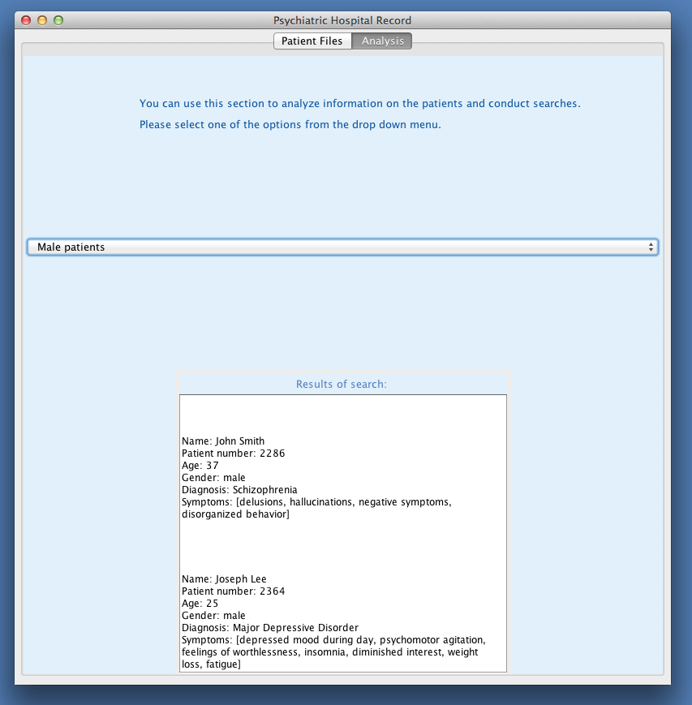

Improvements

Because this is still a rough version of what we would like the program to do, there are lots that we can improve upon. In terms of visual display in the GUI, we would like to make the formatting more clean, which can be done by adding in more subpanels, adding borders, and playing around with the color scheme. Additionally we would like to add more functionality to the program. Currently, the checkboxes in the Criteria Checker do not work, and we would like them to be able to check which symptoms were selected against the criteria.

Also, we would like to have an alternate way to add the diagnosis directly from the Criteria Checker, since it would be useful for the clinician to have a button with options to add a patient using the diagnosis given, add a patient without any diagnosis, or add a patient with a diagnosis they would provide. Instead of doing this is the textbox under the Criteria Checker, it would be very convenient to have it anytime the Criteria Checker reaches a diagnosis or lack thereof.

Next Steps

Some next steps for this program would first be to get the improvements done in order to fix the checkboxes bug, add more functionality at the end of the Criteria Checker, and build on the visuals. To expand the program, more patients would be inputted, remembered by the program, and saved (perhaps to a text file). More disorders would also be added into the choices for Criteria Checker so that the clinician would then be able to check from a variety of suspected diagnoses. With further expansion, the Analysis tab could also give patients for more searches (perhaps based on certain symptoms). This program has much capacity to grow into a bigger database with more analytical tools.

How to Run the Psychiatric Hospital Records program:

Open and run HospitalProgram.java