广东石油化工学院

实训报告

题目： 电信运营商与公司网络设计实训

院 系： 计算机与电子信息学院
专 业： 网络工程
姓 名： 吴玉燕
学 号： 15034460103
指导教师： 周培甲 黄良德

2017 年 6 月 15 日

专业：网络工程
学号：15034460103
姓名：吴玉燕
实训专题：电信运营商与公司网络设计实训
实训地点：中星集团深圳实训基地-6楼
指导老师：周培甲 黄良德
- 实训主要内容
- 了解企业网络规划与实施
- 了解企业网络专业技术VLAN应用
- 了解企业网络专业技术VTP应用
- 了解企业网络专业技术生成树协议应用
- 了解企业网络专业技术HSRP（热备路由）应用
- 了解企业网络专业技术OSPF应用
- 了解企业网络专业技术NAT地址转换应用
- 了解企业网络专业技术RIP路由应用
- 了解企业网络专业技术以太网通道应用
- 实训心得体会
在这次实训中，我收获到了许多课本上所没有的网络知识，老师讲课也非常的轻松幽默，在这样的过程中，学习的东西也容易吸收。通过这次实训，老师也跟我们讲了一下网络工程的职业范围是非常广泛的，以及就业的前景是不错的，此外，也学习到了许多专业的知识，对于vlan的各种功能及使用，我更加熟悉跟了解了，通过老师的讲解，我知道了vlan基于端口的划分:这种划分是根据以太网交换机的交换端口来划分的以及基于端口和IP/MAC地址的划分:MAC地址其实就是指网卡的标识符。不仅如此，我还了解到了企业网络专业技术HSRP（热备路由）应用，热备份是将两台或多台设备模拟成一台设备，平时以一台设备提供网络服务，而另外的设备带电备份，一旦主设备出现故障，备份设备立刻接替主设备工作，从而不使网络中断的技术。此外，我还了解企业网络专业技术OSPF应用和NAT地址转换应用和RIP路由应用。所谓的NAT地址转换应用就是通过NAT地址翻译成合法的IP地址在Internet上使用。在RIP路由应用中，学习了具体路由与交换机配置，让我更感兴趣的是，老师给我们讲了linux操作系统，不再局限于windows系统，这次实训，让我收益良多，更加明白我将来要走的职业方向。
- 实训报告每设备内容
- 实训拓扑
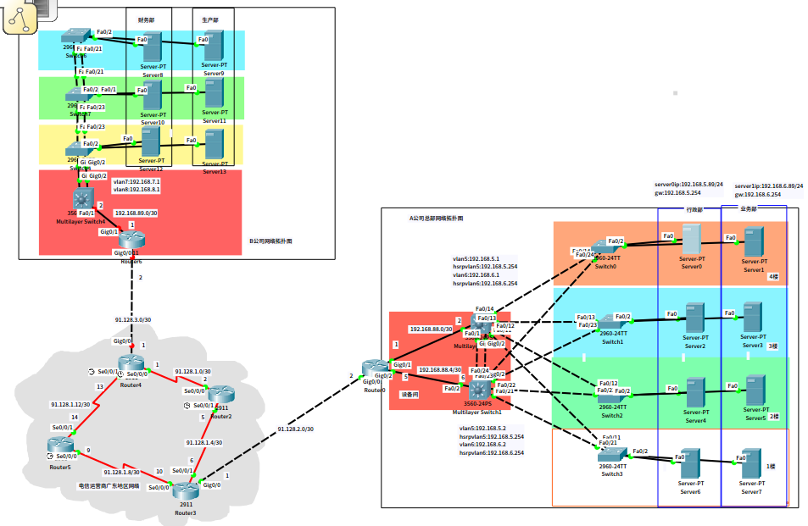
2.具体路由与交换机配置内容如下：
\\注意主机名所对应的机器配置，不要乱
Router2:
en
conf t
int se 0/0/0
ip add 91.128.1.2 255.255.255.252
no sh
int se 0/0/1
ip add 91.128.1.5 255.255.255.252
no sh
exit
route ospf 1
network 91.128.1.0 0.0.0.3 area 0
network 91.128.1.4 0.0.0.3 area 0
end

Router3:
en
conf t
int se 0/0/0
ip add 91.128.1.10 255.255.255.252
no sh
int se 0/0/1
ip add 91.128.1.6 255.255.255.252
no sh
int gi 0/0
ip add 91.128.2.1 255.255.255.252
no sh
exit
route ospf 1
network 91.128.1.4 0.0.0.3 area 0
network 91.128.1.8 0.0.0.3 area 0
network 91.128.2.0 0.0.0.3 area 0

end

Router4:
en
conf t
int se 0/0/0
ip add 91.128.1.1 255.255.255.252
no sh
int se 0/0/1
ip add 91.128.1.13 255.255.255.252
no sh
int gi 0/0
ip add 91.128.3.1 255.255.255.252
no sh
exit
route ospf 1
network 91.128.1.0 0.0.0.3 area 0
network 91.128.1.12 0.0.0.3 area 0
network 91.128.3.0 0.0.0.3 area 3
end

Router5:
en
conf t
int se 0/0/0
ip add 91.128.1.9 255.255.255.252
no sh
int se 0/0/1
ip add 91.128.1.14 255.255.255.252
no sh
exit
route ospf 1
network 91.128.1.8 0.0.0.3 area 0
network 91.128.1.12 0.0.0.3 area 0
end

Router0:
en
conf t
int gi 0/0
ip add 91.128.2.2 255.255.255.252
ip nat outside
no sh
int gi 0/1
ip add 192.168.88.1 255.255.255.252
ip nat inside
no sh
int gi 0/2
ip add 192.168.88.5 255.255.255.252
ip nat inside
no sh
exit
ip route 0.0.0.0 0.0.0.0 91.128.2.1
access-list 1 permit 192.168.88.0 0.0.0.3
access-list 1 permit 192.168.88.4 0.0.0.3
access-list 1 permit 192.168.5.0 0.0.0.255
access-list 1 permit 192.168.6.0 0.0.0.255
ip nat inside source list 1 interface gi 0/0 overload
route ospf 2
network 192.168.88.0 0.0.0.3 area 0
network 192.168.88.4 0.0.0.3 area 0
default-information originate
exit

3560Switch1:
en
conf t
int f0/2
no switchport
ip add 192.168.88.6 255.255.255.252
no sh
exit
ip routing
route ospf 2
network 192.168.88.4 0.0.0.3 area 0
network 192.168.5.0 0.0.0.255 area 0
network 192.168.6.0 0.0.0.255 area 0
exit
int range g0/1 - 2
switchport trunk encapsulation dot1q
switchport mode trunk
channel-group 1 mode on
exit
int range f0/21 - 24
switchport trunk encapsulation dot1q
switchport mode trunk
end
vlan database
vlan 5 name 5
vlan 6 name 6
vtp domain zhongxing
vtp password 123
vtp server
exit
conf t
spanning-tree vlan 5
spanning-tree vlan 5 priority 8192
spanning-tree vlan 5 root primary
spanning-tree vlan 6
spanning-tree vlan 6 priority 4096
spanning-tree vlan 6 root primary
int vlan 5
ip address 192.168.5.1 255.255.255.0
no sh
standby ip 192.168.5.254
standby priority 200
standby preempt
standby track fastEthernet 0/2
\\standby track fastEthernet 0/2 100
exit
int vlan 6
ip add 192.168.6.1 255.255.255.0
no sh
standby ip 192.168.6.254
standby priority 150
standby preempt
exit

3560Switch3:

en
conf t
int f0/1
no switchport
ip add 192.168.88.2 255.255.255.252
no sh
exit
ip routing
route ospf 2
network 192.168.88.0 0.0.0.3 area 0
network 192.168.5.0 0.0.0.255 area 0
network 192.168.6.0 0.0.0.255 area 0
exit
int range gi 0/1 - 2
switchport trunk encapsulation dot1q
switchport mode trunk
channel-group 1 mode on
exit
int range f0/11 - 14
switchport trunk encapsulation dot1q
switchport mode trunk
end
vlan database
vlan 5 name 5
vlan 6 name 6
vtp domain zhongxing
vtp password 123
vtp server
exit
conf t
spanning-tree vlan 6
spanning-tree vlan 6 priority 8192
spanning-tree vlan 6 root primary
spanning-tree vlan 5
spanning-tree vlan 5 priority 4096
spanning-tree vlan 5 root primary
int vlan 6
ip address 192.168.6.2 255.255.255.0
no sh
standby ip 192.168.6.254
standby priority 200
standby preempt
standby track fastEthernet 0/1
\\standby track fastEthernet 0/1 100
exit
int vlan 5
ip add 192.168.5.2 255.255.255.0
no sh
standby ip 192.168.5.254
standby priority 150
standby preempt
exit

Switch0:
en
vlan database
vtp domain zhongxing
vtp password 123
vtp client
exit
conf t
spanning-tree vlan 5
spanning-tree vlan 6
int range f0/14,f0/24
switchport mode trunk
int f0/1
switchport access vlan 5
int f0/2
switchport access vlan 6
end

Switch1:
en
vlan database
vtp domain zhongxing
vtp password 123
vtp client
exit
conf t
int range f0/13,f0/23
switchport mode trunk
int f0/1
switchport access vlan 5
int f0/2
switchport access vlan 6
end

Switch2:
en
vlan database
vtp domain zhongxing
vtp password 123
vtp client
exit
conf t
int range f0/12,f0/22
switchport mode trunk
int f0/1
switchport access vlan 5
int f0/2
switchport access vlan 6
end

Switch3:
en
vlan database
vtp domain zhongxing
vtp password 123
vtp client
exit
conf t
int range f0/11,f0/21
switchport mode trunk
int f0/1
switchport access vlan 5
int f0/2
switchport access vlan 6
end

Router6:
en
conf t
int gi 0/0
ip add 91.128.3.2 255.255.255.252
ip nat outside
no sh
int gi 0/1
ip add 192.168.89.1 255.255.255.252
ip nat inside
no sh
exit
ip route 0.0.0.0 0.0.0.0 gi 0/0
router rip
network 192.168.89.0
network 91.128.3.0
exit
access-list 2 permit 192.168.7.0 0.0.0.255
access-list 2 permit 192.168.8.0 0.0.0.255
access-list 2 permit 192.168.89.0 0.0.0.3
ip nat inside source list 2 interface gi 0/0
end

Multilayer Switch4:
en
vlan database
vlan 7 name 7
vlan 8 name 8
vtp domain zhongguo
vtp password 123
vtp server
exit
conf t
ip routing
int f0/1
no switchport
ip add 192.168.89.2 255.255.255.252
no sh
int vlan 7
ip add 192.168.7.1 255.255.255.0
no sh
int vlan 8
ip add 192.168.8.1 255.255.255.0
no sh
int range gi 0/1 - 2
switchport trunk encapsulation dot1q
switchport mode trunk
channel-group 2 mode on
exit
ip route 0.0.0.0 0.0.0.0 f0/1
router rip
network 192.168.89.0
network 192.168.7.0
network 192.168.8.0
exit

Switch4:
en
vlan database
vtp domain zhongguo
vtp password 123
vtp client
exit
conf t
int range gi 0/1 - 2
switchport mode trunk
channel-group 2 mode on
int range f0/22 - 23
switchport mode trunk
channel-group 3 mode on
exit
int f0/1
switchport access vlan 7
int f0/2
switchport access vlan 8
end

Switch7:
en
vlan database
vtp domain zhongguo
vtp password 123
vtp client
exit
conf t
int range f0/22 - 23
switchport mode trunk
channel-group 3 mode on
int range f0/20 - 21
switchport mode trunk
channel-group 4 mode on
exit
int f0/1
switchport access vlan 7
int f0/2
switchport access vlan 8
end

Switch6:
en
vlan database
vtp domain zhongguo
vtp password 123
vtp client
exit
conf t
int range f0/20 - 21
switchport mode trunk
channel-group 4 mode on
exit
int f0/1
switchport access vlan 7
int f0/2
switchport access vlan 8
end

- 实训考查点（截图）
- server0与server1配置IP 地址
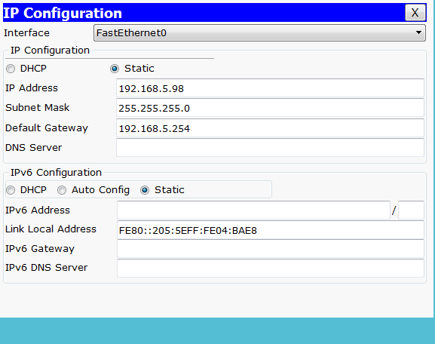
图一

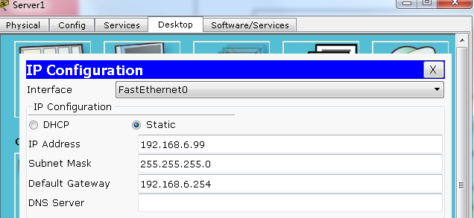
图二

- server0与server1能连通各自的热备网关192.168.5.254与192.168.6.254
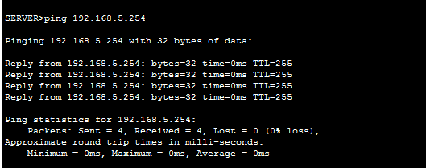
图一

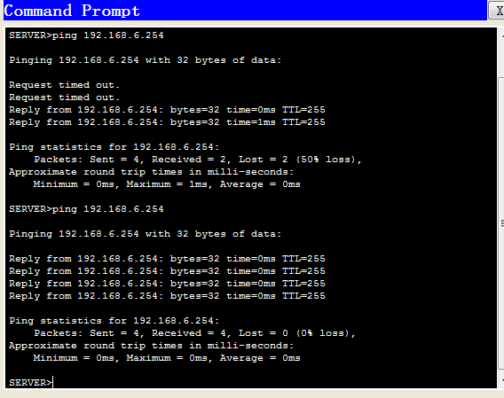
图二

- 查看Multilayer Switch1-HSRP热备状态用命令（show standby b）
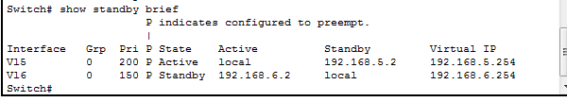
- server0与server1能连通到达电信运营商广东地区网络的任意地址
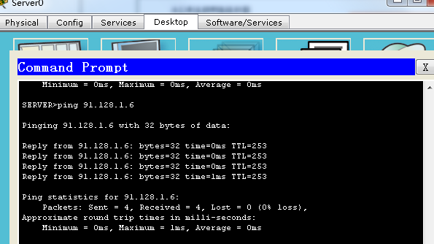
图一
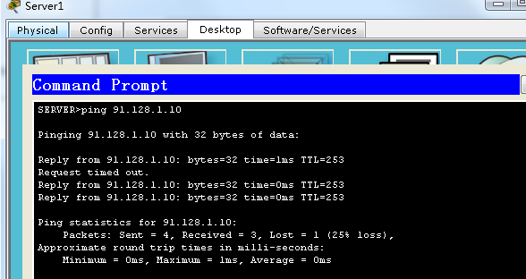
图二

5.电信运营商广东地区网络的任意路由查看OSPF 路由表(show ip route)
