採了個大坑=>花費時間:半天

狀況:串接FB API登入時，出現錯誤訊息:

Error getting access token from facebook.com, OAuth2 redirect uri is: https://gocamping-8c9d3.firebaseapp.com/__/auth/handler, response: OAuth2TokenResponse{params: error=OAuthException&error_description=Error%20validating%20client%20secret., httpMetadata: HttpMetadata{status=400, cachePolicy=NO_CACHE, cacheDurationJava=null, cacheImmutable=false, staleWhileRevalidate=null, filename=null, lastModified=null, retryAfter=null, crossOriginEmbedderPolicy=null, crossOriginOpenerPolicy=null, crossOriginResourcePolicy=null, headers=HTTP/1.1 200 OK

auth/invalid-credential

嘗試很多方法，包含嘗試https://developers.facebook.com/tools/explorer/，FB 圖形API去設定、創建不同帳號等等

使用Firebase回傳的網址，得到下列網頁訊息:

<https://gocamping-8c9d3.firebaseapp.com/__/auth/handler>

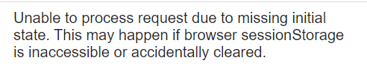

最後透過stackoverflow，試了下面第二個回答，才發現原來創建FB APP時候，密碼不能直接複製，需要顯示後再複製，真是踩在FB精心設計的坑上啊!!!

https://stackoverflow.com/questions/57010980/firebase-authentication-error-auth-invalid-credential