* SSID: 204_2.4G
* Received Signal Power: -26 dBm
* Transmission Rate: 144 Mbps (nearest)

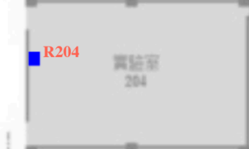

* SSID: 204_2.4G
* Received Signal Power: -39 dBm
* Transmission Rate: 144 Mbps (farest)



* SSID: 204_2.4G
* Received Signal Power: -28 dBm
* Transmission Rate: 144 Mbps (outside the door)



* SSID: 204_5G
* Received Signal Power: -32 dBm
* Transmission Rate: 866 Mbps (nearest)



* SSID: 204_5G
* Received Signal Power: -45 dBm
* Transmission Rate: 585 Mbps (farest)



* SSID: 204_5G
* Received Signal Power: -43 dBm
* Transmission Rate: 468 Mbps (outside the door)
* SSID: 101_2.4G
* Received Signal Power: -23 dBm
* 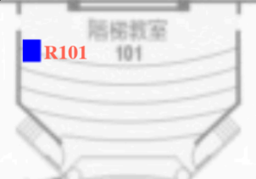Transmission Rate: 144 Mbps (nearest)
* SSID: 101_2.4G
* Received Signal Power: -48 dBm
* Transmission Rate: 144 Mbps(farest)
* SSID: 101_2.4G
* Received Signal Power: -30 dBm
* Transmission Rate: 144 Mbps (outside the door)
* SSID: 101_5G
* Received Signal Power: -27 dBm
* Transmission Rate: 868 Mbps
* SSID: 101_5G
* Received Signal Power: -46 dBm
* Transmission Rate: 585 Mbps
* SSID: 101_5G
* Received Signal Power: -42 dBm
* Transmission Rate: 585 Mbps (outside the door)
* SSID: 102_2.4G
* Received Signal Power: -28 dBm
* 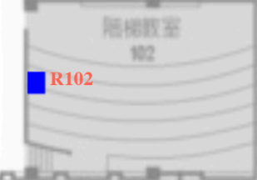Transmission Rate: 144 Mbps (nearest)
* SSID: 102_2.4G
* Received Signal Power: -42 dBm
* Transmission Rate: 144 Mbps (farest)



* SSID: 102_2.4G
* Received Signal Power: -53 dBm
* Transmission Rate: 144 Mbps (outside the door)



* SSID: 102_5G
* Received Signal Power: -35 dBm
* Transmission Rate: 868 Mbps(nearest)



* SSID: 102_5G
* Received Signal Power: -57 dBm
* Transmission Rate: 650 Mbps(farest)



* SSID: 102_5G
* Received Signal Power: -46 dBm
* Transmission Rate: 650 Mbps (outside the door)

