SA



1. <https://whatis.techtarget.com/definition/proxy-server>

<https://en.wikipedia.org/wiki/Proxy_server>

Proxy server acts as an intermediary for requests from clients seeking resources from other servers. A client connects to the proxy server, requesting some file, connection, web page, or other resource available from a different server and the proxy server evaluates the request as a way to simplify and control its complexity.

Reverse proxy is a proxy server which forward requests to one or more ordinary servers which handle the request. The response from the proxy server is returned as if it came directly from the original server. The client will not know its real servers.

Use:

Allow for load balancing between severs.

Stream internal content to Internet users.

Disable access to a site. Ex: when government wants to block a website.

Enable indirect access (website may disallow direct connections as a security measure.)

1. <https://en.wikipedia.org/wiki/Apache_HTTP_Server>

<https://www.oodlestechnologies.com/blogs/Characteristics%2C-Advantages-and-Disadvantages-of-NginX>

<https://en.wikipedia.org/wiki/Nginx>

<http://apachebooster.com/kb/about-apache-web-server-its-advantages-and-disadvantages/>

Apache:

Advantages:

Open source and can be modified to adjust and fixed.

Flexible to add more features and modules, and widespread support.

Multiple websites can run in the same server. (can create virtual hosts)

Good at handling dynamic content

Disadvantages:

New bugs will be created while creating personalized protocol.

If not recognize and disable unwanted services and modules, leaving them on could cause serious threats.

Consume more resource than Nginx.

Nginx:

Advantages:

Resource efficiency and responsiveness under load.

Handle more clients with less number of process

Disadvantages:

Difficulties in module creation

Difficulties in supporting HTTP/1.0 with backend communication

I think it is better to use Nginx as a reverse proxy. Nginx is lighter and good at handle large amount of request. We can use it to handle requests from clients as reverse proxy. This takes advantage of Nginx's fast processing speed and ability to handle large numbers of connections concurrently.

<https://www.digitalocean.com/community/tutorials/how-to-use-apache-as-a-reverse-proxy-with-mod_proxy-on-centos-7>

實作採用複製兩台vm, 一台做web-server另一台做reverse-proxy

Check 所需module

mod_proxy

mod_proxy_http

mod_proxy_balancer

mod_proxy_connect

mod_lbmethod_byrequests

(以下如果要啟用不同服務)

mod_proxy_ajp //AJP13 (Apache JServe Protocol version 1.3)

mod_proxy_fcgi //FastCGI

mod_proxy_ftp //ftp

mod_proxy_scgi //SCGI

mod_proxy_wstunnel //WS and WSS (Web-sockets)

vim /etc/httpd/conf.d/default-site.conf

<VirtualHost *:80>

ProxyPreserveHost On

ProxyPass / http://192.168.56.101/wordpress/

ProxyPassReverse / http://192.168.56.101/wordpress/

</VirtualHost>

systemctl restart httpd

在web server 上裝iptables 來讓主機無法直接碰到web-server而要透過reverse proxy

yum install iptables-services

systemctl enable iptables

systemctl start iptables

vim /tmp/v4

*filter

-A INPUT –s 192.168.56.103 –j ACCEPT (my reverse proxy ip)

-A OUTPUT –s 192.168.56.103 –j ACCEPT (my reverse proxy ip)

-P INPUT DROP

-P OUTPUT DROP

COMMIT

iptables-restore</tmp/v4

service iptables save

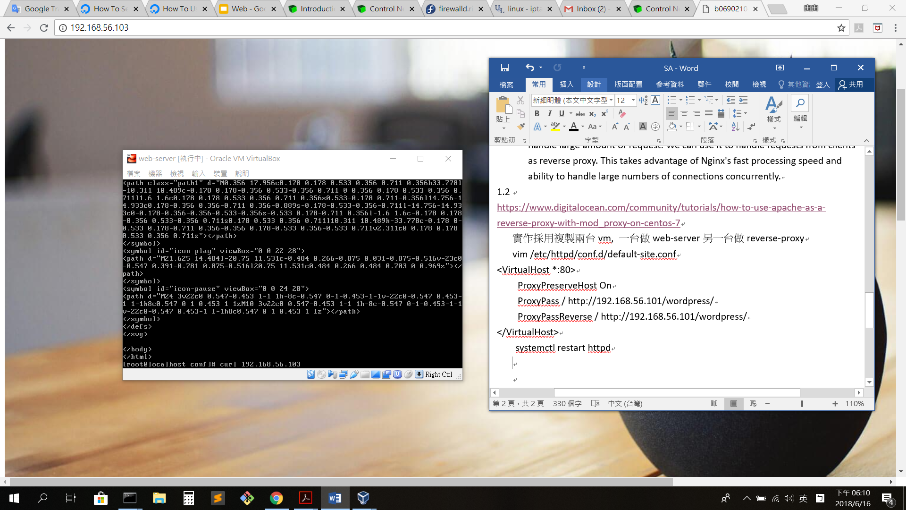curl reverse proxy

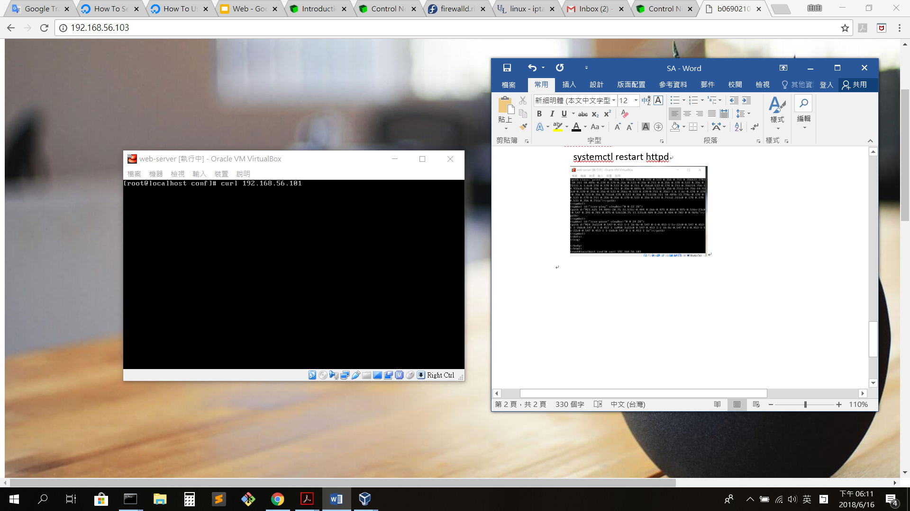curl web server

2. Directive

<https://httpd.apache.org/docs/2.4/vhosts/examples.html>

<https://httpd.apache.org/docs/2.4/mod/mod_authz_core.html>

<https://httpd.apache.org/docs/2.4/rewrite/avoid.html>

Listen 80

<VirtualHost *:80>

ServerName www.example.com

**D**ocumentRoot "/var/www/html"

<Directory " /var/www/html/nasa">

Require ip 192.168.1.105

</Directory>

Redirect "/" "https://www.example.com/"

</VirtualHost >