Tian Qiu

edX:

TianQiu

[ricardotianq@gmail.com](mailto:ricardotianq@gmail.com)

Code grader:

Error: Your code had a runtime error. Here is the error:

terminate called after throwing an instance of 'int'

My system information:

OS version: 10.0.14393 Build 14393 (Windows 10 Pro)

Microsoft Visual Studio version: 14.0.25431.01 Update 3

Build console message:

1>------ Rebuild All started: Project: hw2-windows, Configuration: Debug Win32 ------

1> grader.cpp

1> Transform.cpp

1> shaders.cpp

1> readfile.cpp

1> main.cpp

1> Geometry.cpp

1> display.cpp

1> Generating Code...

1> hw2-windows.vcxproj -> C:\Users\Tian\Dropbox\167homework\hw2-windows\Debug\hw2-windows.exe

1> hw2-windows.vcxproj -> C:\Users\Tian\Dropbox\167homework\hw2-windows\Debug\hw2-windows.pdb (Full PDB)

========== Rebuild All: 1 succeeded, 0 failed, 0 skipped ==========

Debug output:

……

The thread 0x2384 has exited with code 0 (0x0).

The thread 0x2354 has exited with code 0 (0x0).

The thread 0x357c has exited with code 0 (0x0).

The program '[14504] hw2-windows.exe' has exited with code 0 (0x0).

Screenshot:

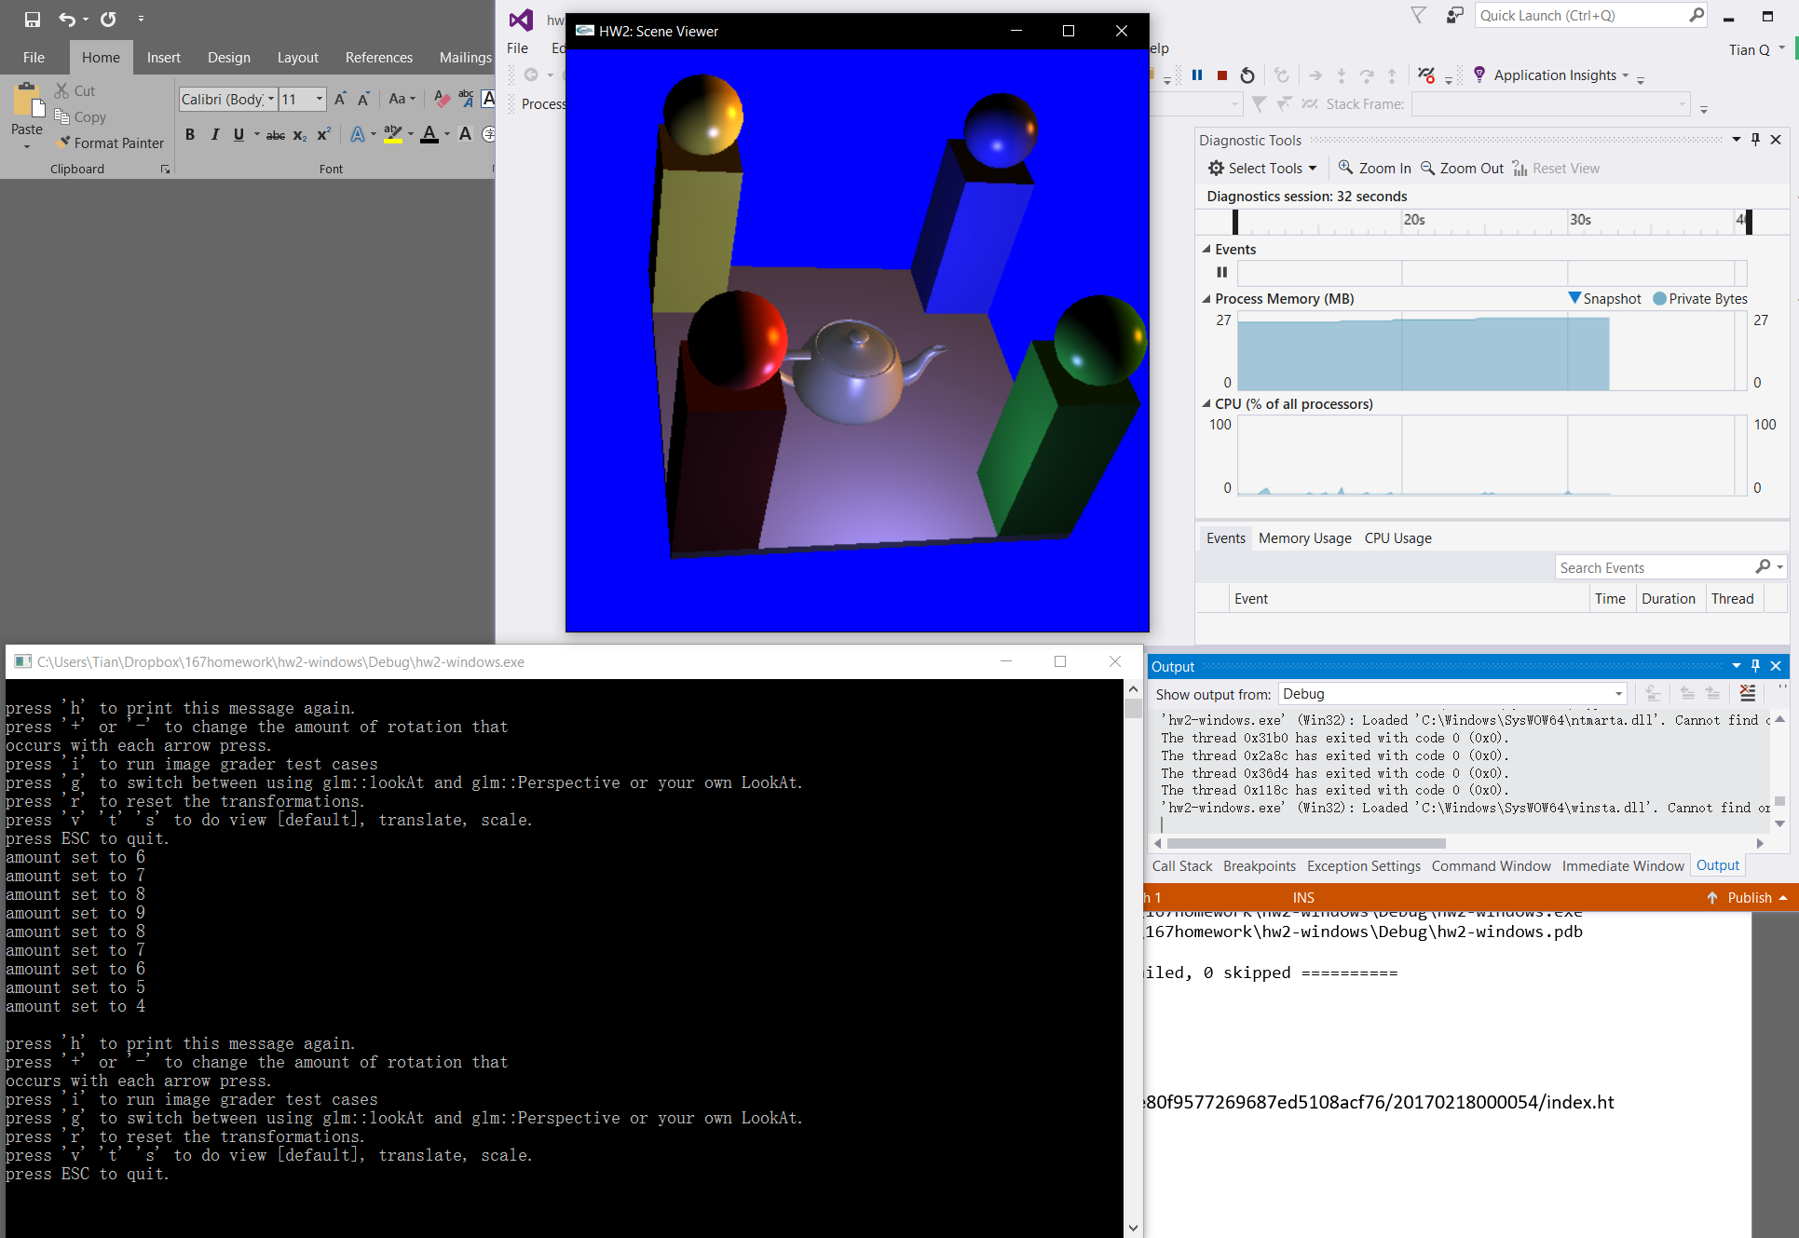

I haven’t modified codes other than specified places. I am not sure why I got this error.

Image grader:

https://lifan.s3.amazonaws.com/hw2/0d5f6d6e80f9577269687ed5108acf76/20170218000054/index.html