URP：Figure 1 与 Figure 10 修订说明
第一部分 · 2026年10月20日 · 四年数据结构、分析流程与气象条件

1. Figure 1重构建议
推荐三列结构：数据输入 → 模型与分阶段校准 → 分析与候选核验。第三列保留Sobol和优化两条不同输入的支路；两个阶段的冻结中心用于优化，分阶段样本用于条件扰动核验。
树状布局作为备选：原模型之下分出Sobol支路和MCMC—优化支路，最后汇入综合解释。两种布局择一用于正文。
Pattern只用于标题或模块边缘窄色带：浅斜线、稀疏点纹、稀疏交叉线。正文区域留白，阶段色使用浅中性色，保留蓝/橙/绿/紫作为四年的固定颜色。
以183mm通栏宽度审阅：流程图正文约8.1–9.5pt；图内保留关系和变量，完整采样与优化预算放入方法。Sobol与优化之间不画“筛选后降维”的箭头。

2. Figure 10英文标签
中文 | 推荐英文
四年实际使用的气象驱动 | Meteorological forcing used in the four annual simulations
环境条件（本图建议具体写成气象条件） | Meteorological conditions during the simulation periods (2019–2022)
参考蒸散 ETo（mm/d） | Reference evapotranspiration, ET₀ (mm d⁻¹)
降水（mm） | Precipitation (mm)
日期 | Date (MM–DD)

3. 推荐英文图注
Figure 10. Daily reference evapotranspiration (ET₀) and precipitation during the simulation periods in (a) 2019, (b) 2020, (c) 2021, and (d) 2022. Colored lines show ET₀ (left axis), and gray bars show daily precipitation totals (right axis). Each panel covers the original calendar window used by the corresponding annual model. The ET₀ series are taken from the audited meteorological inputs used in the simulations.

4. 正文衔接示例
Daily reference evapotranspiration and precipitation used to drive the annual crop models are presented in Figure 10. The records retain their original daily resolution and year-specific simulation windows, providing the meteorological context for comparisons among years. Reference evapotranspiration characterizes atmospheric evaporative demand; actual crop water use and soil water availability are evaluated separately from the simulated water balances.

5. 数据处理说明
Figure 10直接保留原日历内的四年逐日ET₀和降水，共599行。未平滑、缩放或替换序列。跨年坐标范围一致。ET₀表征大气蒸发需求，实际耗水和胁迫需结合模型水量平衡解释。当前任务无需补充数据。

Figure 1：三列推荐方案
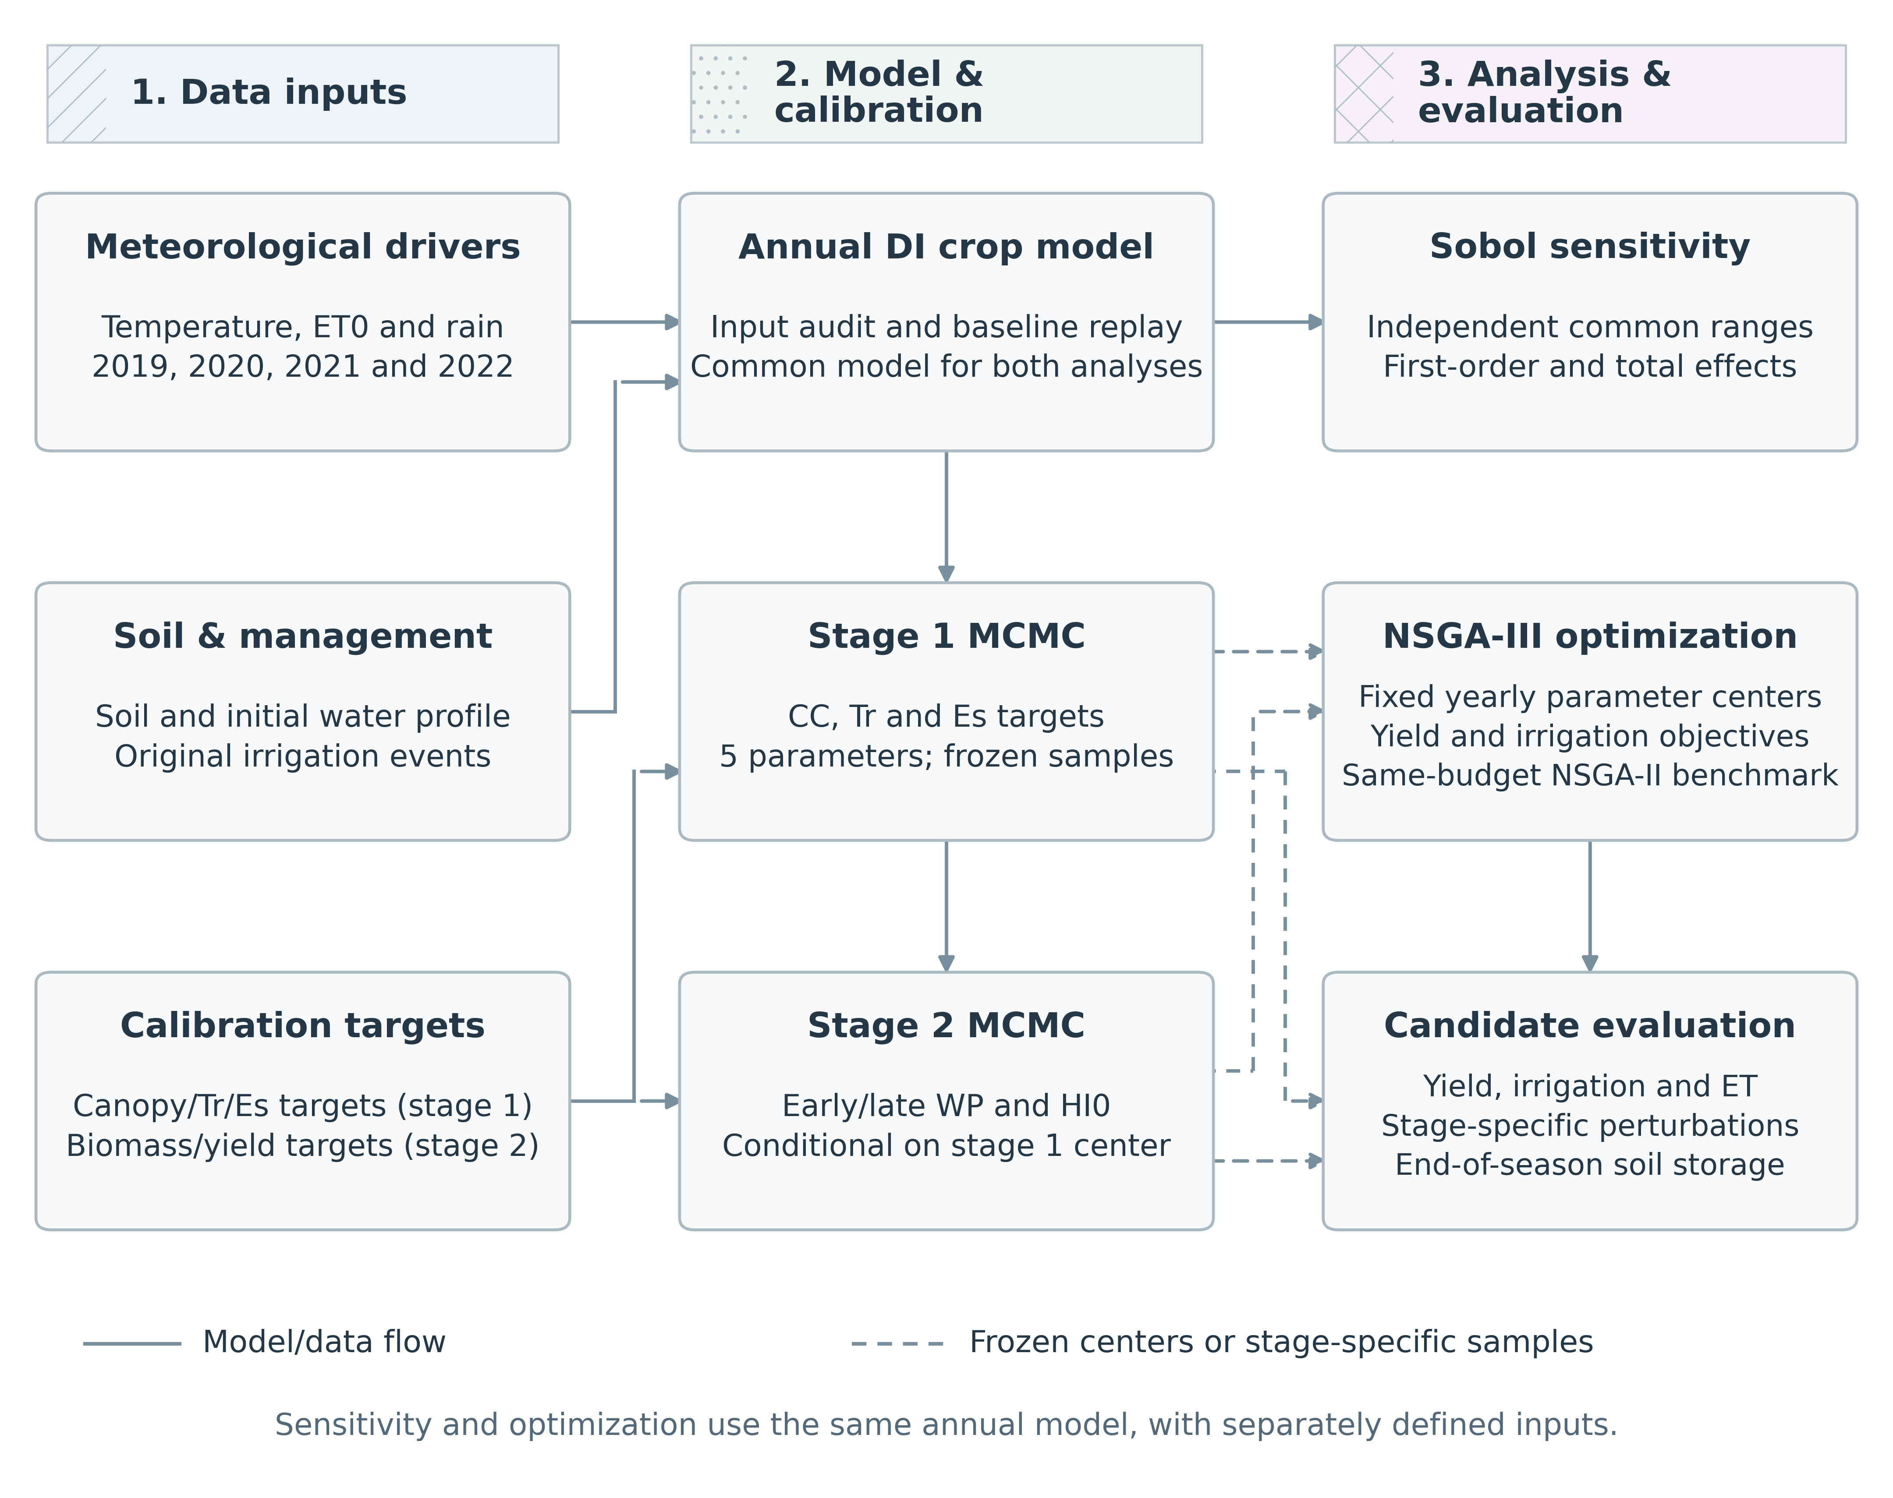
Figure 1. Workflow linking two-stage MCMC calibration, global sensitivity analysis, and irrigation optimization for maize during 2019–2022. Sobol analysis uses eight independently distributed parameters within common uniform ranges, whereas NSGA-III searches for irrigation schedules at frozen year-specific parameter centers. NSGA-II provides a same-budget benchmark. Candidate schedules are assessed using stage-specific conditional perturbations and seasonal water balances, including terminal soil water storage. Dashed arrows indicate the transfer of frozen parameter centers or stage-specific samples; solid arrows indicate model or data flow. Stage-specific inference and sampling-diagnostic limitations are retained.

Figure 1：树状备选方案
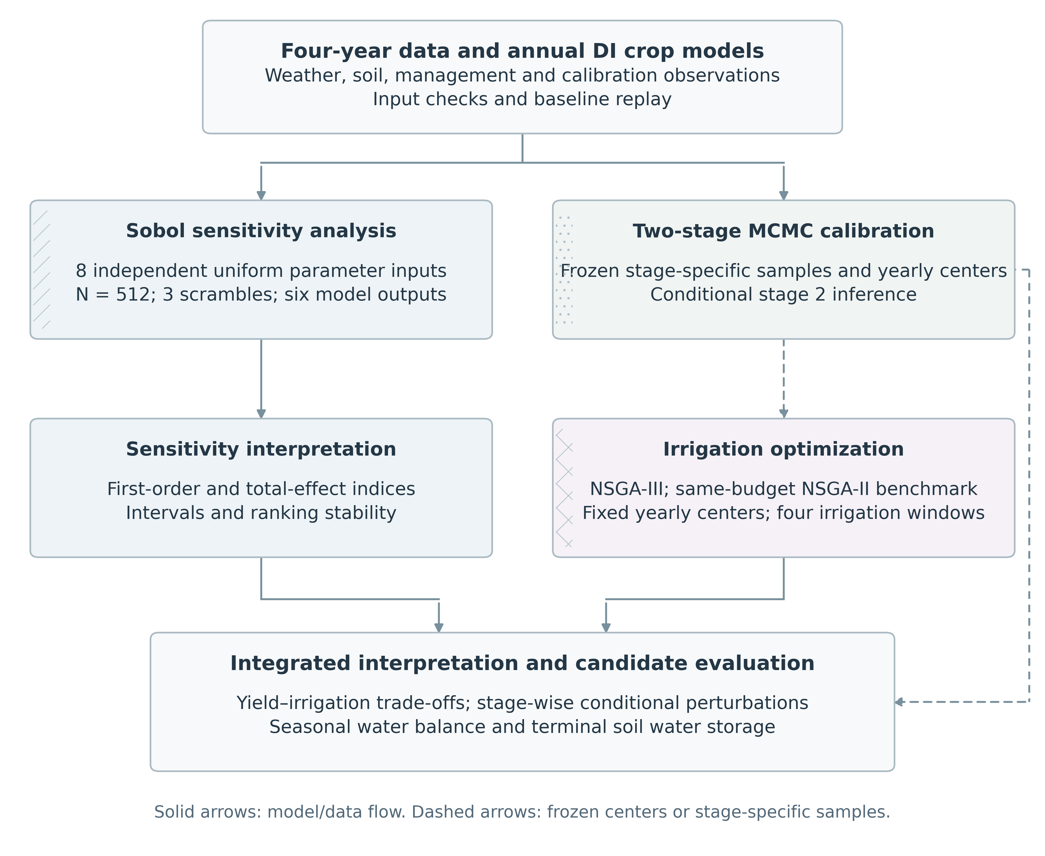
Alternative layout using two analysis branches. Use one Figure 1 layout in the manuscript.

Figure 10：英文版
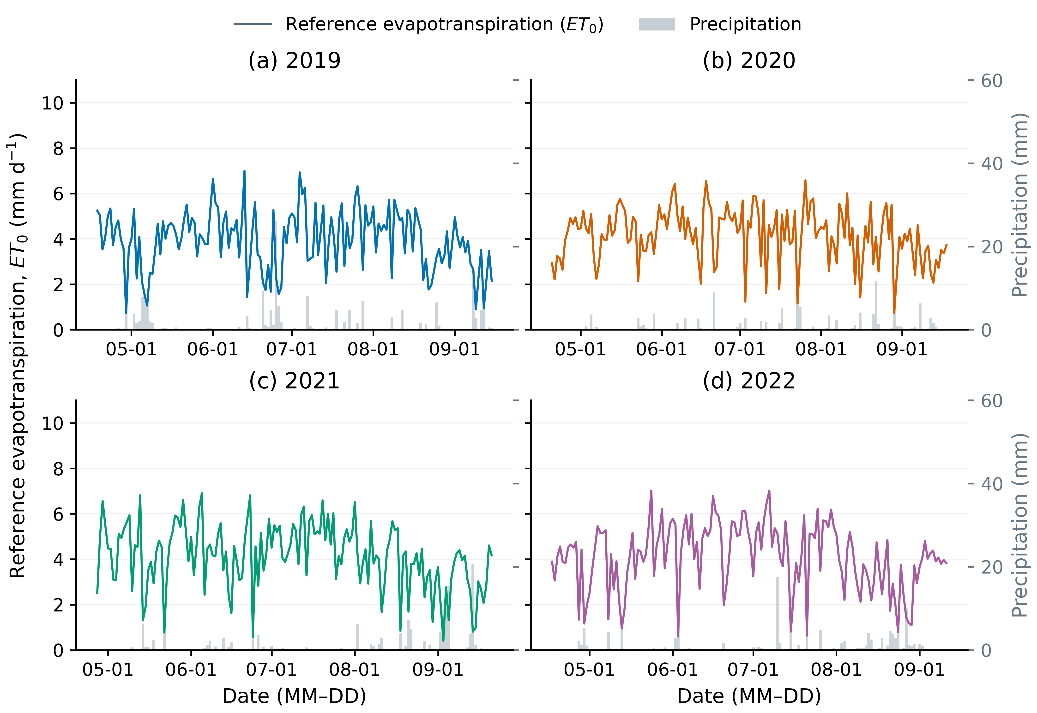
Figure 10. Daily reference evapotranspiration (ET₀) and precipitation during the simulation periods in (a) 2019, (b) 2020, (c) 2021, and (d) 2022. Colored lines show ET₀ (left axis), and gray bars show daily precipitation totals (right axis). Each panel covers the original calendar window used by the corresponding annual model. The ET₀ series are taken from the audited meteorological inputs used in the simulations.

