英文图件解析 / English figure interpretations

Figure 1. Research framework for staged calibration, sensitivity analysis and irrigation optimization.
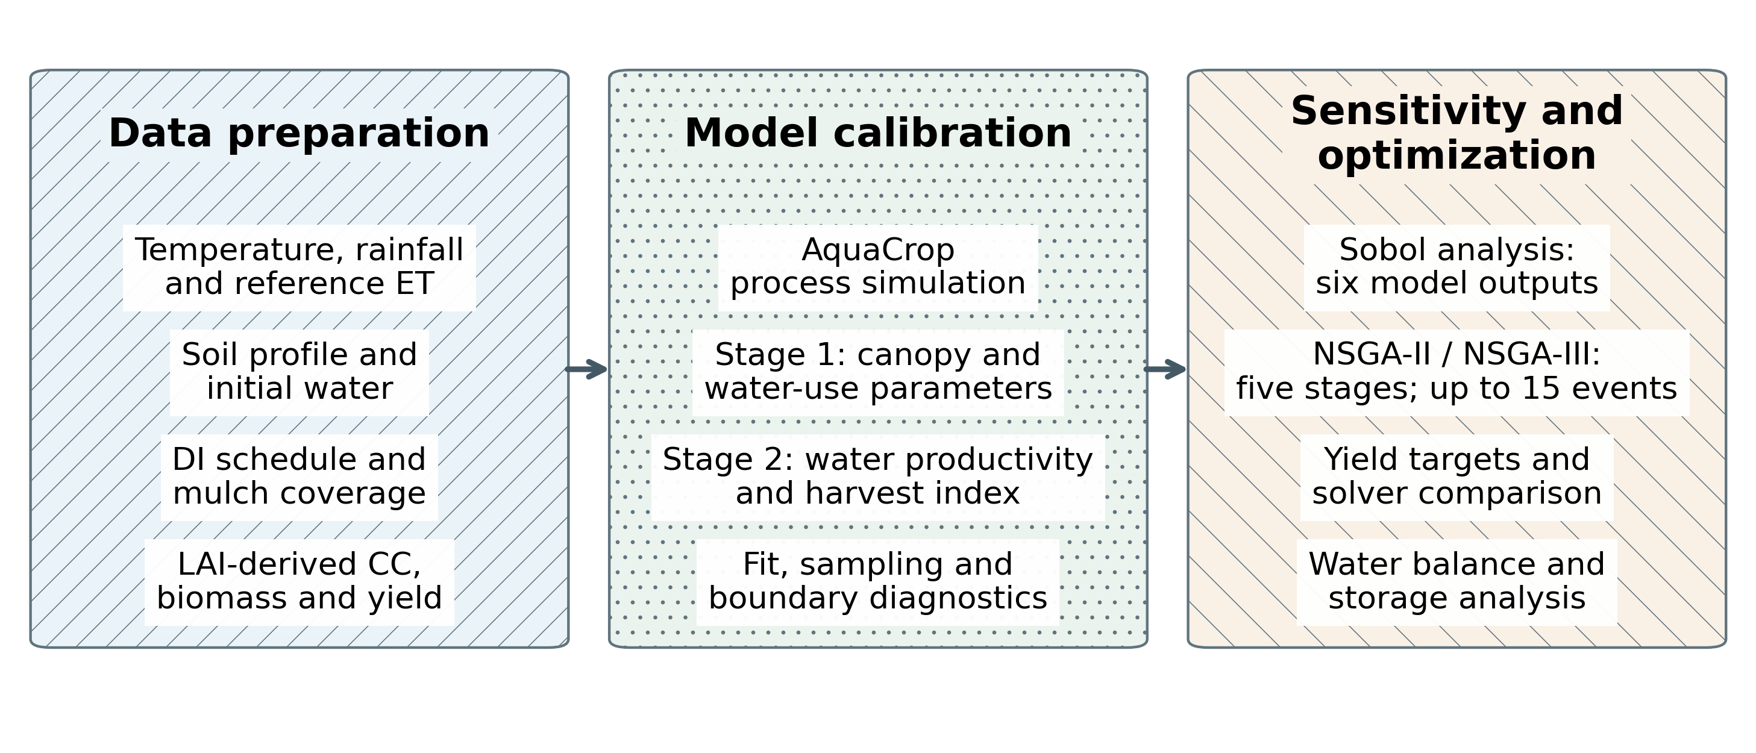
Three patterned columns summarize data preparation, crop-model calibration and decision analysis.
研究技术路线如图1所示，主要包括资料整理、模型校准和分析评价三个部分。资料整理包括气候驱动、土壤及管理条件、作物生长指标；模型校准分为冠层与耗水参数校准、生物量与产量参数校准两个阶段；分析评价包括参数敏感性、灌溉多目标优化、单目标算法对照以及水量核算。各年度模型分别使用相应年份的观测资料和气象驱动。
The workflow comprises data preparation, model calibration and decision analysis (Fig. 1). Inputs include climate forcing, soil and management conditions, and crop-growth observations. Calibration separates canopy and water-use parameters from biomass- and yield-formation parameters. Analysis covers parameter sensitivity, multi-objective scheduling, solver comparisons and water accounting. Each annual model uses its corresponding observations and weather.

Figure 2. Location of the study station and dimensions of the drip-irrigated maize field.
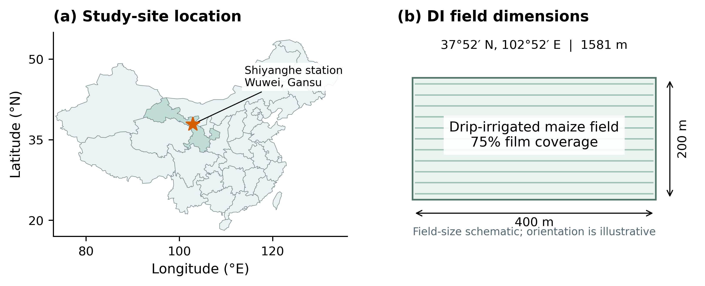
Station coordinates and field dimensions are based on the reported field observations ^{[1]}. The field panel is a size schematic with illustrative orientation.
本研究采用2019—2022年膜下滴灌玉米既有田间观测资料^{[1]}。观测区位于甘肃武威的中国农业大学石羊河实验站（37°52′N，102°52′E），海拔1581 m，属温带大陆性干旱气候，年平均降水量约164 mm，地下水埋深约40～50 m。膜下滴灌玉米观测区面积为400 m×200 m，种植密度为79 365株·ha⁻¹。地膜宽度1.2 m，相邻地膜间距0.4 m，对应覆盖率75%。图2给出试验站位置和DI观测区尺度。
This study uses existing field observations of film-mulched drip-irrigated maize for 2019–2022 ^{[1]}. The observation site is at the Shiyanghe Experimental Station of China Agricultural University in Wuwei, Gansu (37°52′ N, 102°52′ E; 1581 m above sea level). The temperate continental arid climate has mean annual precipitation of approximately 164 mm, with groundwater at a depth of approximately 40–50 m. The DI observation field measured 400 m × 200 m and was planted at 79,365 plants ha⁻¹. Film strips were 1.2 m wide, separated by 0.4 m, giving 75% coverage (Fig. 2).

Figure 3. Daily precipitation and reference evapotranspiration during the four model seasons.
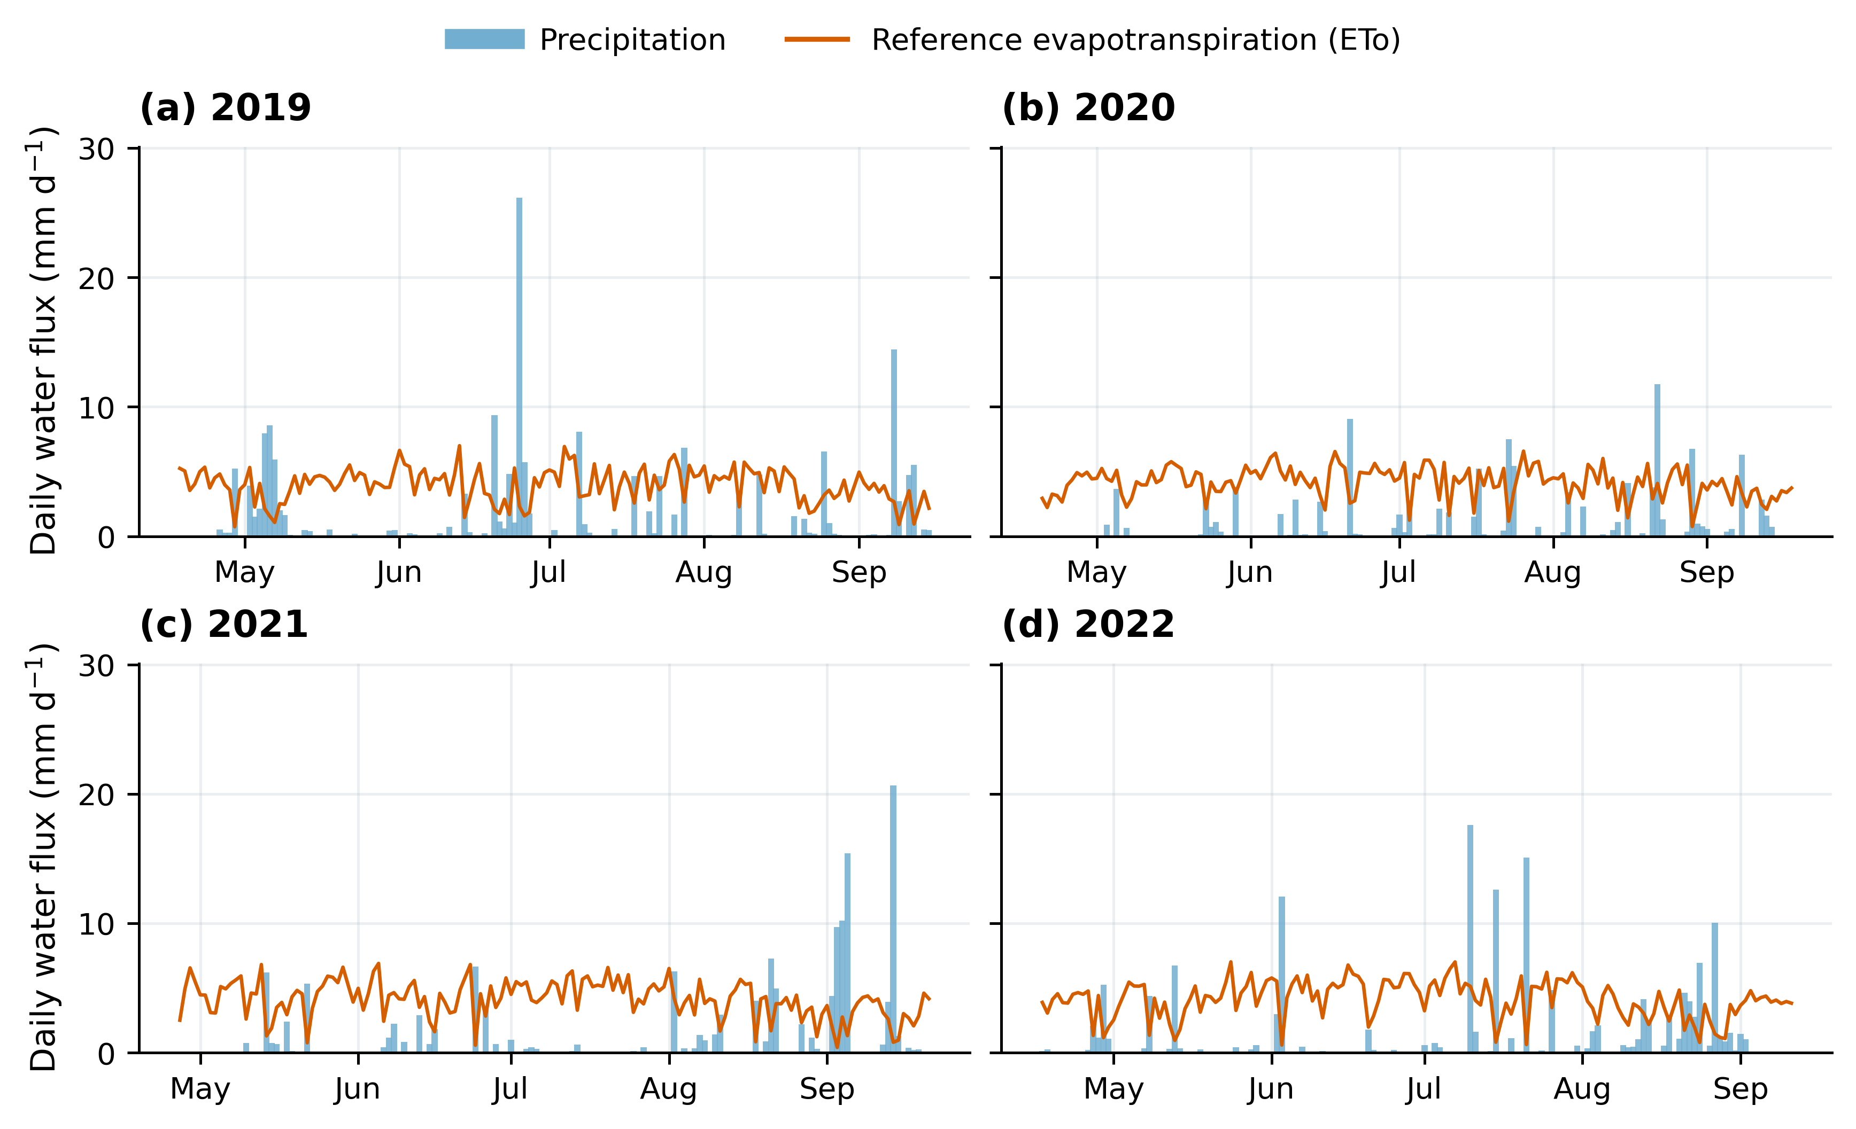
ETo uses the archived audited series; precipitation totals follow the executed model dates.
气象驱动包括逐日最低气温、最高气温、降水和参考蒸散量ETo^{[14]}。新提供的四年气象文件与归档原始输入逐值一致，全年日期连续。模型采用经审计的ETo序列，并按实际执行日历统计水量。四年模型日历内降水量分别为177.87、113.46、143.32和151.38 mm，ETo分别为595.62、632.26、612.93和609.26 mm。图3展示逐日降水和ETo的季节分布，2019年生育期降水较多，2020年参考蒸散需求较高。
Daily forcing includes minimum and maximum air temperature, precipitation and reference evapotranspiration (ETo) ^{[14]}. The newly supplied four-year weather values match the archived raw inputs, with continuous full-year dates. The model uses the audited ETo series and actual executed calendar dates for water accounting. Seasonal precipitation totals are 177.87, 113.46, 143.32 and 151.38 mm, and ETo totals are 595.62, 632.26, 612.93 and 609.26 mm. Figure 3 shows daily distributions: 2019 has greater seasonal rainfall, whereas 2020 has higher reference evaporative demand.

Figure 4. Canopy-cover calibration for drip-irrigated maize in 2019–2022.
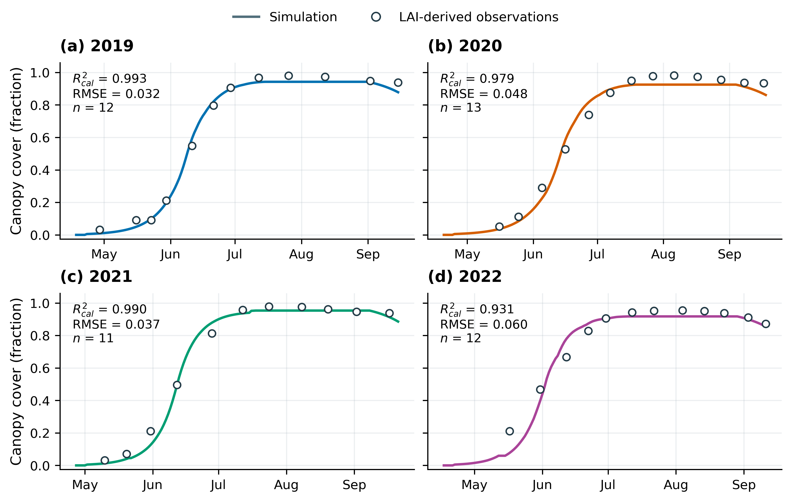
Lines show simulations at phase-specific retained means; circles show LAI-derived calibration observations.
模型较好地再现了四年冠层形成、快速增长及高覆盖期的变化（图4）。2019—2022年CC的R²cal分别为0.9932、0.9794、0.9902和0.9306，RMSE分别为0.0316、0.0482、0.0370和0.0596。2022年的误差相对较高，主要表现为冠层时序与观测点之间的偏离。总体上，校准后的模型能够描述本试验玉米冠层覆盖度的主要季节变化。
The model reproduces the principal canopy development and high-cover periods (Fig. 4). Annual CC R²cal values are 0.9932, 0.9794, 0.9902 and 0.9306, with RMSE values of 0.0316, 0.0482, 0.0370 and 0.0596. The larger 2022 error primarily reflects deviations in canopy timing from the observations. Overall, the calibrated model describes the main seasonal CC dynamics in these experiments.

Figure 5. Observed and simulated aboveground dry biomass in four years.
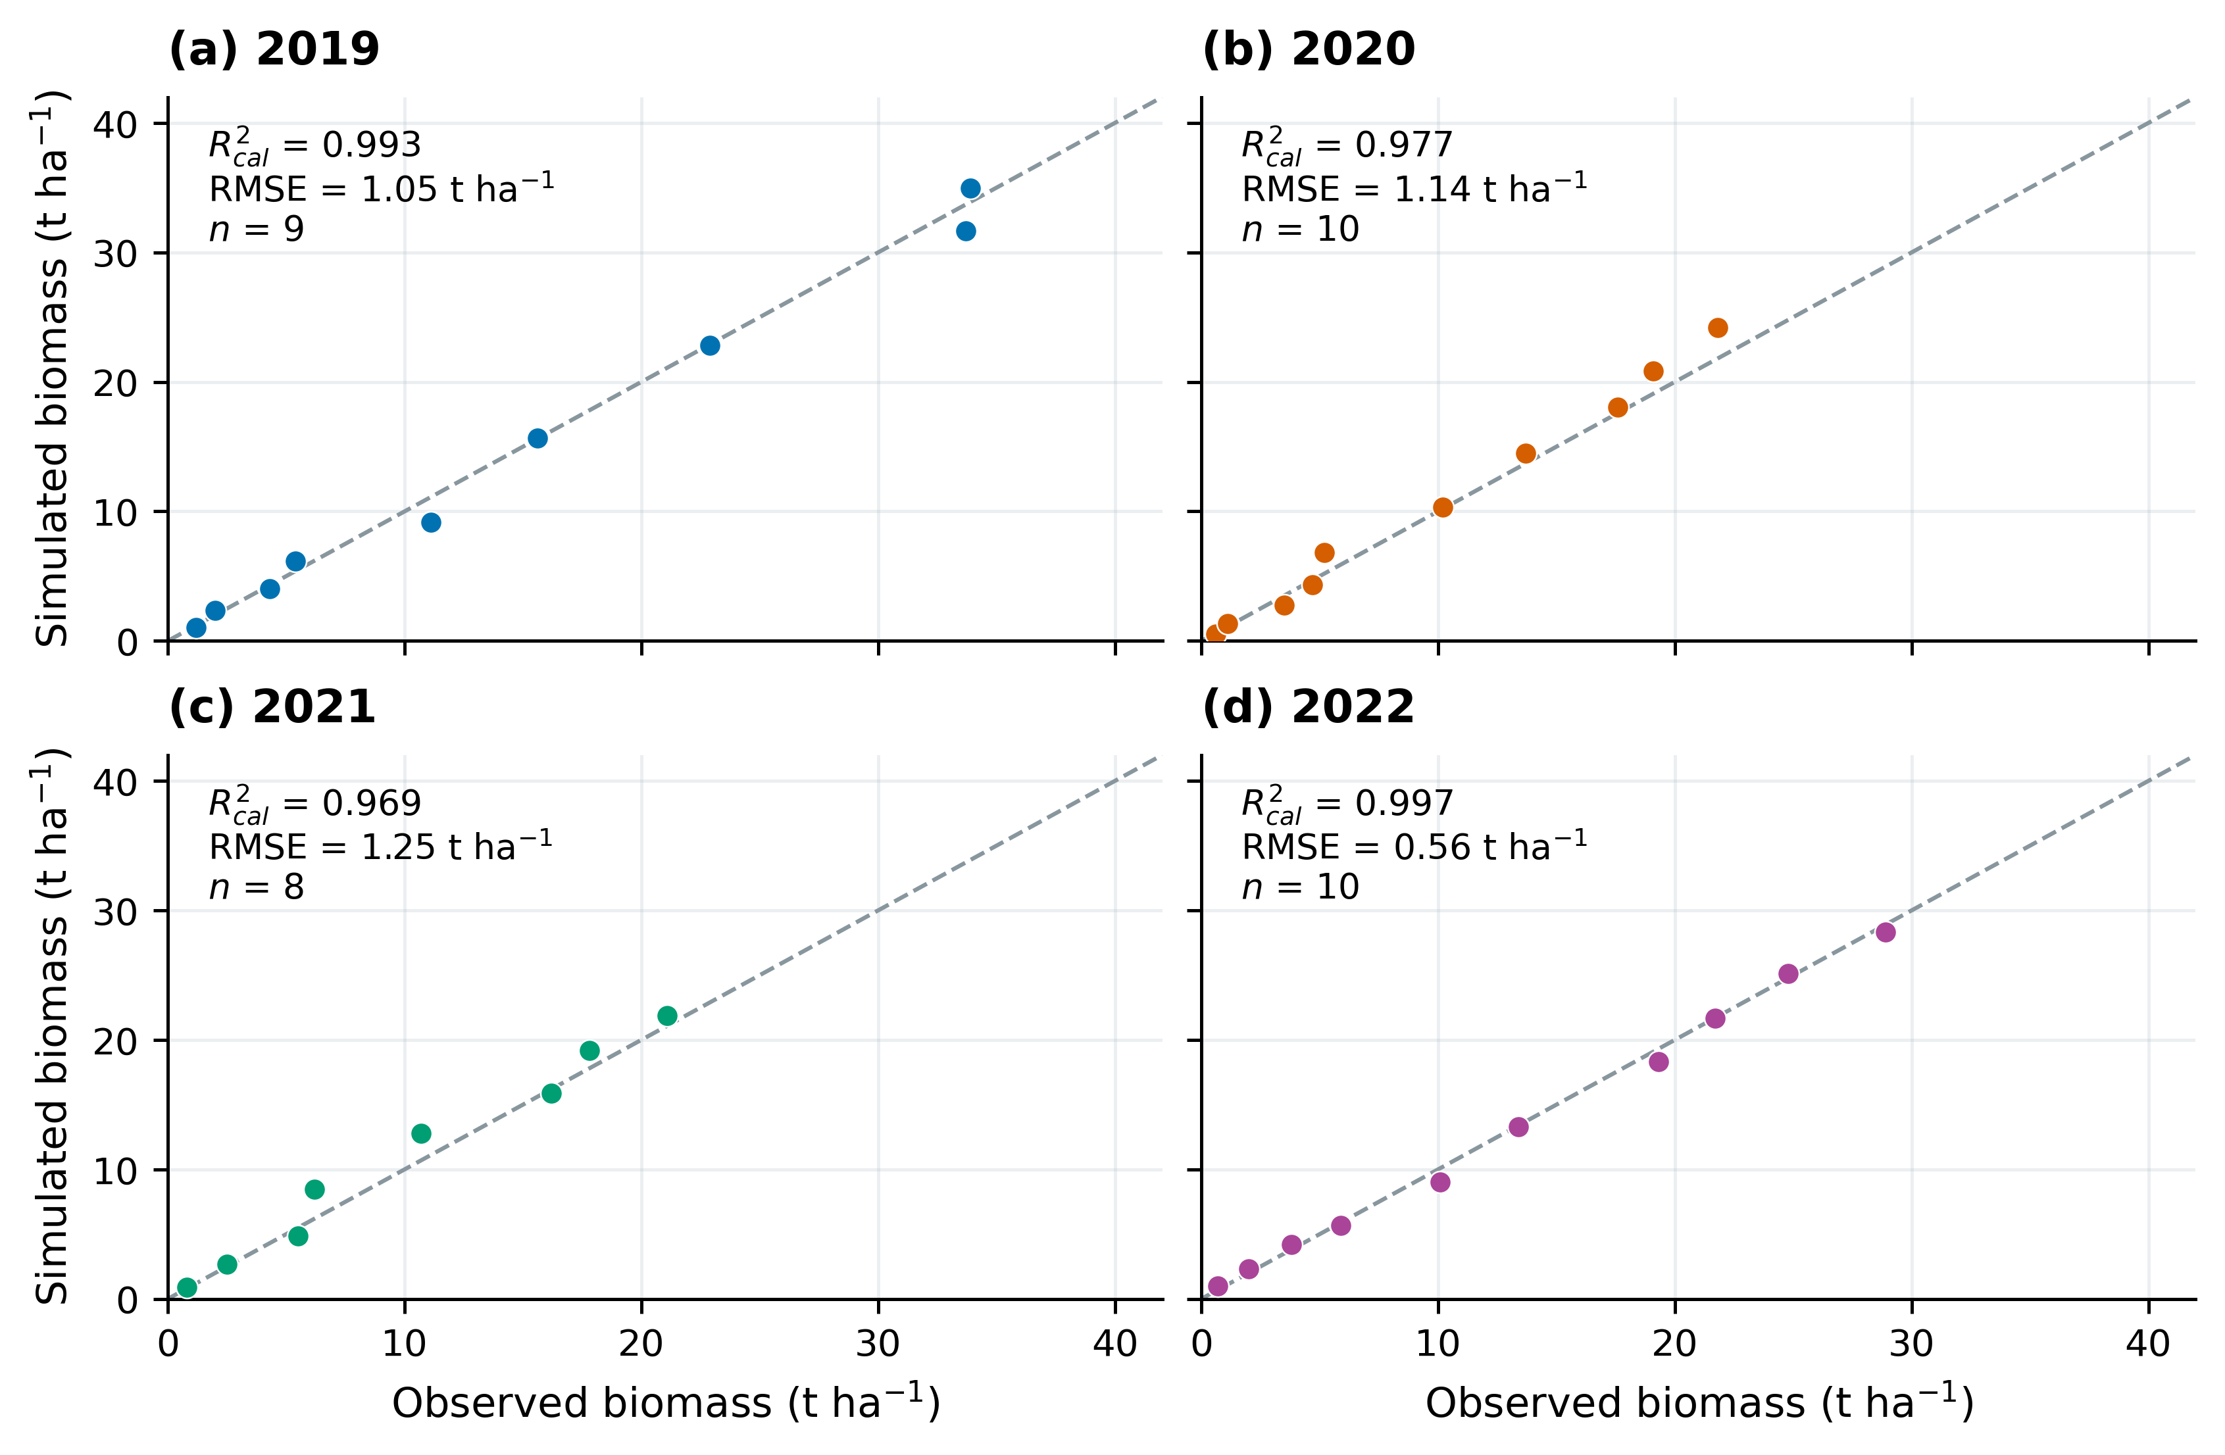
Dashed lines indicate 1:1 agreement. R²cal and RMSE describe calibration fit.
四年地上干生物量模拟值与数字化观测值接近1∶1关系（图5），R²cal为0.9685～0.9966，RMSE为0.5562～1.2520 t·ha⁻¹。2022年生物量误差最小，2021年误差相对较大。年度籽粒产量模拟值依次为16.702、16.804、15.197和14.078 t·ha⁻¹，相对观测值偏差分别为0.92%、−2.81%、−4.18%和−0.02%（表5）。冠层、生物量和产量三类指标共同表明，校准参数能够较好表征各年作物生长与产量水平。
Simulated and digitized observed biomass approach the 1:1 relationship (Fig. 5), with R²cal of 0.9685–0.9966 and RMSE of 0.5562–1.2520 t ha⁻¹. Biomass error is lowest in 2022 and highest in 2021. Simulated grain yields are 16.702, 16.804, 15.197 and 14.078 t ha⁻¹, corresponding to observed-yield biases of 0.92%, −2.81%, −4.18% and −0.02% (Table 5). These complementary indicators characterize annual growth and yield at the retained parameter centers.

Figure 6. Annual parameter centers, retained-sample intervals and prior supports.
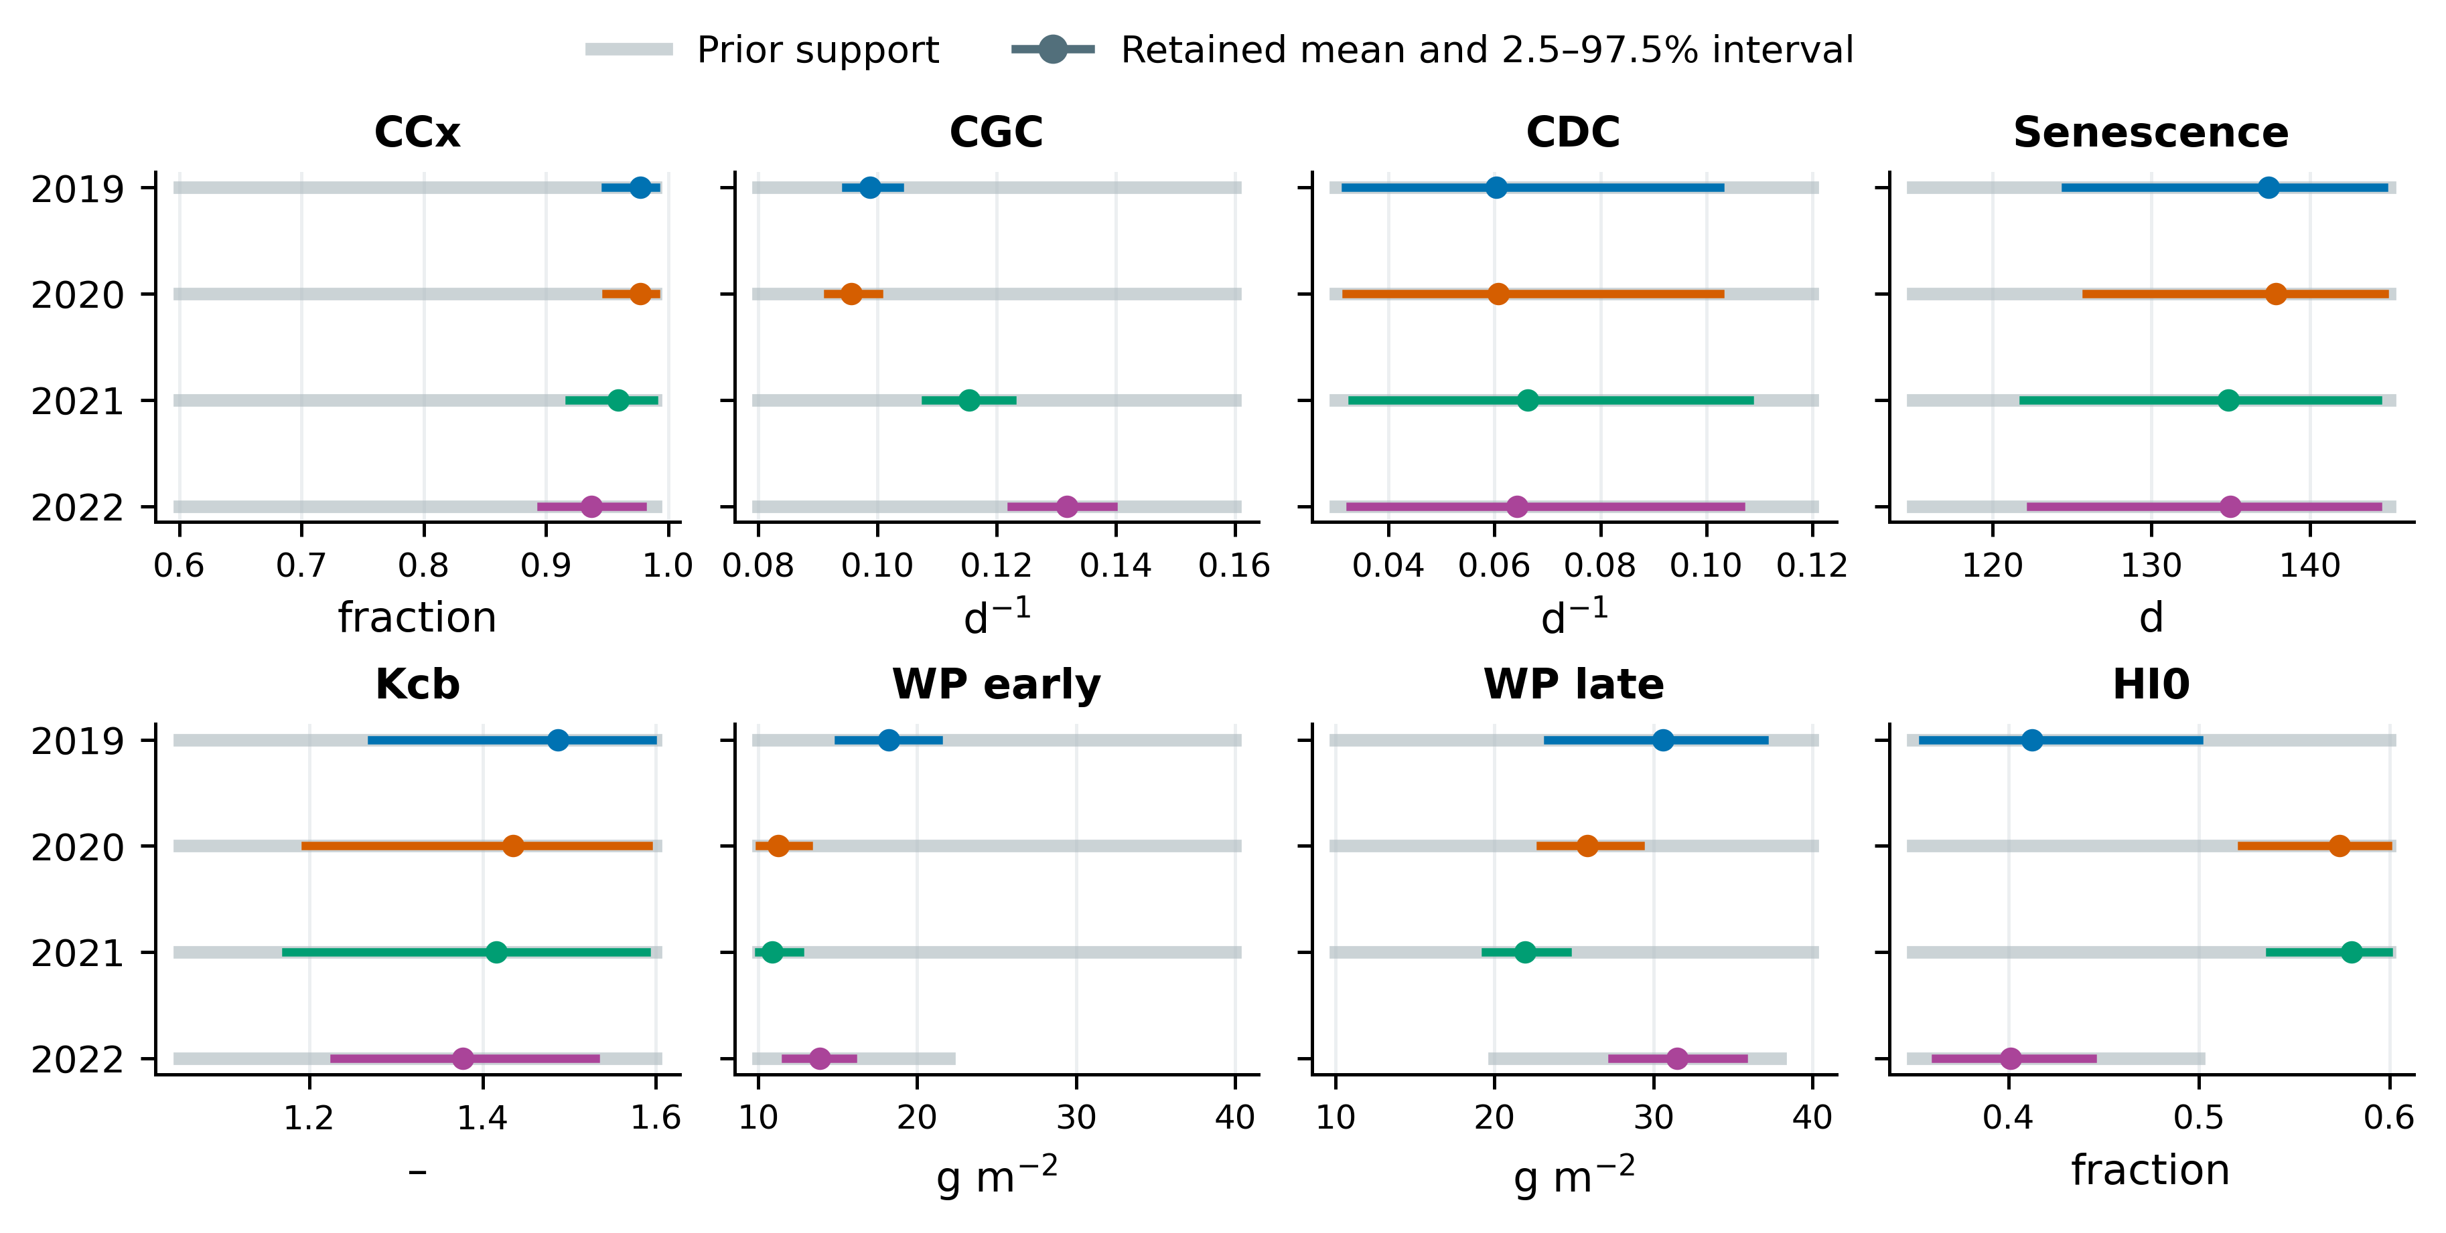
Colored intervals show empirical 2.5–97.5% quantiles within each calibration phase. Gray intervals show annual prior supports.
参数经验区间及先验支持范围如图6所示。CGC_CD的年度区间较集中；CDC_CD和衰老时间的区间相对较宽。2019、2020年CCx在上界1%邻近带中的样本比例分别为22.14%和23.06%，2020、2021年WP_early在下界邻近带中的比例分别为11.43%和23.65%。这些结果说明，不同参数受观测资料约束的程度存在差异，边界邻近集中主要出现在最大冠层覆盖度和早期水分生产率。
Figure 6 shows empirical parameter intervals and prior supports. Annual CGC_CD intervals are relatively narrow, whereas CDC_CD and senescence intervals are wider. Upper-bound-neighborhood mass for CCx is 22.14% in 2019 and 23.06% in 2020; lower-bound-neighborhood mass for WP_early is 11.43% in 2020 and 23.65% in 2021. Observation constraints differ among parameters, with boundary-near concentration most evident for maximum canopy cover and early water productivity.

Figure 7. Pooled four-year regression of simulated against observed biomass.
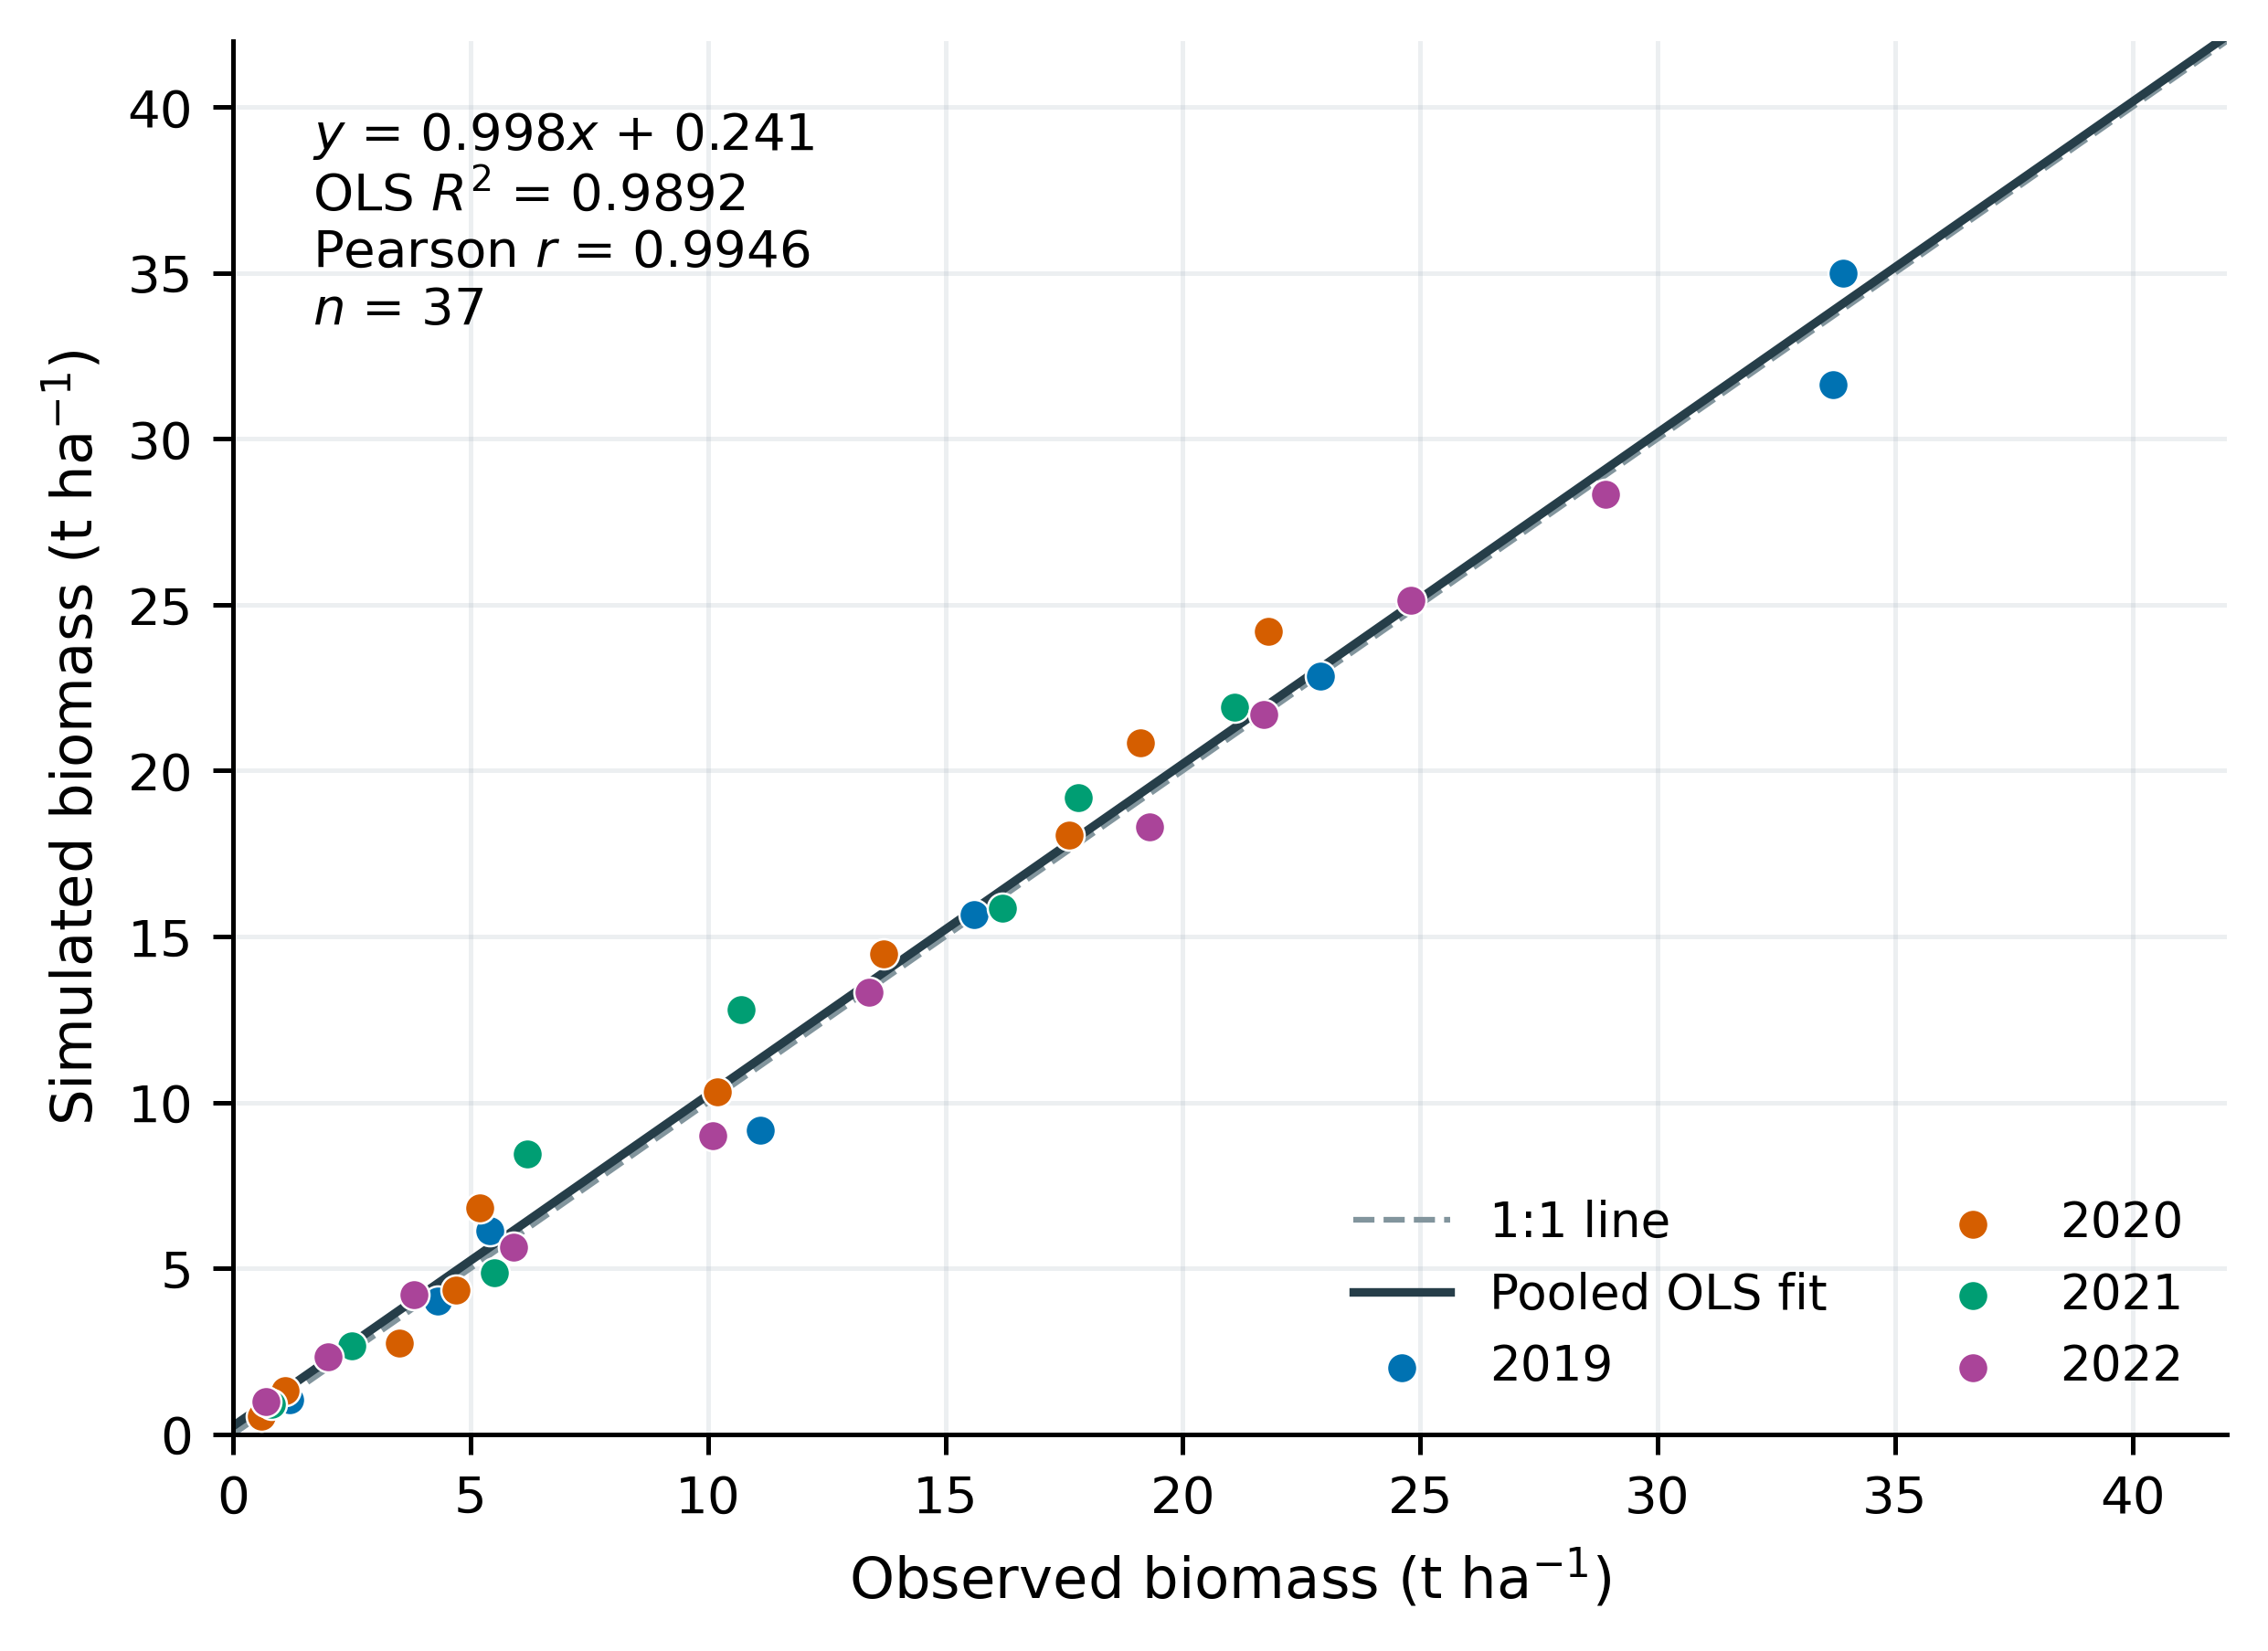
The solid line is the OLS fit to 37 calibration pairs; the dashed line indicates 1:1 agreement.
为综合比较模型对生物量形成过程的描述，汇总四年37个生物量配对点进行线性回归（图7）。以观测生物量为x、模拟生物量为y，得到y=0.9979x+0.2412，OLS R²为0.9892，Pearson r为0.9946，汇总RMSE为1.0205 t·ha⁻¹。回归斜率接近1，表明四年主要生长阶段的生物量变化具有较好一致性。
The pooled regression combines all 37 biomass calibration pairs across years (Fig. 7). With observed biomass as x and simulated biomass as y, the fitted relation is y=0.9979x+0.2412, with OLS R²=0.9892, Pearson r=0.9946 and pooled RMSE=1.0205 t ha⁻¹. The slope near one indicates close correspondence in biomass dynamics over the observed growth stages.

Figure 8. Seasonal inflow, outflow and storage change under the original DI schedules.
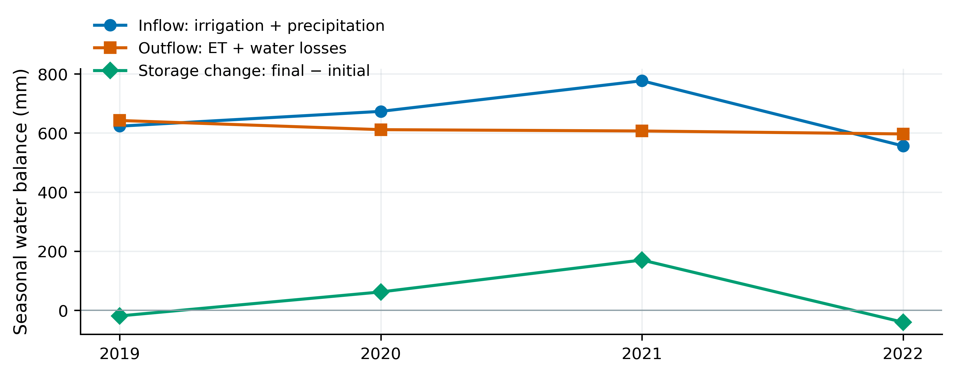
Inflow comprises precipitation and actual irrigation; outflow comprises ET and other losses. Storage change is final minus initial profile and surface water.
原日程年度入流、出流及储水变化见图8。四年入流量分别为623.14、673.22、776.79和556.22 mm，出流量分别为642.37、611.31、606.83和596.81 mm，剖面储水变化分别为−19.23、61.92、169.97和−40.58 mm。其中，2021年灌水量最大，但其ET为605.14 mm，与其他年份处于相近量级；该年全剖面储水由535.70增加至705.67 mm，表现出明显的季内增储。上述差异为解释后续减灌水结果提供了水量依据。
Annual baseline inflows, outflows and storage changes are shown in Fig. 8. Inflows are 623.14, 673.22, 776.79 and 556.22 mm; outflows are 642.37, 611.31, 606.83 and 596.81 mm; and storage changes are −19.23, 61.92, 169.97 and −40.58 mm. Although 2021 receives the greatest irrigation, its ET of 605.14 mm is comparable with the other years. Profile storage increases from 535.70 to 705.67 mm, providing an important basis for interpreting subsequent irrigation reductions.

Figure 9. Total-effect Sobol indices for four crop-model outputs across years.
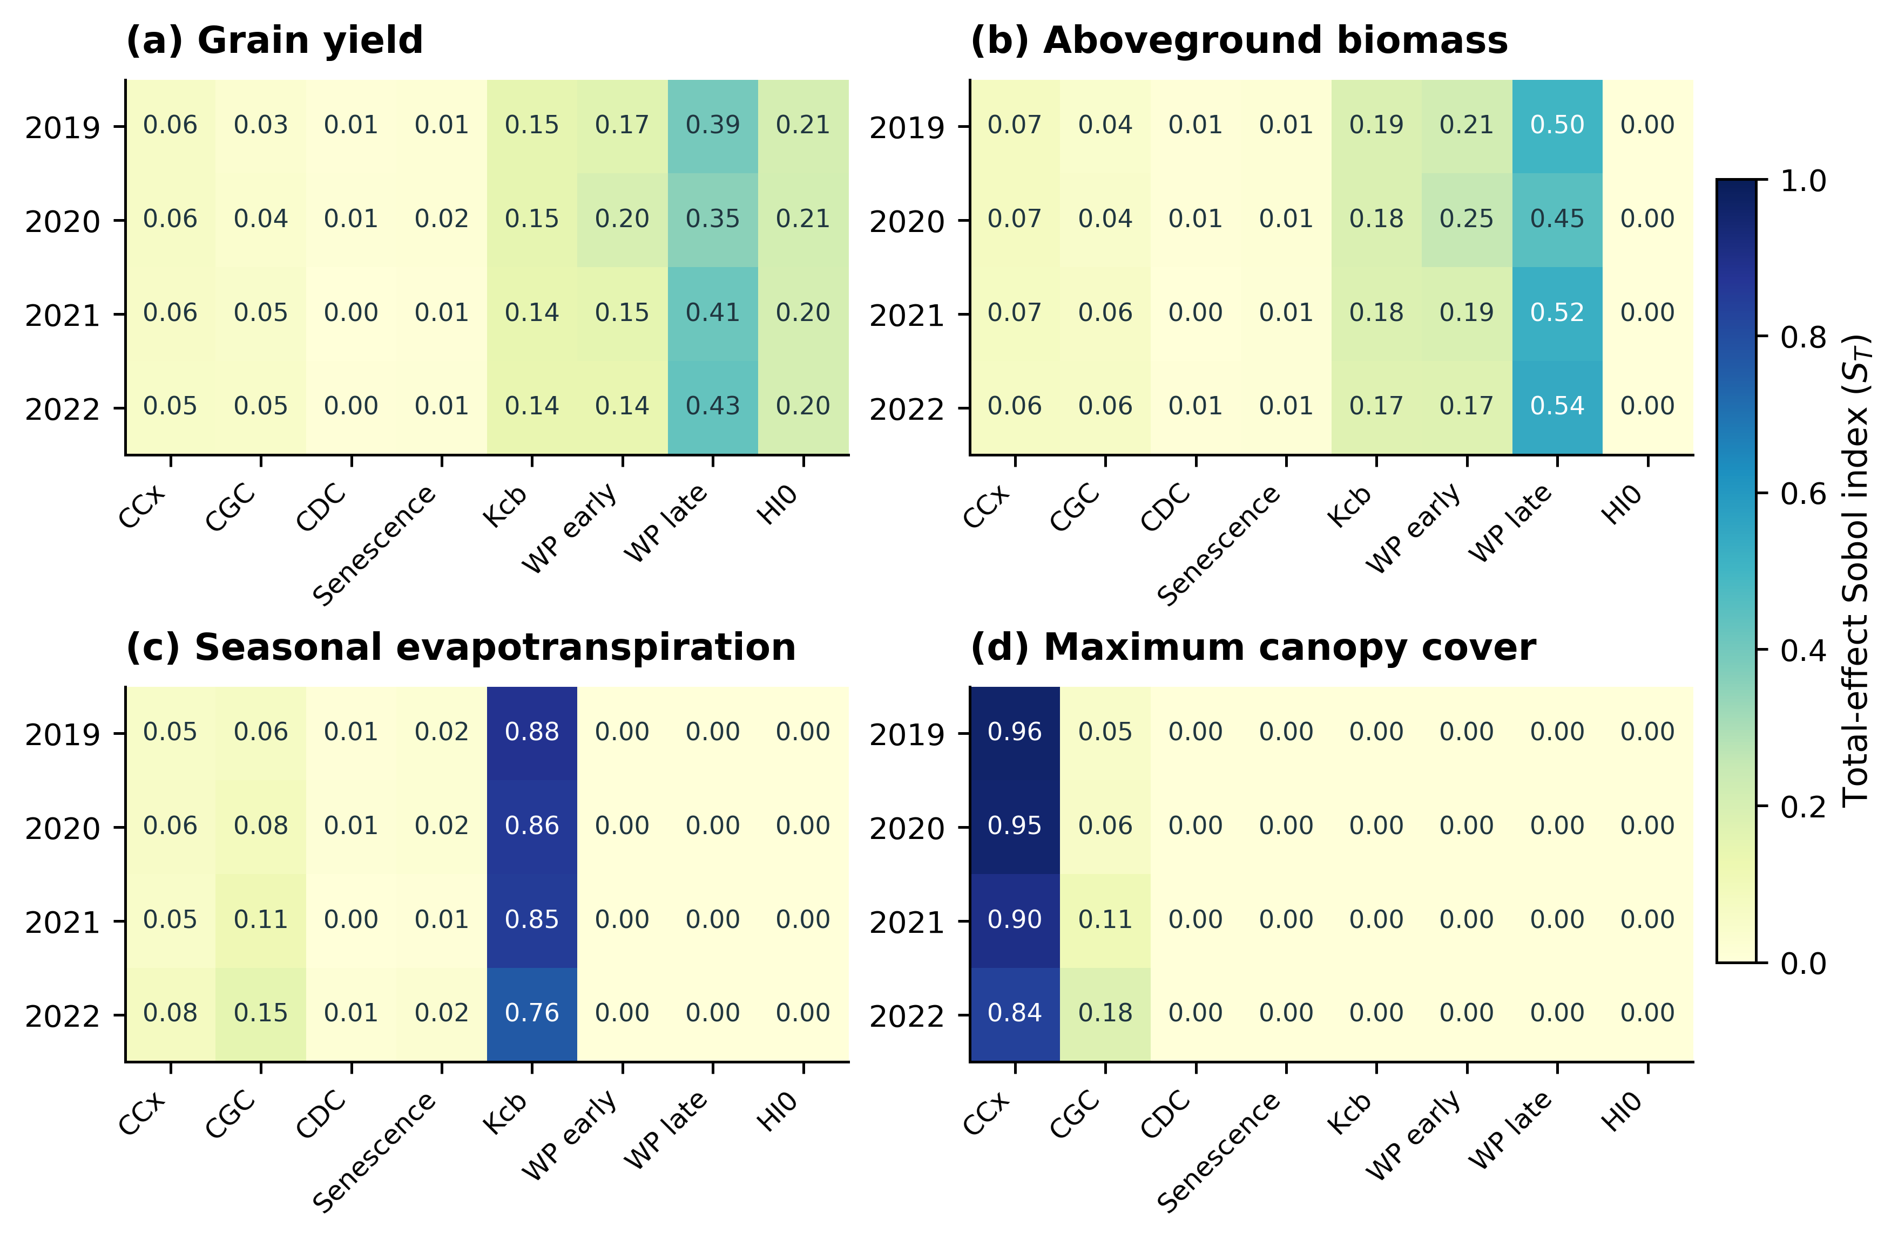
Cells show means of three N=512 scrambles under the same independent input ranges; all panels use the same color scale.
各输出的参数总效应指数见图9。籽粒产量主要受晚期WP、HI0、早期WP和Kcb影响；生物量主要受水分生产率与基础作物系数影响；季节ET以Kcb为主导；最大冠层覆盖度以CCx为主导。产量、生物量、ET及最大CC四个输出的年度平均参数排序在四年间一致，两两年度Spearman排序相关系数均为1.00，说明在本研究共同输入范围内，主要参数的作用层级具有年度稳定性。
Total-effect indices reveal output-specific parameter controls (Fig. 9). Grain yield is primarily sensitive to late WP, HI0, early WP and Kcb; biomass is controlled mainly by water productivity and Kcb; seasonal ET is dominated by Kcb; and maximum CC is dominated by CCx. Annual-mean parameter rankings for yield, biomass, ET and maximum CC agree across all four years, with pairwise Spearman correlations of 1.00 under the common input ranges.

Figure 10. First-order and total-effect yield sensitivity with four-year descriptive means.
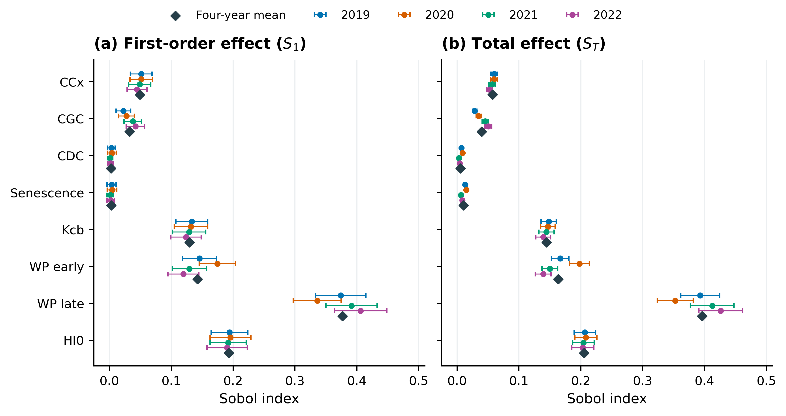
Error bars show approximate 95% numerical bootstrap intervals for three-scramble annual means. Diamonds indicate equal-weight means across the four years.
产量一阶和总效应指数及其数值区间见图10。晚期WP的四年平均Sₜ为0.396，年度范围为0.353～0.426；HI0、早期WP和Kcb分别为0.206、0.164和0.145（表6）。前四个参数的总效应之和约0.911，反映出产量形成主要受生物量转换和水分消耗过程控制。年度排序的一致性支持采用等权四年均值概括主要敏感性层级，年度区间则保留了不同气象及生长条件造成的幅度变化。
First-order and total-effect yield indices and numerical intervals are shown in Fig. 10. Mean late-WP Sₜ is 0.396, with an annual range of 0.353–0.426; means for HI0, early WP and Kcb are 0.206, 0.164 and 0.145 (Table 6). Their total effects sum to approximately 0.911, emphasizing biomass conversion and water-use processes. Consistent annual-mean rankings support an equal-weight summary of the main sensitivity hierarchy, while annual ranges retain differences in magnitude.

Figure 11. Five-stage NSGA-III yield–irrigation fronts and individual-event schedules across four years.
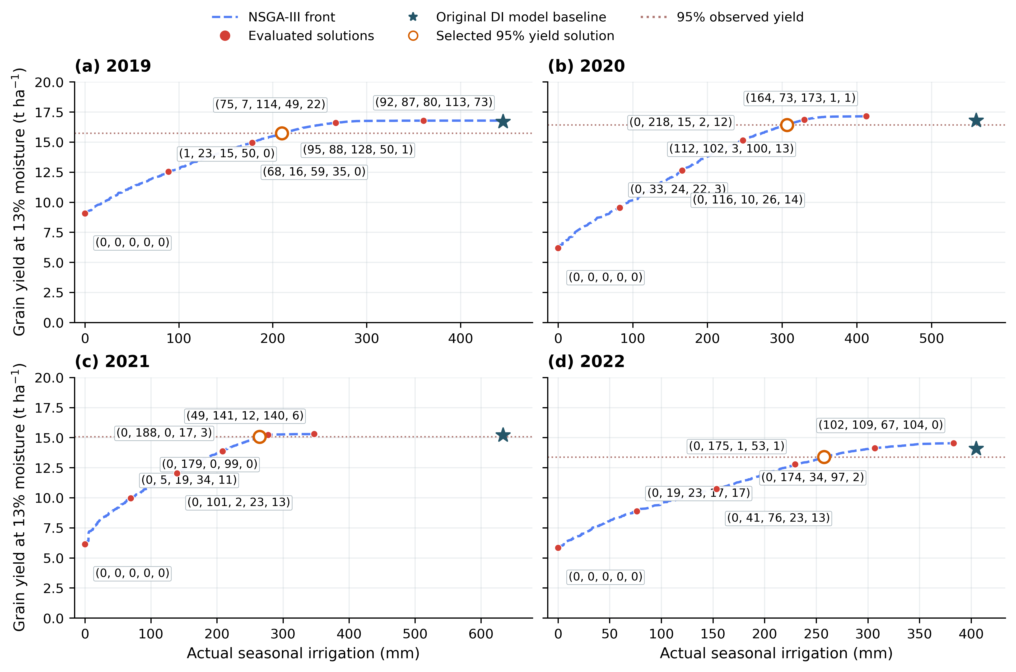
Red labels give rounded actual totals for Seedling, Jointing, Heading, Grain filling and Maturity. Stars show original DI model baselines; orange open circles show formal selected candidates. The displayed full-range fronts pool three 80-individual, 60-generation supplemental searches per year. Irrigation cancelled after crop termination is excluded from actual totals.
图11展示四年全范围五期NSGA-III非支配前沿。蓝色虚线连接已计算的非支配解，红点为标注解，括号内依次给出苗期、拔节期、抽穗期、灌浆期和成熟期的实际灌水合计；橙色空心点标示正式95%门槛主候选。各年前沿呈增加后逐渐趋于平台的关系。零灌水情景保留当年降水和初始土壤水，四年产量分别为9.071、6.184、6.140和5.850 t·ha⁻¹。
Figure 11 presents full-range five-stage NSGA-III fronts. Blue dashed joins connect evaluated nondominated solutions; red-point tuples give rounded actual depths for Seedling, Jointing, Heading, Grain filling and Maturity. Orange open circles identify formal 95%-yield candidates. Yield generally increases and then approaches a plateau. Zero-irrigation simulations retain annual rainfall and initial soil water and yield 9.071, 6.184, 6.140 and 5.850 t ha⁻¹, respectively.

Figure 12. Water-balance components of irrigation reduction under the selected five-stage schedules.
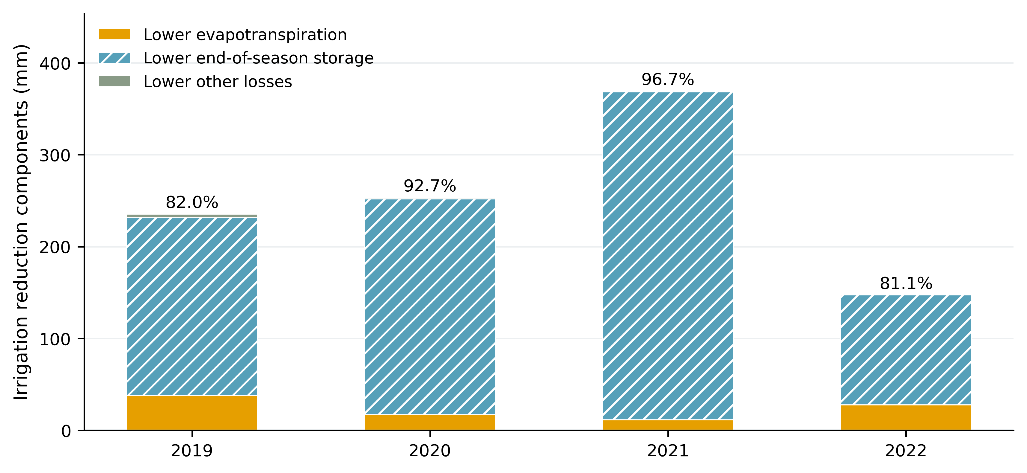
Percentages indicate the terminal-storage difference divided by the irrigation reduction. ET, storage and other-loss differences use identical annual forcing and initial soil water.
原日程与五期主候选的水量差额见图12及表8。四年ET分别下降38.16、17.04、11.46、27.85 mm，占基准ET的5.98、2.79、1.89、4.67%；季末全剖面储水分别下降193.14、234.87、356.85、119.50 mm，解释了82.03、92.74、96.72、81.09%的灌水差额。实际蒸散变化较小，而季末水状态发生明显变化。
Water differences between recorded and selected five-stage schedules are shown in Fig. 12 and Table 8. ET decreases by 38.16, 17.04, 11.46, 27.85 mm, or 5.98, 2.79, 1.89, 4.67% of baseline ET. Terminal profile storage decreases by 193.14, 234.87, 356.85, 119.50 mm, accounting for 82.03, 92.74, 96.72, 81.09% of the irrigation differences. Consumptive-use changes are relatively small compared with the changes in terminal soil water.

Figure 13. Every optimized irrigation date and depth in the selected four-year schedules.
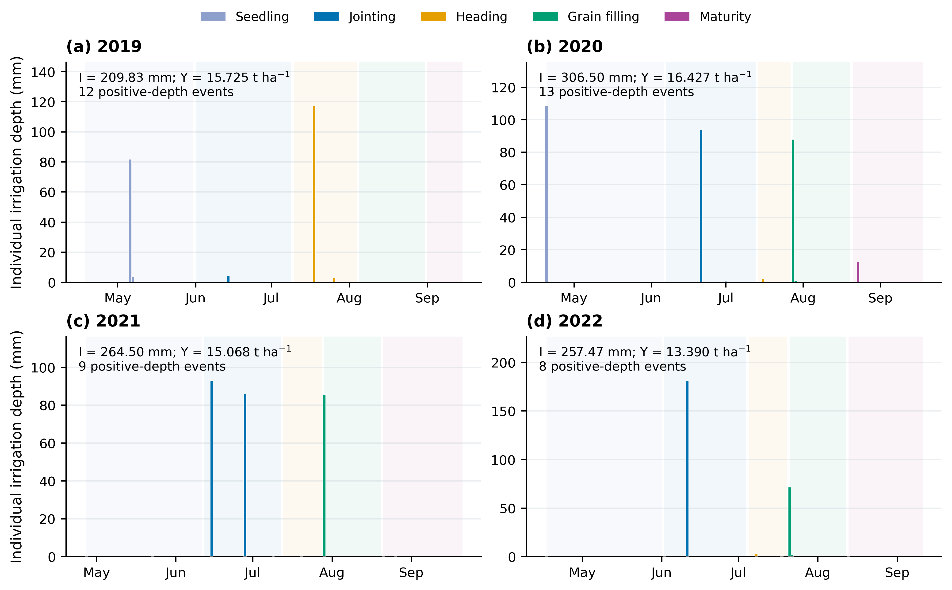
Colors indicate five phenological stages, with up to three optional events in each stage. Positive-depth event counts include trace numerical amounts; counts for depths ≥0.1 mm are reported separately. All exact positive depths remain in the source table.
图13按实际日期绘制四年主候选的每次灌水量，完整日程见附表S5—S8。四年正水量事件数依次为12、13、9和8，其中≥0.1 mm事件分别为8、8、3和6；两种计数对应同一组未取整控制量。2021年≥0.1 mm的事件为6月15日92.959 mm、6月28日85.822 mm和7月29日85.634 mm，其余微量正数同时保留在源表中。
Figure 13 plots every positive-depth irrigation event at its optimized date; complete schedules appear in Tables S5–S8. Exact positive-depth counts are 12, 13, 9 and 8, whereas counts of events ≥0.1 mm are 8, 8, 3 and 6. Both counts describe the same unrounded controls. The 2021 events ≥0.1 mm are 92.959 mm on 15 June, 85.822 mm on 28 June and 85.634 mm on 29 July. Remaining trace positive depths are preserved in the source tables.

Figure 14. Five-stage irrigation totals and positive-depth event counts.
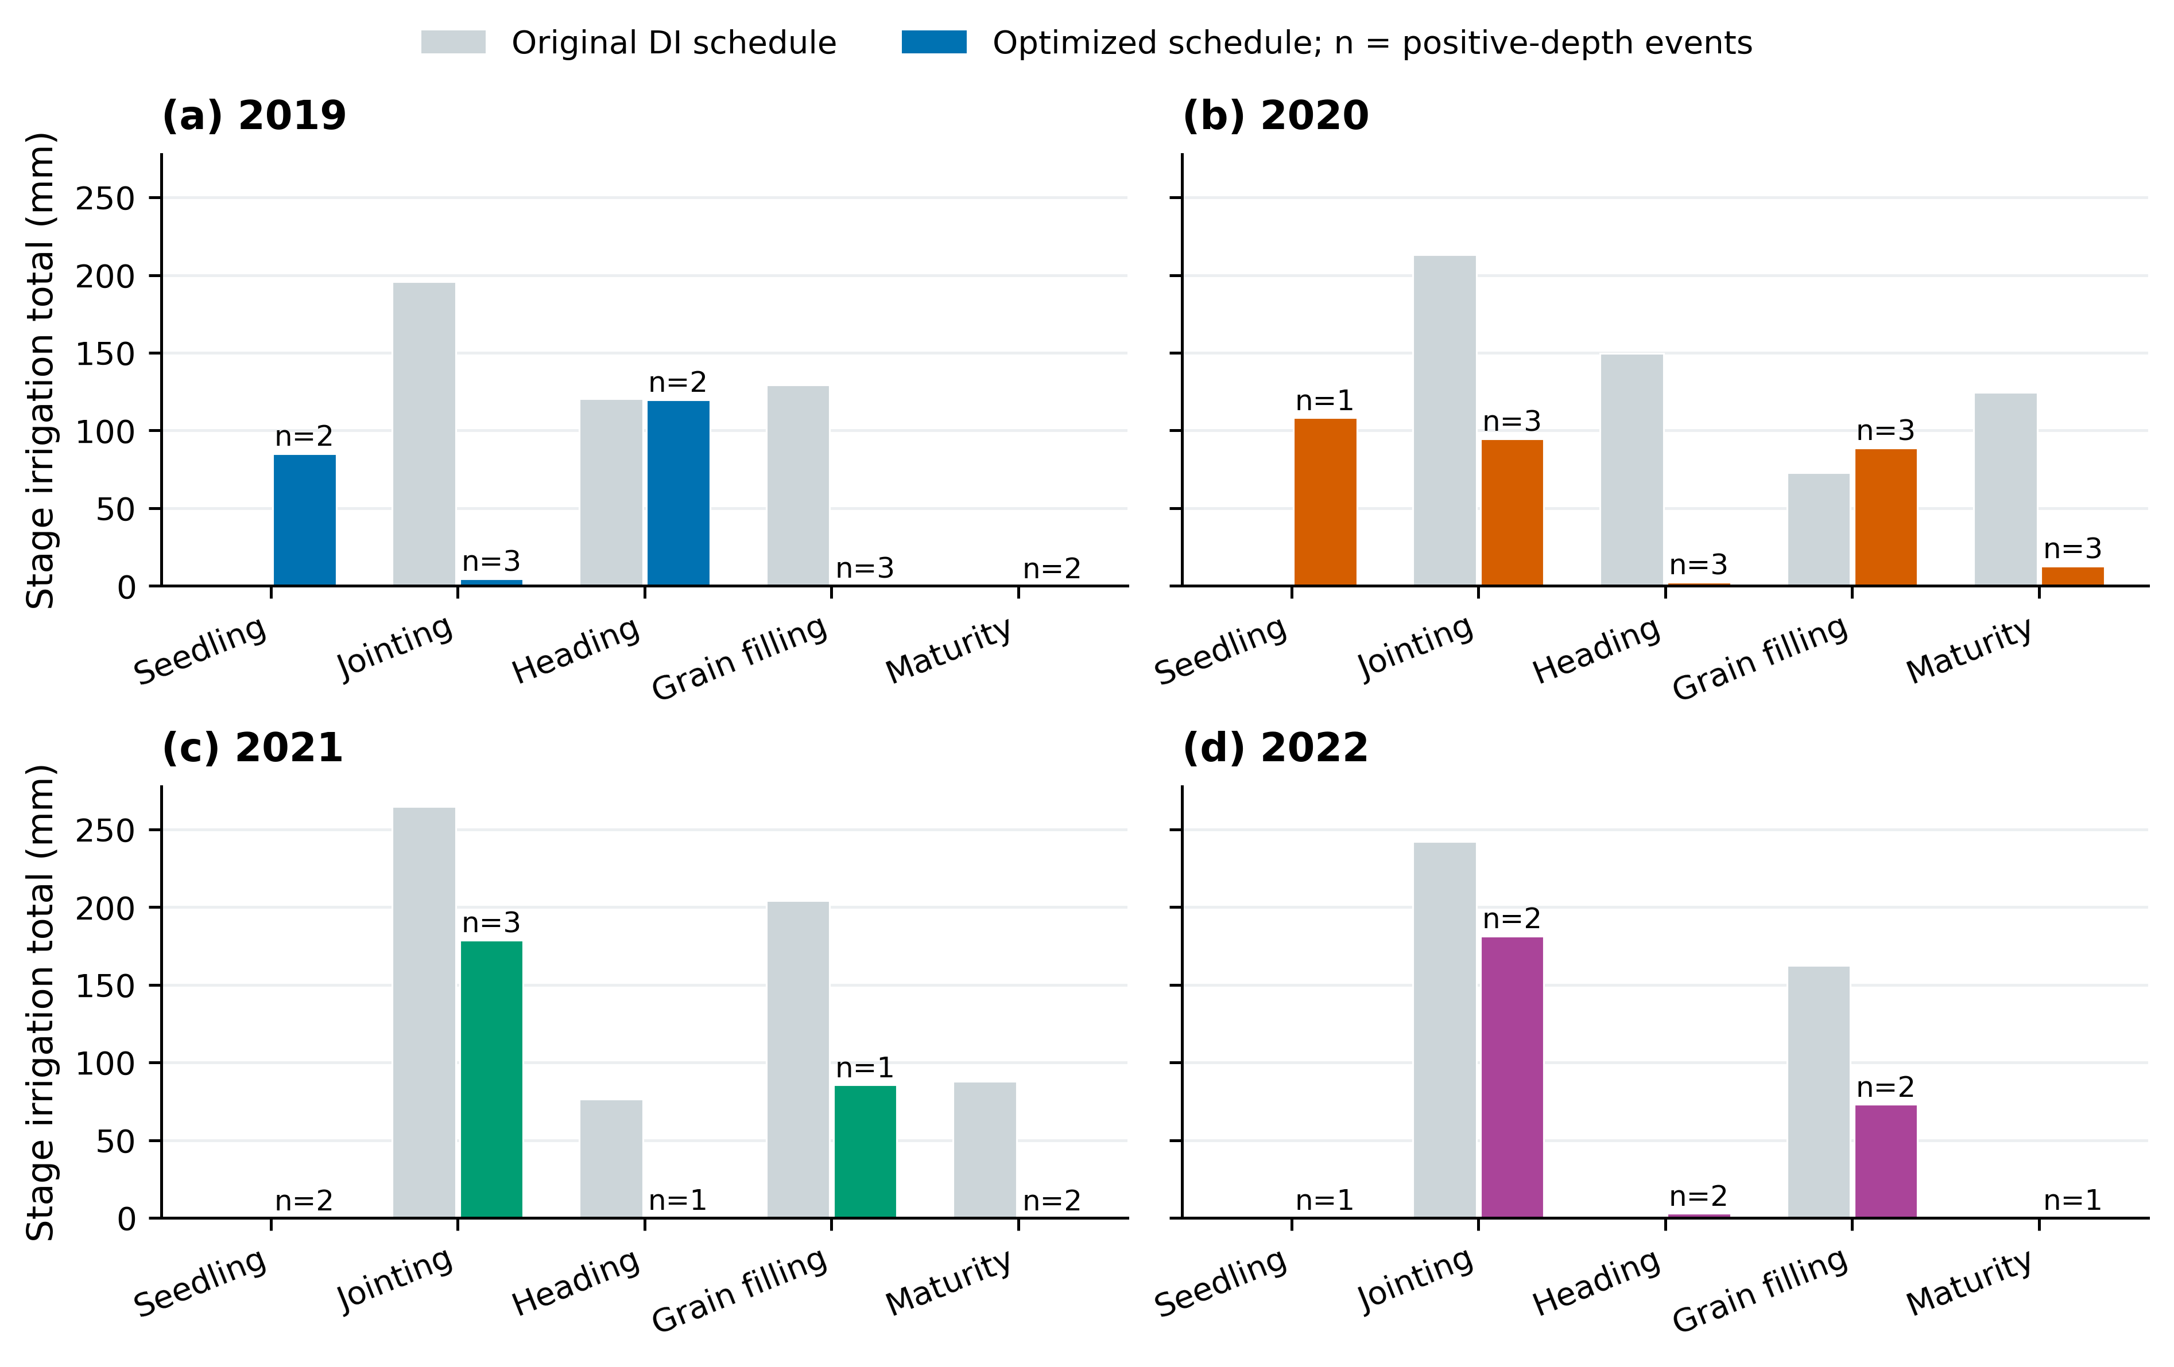
Gray bars show recorded DI schedules and colored bars show selected schedules. Counts include merged exact positive depths. Stage sums reconcile with actually executed seasonal irrigation.
五期总量与次数见图14和表9。2021年水量主要分配在拔节期178.782 mm和灌浆期85.634 mm，其他阶段合计约0.084 mm。2019年则将较多水量分配在苗期与抽穗期。阶段合计、逐次实际执行量及模型季节灌水量相互核对，最大差小于10⁻⁷ mm。各期允许0～3次，并非要求每期都灌满3次。
Stage totals and counts appear in Fig. 14 and Table 9. The 2021 schedule mainly allocates 178.782 mm to Jointing and 85.634 mm to Grain filling, with approximately 0.084 mm across the other stages. The 2019 schedule instead concentrates more water in Seedling and Heading. Stage sums, individual executed depths and modeled seasonal irrigation reconcile within 10⁻⁷ mm. Zero to three events are permitted per stage rather than requiring three applications in every stage.

Figure 15. NSGA-III and NSGA-II population hypervolume across formal searches.
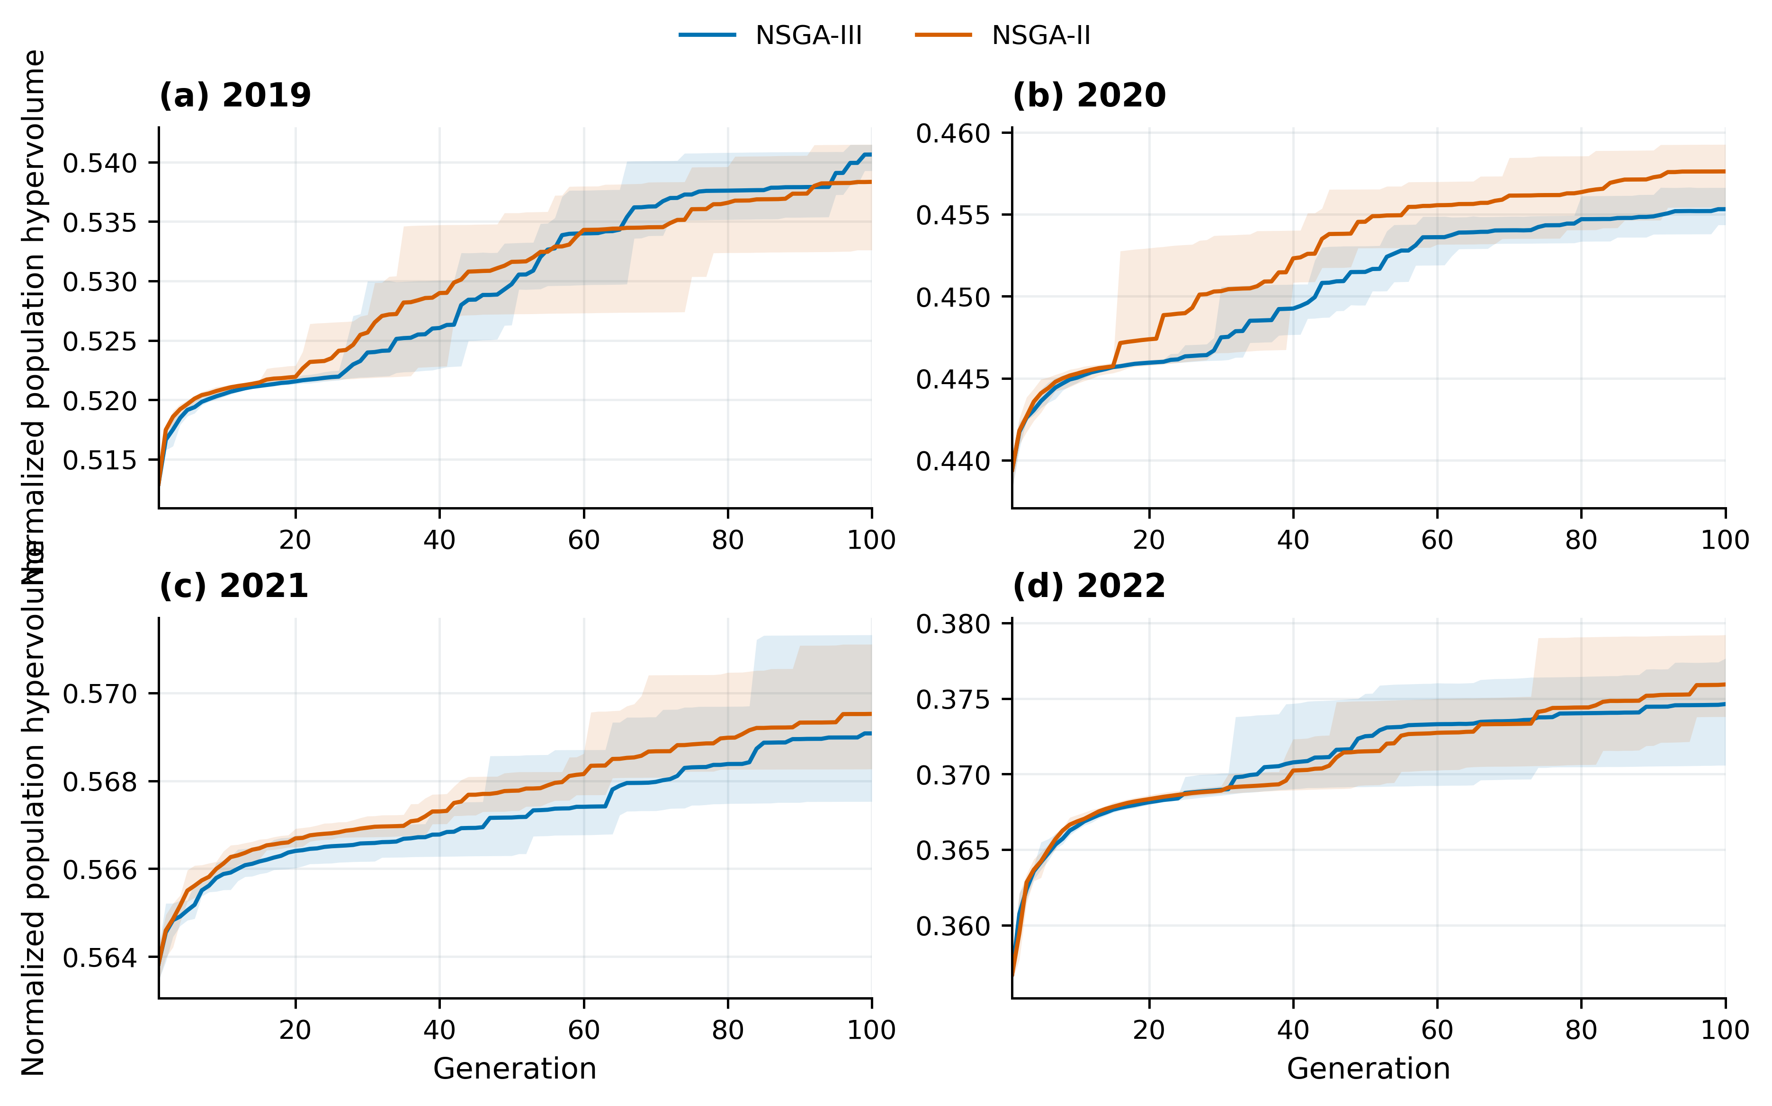
Lines show five-seed means and shading shows seed ranges. Algorithms share disclosed recorded-schedule and four-window initialization anchors. Final feasible-population union metrics are tabulated separately.
两算法五种子的种群超体积变化见图15，最终种群并集指标见表10。NSGA-III与NSGA-II年度最低灌水量之差的绝对值为0.03～1.47 mm，得到相近但不完全相同的权衡关系。主日程按既定NSGA-III选择规则确定；NSGA-II的最低水量及各自最高产量另表给出。共同初值、相同目标和约束下的算法对照与逐日物理核算相互补充。
Figure 15 shows population hypervolume over five seeds for each algorithm; final-population union metrics appear in Table 10. Absolute annual differences between the lowest irrigation values found by NSGA-III and NSGA-II range from 0.03 to 1.47 mm, indicating similar but nonidentical trade-offs. The primary calendar follows the stated NSGA-III selection rule; NSGA-II minima and each algorithm’s maximum yields are listed separately. Comparisons under common anchors, objectives and constraints complement the daily water-process accounting.

