**Report of Project 1: The Basics of FEM**

By Yue Yu, email: [yu_yue@berkeley.edu](mailto:yu_yue@berkeley.edu)

# Introduction & Objectives

Our primary goal is to solve the problem below using FEM:

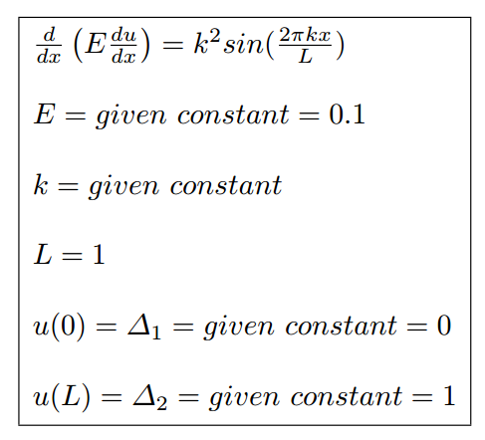

For each k=1,2,4,8,16,32… we will find how many elements (N) are needed to achieve the precision ($e^{N}≤0.05$). And we will find the relationship between N and $e^{N}$ for each individual k.

# Procedure

Chart. 1 Flow-chart

The general procedure is show in the flow-chart. The general weak form of 1-dimantional problem is:

$$\frac{d}{dx}\left(E\frac{du}{dx}\right)+f=0, ∀x∈Ω$$

In this problem:

$$f=-k^{2}sin⁡(2πkx/L)$$

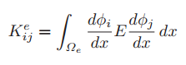

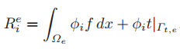

Since E is a constant, ϕ is a linear function, dϕ/dx is also a constant. Ke is the same for every element.

$$Ke=\left[\begin{matrix}E/h & -E/h \\ -E/h & E/h\end{matrix}\right]$$

Where h=L/N is the length of element.

It is a bit more difficult to calculate Re because f varies on every element. We can transform the domain of $Ω_{e}$ to [-1,1] and use Gaussian quadrature. After getting every Ke and Re, we combine they to form a N+1 by N+1 global matric K and a N+1 by 1 global matric R. According to the boundary conditions, a(1)=0 and a(N+1)=L. Then I applied the boundary conditions to K and R. In the equation **KA=R**, K is row 2 to N, column 2 to N of the original K, while R is row 2 to N of original R with the Nth element changed to R(N)-L*K (N, N+1).

Next we have to solve the equation **KA=R**. We can simply get **A=K\R**. Or we can use Gaussian elimination, which is a bit slower.

After we get A, $u^{N}$ is known. But we can only describe $u^{N}$ on each element. So we have to calculate quadrature on every element and sum them when we are trying to get ${||u-u^{N}||}_{E(Ω)}$.

# Findings



Fig.1 k=1 Fig.2 k=2



Fig. 3 k=4 Fig.4 k=8



Fig.5 k=16 Fig.6 k=32

Fig.1-6 show the plot of u and $u^{N}$ for different k and N.

|  |  |
| --- | --- |
| **k** | **Minimum N when eN<=0.05** |
| 1 | 28 |
| 2 | 67 |
| 4 | 142 |
| 8 | 289 |
| 16 | 580 |
| 32 | 1161 |

Table.1

Table.1 shows the minimum N when eN<=0.05 for different k.

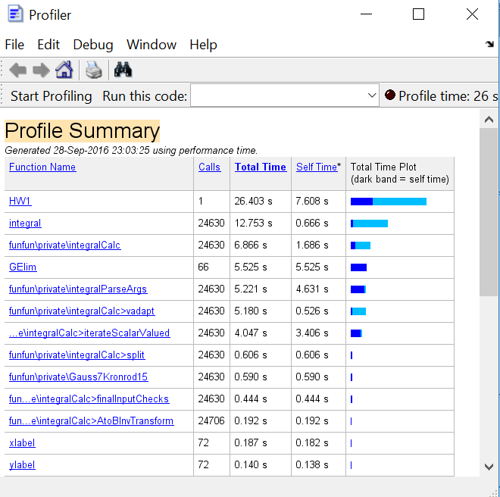

Fig.7 Running time



Fig.8. k=1 Fig.9 k=2



Fig.10 k=4 Fig.11k=8



Fig.12 k=16 Fig.13 k=32

Fig.8-13 show the relationship between N and $e^{N}$, x-axis is log2(N) and y-axis is ln(eN).

# Observations and discussion

1. When N is smaller than a certain value which is dependent on k, $u^{N}$ is basically a straight line, therefore $e^{N}$ stays the same. But when N is big enough, there is a linear relationship between log($e^{N}$) and log2(N), which means $e^{N}∝1/N$. (As indicated above in fig.8-13)
2. It is much faster using Gaussian quadrature to figure out $e^{N}$ than using the built-in function ‘integral’. Calling ‘integral’ will take several seconds in total while it takes less than one second using Gaussian quadrature.

But there is a problem when using Gaussian quadrature. As is described before, when N is small, $u^{N}$ is a straight line. So $e^{N}$ should be the same even for different small Ns ( $e^{N=2},e^{N=4},e^{N=8}$ should be equal to each other), while this is not the case when using Gaussian quadrature to figure out $e^{N}$. I tried using 4 points and 5 points, they have the same problem. But $e^{N}$ seems to be accurate enough when N is bigger than some threshold. I guess the reason may be when N is too small, the element length is relatively too long, causing the error of Gaussian quadrature.

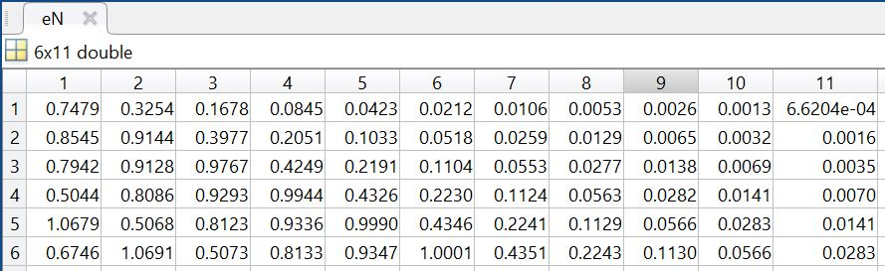

(a)

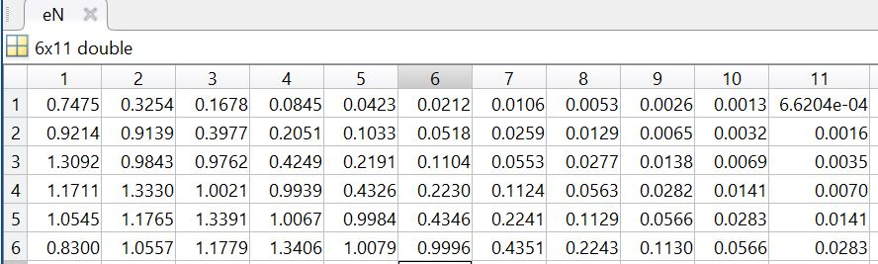

(b)

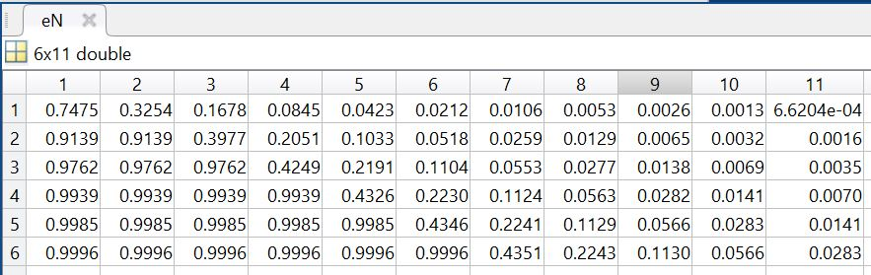

(c)

Fig.14 $e^{N}$ using 4-point(a), 5-point(b) Gaussian quadrature and built-in ‘integral’ function(c), the last one can be taken as the correct result. (k=1,2,4,8,16,32, N=2,4,8,16,32,64,128,256,512,1024,2048)

1. I wrote a special function to do Gaussian elimination. Because of the special structure of K in this problem, we only need to do elementary row operations to the row just below and above K(i, i) instead of all the rows below and above, thus saving a lot of time and computation.

|  |  |  |  |  |  |
| --- | --- | --- | --- | --- | --- |
| X | X | 0 | 0 | 0 | 0 |
| X | X | X | 0 | 0 | 0 |
| 0 | X | X | X | 0 | 0 |
| 0 | 0 | X | X | X | 0 |
| 0 | 0 | 0 | X | X | X |
| 0 | 0 | 0 | 0 | X | X |

Fig.15 Special structure of K in this problem (only those elements on the diagonal and next to diagonal are non-zero).

# Appendix:

1. Matlab code of HW1.m:

GR2=[0.577350269189626 1;

-0.577350269189626 1];

GR3=[0 0.888888888888889;

0.774596669224148 0.555555555555556;

-0.774596669224148 0.555555555555556];

GR4=[0.339981043584856 0.652145154862546;

0.861136311594053 0.347854845137454;

-0.339981043584856 0.652145154862546;

-0.861136311594053 0.347854845137454];

GR5=[0.000000000000000 0.568888888888889;

0.538469310105683 0.478628670499366;

0.906179845938664 0.236926885056189;

-0.538469310105683 0.478628670499366;

-0.906179845938664 0.236926885056189]; %Gauss weights and points

L = 1; %Length

E = 0.1; %constant

for ki=0:5

figure

for Ni=1:11

k = 2^ki;

N = 2^Ni; %number of elements

h = L/N; %length of each element

f =@(x)-k*k*sin(2*pi*k*x/L); %f(x) in the weak form

u =@(x)-L*L/4/pi/pi/E*sin(2*pi*k*x/L)+L*x; %real solution of u(x)

du=@(x)-L*k/2/pi/E*cos(2*pi*k*x/L)+L; %du/dx

fun1=@(x)E*(-L*k/2/pi/E*cos(2*pi*k*x/L)+L).^2;

Ke= zeros(2,2,N);

Re= zeros(2,1,N);

for i= 1:N

Ke(:,:,i)= [E/h,-E/h;-E/h,E/h];

%figure out Re using Gaussian quadrature

Re(1,1,i)=GR3(:,2)'*(f(h/2*(GR3(:,1)+2*i-1))*0.5.*(1-GR3(:,1))*0.5*h);

Re(2,1,i)=GR3(:,2)'*(f(h/2*(GR3(:,1)+2*i-1))*0.5.*(1+GR3(:,1))*0.5*h);

%fRe1=@(z)f(0.5*h*(z+2*i-1))*0.5.*(1-z)*0.5*h;

%Re(1,1,i)=integral(fRe1,-1,1);

%fRe2=@(z)f(0.5*h*(z+2*i-1))*0.5.*(1+z)*0.5*h;

%Re(2,1,i)=integral(fRe2,-1,1);

end

K=zeros(N+1,N+1);

R=zeros(N+1,1);

for i=1:N

K(i,i)=K(i,i)+Ke(1,1,i); %get global K based on local Ke

K(i,i+1)=K(i,i+1)+Ke(1,2,i);

K(i+1,i)=K(i+1,i)+Ke(2,1,i);

K(i+1,i+1)=K(i+1,i+1)+Ke(2,2,i);

R(i,1)=R(i,1)+Re(1,1,i);

R(i+1,1)=R(i+1,1)+Re(2,1,i);

end

R(N)=R(N)-L*K(N,N+1);

R=R(2:N,1);

K=K(2:N,2:N); %reshape K and R according to boundary conditions

K=sparse(K);

A=zeros(N+1,1);

% A(2:N,1)=K\R;

A(2:N,1)=GElim(K,R);

A(1,1)=0;

A(N+1,1)=L; %get ai for uN

x1=0:0.001:1;

u=u(x1);

x2=0:h:1;

uN=A;

hold on

plot(x1,u,x2,uN)

xlabel('x')

ylabel('uN')

uE=integral(fun1,0,L);

uuNE=0;

for i= 1:N

fun2=@(x)E*(du(x)-(A(i+1)-A(i))/h).^2;

uuNE=uuNE +integral(fun2,i*h-h,i*h);

%uuNE=uuNE + GR5(:,2)'*fun2(h/2*(GR5(:,1)+2*i-1))*h/2;

end

uE=sqrt(uE); %||u||E

uuNE=sqrt(uuNE);

eN(ki+1,Ni)=uuNE/uE;

end

hold off

end

for k=1:6

figure;

plot(1:11,log(eN(k,:)),'Marker','*');

xlabel('log2(N)')

ylabel('log(eN)')

end

1. Matlab code of GElim.m:

function A = GElim( K,R )

%doing Gause elimilation for a special sparse matrix

l=length(R);

B=[K,R];

for i=1:l-1;

B(i,:)=B(i,:)/B(i,i);

B(i+1,:)=B(i+1,:)-B(i,:)*B(i+1,i);

end

B(l,:)=B(l,:)/B(l,l);

for i=l:-1:2;

B(i-1,:)=B(i-1,:)-B(i-1,i)*B(i,:);

end

A=B(:,end);